

Report
Australian Community Trends

Australian Community Trends Report

National Research Study

February 2019

© McCrindle Research Pty Ltd, February 2019 Suite 105, 29 Solent Circuit
Norwest, NSW, 2153 www.mccrindle.com.au
+61 2 8824 3422 | info@mccrindle.com.au

Contents
Introduction from McCrindle 4
Introduction from Clarety 5
Research objectives 6
Research methodology 6
Demographic summary 7
Demographic summary 8
Executive summary 9
The Australian not-for-profit landscape 11
Giving practices in Australia 12
Drivers for engagement 21
Charity essentials 24
Blockers and enablers to giving 30
Trust in the charity sector 35
Working in the charity sector 37
Future of the charity sector 42
Charity sector in Australia 44

Introduction from McCrindle

The not-for profit sector and the charities, social enterprises and community organisations across this nation provide much of the social infrastructure that builds the capacity of communities Australia wide. Their value to this nation is demonstrated by the almost $143 billion given in the last year, most of it by the community rather than government. The esteem of this sector is demonstrated by the size of the charity workforce, which employs one in every ten Australian workers.

While the sector is viewed in a positive light and five in six Australians give to charities, these are uncertain times and Australia is changing rapidly. Demographic shifts, social changes and constant technological advancement are transforming Australian communities. How and where Australians live, and how they allocate their time and money is shifting.

There are also big generational transitions taking place. From 2019, there will be more Australians born since 1980 than before 1980.

While the emerging generations are purpose- driven and socially conscious, they are also less likely to commit long-term to a specific charity or not-for-profit organisation. Almost four in five Australians (79%) agree that charities will struggle in the future as younger Australians are less actively involved than previous generations. Engaging this post-loyal generation will be key, as from 2019 Generations Y and Z will comprise the majority of the workforce — outnumbering Generations X and the Baby Boomers for the first time.

The purpose of this annual Australian Communities Report is to equip leaders in the sector to respond with relevance to the changing external environment and the emerging trends. This 2019 study builds on the results from the 2017, 2016 and 2015 research and offers insights to help Australia’s not-for- profit leaders continue to create ripples of change that over time will build the capacity of communities locally, nationally and indeed globally.

Introduction from Clarety

The sector that most directly and deliberately improves and supports Australian communities is the not-for-profit sector. The value of the sector can be demonstrated by its 52,166 charities which are growing annually, and 1.3 million paid staff and 2.9 million volunteers.

As the Australian Community Trends Report findings indicate, five in six Australians give to charities or not- for-profit organisations and the majority of those working in the sector believe in the next five years their organisation will be better. We are truly a giving nation, with a vision to see more positive change.

Now in its fifth year, the report provides a detailed analysis of the effectiveness, engagement and awareness of the not-for- profit sector. It continues to help organisations understand the Australian community – the developing trends, the giving landscape, and the current and emerging supporter segments.

The report not only showcases the sentiments of the broad Australian community, but also by surveying not-for-profit professionals, reveals the current opportunities and challenges that affect the not-for-profit sector.

In the year where Generations Y and Z will comprise the majority of the workforce, it is encouraging to see that younger Australians are keen to advocate and raise awareness for specific issues and causes. This engagement is
most pronounced in their willingness to support mental health causes, more so than older Australians - a welcome development.

Through our provision of supporter engagement solutions to the not-for-profit sector, Clarety can attest to the findings of this report. Not-for-profit professionals face increased pressure to provide seamless engagement experiences for their supporters, who are more tech-savvy than previous generations. Continuing to improve visibility and accountability to supporters and meet community expectations around administration costs will require new innovation from the sector.

As one of Australia’s best-known research- based advisory firms, McCrindle brings decades of insight to this report. It is our hope that combined with the technology leadership and experience of Clarety, our partnership on the Australian Community Trends Report will enable the not-for-profit sector to improve and support Australian communities for many years to come.

Thank you to all those who participated in or helped create this report and to the numerous not-for-profit professionals who participated in this research. Your combined knowledge is helping to uncover valuable insights in this industry.

Research objectives

The objectives of the Australian Community Trends Report 2019 are to continue the longitudinal study which began in 2015 and to provide a detailed analysis of the effectiveness, engagement and awareness of the not-for-
profit sector. Another objective is to help organisations understand the Australian community with focus on the emerging trends, the giving landscape as well as enablers and blockers to giving.

Research methodology

National survey
The survey was sent to a sample of Australians that reflected national demographics, and those who indicated that they ‘do not give financially to charitable organisations’ or those who give every few years were screened out of the survey. Survey respondents, therefore, have given to a charitable organisation in at least the last 12 months.

This survey was in field from 10 January to 17 January 2019. There were 1,503 respondents in the nationally representative sample, of which 1,103 had given to a charity in the last 12 months and therefore completed the survey.

Charity workers survey
The survey was distributed through event partner Clarety’s network of charitable workers and advertised through McCrindle’s contacts. The online survey was infield from 10 October to 18 December yielding 169 completed responses.

Terminology
National survey respondents in this report are referred to as ‘givers’ or ‘Australian givers’ as they have given to a charitable organisation in the last 12 months.
Survey respondents who work in the charity sector are referred to as charity workers throughout this report.

Generational insights are based on the following age brackets.

- Generation Z: aged 18 to 24
- Generation Y: aged 25 to 39
- Generation X: aged 40 to 54
- Baby Boomers: aged 55 to 73
- Builders: aged 74+

Graphs and rounding
Data labels on the graphs in this report have been rounded to the nearest whole number and may, therefore, sum to 99% or 101%. Any calculations where two data points have been added are based on raw data (not the data labels on the graph) which have been rounded once combined.

Additional sources
References to the economic and financial reporting of the Australian charity sector has been made throughout this report. The sources used for this are the Australian Charities Report 2016 and the Australian Charities and Not-for- profits Commission; Annual Report 2017-2018.

Demographic summary

Nationally representative survey of Australian givers
Are you male or female?
What age will you be in 2019?

 |  |  | Gen Z | 10%
 |  |  | Gen Y |  |  |  |  | 30%
49% | 51% |  | Gen X |  |  | 25%
 |  |  | Baby boomers |  |  | 26%
 |  |  | Builders | 9%

Where do you usually live?

NSW
1%
VIC
20%
QLD
10%
7%
WA
33%
SA
2%
TAS
ACT
26%
2%
NT
Which of the following best describes your employment status?
Full-time work
39%
Retired 20%
Part-time work 16%
Full-time household responsibles
Casual work Not employed Self-employed
Full-time student
7%
5%
5%
4%
3%

What type of household do you currently live in?
33%
Couple family without dependent children
28%
Couple family with dependent children
18%
Living alone
8%
Living at home with parents
6%
Group household member
6%
One-parent families with dependent children

Which of the following best represents your household's combined gross annual income? (i.e. before taxes)
Note: Combined household income refers to the combined income of yourself and any other adults in the household - Include pensions, allowances, overt
$3,000 or more per week (or $156,000 or more per year)
13%
$2,000 to $2,999 per week (or $104,000 to $155,999 per year) 19%
$1,200 to $1,999 per week (or $62,400 to $103,999 per year) 28%
$700 to $1,199 per week (or $36,400 to $62,399 per year) 22%
Less than $699 per week (or less than $36,399 per year) 17%

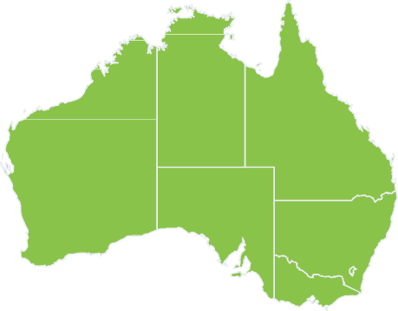
What is your highest level of completed education?

Year 11 or below

Year 12

Certificate III/IV

Diploma and Advanced Diploma

Bachelor Degree

Postgraduate Qualification
Where do you usually live?

NSW
1%
VIC
10%
QLD
3%
5%
SA
57%
TAS
1%
WA
ACT
20%
4%
NT

Demographic summary

Charity workers survey
What age will you be in 2018?
Generation Z Generation Y Generation X
Baby boomers

Are you male or female?

33%
67%
1%
36%
40%
23%

Have you worked for other not-for-profit organisations?

No
31%
Yes
69%

2%
6%
4%
18%
34%
36%

How long have you been working for your organisation?
Less than 2 years
35%
2 - 5 years
31%
6 - 10 years
15%
11 - 15 years
8%
16+
11%

Executive summary

Charitable giving remains strong in Australia.

Australian Community Trends Report

9
Five in six Australians give to charities or not- for-profit organisations (83%). More than three quarters of Australians (77%) give at least annually, while 17% do not give at all.

Australian generosity extends more than just financially. In the past 12 months, two thirds of Australian givers (66%) have donated goods, while one in three (32%) have volunteered.
Advocacy and raising awareness is on the rise with one in five Australian givers supporting charities/not-for-profits in this way (21% 2019 cf. 15% 2017).

Australian givers are increasingly ‘need responders’ with two in five most likely to give when they hear about a need or issue (40%).

Givers prefer to support charities with a local focus.
Australians still have a desire to look after their own backyard. Three in five Australian givers (61%) prefer to support charitable organisations with a local/national focus.

While raising awareness for causes and issues is growing among the younger generations, Australian givers are still more likely to want to support charities which directly assist in responding to an issue (38%) as opposed to those which raise awareness of an issue (29%).

Knowing and trusting an organisation is key to engagement.
For two thrids of Australian givers (66%), knowing and trusting the organisation is an extremely or very significant motivator for getting involved. There is also a need for personal values to align with the organisation
receiving the donation (58%) and a desire to make the world a better place for the less fortunate (55%).

Australian givers are looking for transparency and impact from charitable organisations.
Almost seven in ten givers (69% extremely/very important) look for transparent reporting of administration costs from charities. Givers want to support an organisation with a proven track record (68%), that provides a detailed breakdown of where donations are allocated (67%) and that reports on the impact they are having (62%).

Keeping administration costs below 20% will achieve positive perceptions among the public.
More than four in five (84%) Australian givers believe 20% or less of an organisation’s total revenue should be allocated to administration costs. Almost half of Australian givers (47%), however, believe that less than 10% of total revenue should be used by an organisation on administration. This perspective creates a challenge for charity workers with just 7% believing their organisation could have its greatest impact if their administration costs were below 10%.

The challenge of trust in today’s

society.
Positively, three in five Australian givers (61%) believe the registered charities they support are extremely or very trustworthy.

These trust levels, however, decrease when looking at not-for-profit organisations (37%), the charity sector as a whole (29%) and social enterprises (23%).

A U S T R A L I A N G I V I N G T R E N D S

The charity landscape†

52,166 $143 BIL 1.3 MIL 2.9 MIL

2017-2018

2,832 1,041
Top 8 causes
% who would support

50%

45%

Rank up from 2017 Rank down from 2017
% change from 2017

- 47% ↑ from 2nd
Children’s charities

- 42% ↑ from 4th Animal welfare

Charities Total revenue Paid staff Volunteers
New charities (entries)
Charities ceasing (exits)

40%
- 38% ↓ from 1st
Medical research

- 34% ↑ from 5th Disaster response in Australia

- in 6 Australians give
financially to charities or not-for-profits (83%)
Australians are increasingly
‘need responders’
Choosing to give when they hear about a

35%

- 31% ↑ from 6th
Mental health

need or issue - 40% ↑ from 32% in 2017
30%

- 30% ↑ from 8th Disability and medical support
- 30% ↓ from 3rd

1 in 4 (27%) give at
However, 1 in 6 (17%)
Volunteering

25%
Homelessness

least once a month
don’t give at all Almost half (46%) of
those who volunteer
8 26% ↓ from 7th
Aged care

Most of these give in other ways too
66% - Donating goods
do so at least once
a month

Why volunteer?

Mental health is a key cause for younger givers -
45% Gen Z
Z

32% - Volunteering
56% - To give back to the community

Social enterprises or traditional charities

23% - Fundraising/promoting

21% - Raising awareness
50% - To make the world a better place

47% - The feeling I get when I volunteer

54%
Prefer traditional charities
Z

31%
Would support either

15%
Prefer social enterprises

Gen Z’s are the most likely to have volunteered for a charity in the past 12 months - 44%
Z

60% of charity workers say their organisation relies on
volunteers to operate effectively and they need more*
Younger givers are more likely than older givers to prefer to support social enterprises over traditional charities - 26% Gen Z vs 6% Builders

K E Y D R I V E R S F O R E N G A G E M E N T

Top motivators for getting involved
% who say this is extremely/very significant
Blockers and enablers for giving

E M O T I O N A L

1

66%
2 3

58%

55%

Doubt how much money reaches those in need
Lack of trust in charities Oversaturation of charities
Not seeing the impact of giving
Already give to people in need

Communicate the impacts of giving Values alignment with organisation
Communicate the vision and mission of the organisation
Personal connection Frontline participation

Know and trust the charity
Personal values align
Making the world a better place
B L O C K E R S E N A B L E R S

A personal connection with the organisation is extremely or very important for 50% of Gen Z
Z

Variable income/rising cost of living Transparency regarding admin costs Intrusive donation requests
Fixed giving amounts/frequency
Not aware of the need

Cost effective organisations Positive donor experience One-off giving
Simple giving process Flexible donation amount

The top 5 charity essentials
% who say this is extremely/very important
P R A C T I C A L

1 69%
$
Transparent reporting of admin costs

2 68%

Trust in the not-for-profit sector
% who believe they are extremely/very trustworthy

Z
VS

Younger givers are looking

Older givers are looking

Well established with a proven track record
61%
37%
for personal connections
(54% Gen Y cf. 33% Builders)
for transparency (87%
Builders cf. 53% Gen Z)

3 68%
Verification of registration as a charity

67%
4
$ Where donations are allocated

5 62%

Registered charities you personally support

29%

The charity sector as a whole

Not-for-profit organisations (e.g. local community groups, sports clubs)

23%

Social enterprises
(e.g. Thankyou, Zambrero)

Methodology
Nationally representative survey, n=1103.
* Charity workers survey, n= 169.
† ACNC Annual report 2018, Australian Charities Report 2016.
Research and infographic by McCrindle - cb2019

Reporting of specific impacts
Gen Z (43%) are 14 times as likely as Builders (3%) to
consider social enterprises extremely/very trustworthy
Z

mccrindle.com.au

The Australian not-for-profit landscape

A growing number of charities
The Australian charity sector comprises more than 52,000 charities. This number is growing with 2,832 new charities having been registered in the last 12 months. More than 1,000, however, have ceased operating (1,041) during this period. The sector is diverse, with annual revenues ranging from less than
$50,000 to over $100 million.

The charity sector employs 1.3 million paid staff and relies heavily on volunteers. The ACNC records 2.9 million volunteers engage with Australian charities and not-for-profits.

Charities have a local focus
More than half of Australian charities (59%) have a local focus. This involves helping a large cross section of the general community within Australia rather than specific groups within a community.
Religious activity continues to be the main activity of more than three in ten charities (30.8%). The second most common activity is primary and secondary education (9.1%), followed by other education (7.9%) which includes early childhood education and care. Just 1.3% of charities focus on mental health and crisis intervention and 1.2% on animal protection.

While religious charities comprise the biggest share, they have the lowest proportion of $100 million+ revenues at 6.9% compared to 40.6% education and research and 30% health.

Total revenue
Charities recorded a total revenue of $142.8 billion in the last year. Four in five charities (83%), however, recorded a total revenue of less than $1 million, and two in five (40%) less than $50,000.

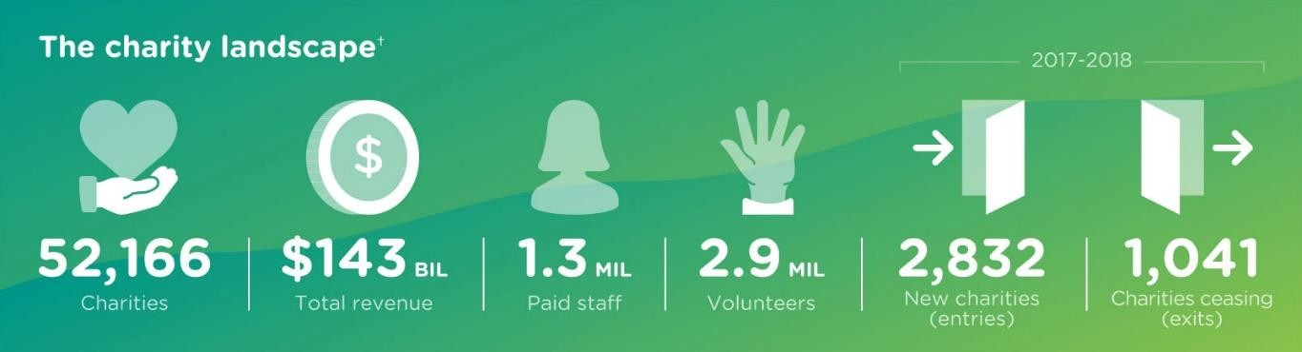

Giving practices in Australia

Five in six Australians give to charities.

Charitable giving remains strong in Australia with five in six Australians giving to charities or not-for-profit organisations (83%). More than three quarters of Australians (77%) give at least annually, while 17% do not give at all.

The regularity of Australian giving has increased since 2017. More than three in five Australians (62%) give to charity at least every six months compared to 57% in 2017. Positively, more than one in four Australians (27%) are giving at least monthly compared to 24% in 2017.

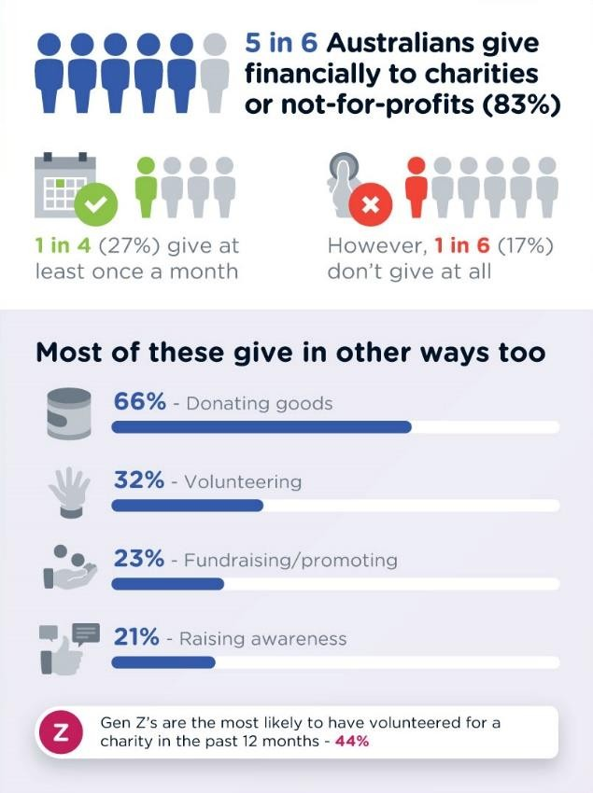
Australian generosity extends further than just giving financially.
In the past 12 months more than two thirds of Australian givers (66%) also donated goods. One in three (32%) volunteered, while more than one in five fundraised or promoted a specific charity (23%).

Australians are increasingly supporting charities/not-for-profits through advocacy and raising awareness, increasing by six percentage points since 2017 (21% 2019 cf. 15%
2017).

The youngest Australians are the most likely to not give at all to charities or not-for-profit organisations (23% Gen Z cf. 14% Gen Y, 17% Gen X, 16% Baby Boomers, 16% Builders).
The older a giver is the more likely they are to donate goods (77% Builders cf. 53% Gen Z).
Younger givers, however, are more likely to volunteer (44% Gen Z cf. 29% Builders) or advocate and raise awareness than their older counterparts (29% Gen Z cf. 16% Builders).

How often do you give financially to a charity or not-for- profit organisation?

Once a week Once a month
7%
20%

21%
14%
15%
6%
17%
Once every few months Once every six months
Once a year

Every few years
I don't give financially to charities or not-for-profit organisations
0% 5% 10% 15% 20% 25%

In addition to giving financially, which of the following ways have you also supported charities in the past 12 months?

Please select all that apply.

Donating goods Volunteering
66%
32%
23%

21%
8%
Fundraising/ promoting for a specific charity
Advocating and raising the awareness of a specific issue or cause
Other (please specify)

0% 10% 20% 30% 40% 50% 60% 70%

Ways of giving
 | Gen Z | Gen Y | Gen X | Baby Boomers | Builders
Donating goods | 53% | 63% | 69% | 68% | 77%
Volunteering | 44% | 35% | 27% | 29% | 29%
Advocating and raising awareness of a specific issue or cause | 29% | 27% | 20% | 13% | 16%
Fundraising/promoting for a specific charity | 28% | 32% | 24% | 15% | 14%

Australian givers are increasingly need responders.

Australian givers are most likely to give when they hear about a need or issue (40%) and this trend is growing. In 2017 one in three (32%) gave in this way compared to two in five (40%) in 2019.

Conversely, the number of Australians giving on a frequent or regular basis are continuing to decline to just over one in ten (12%) compared to one in six (17%) in 2017 and one in five (19%) in 2016.

Australians giving on a regular (12%) or semi- regular basis (28%), however, still comprise 40% of all charitable givers.

Older Australian givers are more likely to be regular givers than their younger counterparts (24% Builders cf. 6% Gen Z).
Gen Z (21%) and Gen Y (28%), however, are more likely to give when approached for a donation (cf. 16% Gen X, 18% Baby Boomers, 13% Builders).

When are you most likely to give to a charitable organisation?

When I hear about a need or issue
40%
32%
30%
28%
30%
28%
20%
21%
23%
12%
17%
19%

Semi regularly throughout the year

When I am approached for a donation or support

On a frequent or regular basis

0% 5% 10% 15% 20% 25% 30% 35% 40% 45%
2019 2017 2016

When are you most likely to give to a charitable organisation?
 | Gen Z | Gen Y | Gen X | Baby Boomers | Builders
Hear about a need or issue | 56% | 39% | 41% | 37% | 33%
Semi regularly throughout the year | 17% | 25% | 36% | 28% | 31%
Approached for a donation or support | 21% | 28% | 16% | 18% | 13%
Frequent or regular basis | 6% | 8% | 8% | 17% | 24%

Children’s charities are the top cause for Australian givers.

Almost half of Australian givers would be highly motivated to give money to, or volunteer for causes focusing on children’s charities (47%).
This was followed by animal welfare and wildlife support (42%) and medical and cancer research (38%).

Medical and cancer research, while being the third most likely cause to support, has decreased from the number one cause in 2017 (43%).

Animal welfare continues to rise in prominence moving from the fourth most likely cause to support in 2017, to the second most likely cause in 2019. Conversely, homelessness has moved from the third most likely cause in 2017 to the seventh most likely cause in 2019.

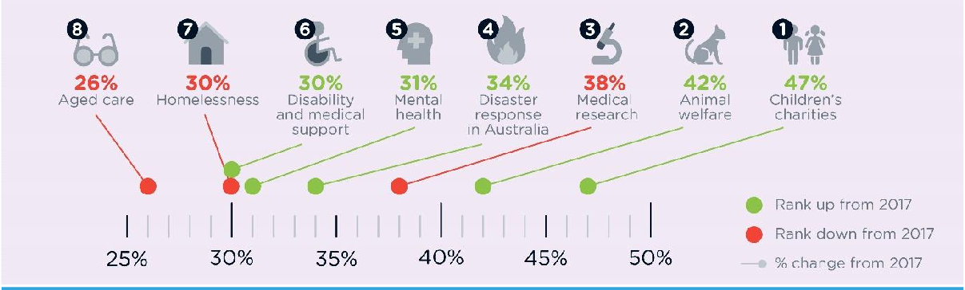
Females (52%) are more likely than males (31%) to support animal welfare and wildlife support.

Generations relate to causes that are relevant to their own life stage. Supporting medical and cancer research is a greater priority for older Australian givers (55% Builders, 44% Baby Boomers, 38% Gen X cf. 30% Gen Y, 28% Gen Z).
Mental health, however, is more likely to be supported by younger givers (45% Gen Z, 34% Gen Y cf. 37% Gen X, 21% Baby Boomers, 18% Builders).
While Children’s charities is in the top three causes to support among all generations, it is highest among Gen Z (52%) and Gen Y (52%)
The cause of human rights shows a significant difference among the generations and is more likely to be supported by younger Australian givers (31% Gen Z, 22% Gen Y cf. 14% Gen X, 12% Baby Boomers, 6% Builders).

 |  | Top three causes
Gen Z | Gen Y | Gen X | Baby Boomers | Builders
Children’s  charities (52%) | Children’s  charities (52%) | Animal welfare and wildlife support (47%) | Medical and cancer research (44%) | Medical and cancer research (55%)
Mental health (45%) | Animal welfare and wildlife support (46%) | Children’s  charities (46%) | Children’s  charities (42%) | Disaster response in Australia (43%)
Animal welfare and wildlife support (42%) | Mental health (34%) | Medical and cancer research (38%) | Animal welfare and wildlife support (37%) | Children’s  charities (35%)

*Bolding denotes the generation where the cause has the highest support.

Which of the following areas of need would you be highly motivated to give money to, or to volunteer for an organisation associated with this area?

Please select all that apply.

Children's charities
43%47%
48%

Animal welfare and wildlife support
37% 42%
45%

Medical and cancer research Disaster response in Australia
Mental health Disability and medical support
Homelessness

31 34%
29 31%
%
%
31%
26% 30%
33%
30%
32%
38%

38%

38%
43%
46%

Aged care
Health and illness services Domestic and family violence
26%
27%
30%
22% 26%
26%
24%
25%
28%

Poverty alleviation in Australia
24%
24%
27%

Environment Disaster response overseas
Human rights

13%
22%
20%
20%
18%
21%
17%
18%
18%

Youth support
15%
16%
18%

Religious mission/ministry

Poverty alleviation overseas
12%
11%
1 12%

16%

Drug and alcohol rehabilitation

Refugees
0%
12%
11%
12%
11%
11%
16%

Culture and arts Sport and recreation Prisoner support Political engagement Other (please specify)
13%
8%
8%
6%
8%
5%
5%
4%
3%
4%
3%
3%
3%
4%
3%
4%

0% 10% 20% 30% 40% 50% 60%
2019 2017 2016

Australian givers believe that political engagement should not receive charitable status.

Three in ten Australian givers (29%) are supportive of all causes receiving charitable status and the subsequent tax benefits. Almost two in five (38%), however, believe that political engagement should not receive charitable status.

Further to this, just over one in five givers believe that religious mission/ministry (22%), prisoner support (22%) and culture and arts (22%) should not receive charitable status.

Older Australian givers are much more likely than younger givers to believe political engagement should not receive charitable status (59% Builders cf. 22% Gen Z).
Consistent across the top four causes, older generations are the most likely to believe organisations should not receive charitable status. Younger generations, however, are more open to organisations receiving charitable status and the subsequent tax benefits.

Causes which should not receive charitable status
 | Gen Z | Gen Y | Gen X | Baby Boomers | Builders
Political engagement | 22% | 25% | 39% | 52% | 59%
Religious mission/ministry | 17% | 20% | 23% | 25% | 27%
Prisoner support | 13% | 16% | 27% | 27% | 26%
Culture and arts | 21% | 19% | 21% | 24% | 33%

Are there any causes in the list which you think should not receive charitable status and the tax benefits which come with this?

Please select all that apply.

Political engagement |  |  |  |  |  | 38%
Religious mission/ministry |  |  |  |  | 22%
Prisoner support |  |  |  |  | 22%
Culture and arts |  |  |  |  | 22%
Sport and recreation |  |  | 18%
Refugees |  |  | 17%
Poverty alleviation overseas |  | 12%
Disaster response overseas |  | 11%
Drug and alcohol rehabilitation |  | 10%
Environment |  | 9%
Animal welfare and wildlife support | 7%
Aged care | 6%

Human rights Children's charities
5%

5%

4%

4%

4%

4%

4%

3%

3%

3%

2%

1%
29%
Disability and medical support Domestic and family violence
Mental health Youth support Homelessness
Disaster response in Australia Health and illness services Medical and cancer research Poverty alleviation in Australia Other (please specify)
All of these should receive charitable status

0% 5% 10% 15% 20% 25% 30% 35% 40% 45%

Australian givers prefer to support charities with a local focus.

The Australian sentiment of looking after one’s own back yard is still strong when it comes to charitable organisations. Three in five Australian givers (61%) prefer to support charitable organisations with a local/national focus. One in three have no preference (34%) and just 5% prefer to support organisations with a global focus.

Australian givers are also more likely to want to directly assist and engage in responding to an issue (38%) as opposed to raising awareness of an issue (29%).

The desire to raise awareness around an issue is much higher among the younger generations. Gen Y (44%) are more than twice as likely as Builders (16%) to prefer to support charitable organisations which are focussed on raising awareness (44% Gen Y, 24% Gen X, 17% Baby Boomers).
Older Australian givers, however, are more likely to prefer to support organisations taking direct action (50% Builders, 48% Baby Boomers, 37% Gen X cf. 27% Gen Y, 33% Gen Z).

Do you prefer to support a charitable organisation with a local/national focus or a global focus?

I only support those with a local/national focus I prefer to support those with a local/national focus
24%
37%
34%
5%
0.5%
No preference I prefer to support those with a global focus I only support those with a global focus
0% 5% 10% 15% 20% 25% 30% 35% 40%

Do you prefer to support charitable organisations which are focused on raising awareness around an issue OR directly assist and are actively engaged in responding to an issue?
Much more likely to want to raise awareness of the issue
14%
15%
33%
17%
20%
Slightly more likely to want to raise awareness of the issue
No preference Slightly more likely to directly assist and engage in
responding to an issue
Much more more likely to directly assist and engage in responding to an issue
0% 5% 10% 15% 20% 25% 30% 35% 40%

Australian givers prefer to support traditional charities.

More than half of Australian givers (54%) see a difference between social enterprises and traditional charities and prefer to support traditional charities.

One in seven Australian givers (15%), however, see a difference and prefer to support social enterprises over traditional charities.

Three in ten Australian givers (31%), do not see a difference between traditional charities and social enterprises, viewing them both as passionate about supporting causes, and so would support either.

Social enterprises are likely to be more familiar to younger givers with Gen Y’s 4x as likely as Builders to support a social enterprise over a traditional charity (26% Gen Y cf. 6% Builders).
Older Australian givers, however, are more likely to prefer to support traditional charities (71% Baby Boomers cf. 39% Gen Z).
Australian givers under the age of 40 are 1.5x as likely to support a traditional charity over a social enterprise (39% cf. 26%). Givers aged 55+, however, are 14x as likely to support a traditional charity over a social enterprise (70% cf. 5%).

Do you see a difference between social enterprises and traditional charities and do you have a preference for either when deciding to give?

Yes, and I prefer to support traditional charities over social enterprises
54%
31%
15%

No, they are both passionate about supporting causes so I would support either

Yes, and I prefer to support social enterprises over traditional charities

0% 10% 20% 30% 40% 50% 60%

Do you see a difference between social enterprises and traditional charities and do you have a preference for either when deciding to give?
 | Gen Z | Gen Y | Gen X | Baby Boomers | Builders
Yes, and I prefer to support social enterprises over traditional charities | 26% | 26 % | 12 % | 4% | 6%
Yes, and I prefer to support traditional charities over social enterprises | 39% | 39% | 53% | 71% | 68%
No, they are both passionate about supporting causes so I would support either | 35% | 34% | 34% | 25% | 26%

Drivers for engagement

Knowing and trusting an organisation is the top motivator for engagement.

Knowledge and trust of the organisation continues to be the most significant influence on an Australian giver’s decision to get involved with a charitable organsation. Two thirds of Australian givers (66%) indicate this is extremely or very significant as a motivation for getting involved. Australians are also highly motivated to get invovled when their personal values align with the organisation receiving the donation (58%) and to make the world a better place for the less fortunate (55%).
Almost half of Australian givers see giving back to the community (48%) and the feeling they get from doing something for others (47%) as extremely or very significant motivators on their decision to get involved.

A personal connection with the organisation is extremely or very important for 50% of Gen Zs when choosing to engage with a charity (cf.
49% Gen Y, 41% Gen X, 34% Baby Boomers,
24% Builders).

How significant are the following motivators in your decision to get involved with charities or not-for-profit organisations?

Knowledge and trust of the organisation My personal values align with the organisation
receiving the donation
Making the world a better place for those who are less fortunate
32%

24%

23%
34% 25% 8%

33% 29% 10% 4%

32% 30% 10% 5%

The feeling I get from doing something for others | 19% | 29% 32% 12% 8%
To give back to the community | 18% | 31% 32% 14% 6%
Responding to a need I'm presented with | 13% | 28% 38% 14% 7%
A personal connection with the organisation | 14% | 27% 33% 13% 13%
Partnering for long-lasting change | 14% | 28% 32% 15% 10%

My giving benefits the organisation as well as me and my community
My faith and beliefs
14%

17%
26% 35% 16% 10%

21% 28% 13% 22%

The responsibility I feel to share my wealth Social pressure to be a 'good person'
10% 18% 34% 17% 21%

8% 12% 23% 19% 38%

0% 10% 20% 30% 40% 50% 60% 70% 80% 90% 100%
Extremely significant Very significant Somewhat significant Slightly significant Not at all significant

The top motivator for volunteering is giving back to the community.

Almost a third of Australian givers (32% pg. 12) have supported charities by volunteering in the past 12 months.

Almost half of those who volunteer (46%), do so at least once a month, with a further one in four (26%) volunteering every few months.

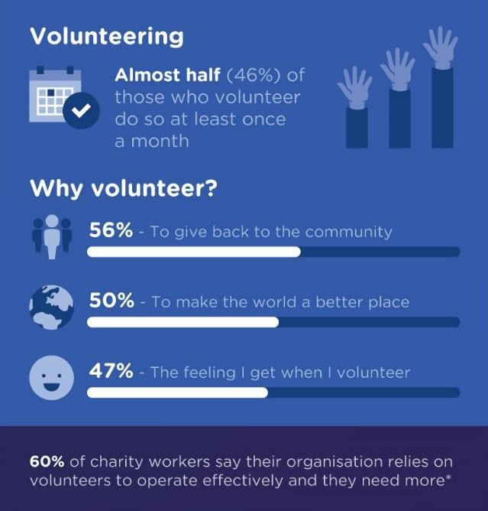
Key motivators for those who volunteer are the responsibility they feel to give back to the community (56%), to make the world a better place (50%) and the feeling they get when they volunteer (47%).

So, while Australian givers are altruistic, shared responsibility and personal satisfaction from engagement continue to be key drivers for volunteer engagement.

There is a need for more volunteers
Almost four in five charity workers (78%) say their organisations rely on volunteers to operate effectively.
Despite this reliance on volunteers, three in five charity workers (60%) say their organisation is in need of more. This presents an engagement challenge for charitable organisations to motivate Australian givers to actively get involved through frontline participation with charities.

How often do you volunteer for a charity or not-for-profit organisation?

n=349

Once a week Once a month
25%
21%
26%
13%
15%
Once every few months Once every six months
Once a year

0% 5% 10% 15% 20% 25% 30%

Why do you choose to volunteer for charities or not-for-

profit organisations?

n=349

My responsibility to give back to the community
56%
50%
47%
34%
33%
13%
9%
To make the world a better place The feeling I get when I volunteer To meet people and connect
I am motivated by my faith and beliefs It looks good on my resume or LinkedIn profile
Other (please specify)

0% 10% 20% 30% 40% 50% 60%

Does your organisation rely on volunteers in order to operate effectively and if so, are you in need of more?

Charity workers

Yes, and we are in need of more Yes, but we are not in need of more No, but we are in need of some
60%
18%
14%
8%

No, and we are not in need of any

0% 10% 20% 30% 40% 50% 60% 70%

Charity essentials

Transparency is key for Australian givers.

In a challenging external environment (pg. 30) Australian givers want their giving to have maximum impact. In light of this, Australian givers are holding charities/not-for-profits to a higher account for transparency and information.

The most important characteristic Australian givers look for in a charity to support is transparent reporting of administration costs. Almost seven in ten Australian givers (69%) see this as extremely or very important.

A further seven in ten desire the charity to be well-established with a proven track record (68%) and want to see verification of its registration as a charity (68%).

In line with the desire for transparency, two thirds of Australian givers (67%) see it as extremely or very important that organisations provide a detailed breakdown of where donations are allocated.

Australian givers also want to see how their giving is making a difference, with 62% wanting an overview of the impacts the charity has had through reporting of specific results and numbers.

A well-established charity with a proven track record is more important to older Australian givers than their younger counterparts (81% Builders, 77% Baby Boomers, 68% Gen X cf. 62% Gen Y, 56% Gen Z).
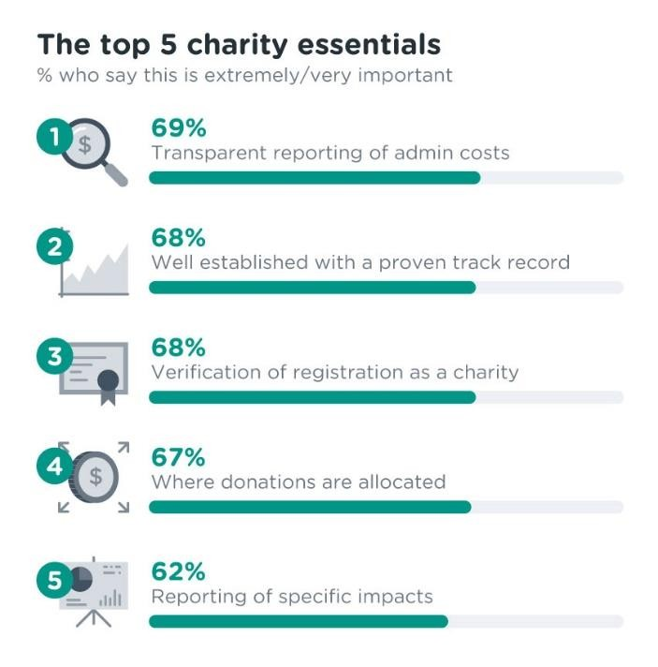
Tax deductibility status, however, is more important to younger givers (38% Gen Z, 45% Gen Y cf. 37% Gen X, 26% Baby Boomers, 13% Builders).

How important is it that charities or not-for-profit organisations have the following characteristics for you to support it?

Transparent reporting of administration costs
38% |  |  |  | 31% |  |  |  |  | 23% |  |  |  | 7%
33% |  |  | 36% |  |  |  |  |  | 24% |  |  |  | 7%
34% |  |  | 34% |  |  |  |  |  | 22% |  |  |  | 7%
35% |  |  | 32% |  |  |  |  |  | 23% |  |  |  | 8%
25% |  | 37% |  |  |  |  | 28% |  |  |  |  |  | 8%
23% |  | 33% |  |  |  | 29% |  |  |  |  |  | 11%
23% |  | 29% |  |  | 29% |  |  |  |  |  | 10% |  | 9%
16% | 18% |  | 29% |  |  |  |  | 14% |  | 22%

Well-established with a proven track record Verification that it is a registered charity (not just a
community organisation or not-for-profit)

Detailed breakdown of where donations are allocated

An overview of the impacts the charity has had by reporting specific results and numbers
The leadership structure and overview of the executive management and governance/board members

That it is an Australian-based organisation

That my giving is tax deductible

0% 10% 20% 30% 40% 50% 60% 70% 80% 90% 100%
Extremely important Very important Somewhat important Slightly important Not at all important

Websites are the most important communication channel.

Telling the story of who the charity is and what they stand for is an important way for causes and charities to engage with Australian givers. Two in five Australian givers (39%) see the website as an important channel to help them engage (extremely/very important).

Word of mouth from friends/family members is important for more than a third of givers (35%). A further third of givers see advertising through stories in media (33%) and television (33%) as important channels of engagement.

Younger Australian givers are looking for more information from charities/not-for-profits. In every area younger givers are more likely to see the communication channel as extremely or very important.
The website is the area of greatest difference with more than three in five Gen Z’s (63%) seeing this as extremely or very important compared to 15% of Builders and 23% of Baby Boomers.

How important are the following communication channels in helping you engage with causes and charities and not- for-profit organisations?

Website Friend or family member
14%

12%
25% 31% 13% 16%

24% 32% 17% 16%

Stories in media 10% 23% 35% 15% 17%

Television
11%
22% 29% 17% 20%

Email 10% 18% 29% 18% 24%

Social media channels
11%
16% 28% 16% 29%

Radio Ads in newspapers/magazines
Mail
Organisation representative on the street Receiving text messages from charities or not for
profit organisations
Celebrity endorsement Phone calls from charities or not for profit
organisations
8% 16% 29% 19% 28%

8% 15% 28% 18% 31%

9% 14% 29% 19% 30%

7% 15% 26% 18% 34%

8% 12% 21% 16% 43%

6% 12% 20% 17% 45%

6% 11% 19% 17% 47%

0% 10% 20% 30% 40% 50% 60% 70% 80% 90% 100%

Extremely important Very important Somewhat important Slightly important Not important at all

Administration costs vs impact.

Administration costs continue to be a challenging area for charities/not-for-profit organisations. The average Australian’s expectation is that administration costs should be 20% or below. Australian givers are reasonably consistent with this trend. More than four in five (84%) believe administration costs should comprise 20% or less of an organisation’s total revenue. Almost half of Australian givers (47%), however, believe that less than 10% of total revenue should be used by an organisation on administration.

This perspective creates a challenge for charity workers with just 7% believing their organisation could have its greatest impact if their administration costs were below 10%. Staff of charities believe they can achieve greater outcomes if their administration costs are above 20%. This is not accepted by the average Australian, however, with just 16% of givers seeing administration costs greater than 20% as reasonable compared to 53% of charity workers.

Older Australian givers are the most likely to believe administration costs should be kept below 10% (60% Builders, 58% Baby Boomers, 51% Gen X cf. 35% Gen Y, 29% Gen Z).

Keeping administration costs below 20% will achieve positive perceptions among the public
Four in five charity workers (79%) strongly or somewhat agree that keeping administration costs below 20% will result in positive perception among the public.

More than half (54%) believe that it will lead to increased donor engagement, however, the same proportion (54%) believe keeping administration costs below 20% will lead to overworked and stressed staff.

Positively, 52% believe keeping administration costs below 20% will help organisations become more financially efficient.

What percentage of total revenue do you think is reasonable for the organisation you support to spend on administration?

Below 10%
47%
38%
11%
3%
2%
10% - 20%
21% - 30%
31% - 40%
Above 40%
0% 5% 10% 15% 20% 25% 30% 35% 40% 45% 50%

What is the optimum percentage of administration costs that would enable your organisation to have the greatest impact?

Charity workers

Below 10%
7%
40%
37%
11%
5%
10 - 20%
21 - 30%
31 - 40%
Above 40%
0% 5% 10% 15% 20% 25% 30% 35% 40% 45%

To what extent do you agree that keeping administration costs below 20% will achieve the following for Not-for- Profit organisations?

Charity workers

Positive perception among public
45%
34% 14% 5%

Increased donor engagement More financially efficient Overworked and stressed staff
Increased profitability More operationally efficient

24%

21%

22%

17%

16%

30% 25% 12% 6% 4%

31% 20% 17% 8% 4%

32% 15% 16% 6% 9%

27% 28% 15% 9% 5%

28% 21% 20% 10% 5%

There are no benefits
6% 16% 20% 20% 12% 26%

0% 10% 20% 30% 40% 50% 60% 70% 80% 90% 100%

Strongly agree Somewhat agree Slightly agree Slightly disagree Somewhat disagree Strongly disagree

Events are the most effective fundraising strategy.

Understanding the most effective fundraising strategies is important for any charity/not-for- profit. Almost three in ten charity workers (29%) rank government grants as the most effective strategy their organisation uses to fundraise.
One in four (25%), however, rank events as the most effective fundraising strategy.

For one in five charity workers (20%) social media is ranked the 2nd most effective strategy followed closely by events (19%).
Similarly, events (20%), social media (20%) and print media (17%) are ranked the 3rd most effective strategy by around one in five charity workers.

Overall, 64% of charity workers rank events in their top three most effective fundraising strategies, whilst 50% include social media.

What are the most effective strategies your organisation uses to fund raise?

Top 3 rank distribution

1
25% |  |  | 10% | 8% |  |  | 29% |  |  |  |  | 4% |  | 5% |  | 4% | 10% 2 |  |  |  |  | %
19% | 20% |  |  |  | 11% |  |  | 9% |  | 4% 8% |  | 5% | 4% |  | 8% |  |  | 7% |  |  | 3% | 4%
20% |  | 20% |  |  |  | 17% |  |  | 5% |  | 5% 5% | 5% |  | 9% |  |  | 3% |  |  | 8% 1

2

3 %

0% 10% 20% 30% 40% 50% 60% 70% 80% 90% 100%
Events Social Media Print media
Government grants Radio Product sales
Cold calling Television Membership fees
Shopping centre promoters Raffles Door-knocking

Blockers and enablers to giving

Cost of living is impacting Australian givers ability to give.

More than half of Australian givers (56%) agree the cost of living and changing housing prices in Australia have significantly or somewhat decreased their ability to give to charities.

Just one third of Australian givers (36%) feel the current economic environment has not impacted their ability to give.

Females (62%) are more likely than males (49%) to indicate the cost of living and changing house prices in Australia has significantly or somewhat decreased their ability to give.

To what extent has the cost of living and changing housing prices in Australia over the last year or so increased or decreased your ability to give to charities?

Significantly decreased my ability to give Somewhat decreased my ability to give No impact on my ability to give Somewhat increased my ability to give Significantly increased my ability to give
25%
30%
36%
6%
3%
0% 5% 10% 15% 20% 25% 30% 35% 40%

Transparency is key for Australian givers journeying from apathy to becoming active donors.

Australian givers continue to prioritise transparency. More than seven in ten Australian givers (71%) strongly or somewhat agree that greater transparency regarding an organisation’s finances will help Australians journey from apathy to becoming active donors. Communicating the impact of their contribution is also high on givers’ priority list with more than three in five (62%) believing this will help Australians become more active donors.

There is a slight disconnect between charity workers and Australian givers, however, as to what will help Australians journey from apathy to becoming active donors. The only area where Australian givers have higher expectations than charity workers is regarding transparency (71% cf. 59%).

Charity workers, however, are much more likely than Australian givers to agree that creating personal connections for potential donors will help Australians become active donors (93% charity workers cf. 48% Australian givers).

Creating personal connections for potential donors is an important method for young Australian givers to journey from apathy to becoming active donors (49% Gen Z, 54% Gen Y cf. 43% Gen X, 50% Baby Boomers, 33% Builders strongly/somewhat agree).
More transparency regarding the organisation’s finances, however, is important to older givers (87% Builders, 80% Baby Boomers, 66% Gen X cf. 69% Gen Y, 53% Gen Z).

Intrusive donation requests are a key blocker for giving.
More than seven in ten Australian givers (72%) and almost four in five charity workers (78%) strongly or somewhat agree that intrusive or excessive donation requests are a blocker to giving.

Accountability and transparency continue to be key, with doubt surrounding how money is used being a blocker for more than seven in ten Australian givers (72%) and charity workers (73%).

Charity workers, however, are much more likely to identify the over saturation of charities and poorly targeted communications strategies as blockers to giving, than Australian givers (79% cf. 66% and 77% cf. 53% respectively).

Intrusive or excessive donation requests is more likely to be a blocker to giving for older Australian givers (86% Builders, 83% Baby Boomers, 71% Gen X cf. 67% Gen Y, 49% Gen Z).

Will the following methods help Australians journey from apathy to becoming active donors?

Strongly/somewhat agree

More transparency regarding the organisation's finances
71%
59%

62%
94%
55%
89%
53%
79%
48%
93%
45%
66%

Helping potential donors understand the impact of their contribution

Propagating more stories of how the organisation has helped people
Simpler and more accessible ways to donate More focus on creating personal connections for
potential donors

Increased media presence (Socials, TV, Print, Online)

0% 10% 20% 30% 40% 50% 60% 70% 80% 90% 100%
Australian givers Charity workers

Are the following blockers to giving?

Strongly/somewhat agree

Intrusive or excessive donation requests
72%
78%
72%
73%
71%
65%
66%
53%
77%
52%
65%
79%

Doubt surrounding how your money is used

The rising cost of living

Over saturation of charities

Poorly targeted communications strategy

Complex giving process

0% 10% 20% 30% 40% 50% 60% 70% 80% 90%
Australian givers Charity workers

Doubt and distrust over how much money reaches those in need is one of the greatest blockers to givers engaging with charities.

The following emotional and practical blockers and enablers to charitable giving were defined by two open ended qualitative questions.

Emotional refers to something that personally disconnects or engages someone in charitable giving.

Practical refers to an organisation’s tangible actions which stop or encourage a charitable donation.
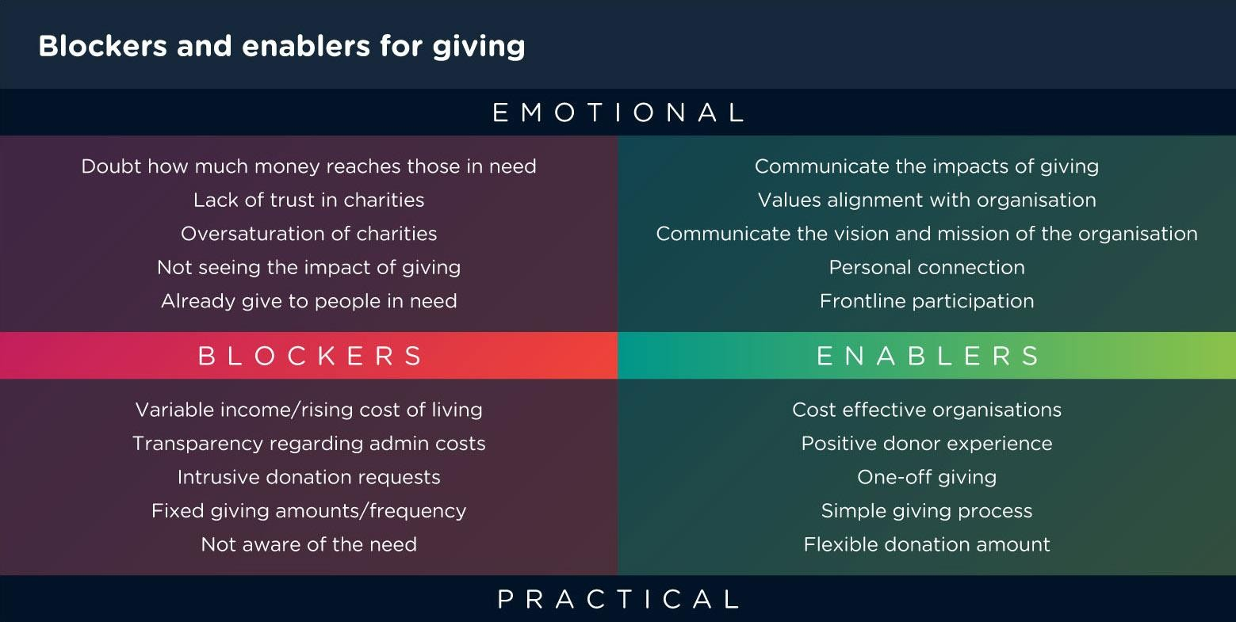

Overcoming blockers
The following are suggestions for how charities can overcome the blockers to giving indicated above.

Create options for one time giving

“I tried to make cash donations once at a shopping centre and they turned the money down and wanted me to set up a direct debit... it was really annoying and turned me off donating for a while.”

Communicate the impact

“Help people better understand exactly where their money is going, to how much even the smallest donation is helping.”

Breakdown of donation allocation

“Be very clear in what percentage of my donation goes to the charity and how much is in administration fees.”

Cost effective organisations

“Reduce overheads so a greater portion reaches the need for which donation was made.”

Australian Community Trends Report

34

I do what I hope others would do for me if I was in the unfortunate position to need help
- Australian volunteer

Trust in the charity sector

Younger givers are more trusting of the charity sector than older givers.

Trust is an important commodity in today’s society. Positively, three in five Australian givers (61%) believe the registered charities they support are extremely or very trustworthy.

These trust levels, however, decrease when looking at not-for-profit organisations (37%), the charity sector as a whole (29%) and social enterprises (23%), highlighting the importance of personal connection for supporters.

Gen Z’s (43%) are 14 times as likely as Builders (3%) to consider social enterprises extremely or very trustworthy.

Australian givers trust some but not all registered Australian charities.
Trust in Australian registered charities varies among Australian givers. Just 11% of Australian givers highly trust all registered charities.
Almost two in five (38%) highly trust most but not all, while a further two in five (38%) trust some but have little trust in other registered Australian charities.

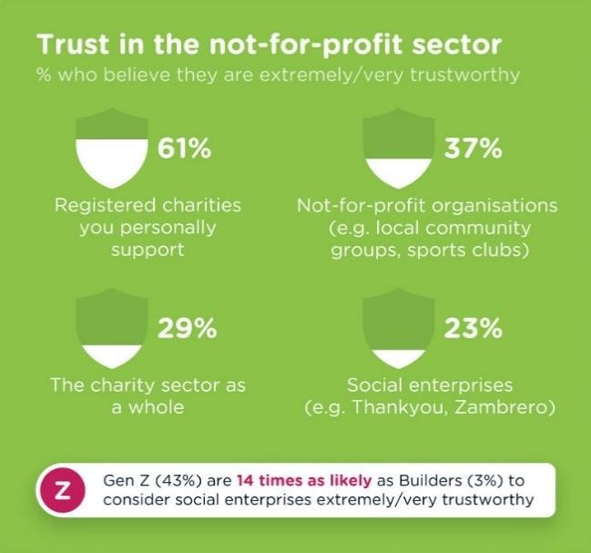
One in eight Australian givers (13%), however, have low or no trust in registered Australian charities.

Gen Y (18%) are the most likely to trust all registered Australian charities (cf. 13% Gen Z, 7% Gen X, 8% Baby Boomers, 4% Builders).

How trustworthy do you believe the following are?

Registered charities you support (eg. Red Cross, Salvation Army)
Not-for-profit organisations (eg. local community groups, sports clubs)
The charity sector as a whole Social enterprises (eg. Thankyou water, Zambrero)

37% 28% 8%3%

% 45% 15% 4%
24%
9% |  | 27
7% | 22%
6% | 17%

48% 17% 5% 37% 23% 17%

0% 10% 20% 30% 40% 50% 60% 70% 80% 90% 100%
Extremely trustworthy Very trustworthy Somewhat trustworthy Slightly trustworthy Not at all trustworthy

How trustworthy are the following?
Extremely/very trustworthy
 | Gen Z | Gen Y | Gen X | Baby Boomers | Builders
Registered charities you support | 55 % | 58% | 52% | 71% | 71%
Not-for-profit organisations | 52% | 41 % | 34% | 34% | 20%
Social enterprises | 43% | 36% | 18% | 11% | 3%
The charity sector as a whole | 40% | 40% | 24% | 21% | 21%

To what extent do you trust registered Australian charities to collect donations ethically and ensure as much of these funds are used to make a difference for their charitable purpose?

I highly trust all registered Australian charities
11%
38%
38%
11%
2%

I highly trust most but not all registered Australian charities
I highly trust some but have little trust in other registered Australian charities
I have low levels of trust in registered Australian charities

I have no trust in registered Australian charities

0% 5% 10% 15% 20% 25% 30% 35% 40% 45%

Working in the charity sector

Charities and not-for-profit organisations are purposeful and impacting.

Charity workers positively reflect on the sector they work in and are most likely to use the words purposeful (76%), impactful (66%) and friendly (63%) to describe their organisation.

A further three in five use the words trustworthy (62%) or caring (58%) to describe their organisation.

Charitable organisations are highly effective at sharing their mission and values.
Charity workers are likely to believe their organisation is extremely or very effective at clearly articulating (69%) and achieving their organisation’s mission and values (69%).

More than half of charity workers (57%) believe their organisation is effective at creating an engaging work culture. Two in five charity workers (40%) believe their organisation is extremely or very effective at developing staff professionally.

Which of the following words or phrases would you use to best describe your organisation?

Please select all that apply.

Charity workers.

Purposeful |  |  |  | 76%
Impactful |  |  | 66%
Friendly |  |  | 63%
Trustworthy |  |  | 62%
Caring |  |  | 58%
Professional |  |  | 56%
Approachable leadership |  | 50%
Cost efficient/financially effective | 43%
Innovative | 43%

Helpful Other (please specify)
42%
8%
0% 10% 20% 30% 40% 50% 60% 70% 80%

In your opinion, how effective is your organisation in the following areas?

Charity workers

Clearly articulating mission and values Achieving mission and values
Managing operations of the organisation
29% 40% 26% 4%

22% 47% 27% 3%

17% 43% 31% 7%
15% | 41% | 38% | 5%
18% 36% 34% 11%

18% 39% 27% 10% 6%

15% 25% 43% 11% 6%

Communicating with existing supporters Communicating the organisation's vision to potential
supporters
Creating an engaging work culture Developing staff professionally
0% 10% 20% 30% 40% 50% 60% 70% 80% 90% 100%
Extremely effective Very effective Somewhat effective Slightly effective Not at all effective

More than four in five charity workers believe their organisation is moving forward in the right direction.

Nine in ten charity workers strongly or somewhat agree their organisation is characterised by hard-working and committed staff (91%) and is a successful organisation (89%).

More than four in five charity workers agree the organisation is moving forward in the right
direction (85%) and is highly regarded in the general community (83%).

Charity workers are least likely to see their organisation as agile and responsive. Three in five (62%) strongly or somewhat agree their organisation is responsive, adaptive and accepting of change by internal forces.

To what extent do you agree with the following statements about your organisation?

Charity workers

The organisation is characterised by hard-working and committed staff.
The organisation is highly regarded in the general community.

64%

50%
27% 5%

33% 13% 4%

It is a successful organisation.

The organisation is moving forward in the right direction.
I think the organisation accepts individual needs/differences.
43%

49%

35%
46% 7%

36%
9%2%

42% 15% 5%

I believe the organisation is responsive, adaptive & accepting of change created by external forces.
I am happy with the rate of change the organisation has adopted.
I believe the organisation is responsive, adaptive & accepting of change created by internal forces.

26%

27%

26%

45% 14% 7%

38% 17% 9% 4%
7%

36% 21% 7% 6%

0% 10% 20% 30% 40% 50% 60% 70% 80% 90% 100%
Strongly agree Somewhat agree Slightly agree Slightly disagree Somewhat disagree Strongly disagree

Charity workers are purposeful and fulfilled in their roles.

Positivity regarding their role within an organisation is high amongst charity workers. Almost all charity workers are proud to work at their organisation (96% yes definitely/somewhat) and feel accepted and well regarded by their peers (96%).
Nine in ten feel part of their staff community (93%), find their work satisfying and fulfilling (93%), enjoy going to work every day (93%), and feel successful in their role (93%).

Please respond to the following questions about your work with your organisation?

Charity workers

Are you proud to be a staff member at this organisation?
Do you feel accepted and well-regarded by your peers?

Do you feel part of the staff community? Do you find your work satisfying and fulfilling?
Do you enjoy going to work each day?

Do you feel the senior leadership are accessible to you?

Do you feel successful in your role?

Do you feel that the organisation cares about you as a person?
Do you feel you are dealt with in a professional manner in your organisation?
Do you feel that your views are listened to at work and that you have a voice?
Is this organisation currently your preferred organisation to work for?
Does this organisation allow you to grow professionally?
Do you aspire to a more senior position within the organisation?

Are you considering a career change?

23% 4%

27% 4%
73%
69%

25% 6%
68%

25% 6%
67%

37% 6%
56%

25% 8%
63%

39% 6%
54%

27% 9%
60%

35% 8%
56%

30% 8%
59%

22% 12%
63%

28% 15%
52%

22% 30% 18%
29%

28% 38% 24%
10%

0% 10% 20% 30% 40% 50% 60% 70% 80% 90% 100%
Yes, definitely Yes, somewhat No, not really No, not at all

Charity workers are highly likely to recommend their organisation as a place to work.

The Net Culture Score (NCS) for Charity workers is 30, which is a very high score and communicates an engaged and positive workforce.

Charity workers are highly likely to recommend their organisation as a place to work to a friend
or contact, with 49% scoring their organisation a nine or ten out of ten, therefore being labelled as ‘promoters’.

Three in ten are ‘passives’ (scoring a 7 or 8), and one in five are ‘detractors’ (scoring a 0 to 6).

On a scale from 0-10, how likely is it that you would recommend your organisation as a place to work to a friend or contact?

Promoter
49%
31%
20%

Passive

Detractor

0% 10% 20% 30% 40% 50% 60%

Future of the charity sector

There is a greater need for charitable giving as the gap between rich and poor grows.

Australian givers believe the future will bring a greater need for charitable giving. Three in five givers (61%) and more than half of charity workers (56%) believe the gap between rich and poor will grow in Australia, requiring a greater need for charitable giving.

Givers are less optimistic, however, about the giving of future generations than charity workers. More than half of givers (52%) believe charities will struggle in the future as the younger generation are less actively involved than previous generations. Charity workers are slightly more optimistic, however, with just two in five (40%) believing charities will struggle in the future due to the emerging generation being less involved.

Charity workers are optimistic about the future of the not-for-profit sector.
Charity workers are much more optimistic about the future of the charity sector than Australian givers. More than four in five charity workers (83%) believe the organisation they work for will be significantly or somewhat better in five years’ time. One third of Australian givers (34%), however, believe the organisations they support will be better in five years’ time.

Charity workers are also twice as likely as Australian givers to believe the not-for-profit sector as a whole will be significantly or somewhat better in five years’ time (61% cf. 30%).

To what extent do you agree with the following statements?

Strongly/somewhat agree

As time goes on, the gap between rich and poor in Australia grows, so there will be the need for more charitable giving in the future
61%
56%
52%
40%
49%
35%

Charities will struggle in the future as the younger generation are less actively involved than previous generations

If the government was doing its job properly we would hardly have the need for charities and giving

0% 10% 20% 30% 40% 50% 60% 70%
Australian givers Charity workers

When you think forward over the next 5 years about the future of Not-for-Profit organisations in Australia, how optimistic are you compared to how the sector is today?

Will be significantly/somewhat better in 5 years' time

The organisation/s I support / The organisation I work for
34%
83%
30%
61%

The not-for-profit sector as a whole

0% 10% 20% 30% 40% 50% 60% 70% 80% 90%
Australian givers Charity workers

Charity sector in Australia

The Australian charity sector is well regarded and established within Australian society. The majority of those working in the sector believe their organisation will be better (83% significantly/somewhat) in the next five years, as will the not-for-profit sector as a whole (61%).

There is a communication gap, however, with Australian givers less likely to believe in the future of the charitable sector. Charity workers are immersed in the day-to-day mission, strategy and impacts of the organisation, so it makes sense for them to feel more positive towards the future of the sector.

The last few years have brought about a decrease in Australians’ trust towards organisations and an increase in scepticism. This creates a need to communicate the strategy, impacts and optimism of the sector to Australian givers and those who are not yet engaged with not-for-profit organisations or charities. In order for the sector to thrive and continue to be a positive force for change,
Australian givers need to be convinced that the future of the charitable sector in Australia is positive, and that it will continue to be a catalyst for improving our society and our nation.

One of the greatest assets of the charitable sector in Australia is its staff, who not only work in the sector, but who believe that not-for-profit organisations are a positive force for change. The sector continues to provide a workplace culture for this workforce that is purposeful, impacting and focussed on making a difference. This is reflected in the strong Net Culture Score (30) given by those who work in the charities sector.

Over the last four years McCrindle has seen the sentiment towards the charitable sector continue to improve overall. We endeavour to continue providing insights that will help the charitable sector achieve its goals of shaping Australian communities now and into the future.

Get in touch.

Phone +61 2 8824 3422

Australian Community Trends Report



45

Email info@mccrindle.com.au

Website mccrindle.com.au

Blog blog.mccrindle.com.au

Address Suite 105, 29 Solent Circuit,
Norwest, NSW 2153
 mccrindleresearch markmccrindle mccrindleresearch
company/mccrindle-research

