

East Asia Vision Program - Cambodia Case Study
Capacity Building for Ophthalmologists

Program component: Eye Health Workforce Development
Implementing agency: Royal Australian and New Zealand College of Ophthalmologists
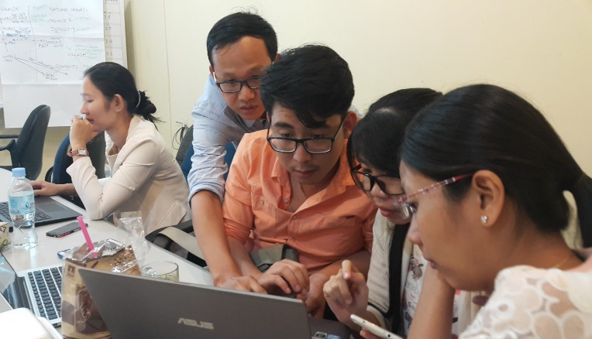

A Continuing Professional Development roll out meeting
Photo credit: The Royal Australian and New Zealand College of Ophthalmologists
The Royal Australian and New Zealand College of Ophthalmologists (RANZCO) has been working with the Cambodian Ophthalmology Society (COS) to enhance professional standards in ophthalmic practice through the development of Continuing Professional Development (CPD) practices for Cambodian ophthalmologists.
A functioning CPD system ensures the maintenance of both clinical expertise as well as essential non-clinical skills including risk management, clinical governance and professional values and in 2015 the COS launched the first medical CPD framework in Cambodia. From no formalised CPD system three years ago, the COS has since positioned itself as strong advocators for ongoing retention and development of knowledge, skills and attitudes related to clinical expertise.
Lack of engagement from local ophthalmologists was identified as a challenge at the onset of the program, highlighting that ongoing education and communication would be crucial in managing the change. The COS, with the support of RANZCO, has been active in delivering educational sessions at the biannual continuing education meetings and separate workshops to promote to role of CPD and ensure members are knowledgeable and engaged in CPD themselves. The CPD Committee also conducted additional two-hour support workshops for small groups devoted to demonstrating the CPD program and on-line access (helping users log in and entering their CPD activity).

Dr Mar Amarin (COS committee member) feels that the CPD committee has been committed and patient in advocating for ophthalmologists to embrace the idea of CPD and he feels proud of the progress made, with COS membership reaching nearly 100, all ophthalmology members have registered for CPD with 43 per cent entering their CPD activity in the CPD database during the pilot phase in 2015. This suggests the beginning of positive acceptance among COS members for the voluntary program.
Dr Kossama Chukmol, a young female ophthalmologist and member of the COS CPD committee, has been helpful in providing feedback regarding the CPD program. She believes that participating in CPD activities will result in positive benefits for her patients; “A side benefit of the CPD program is a stronger connection among eye health personal, helping us create a better referrals system to help the patients on time.” Overall CPD is considered a positive move in the growth of ophthalmology. Dr Kossama is encouraged that with more information and knowledge provided to practitioners their clinical knowledge will be expanded and utilised in actual practice with less hesitation or uncertainty.
The CPD Program is currently dependant on the COS. As the COS is a membership based body, it needs to look for additional resources and reduce reliance on NGO support. From the outset of the EAVP, the COS has been encouraged to diversify their funding sources. Dr Pok Thorn, current President of COS, speaking at the December 2015 CME on behalf of the COS Committee, shared COS’s vision and overarching strategy towards sustainability. Proposed plans include increasing the annual membership fee, increased advocacy for industry sponsorship, and providing less logistical support for members to attend events. They also proposed reducing costs by reducing CME meetings held each year to one ‘bigger and better’ annual CME meeting.
CPD is not currently mandatory in Cambodia, but it has always been the COS’ plan that CPD would become mandatory and self-sustaining in the future. There are indications that the Medical Council of Cambodia (MCC) is moving towards mandatory linkage of CPD to medical registration/licensing and has shown interest in the CPD model developed by COS. Government recognition and support from the MCC will strengthen the program and help cement its credibility. Dr Sarin pointed out that in general the government leads these activities and societies follow, but it is different with COS CPD certification licensing as COS is taking the lead. Commitment and support from the Minister of Health and Government, in the interests of ensuring quality health care and patient safety, via the continuing professional development of health care providers, is crucial for the long-term success of the CPD program.

