

East Asia Vision Program – Vietnam Case Study
Mr Tran Hoai Long – Optometry educator

Program component: Eye Health Workforce Development Implementing
Implementing agency: Brien Holden Vision Institute

The East Asia Vision Program (EAVP) supported the establishment of the first ever Bachelor program for optometry in Vietnam.
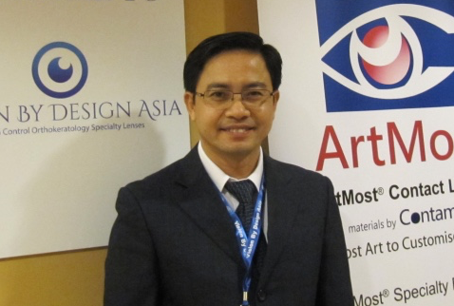
Mr Tran Hoai Long was supported to be the first optometrist in Vietnam to hold a Master’s degree in optometry from the University of New South Wales, Australia. Since completing his masters and returning to Vietnam in 2013, Mr Long has devoted his time to the field of refraction and optometry.
Prior graduating with the Masters in Optometry, Mr Long together with colleagues of the refraction department of Ho Chi Minh City Eye Hospital (HCMCEH), organised and
Mr Long Photo Credit: Brien Holden Vision Institute
delivered a series of refraction training courses. He also worked as a clinician at the contact lens clinic and low vision clinic, where patients regardless of age or gender have equal access to eye care services.
In 2014, Mr Long was transferred from HCMCEH to work at the University of Medicine Pham Ngoc Thach (UPNT) as an optometry lecturer with the role to also develop optometry education and promote refractive services and eye health in Vietnam. The official opening of Vietnam’s first optometry program took place at the UPNT in September 2014 with 16 students. In 2015, there were 30 new students who passed the national entrance examination and began their optometry training.
Mr Long is responsible for managing and delivering the optometry courses at the university: “I am acting as the head of the newly formed Optometry Sub-Department. I organise the teaching of the sub-department and cooperate with other departments to teach our optometry students professional subjects. I also give lectures and conduct practical sessions to our students,” he said.
“To fulfill these tasks I have to plan my work very carefully by making a logical time table. I work at the HCMCEH in the morning and at the UPNT in the afternoon. However, in this new academic year I have to cut down the working time at the hospital and spend more time for the teaching and administration at the university,” he said.
“I think the key thing to help me to manage the work between the two places is work planning and team work. Thanks to the support of my colleagues at both the university and hospital, I would be able to fulfill all my responsibilities. I always put my good efforts to accomplish my tasks and whenever each work finished I always think back ‘what I have done well and how I can do to improve in the future?’
As an optometry educator and manager of the optometry program, Mr Long’s workload and responsibility has increased over the last year. Nonetheless, he continues to exhibit a friendly attitude to his colleagues and students while also demonstrating a high level of enthusiasm.
“I like the working environment at the university because this is good chance for me to act as an optometry teacher and also as an optometry leader. The university gives me great support and this encourages me a lot to do the work, however sometimes it takes long time to get approval from the board members and things have gone through many steps to be completed. I have built a good relationship with other departments at the university and collaborated well with them in daily work, however our sub-department was very young and everything was new so we have to learn to do things and learn from our mistakes,” he shared.
“As a Head of Optometry Sub-department for over a year, the most important achievement I have gained was experience in management and teaching. I have learnt to work independently and to make decisions and be responsible for the decisions that I have made. I think it is a good chance for me to develop the sub-department to become a department with faculties and teaching capacity which can adapt and respond to the need of optometrist training of the society. Sometimes I feel that I do not have enough time to do everything,” he added.
Speaking about the future development of optometry education, Mr Long revealed, “I expect the sub-department could become the Optometry Department. In order to do so, the most important thing is to foster and develop teaching faculty in term of quality and quantity. Initially, the sub-department will need to recruit lecturers those who are new graduates in ophthalmology and optometry. This opportunity is opened equally for both men and women to work and contribute to the optometry education at the UPNT. Alongside the development of optometry education, another very important issue is to recognise the optometry profession in the healthcare system of Vietnam to enable future Vietnamese optometry graduates to work in official positions within the existing health system and to establish an optometrist association in Vietnam to represent members of this emerging profession in the near future.”
Mr Long would also like to complete his Doctor of Philosophy (PHD) in optometry to better serve the optometry sector in Vietnam and to assist in the development of the optometry sub-department.

