
East Asia Vision Program – Timor-Leste Case Study
Orientation and Mobility Trainees

Program component: Eye Health Workforce Development
Implementing agency: The Royal Australasian College of Surgeons

A snapshot of Trainers
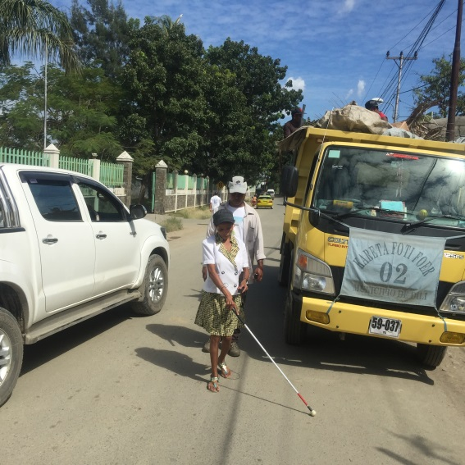
The Orientation and Mobility (O&M) Train-the-Trainer program teaches Timorese instructors to provide essential O&M skills to people in the community with vision impairment. It is designed to empower people who are blind or vision impaired with the skills and knowledge to not only independently navigate their own lives, but to actively contribute to their community by training others.

Before the Australian Government supported the training program, there were no national Timorese people qualified as mobility trainers and subsequently a gap in services available locally. There was a desire from various blind and vision impaired individuals to not only receive training, but to enhance their skills and become mobility trainers. This was supported by the small but active vision rehabilitation sector in Timor-Leste.
Orientation and Mobility training in Dili.
Photo Credit: RACS
The training was conducted by Australian specialist O&M
instructors, who have adapted their teaching techniques
toensure people who are blind or vision impaired can participate in the Train-the-Trainer program. This training model is a powerful way of providing job opportunities for vision impaired individuals in Timor-Leste where jobs are limited. This approach is unique, as in other training contexts, most trainers are sighted.

The following is a snapshot of the final cohort of O&M trainees who graduated from the training program in November 2015. There are now six Timorese O&M instructors, who will be able to meet the O&M training needs in Dili and Same, reducing the need for international support.

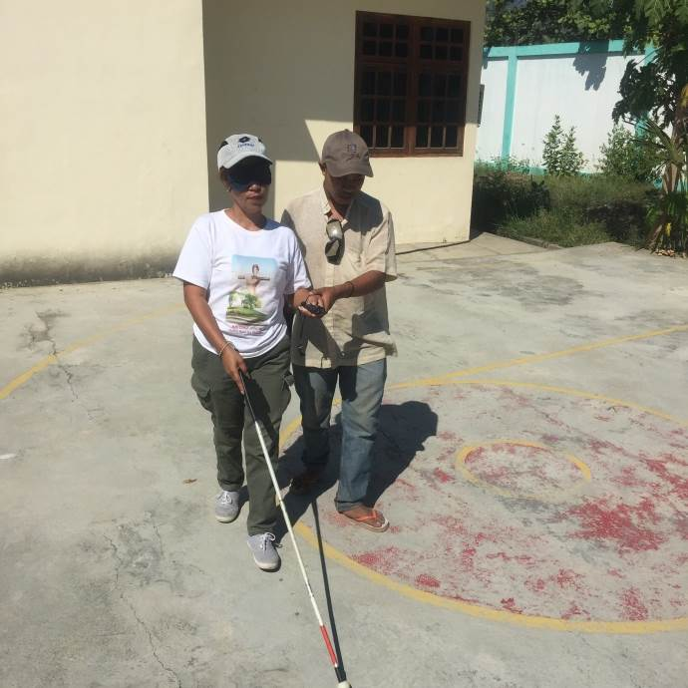
Domingos Savio Fernandes Gusmao
Domingos Gusmao is the President of the East Timor Blind Union (ETBU), a Timorese vision rehabilitation organisation that provides education, training and support to people who are blind or vision impaired. Domingos has a genetic eye condition causing him low vision and his sister and brother are also vision impaired. They are all active members of the ETBU, and are passionate about ensuring that vision impaired people are not disadvantaged in Timor.
Domingos is a positive role model for ETBU clients as he is not only the President of the organisation, a role that requires leadership and strategic oversight, but he also teaches English at the national university in Dili.
Orientation and Mobility training in Dili. Photo Credit: RACS
Domingos advised that this O&M training is more advanced than other training he has participated in, and the skills learnt are also useful for his own mobility and subsequent ability to safely navigate the bustling streets of Dili.
Domingos stated: “They teach us how to use a cane, how to move from one place to another, how to change direction, how to cross streets and how to travel. The skills are useful.”
Domingos is eager to provide other vision impaired individuals with O&M training once he graduates, as he believes he is very fortunate to have worked with the Australian specialist instructors.
He stated: “We will transfer the training to others, not just at ETBU, but (the knowledge) we get from our teachers we should give the gift … we are taking a gift (the training) and we will transfer it to others”.

Felomena de Jesus
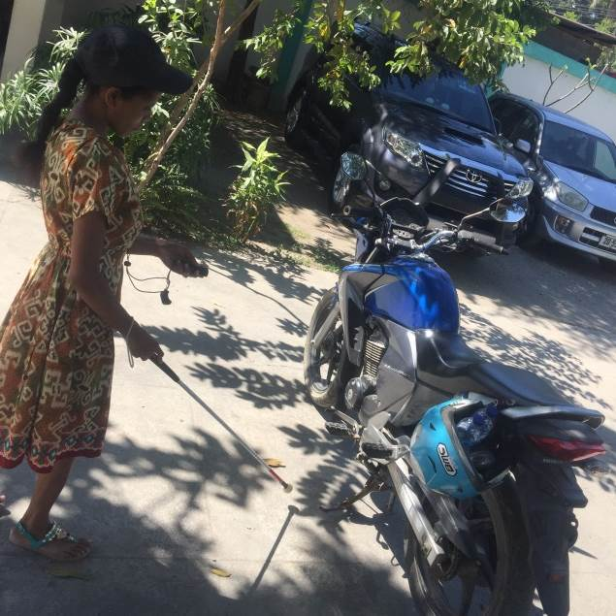
Felomena de Jesus is taking O&M training in her stride. She is totally blind and is a top student of the program. She is currently working at Hallibur Deficiente Matan Timor-Leste (HDMTL)— a Timorese vision rehabilitation organisation, focusing on training, advocacy and human rights —where she teaches Braille literacy to children.
She has quickly grasped the use of the mobility equipment including the Miniguide, an electronic travel aid that provides sonar feedback. It is Filomena’s favourite element of the training program, she stated that: “Miniguide is my favourite, it is very good to identify obstacles … we will not hit people or obstacles because the Miniguide will give a signal.”
In addition to Felomena’s love for Miniguides, she finds the whole program useful. She explained: “I like all of it because I cannot see but this this training is like a third eye for me.”
Orientation and Mobility training in Dili. Photo Credit: RACS
This again demonstrates the impact that the O&M training is having on individuals’ independence and confidence.

Eukin Cortereal Soares
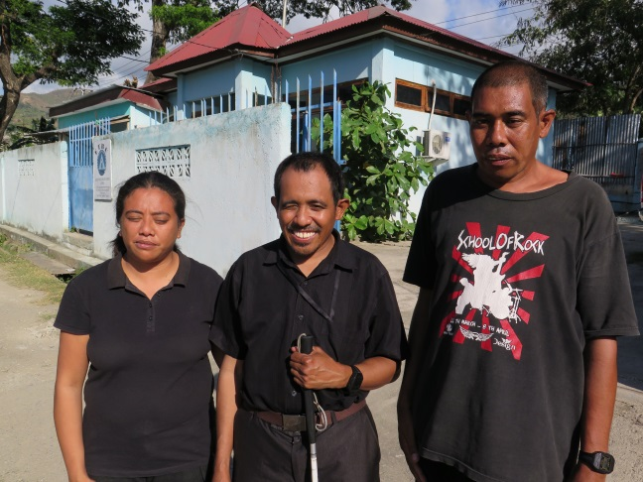
Eukin is a young and ambitious client of HDMTL. He is currently undertaking Braille training at HDMTL and hopes to teach O&M at HDMTL once he graduates from the training program.
He has low vision, and is a full time carer for his ill mother, but prioritises the time to attend the O&M training. He is very committed to the training and eager to pass on his skills to others, as he explained: “I think the training is quite difficult but I want to learn. I want to guide other people and I want to show other people how to be a good guide.”
Eukin’s favou rite element of the teaching program was learning upper body protection. “When we were in the classroom we weren’t allowed to use our canes but just use upper body protection—this is a new technique for me.”
Graduates of the trainee program. Photo Credit: RACS
Domingos, Felomena and Eukin graduated the O&M training program in November 2015, which brought the number of trained O&M instructors to six. This will provide the vision rehabilitation sector in Timor-Leste with increased numbers to deliver O&M services sustainably in Dili.

