National Eye Health Survey (NEHS)
Full Report 2016

Report authors
Joshua Foreman^{1,2}, Stuart Keel¹, Jing Xie¹, Peter van Wijngaarden^{1,2}, Jonathan Crowston^{1,2}, Hugh R Taylor³, Mohamed Dirani¹
- Centre for Eye Research Australia, Royal Victorian Eye & Ear Hospital, Melbourne, Australia
- Ophthalmology, University of Melbourne, Department of Surgery, Melbourne, Australia
- Indigenous Eye Health Unit, Melbourne School of Population and Global Health, University of Melbourne, Melbourne, Australia

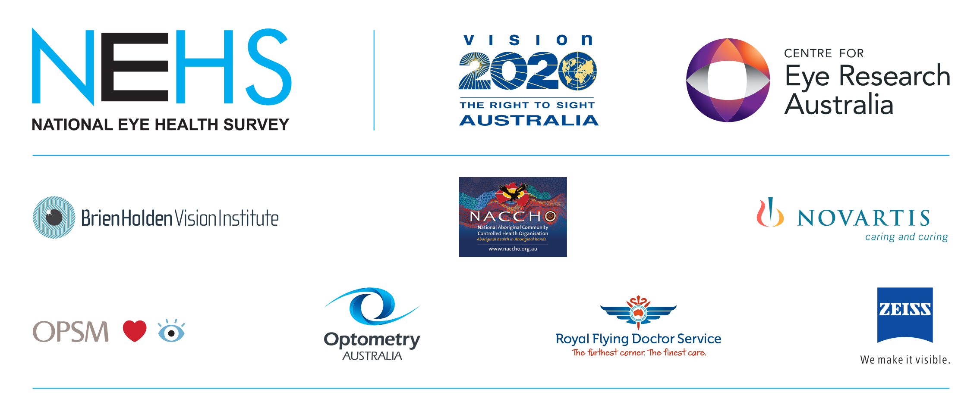
Table of Contents
List of Tables 7
List of Figures 8
Glossary of abbreviated terms 10
Definitions 13
Symbols 16
1 Acknowledgements 17
2 Executive summary 18
2.1 Overview 18
2.2 Introduction to the NEHS 19
2.3 The NEHS team 20
2.4 The sampling, recruitment and testing protocol of the NEHS 21
2.5 Recruitment statistics and sample demographics 21
2.6 Main findings 22
2.6.1 The prevalence and major causes of bilateral vision impairment (VI) and blindness 22
2.6.2 The prevalence and major causes of bilateral vision impairment and blindness by gender, age and geographical area 23
2.6.3 Detection and treatment coverage rate of major eye diseases and conditions 24
3 Introduction to the NEHS 26
3.1 Background 26
3.1.1 The global burden of vision impairment and blindness 26
3.1.2 Initiatives to reduce the burden of VI and blindness 26
3.1.3 Population-based prevalence studies on VI and blindness in Australia 28
3.2 The rationale for conducting the NEHS 29
3.3 The objectives of the NEHS 30
3.4 The significance of the NEHS 31
4 The NEHS team 32
5 The sampling, recruitment and testing protocol of the NEHS 34
5.1 Ethics approval 34
5.1.1 Indigenous community consultations and ethics approvals for the NEHS 34
5.2 The selection of testing sites for the NEHS 37
5.2.1 Overview 37
5.2.2 Estimating the number of participants required in the NEHS 37
5.2.3 Setting the geographical sampling unit for NEHS testing sites 37
5.2.4 Stratifying Australian Statistical Areas by remoteness 38
5.2.5 39
5.2.6 Selecting the NEHS testing sites 40
5.2.7 Secondary selection of targeted geographical areas for recruitment and testing 40
5.3 Recruitment of participants in the NEHS 46
5.3.1 Overview 46
5.3.2 Steps of the recruitment process 46
5.3.3 Additional modes of recruitment 47
5.3.4 Reminder calls and text messages 48
5.3.5 Fail to Attend (FTA) and follow up 48
5.4 Testing protocol of the NEHS 50
5.4.1 Overview 50
5.4.2 Informed consent and registration 50
5.4.3 Interviewer-administered general questionnaire 51
5.4.4 Vision assessment 51
5.4.5 Anterior segment examination 52
5.4.6 Visual field testing 53
5.4.7 Fundus photography 53
5.4.8 Intraocular pressure 54
5.4.9 Verbal feedback and recommendation for referral 54
5.4.10 Certificate of participation and sunglasses 55
5.4.11 Participant evaluation forms 55
6 Data management and analysis 57
6.1 Online tablet-based database 57
6.2 Hardcopies 57
6.3 Online database data backup and export 58
6.4 Management of DRS camera photographs 58
7 Protocols for determining causes of vision impairment and blindness 60
7.1 Refractive error 60
7.2 Cataract 60
7.3 Trachoma 60
7.4 Grading of retinal pathology 61
7.4.1 Retinal image quality 62
7.5 Diabetic retinopathy (DR) 63
7.6 Age related macular degeneration (AMD) 63
7.7 Glaucoma 63
7.8 Assigning main cause of bilateral vision impairment or blindness 64
8 Data analysis 65
8.1 General analysis 65
8.2 Positive response rates and examination rates 65
8.3 Comparison by Remoteness Areas 66
8.4 Comparison by state/territory 66
8.5 Definitions of vision impairment and blindness 67
9 Recruitment statistics and sample demographics 68
9.1 Recruitment statistics 68
9.1.1 Overall positive response rates and examination rates 68
9.1.2 Positive response rates and examination rates of non-Indigenous and Indigenous populations 68
9.1.3 Positive response rates and examination rates by Remoteness Area 72
9.1.4 Positive response rates and examination rates by state/territory 72
9.2 Key characteristics of participants in the NEHS 74
9.3 Ethnicity of non-Indigenous participants in the NEHS 74
10 Main findings 76
10.1 The prevalence and major causes of bilateral vision impairment and blindness 76
10.1.1 The prevalence of bilateral vision impairment 76
10.1.2 The prevalence of bilateral blindness 76
10.1.3 The main causes of bilateral vision impairment 77
10.1.4 The major causes of bilateral blindness 78
10.2 The prevalence and major causes of bilateral vision impairment and blindness by gender, age and geographical area 81
10.2.1 Prevalence and causes by gender 81
10.2.2 Prevalence and causes by age 84
10.2.3 Prevalence by geographical area 85
10.3 Detection and treatment coverage rates of major eye diseases and conditions 90
10.3.1 Undiagnosed major eye diseases and uncorrected refractive error 90
10.3.2 Adherence to National Health and Medical Research Council (NHMRC) diabetic eye examination guidelines 91
10.3.3 Cataract surgery coverage rate and treatment of refractive error 94
11 References 96
12 Appendices 98
12.1 Contributing individuals and organisations 98
12.1.1 NEHS Steering Committee 98
12.1.2 National Aboriginal Community Controlled Health Organisation 98
12.1.3 Organisations and individuals by state 99
12.2 Ethics approvals and endorsements obtained in the NEHS 103
12.3 Primary Indigenous organisations consulted in each NEHS site 123
12.4 Standardised screening script 125
12.5 NEHS recruitment pack 126
12.6 NEHS site summary data and descriptions 132
12.6.1 Remoteness Area: Major City 132
12.6.2 Remoteness Area: Inner Regional 146
12.6.3 Remoteness Area: Outer Regional 154
12.6.4 Remoteness Area: Remote 160
12.6.5 Remoteness Area: Very Remote 165
12.7 Tablet computer recruitment user interface for the NEHS online database 169
12.8 Examination equipment 172
12.9 Tablet computer clinical examination user interface 175
12.10 NEHS participant information and consent form 182
12.11 General questionnaire and examination hardcopy 194
12.12 Van Herick grading protocol 203
12.13 Recommendation letter 204
12.14 Referral guidelines 205
12.15 NEHS certificate of participation 208
12.16 Tablet computer administration user interface 209
12.17 Recruitment hardcopy 210

List of Tables
Table 1. Conversion of Accessibility/Remoteness Index of Australia Classifications to Remoteness Areas 39
Table 2. Distribution of SA2 geographical areas across Remoteness Areas 39
Table 3. National Eye Health Survey selected sites 42
Table 4. Retinal image quality in the NEHS 62
Table 5. Reasons for ungradable or missing retinal images 62
Table 6. Recruitment statistics for the NEHS 68
Table 7. Positive response rates and examination rates for recruitment of Indigenous and non-Indigenous participants by Remoteness Area 73
Table 8. Positive response rates and examination rates for recruitment of Indigenous and non-Indigenous participants by state/territory 73
Table 9. Key characteristics of participants in the NEHS 74
Table 10. Ethnicity of non-Indigenous participants in the NEHS 75
Table 11. Prevalence of bilateral presenting vision impairment and blindness in the NEHS 77
Table 12. Main causes of bilateral presenting vision impairment and blindness in the NEHS 79
Table 13. Prevalence of vision impairment and blindness by gender 82
Table 14. Gender proportions for major causes of vision impairment in Indigenous and non-Indigenous Australians 83
Table 15. The prevalence of vision impairment in Indigenous and non-Indigenous Australians by age 84
Table 16. The mean age of participants with the major causes of vision impairment 85
Table 17. Crude and age-adjusted prevalence of bilateral presenting vision impairment (VA<6/12-6/60) in non-Indigenous and Indigenous participants in the NEHS, by Remoteness Area 86
Table 18. Prevalence of bilateral presenting blindness (VA<6/60) in non-Indigenous and Indigenous participants in the NEHS, by remoteness area 87
Table 19. Prevalence of bilateral presenting vision impairment (VA<6/12-6/60) in non-Indigenous and Indigenous participants in the NEHS, by state/territory 89
Due to the small number of participants with bilateral blindness (n=12), statistical comparisons of the prevalence of blindness between states/territory were not conducted. Table 20 provides a breakdown of the prevalence of bilateral blindness by state/territory and by Indigenous status. Table 20. Prevalence of bilateral presenting blindness (VA<6/60) in non-Indigenous and Indigenous participants in the NEHS, by state/territory 90
Table 21. Undiagnosed major eye diseases and conditions in participants with vision impairment 91
Table 22. Adherence rates to the National Health and Medical Research Council (NHMRC) diabetic eye examination guidelines 92
Table 23. Diabetes eye examination rate in non-Indigenous and Indigenous participants in the NEHS, by Remoteness Area 93
Table 24. Rates of cataract surgery coverage in non-Indigenous and Indigenous participants in the NEHS 95
Table 25. Ethics approvals and endorsements obtained in the NEHS 103
Table 26. Indigenous organisations consulted in each NEHS site, by remoteness 124
Table 27. Major equipment items required for clinical examinations 172
Table 28. Van Herick grading system 203
Table 29. Referral guidelines for the NEHS 205

List of Figures
Figure 1. Organisational flowchart of the NEHS team 33
Figure 2. Indigenous ethics approvals and community consultations for the NEHS 36
Figure 3. Sampling methodology flowchart 41
Figure 4. NEHS survey sites 45
Figure 5. Flowchart illustrating the process of participant recruitment in the NEHS 49
Figure 6. Clinical Examination Flowchart 56
Figure 7. Data flow and management 59
Figure 8. Overall recruitment statistics for the NEHS 69
Figure 9. Recruitment statistics of the target non-Indigenous population in the NEHS 70
Figure 10. Recruitment statistics of the target Indigenous population in the NEHS 71
Figure 11. The main causes of presenting bilateral vision impairment (VA<6/12-6/60) in non-Indigenous Australians 80
Figure 12. The main causes of presenting bilateral vision impairment (VA<6/12-6/60) in Indigenous Australians 80
Figure 13. The prevalence of vision impairment in Indigenous and non-Indigenous Australians by age Error bars are 95% confidence intervals 84
Figure 14. Brighton (QLD) survey site and surrounding areas targeted for recruitment 133
Figure 15. Springfield (QLD) survey site and surrounding areas targeted for recruitment 134
Figure 16. Parklea-Kellyville Ridge (NSW) survey site and surrounding areas targeted for recruitment of non-Indigenous participants 135
Figure 17. The specifically selected Major City backup site of Elizabeth Vale (SA) targeted for recruitment of Indigenous Australians 136
Figure 18. Chipping Norton-Moorebank (NSW) survey site and surrounding areas targeted for recruitment 137
Figure 19. Concord-Mortlake-Cabarita (NSW) survey site and surrounding area targeted for recruitment 138
Figure 20. The backup site of Morphett Vale (SA) targeted for recruitment of Indigenous Australians 138
Figure 21.Mornington (VIC) survey site and surrounding area targeted for recruitment 139
Figure 22. Rowville-Central (VIC) survey site and surrounding area targeted for recruitment 140
Figure 23. Craigie-Beldon (WA) survey site and surrounding area targeted for recruitment 141
Figure 24. Bassendean-Eden Hill-Ashfield (WA) survey site and surrounding area targeted for recruitment 142
Figure 25. Kalamunda-Maida Vale-Gooseberry Hill (WA) survey site and surrounding area targeted for recruitment 143
Figure 26. Elderslie-Harrington Park (NSW) survey site and surrounding area targeted for recruitment 144
Figure 27 .Warilla (NSW) survey site and surrounding area targeted for recruitment 145
Figure 28.The Ipswich area, corresponding to the backup site, Seventeen Mile Rocks-Sinnamon Park (QLD), targeted for recruitment of Indigenous Australians 146
Figure 29. Lesmurdie-Bickley-Carmel (WA) survey site and surrounding area targeted for recruitment 147
Figure 30. Goulburn (NSW) survey site and surrounding area targeted for recruitment 148
Figure 31. Wodonga (VIC) survey site and surrounding area targeted for recruitment 149
Figure 32. Tomerong-Wandandian-Woollamia (NSW) survey site and surrounding area targeted for recruitment 151
Figure 33. Ulladulla Region (NSW) survey site and surrounding area targeted for recruitment 152
Figure 34. Rockhampton Region-East (QLD) survey site 153
Figure 35. Suburb of Koongal in the Rockhampton Region-East (QLD) targeted for recruitment 154
Figure 36. Whyalla (SA) survey site and surrounding area targeted for recruitment 155
Figure 37. Geraldton (WA) survey site and surrounding area targeted for recruitment 156
Figure 38. Wagaman (NT) survey site and surrounding area targeted for recruitment 157
Figure 39. Inverell (NSW) survey site and surrounding area targeted for recruitment 158
Figure 40.Eden (NSW) survey site and surrounding area targeted for recruitment 159
Figure 41. Katanning (WA) survey site and surrounding area targeted for recruitment 160
Figure 42. Banana (QLD) survey site and surrounding area targeted for recruitment of non-Indigenous participants 161
Figure 43.Relative positions of the Biloela back up site, targeted for recruitment of non-Indigenous participants and Mount Morgan, targeted for recruitment of Indigenous participants 161
Figure 44.Daintree (QLD) survey site and surrounding area targeted for recruitment 162
Figure 45.Yorke Peninsula-South (SA) survey site and surrounding area targeted for recruitment 164
Figure 46. Yorke Peninsula (WA) map illustrating the relative positions of Indigenous and non-Indigenous recruitment sites 164
Figure 47. South Hedland (WA) survey site and surrounding area targeted for recruitment 165
Figure 48. Exmouth (WA) survey site and surrounding area targeted for recruitment 166
Figure 49. Exmouth (WA) survey site targeted for non-Indigenous recruitment and Onslow (WA) survey site targeted for Indigenous recruitment 167
Figure 50. Esperance Region (WA) survey site located in Hopetoun targeted for recruitment 168
Figure 51. Esperance Region (WA) survey site in Hopetoun targeted for non-Indigenous recruitment and the eastern segment of the Esperance Region SA2 targeted for Indigenous recruitment 168
Figure 52. Recruitment user interface of the NEHS cloud-based database 171
Figure 53. Clinical examination user interface of the NEHS cloud-based database 181
Figure 54.Illustration of the anterior chamber angle using the Van Herick method 203
Figure 55. Administration user interface of the NEHS cloud-based database 209

Glossary of abbreviated terms
A&TSIC Aboriginal and Torres Strait Islander Committee
ABS Australian Bureau of Statistics
ACCHS Aboriginal Community Controlled Health Service
AH&MRC Aboriginal Health and Medical Research Council
AHCSA Aboriginal Health Council of South Australia
AHCWA Aboriginal Health Council of Western Australia
AMD Age-related Macular Degeneration
AMSANT Aboriginal Medical Services Alliance of the Northern Territory
ANOVA Analysis of Variance
ARIA+ Accessibility/Remoteness Index of Australia Plus
ASCCEG Australian Standard Classification of Cultural and Ethnic Groups
ASGC Australian Standard Geography Classification
ASGS Australian Statistical Geography Standard
AusDiab Australian Diabetes, Obesity and Lifestyle Study
BCVA Best Corrected Visual Acuity
BMES Blue Mountains Eye Study
CDR Cup to Disc Ratio
CERA Centre for Eye Research Australia
CI Confidence Interval
CO Corneal Opacity
DRS Diabetic Retinopathy Screening
DYHS Derbarl Yerrigan Health Service
FDT Frequency Doubling Technology
FTA Fail To Attend
GRAMS Geraldton Regional Aboriginal Medical Service
HREC Human Research Ethics Committee
IAPB International Agency for the Prevention of Blindness
IOP Intra Ocular Pressure
IPC Independence and Participation Committee
IQR Inter Quartile Range
logMAR logarithm of the Minimum Angle of Resolution
mmHg Millimetres of mercury
NACCHO National Aboriginal Community Controlled Health Organisation
NEHS National Eye Health Survey
NFIP Implementation plan under the National framework for action to promote eye health and prevent avoidable blindness and vision loss
NHMRC National Health and Medical Research Council
NIEHS National Indigenous Eye Health Survey
NSW New South Wales
NT Northern Territory
OA Optometry Australia
OPSM Optical Prescription Spectacle Makers
OR Odds Ratio
OU Oculus Uterque
PEIC Prevention and Early Intervention Committee
PR Public Relations
pt Part
QAIHC Queensland Aboriginal and Islander Health Council
QLD Queensland
RA Remoteness Area
RVEEH Royal Victorian Eye and Ear Hospital
SA South Australia
SA Statistical Area
SA1 Statistical Area Level 1
SA2 Statistical Area Level 2
SA3 Statistical Area Level 3
SA4 Statistical Area Level 4
SD Standard Deviation
SE Standard Error
SQM Square Metre
Tap NP Target Non-Indigenous Population
Tar IP Target Indigenous Population
TT Trachomatous Trichiasis
VA Visual Acuity
VACCHO Victorian Aboriginal Community Controlled Health Organisation
VI Vision Impairment
VIC Victoria
VIP [Melbourne] Visual Impairment Project
WA Western Australia
WHA World Health Assembly
WHO World Health Organization

Definitions
Age-adjustment | A technique in epidemiology and demography used to allow populations to be compared when the age profiles of the populations are quite different
Age-related macular degeneration | A degenerative disease that affects the central area of the retina called the macula, causing it to thin and in some cases bleed
Anterior chamber angle closure | Blockage of the drainage angle of the eye, resulting in high eye pressure
Anterior segment | The front part of the eye
Auto-refractor | A machine used to provide an objective measurement of a person's refractive error and prescription for correction
Blindness | Presenting distance visual acuity <6/60 in the better eye
Cataract | A cloudy area on the eye’s lens, formed when protein in the lens is damaged and clumps together, limiting the amount and clarity of light passing through the lens to the retina, causing poor vision.
Chalazion | A cyst in the eyelid that is caused by inflammation of a blocked gland, usually on the upper eyelid
Corneal Opacity | Scarring and opacification of the cornea (the transparent thin layer over the front of the eye)
Cotton-wool spots | Fluffy white patches on the retina caused by damage to nerve fibres
Cup notching | Focal reduction in the width of the rim of the optic nerve associated with a change in the curvature of the rim in glaucoma
Cup to disc ratio | Comparison of the diameter of the central cup portion of the optic disc with the total diameter of the optic disc in assessing glaucoma
Design effect | An adjustment used to quantify the extent to which the expected sampling error in a survey departs from the sampling error that can be expected under simple random sampling
Diabetes | A group of metabolic diseases in which there are high blood sugar levels over a prolonged period

Diabetic retinopathy | Diabetic retinopathy is a complication of diabetes that damages blood vessels inside the retina at the back of the eye. It commonly affects both eyes and can lead to vision loss if it is not treated
Drusen | Yellow or white accumulations of material in the retina, associated with normal ageing and age-related macular degeneration
Fovea | The central pit of the macula in the retina responsible for sharp central vision
Fundus | The interior surface of the eye opposite the lens that includes the retina, optic disc, macula, fovea, and posterior pole
Geographic atrophy | Damage to the deepest cells of the macular in the advanced stage of dry age-related macular degeneration
Glaucoma | A group of eye diseases in which the optic nerve at the back of the eye is slowly destroyed. In most people this damage is due to an increased pressure inside the eye - a result of blockage of the circulation of aqueous, or its drainage. In other patients the damage may be caused by poor blood supply to the vital optic nerve fibres, a weakness in the structure of the nerve, and/or a problem in the health of the nerve fibres themselves
Hard exudates | Yellow spots on the retina, resulting from lipid breakdown after macular oedema subsides in diabetic retinopathy
Intraocular pressure | The fluid pressure inside the eye
Intra-retinal microvascular abnormalities | Abnormal branching or dilation of existing blood vessels (capillaries) within the retina that act to supply areas of insufficient blood supply in diabetic retinopathy
Macular oedema | Build-up of fluid in the macula
Micron | One millionth of a metre
Mydriatic | Pertaining to or producing pupil dilation
Neovascularisation | Proliferation of blood vessels in tissue not normally containing them, or proliferation of blood vessels of a different kind than usual in tissue
Neuro-retinal rim thinning | Thinning of the rim of the optic nerve in glaucoma
Optic atrophy | Damage to the optic nerve resulting in a degeneration or destruction of the optic nerve
Optic disc | The point of exit for the optic nerve leaving the eye
Perimeter | An instrument for measuring the extent and characteristics of a person's field of vision
Pterygium | An overgrowth of issue with blood vessels that grows from the conjunctiva (the thin membrane that covers the white of the eye) on to the cornea (the clear central part of the eye)
Refractive error | A condition in which light that passes through the front of the eye fails to focus precisely on the retina. It causes long or short sightedness and difficulties changing focus
Stratified sampling | A type of sampling method in which the population is divided into separate groups, called strata, from each of which a probability sample is selected
Stye | An infection of the glands in the base of the eyelashes
Tonometer | A device that measures the fluid pressure in the eye
Trachoma | A contagious infection of the conjunctiva and cornea, characterised by the formation of granulations and scarring and caused by the bacterium Chlamydia trachomatis
Trachomatous Trichiasis | Ingrowth or introversion of the eyelashes caused by trachoma infection
Tropicamide | A drug that induces pupil dilation
Van Herick grading | A test using a slit lamp that measures the anterior chamber depth to estimate the risk of anterior chamber angle closure
Venous beading | Saccular bulges in the wall of a vein resulting from inadequate blood supply
Vision impairment | Presenting distance visual acuity <6/12 in the better eye
Visual field | The total area in which objects can be seen in the side (peripheral) vision as you focus your eyes on a central point

Symbols

< | Less than
> | More than
≤ | Less than or equal to
≥ | More than or equal to
/ | Or
+/- | With or without
Μm | Micrometre/micron
χ² | Chi squared statistic

Acknowledgements
The Centre for Eye Research Australia (CERA) and Vision 2020 Australia wish to recognise the contributions of all parties involved in the planning, implementation and completion of the National Eye Health Survey (NEHS) (Appendix 12.1). The National Eye Health Survey was funded the Australian Government, with other in-kind and financial contributions coming from CERA, OPSM, Novartis, Zeiss, Brien Holden Vision Institute, Optometry Australia, the National Aboriginal Community Controlled Health Organisation (NACCHO) and the Royal Flying Doctors Service. We also appreciate the governance provided by the NEHS Steering Committee. We acknowledge the commitment of the core CERA research team, the overwhelming support provided by all Indigenous organisations and the contributions from all volunteers.

Executive summary

Overview
Recruitment for the NEHS was undertaken in 30 randomly selected sites between 11 March 2015 and 18 April 2016. In this time over 23,000 doors were knocked and 85.27% of those eligible to enrol in the study did so.
The NEHS used stratified, multistage random-cluster sampling and examined a total of 3,098 non-Indigenous Australians aged 50 years or older and 1,738 Indigenous Australians aged 40 years or older. The survey achieved a positive response rate of 85.27% and an examination rate of 71.54%.
The age-adjusted prevalence of vision impairment (VI) (13.60%) and blindness (0.36%) in Indigenous Australians were both three times higher than in non-Indigenous Australians (4.57% and 0.12%, respectively).
In 2016, more than 453,000 Australians are living with vision impairment or blindness. This was calculated by using the age adjusted prevalence of vision impairment or blindness multiplied by the target population, stratified by remoteness. Based on the NEHS and age adjusted population data, it is estimated that this includes up to 432,800 non-Indigenous Australians aged 50 years or older and up to 18,300 Indigenous Australians aged 40 years or older.
The main causes of VI in both Indigenous and non-Indigenous Australians were uncorrected refractive error (63.39% and 61.69%) and cataract (20.22% and 13.93%), highlighting that approximately 80% of VI is treatable with spectacle correction or cataract surgery.
The prevalence of VI did not differ between males and females, and the uncorrected refractive error and cataract were the major causes for both males and females in both Indigenous and non-Indigenous groups. VI increased with age in both groups. Geographic remoteness had a significant effect on the prevalence of VI in Indigenous Australians but not in non-Indigenous Australians.
More than half of those with VI or blindness attributed to one of the five main causes of vision loss had not previously been diagnosed with the attributed condition.
52.87% of the 645 Indigenous Australians and 77.72% of the 431 non-Indigenous Australians with self-reported diabetes reported having undergone a diabetes eye examination within the last year and last two years, respectively, in accordance with the NHMRC guidelines.
The cataract surgery coverage rate of 87.63% in non-Indigenous Australians was significantly higher than that of Indigenous Australians, with a surgery coverage rate of 61.47%.
The treatment rate for refractive error was 83.28% in Indigenous Australians and 93.65% in non-Indigenous Australians.

Introduction to the NEHS
The NEHS is the first nationwide Australian population-based survey designed to:
- determine the prevalence and causes of vision impairment and blindness in Indigenous Australians aged 40 years and over, and non-Indigenous Australians aged 50 years and over, by gender, age, and geographical area.
- measure the detection and treatment coverage rate of major eye diseases and conditions in both Indigenous and non-Indigenous Australian adults by:
  - Determining the proportion of Australians with undiagnosed major eye diseases and uncorrected refractive error. All participants will be provided with verbal feedback on their eye results at the completion of the clinical examination, and any participant with undiagnosed eye disease that can be detected through the survey’s testing protocol will receive a letter of recommendations for referral to an eye care professional.
  - Determining the proportion of Australians with known diabetes who adhere to the recommended retinal examination set by the National Health and Medical Research Council (NHMRC); biennial for non-Indigenous Australians and annually for Indigenous Australians.
  - Establishing the coverage of cataract surgery and the treatment of uncorrected refractive error in Australia
The findings of the NEHS are intended to provide an indication of the effectiveness of existing eye health care services in Australia, and will guide future resource allocation, policy development and economic analysis for eye health care service delivery in Australia as outlined in the “Implementation plan under the National framework for action to promote eye health and prevent avoidable blindness and vision loss” (NFIP). The NEHS marks a significant contribution to Australia’s commitment to the “Universal Eye Health: a Global Action Plan 2014-2019” (the Global Action Plan) endorsed at the 66th World Health Assembly in 2013, which aims to reduce avoidable blindness by 25% by the year 2019. The survey provides up-to-date baseline data that will form the basis for follow-up studies to measure the impact of eye health interventions and to monitor progress in line with the objectives of the Global Action Plan.

The NEHS team
The NEHS was conducted by investigators at the Centre for Eye Research Australia (CERA) in partnership with Vision 2020 Australia, the national peak body for eye health and vision care in Australia. The project was governed by a Steering Committee consisting of representatives from CERA, Vision 2020 Australia, the Australian Government, major contributing partners and the eye health and vision care sector.

The sampling, recruitment and testing protocol of the NEHS
Using a multi-stage, random cluster sampling methodology, 30 geographic areas stratified by remoteness were selected to provide a target population of 3,000 non-Indigenous Australians aged 50 years and older and 1,400 Indigenous Australians aged 40 years and older. Recruiters from CERA went door-to-door at each site to recruit participants.
At a centralised testing centre each participant completed an interviewer-administered general questionnaire, and underwent assessment of their vision, anterior segments, visual fields and intraocular pressures (IOP). Fundus photography was performed. Participants were provided with verbal feedback regarding the health of their eyes and a referral letter was generated if abnormalities were detected. Retinal images were graded at CERA using standardised protocols. The entire testing process for a participant was 30 minutes on average.

Recruitment statistics and sample demographics
The NEHS achieved a positive response rate of 85.27% (residents identified as eligible at the time of recruitment and initially agreed to participate/residents identified as eligible at the time of recruitment x 100) and an examination rate of 71.54% (residents identified as eligible at the time of recruitment and were examined/residents were identified as eligible at the time of recruitment x 100).
The total sample of 4,836 consisted of 1,738 Indigenous Australians (58.92% female vs 41.08% male) aged 40 to 92 years (mean age [SD] = 55.0 [9.97] years) and 3,098 non-Indigenous Australians (53.62% female vs 46.38% male) aged 50 to 98 years (mean age [SD] = 66.57 [9.69] years). 69.14% of non-Indigenous participants were born in Australia.

Main findings

The prevalence and major causes of bilateral vision impairment (VI) and blindness

The prevalence of bilateral vision impairment
The crude prevalence of bilateral VI (<6/12-6/60) was 1.6 times higher in Indigenous Australians when compared to non-Indigenous Australians (10.53% vs. 6.49%, p<0.001). After age-adjustment, the prevalence of VI increased to 13.60% for Indigenous Australians and decreased to 4.57% for non-Indigenous Australians (p<0.001), resulting in a 3.0-fold higher age-adjusted prevalence in Indigenous Australians than in non-Indigenous Australians.

The prevalence of bilateral blindness
The crude prevalence of bilateral blindness (<6/60) was 0.29% in Indigenous Australians and 0.23% in non-Indigenous Australians. The age-adjusted prevalence of bilateral blindness was three times higher in Indigenous Australians compared to non-Indigenous Australian (0.36% vs. 0.12%, p<0.001).

Major causes of bilateral vision impairment
The main cause of VI for both Indigenous and non-Indigenous Australians was uncorrected refractive error (63.39% and 61.69%, respectively) followed by cataract (20.22% and 13.93%, respectively). The proportion of VI cases explained by AMD was higher for non-Indigenous Australians compared to that in the Indigenous Australian group (8.96% vs. 1.09%), while diabetic retinopathy (diabetic eye disease) contributed to a higher proportion VI cases in Indigenous Australians when compared to their non-Indigenous counterparts (5.46% vs. 1.49%).
Approximately 90% of vision impairment and blindness among both Indigenous and non-Indigenous Australians is preventable or treatable. This was calculated by combining the five major conditions responsible for the majority of vision impairment and blindness in Australia (age-related macular degeneration, cataract, diabetic retinopathy, glaucoma and uncorrected refractive error) as a percentage of all vision impairment and blindness.

Major causes of bilateral blindness
The primary cause of bilateral blindness in non-Indigenous participants was AMD (5/7, 71.4%), while the causes of blindness in Indigenous participants were cataract (2/5, 40%), diabetic retinopathy (1/5, 20%), optic atrophy (1/5, 20%) and a combination of mechanisms (1/5, 20%).

The prevalence and major causes of bilateral vision impairment and blindness by gender, age and geographical area

Prevalence and causes by gender
There was no significant difference in the prevalence of VI between males and females in both Indigenous (p=0.194) and non-Indigenous Australians (p=0.20). Similarly, blindness did not differ significantly between males and females for both Indigenous (p=0.389) and non-Indigenous Australians (p=0.29).
For both females and males in Indigenous and non-Indigenous groups, the main causes of VI were uncorrected refractive error and cataract. Of those participants for whom uncorrected refractive error was the main cause of VI, 60.34% were female in the Indigenous sample, while 50% were female in the non-Indigenous sample. For those with VI attributed to cataract, 75.68% were female in the Indigenous group, while 42.86% were female in the Indigenous group.

Prevalence and causes by age
Prevalence of VI increased with age for both Indigenous and non-Indigenous Australians. In Indigenous Australians, the prevalence of VI was more than eight times higher in those aged 80 years and older (46.15%) compared to those aged 40-49 years (5.66%). VI was 3.44 times higher in non-Indigenous Australians aged 80 years and older (15.21%) than those aged 50-59 years (4.42%).

Prevalence by geographical area
The age-adjusted prevalence of VI for Indigenous Australians and non-Indigenous Australians in each Remoteness Area, respectively, were; 11.01% vs 4.91% in Major Cities, 10.20% vs 3.48% in Inner Regional, 21.59% vs 5.54% in Outer Regional, 11.10% vs 4.22% in Remote, and 17.96% vs 5.31% in Very Remote sites.
While remoteness did not affect the prevalence of VI in non-Indigenous Australians, the prevalence of VI in Indigenous Australians was significantly higher in Outer Regional sites (age-adjusted prevalence of 21.59%, p<0.001) than in other Remoteness Areas.
The prevalence of blindness for Indigenous Australians and non-Indigenous Australians in each Remoteness Area, respectively, were; 0.13% vs 0.32% in Major Cities, 0.00% vs 0.00% in Inner Regional, 0.25% vs 0.16% in Outer Regional, 1.10% vs 0.27% in Remote, and 1.04% vs 0.46% in Very Remote sites. Due to small sample sizes, statistical comparisons between areas could not be made.

Detection and treatment coverage rate of major eye diseases and conditions

Undiagnosed major eye diseases and uncorrected refractive error
Of those Indigenous Australians with VI or blindness attributed to one of the five main causes of vision loss, 57.40% had not previously had that condition diagnosed. This represents 5.58% of all Indigenous participants. In non-Indigenous participants for whom VI or blindness were attributed to one of the five main causes, 51.93% reported to have not had that condition previously diagnosed, corresponding to 3.03% of the total non-Indigenous sample.

Adherence to the National Health and Medical Research Council (NHMRC) diabetic eye examination guidelines
Indigenous Australians had a significantly higher rate of self-reported diabetes (crude rate=37.11%, age-adjusted rate=43.77%) than non-Indigenous Australians (crude rate=13.91%, age-adjusted rate=11.49%, p<0.001). Overall, 52.87% (341/645) of Indigenous participants with self-reported diabetes had had an eye examination in the preceding year, in accordance with NHMRC diabetic eye examination guidelines. However, 26.20% reported that they had never been examined. Diabetic eye examination rates for Indigenous Australians were significantly lower in Very Remote sites (35.42%) when compared to Major City sites (55.22%, p=0.013). Greater adherence to these guidelines was observed in non-Indigenous Australians, with approximately 77.72% of participants (335/431) with self-reported diabetes having had a diabetic eye examination within the past 2 years.

Cataract surgery coverage rate and treatment of refractive error
The cataract surgery coverage rate (participants who had cataract surgery (self-reported) in at least one eye/participants who had cataract surgery (self-reported) in at least one eye + participants who had VI or blindness with cataract (graded as probable or definite by trained graders) x 100) was significantly higher in non-Indigenous Australians (87.63%) than in Indigenous Australians (61.47%, p<0.001). Cataract surgery coverage did not differ by remoteness for either group.

Refractive error treatment rate
The treatment coverage rates for refractive error were 83.28% in Indigenous Australians and 93.65% in Indigenous Australians.

Introduction to the NEHS

Background

The global burden of vision impairment and blindness
The Global Burden of Disease (GBD) Vision Loss Expert Group estimated that 191 million people suffer from vision impairment (VI) globally, and 32.4 million are blind [1]. Recent estimates suggest that 80% of VI and blindness is avoidable or curable through the appropriate implementation of cost-effective prevention and treatment strategies. Spectacle correction and cataract surgery are two highly cost effective interventions that can address two of the leading causes of VI, uncorrected refractive error (42%) and cataract (33%) [2]. Additionally, improvements in infrastructure and access to eye screening will improve the prevention of eye disease and facilitate its early detection and management, reducing the global burden of curable or avoidable VI and blindness [3-5].

Initiatives to reduce the burden of VI and blindness
The feasibility of reducing the burden of avoidable VI and blindness globally has prompted a number of initiatives to address this growing problem. The Global Initiative for Elimination of Avoidable Blindness, also known as Vision 2020 – the Right to Sight, was established by the World Health Organization (WHO) and the International Agency for the Prevention of Blindness (IAPB) in 1999. Additionally, the World Health Assembly (WHA) identified this public health problem as a high priority on its agenda, and has passed three resolutions calling for the reduction of avoidable blindness.
As a response to the WHA’s call for member nations to develop a national Vision 2020 plan (resolution WHA 56.26), the Australian Government developed the “National Framework for Action to Promote Eye Health and Prevent Avoidable Blindness and Vision Loss” (the National Framework). The National Framework is a blueprint for coordinated action by governments, health professionals, non-government organisations and industry to work in partnership to focus activity on the prevention and avoidance of vision loss and disease. The National Framework was endorsed by the Australian Health Ministers’ Conference in November 2005.
In late May 2013, the 66th WHA endorsed the “Universal Eye Health: a Global Action Plan 2014-2019” (the Global Action Plan)[6]. To achieve the goal of the Global Action Plan, ‘a world in which nobody is needlessly vision impaired’ three objectives were defined by Member States, the Secretariat and international partners. Australian representatives made significant contributions in defining the national indicators for this plan. Of the three objectives, the need to generate reliable evidence of the prevalence and causes of VI was emphasised and endorsed by all participating parties. A global target was set to reduce ‘the prevalence of avoidable visual impairment by 25% by 2019 from the baseline in 2010’ [6].
As a signatory to the Global Action Plan, Australia aims to uphold its commitment to reducing avoidable blindness globally by 25% by 2019 [7]. Accordingly, the NFIP was developed to support the National Framework and outlines key priority areas and actions, aiming to ensure that all Australians have access to high quality health care and medicines. The purpose of the Plan is to build on existing eye health care services and programmes, support coordination of effort, provide guidance on the mechanisms to address key priorities, identify indicators and other measures of progress, and guide investment and future activity and action across the Department [7].
Specifically, the NFIP emphasised the need for up-to-date, representative prevalence data on eye health conditions from a national survey to inform reporting against the key indicators in the Global Action Plan. The NEHS will therefore contribute to fulfilling Australia’s commitment to the Global Action Plan by satisfying the requirement for current prevalence data for VI and blindness. The results will form the basis for follow-up studies to document the effectiveness of future eye health care interventions and measure the progress being made in achieving the objectives of the WHA Global Action Plan.

Population-based prevalence studies on VI and blindness in Australia
Australia lacks recent population-based data on the prevalence of VI and blindness. Two population-based studies were conducted in the early 1990s, the Melbourne Visual Impairment Project (VIP) [8] and the Blue Mountains Eye Study (BMES) [9] that provided insights into the prevalence of VI and blindness at that time. Although the data from the VIP and BMES were collected more than 20 years ago, they remain as the reference studies for the prevalence and causes of VI and blindness in Australia. The VIP collected data from nine selected sites in Melbourne metropolitan areas, four regional sites and 14 nursing homes in the state of Victoria. The BMES collected data from four selected areas in Sydney’s west. Both studies had restricted geographic coverage of the Australian population. Additionally, these studies did not collect data on Indigenous Australians. Consequently, the extent to which the findings from the BMES and VIP can be extrapolated to the current Australian population is limited.
In 2008, the National Indigenous Eye Health Survey (NIEHS) was conducted to investigate the prevalence and causes of VI and blindness in the Indigenous Australian population [10]. Thirty testing sites, stratified by remoteness were randomly selected. At each site approximately 50 Indigenous adults aged 40 years or older and 50 Indigenous children aged 5 to 15 years were examined. While the NIEHS included a small opportunistic sample of 136 non-Indigenous Australians living in the Indigenous sampling areas, the study did not investigate the prevalence of VI and blindness in non-Indigenous Australians, and therefore the burden of VI and blindness could not be compared between these two populations. As the NIEHS was conducted in 2008, follow-up data is required to ascertain the effectiveness of interventions implemented since the study was conducted.
The Australian Bureau of Statistics (ABS) conducts regular National Health Surveys (NHS) to obtain information on the health status of Australians, including information about vision loss and eye conditions [11]. However, these surveys rely entirely on self-report, and respondents do not undergo clinical examinations to verify their responses to questions about eye health.
The paucity of national data on the prevalence and major causes of VI and blindness in Australia necessitates a comprehensive population-based eye health survey. CERA and Vision 2020 Australia developed a proposal for the Australian Government to fund the NEHS. A total of $1.8 million was provided by the Australian Government under the Chronic Disease Prevention and Service Improvement Fund alongside financial and in-kind contributions provided by partner organisations in the eye health and vision care sector.

The rationale for conducting the NEHS
Australia did not have current national population-based data on the prevalence and causes of VI and blindness. At present, the planning of eye health interventions is based on 20 year-old data derived from state-based studies. A number of government and non-government initiatives have been implemented to reduce vision loss in both Indigenous and non-Indigenous groups. An assessment of their impact will be of value in guiding the development of future interventions. Several public health and economic factors also provide a compelling case for a national eye health survey. These include:
- The ageing of the population – it is estimated that almost 85% of all vision impairment affects those aged 50 years or more [7].
- The rapid rise in the prevalence of diabetes, and thus diabetic eye disease [12].
- The increase in risk factors for diabetes, such as obesity [13].
- Advances in eye testing technologies.
- The escalating cost of treating late stage disease and the enormous indirect costs of blindness and vision impairment [14].

The objectives of the NEHS
- To determine the prevalence and causes of VI and blindness in Indigenous Australians aged 40 years and over, and non-Indigenous Australians aged 50 years and over, by gender, age, and geographical area.
- To measure the detection and treatment coverage rate of major eye diseases and conditions in both Indigenous and non-Indigenous Australian adults by:
  - Determining the proportion of Australians with undiagnosed major eye diseases and uncorrected refractive error. All participants will be provided with verbal feedback on their eye results at the completion of the clinical examination, and any participant with undiagnosed eye disease that can be detected through the survey’s testing protocol will receive a letter of recommendations for referral to an eye care professional.
  - Determining the proportion of Australians with known diabetes who adhere to the recommended retinal examination set by the National Health and Medical Research Council (NHMRC); biennial for non-Indigenous Australians and annually for Indigenous Australians.
  - Establishing the coverage of cataract surgery and the treatment of uncorrected refractive error in Australia

The significance of the NEHS
The findings from the NEHS can be presented to the WHO as part of the Australian Government’s report to the WHA as called for by the WHA Global Action Plan.
The findings of the NEHS will assist in eye health care in multiple ways. They will:
- Inform economic analysis and policy formulation for eye health service delivery in Australia.
- Act as a reference point for measuring the progress and impact of eye health care services in Australia.
- Guide the use of resources in reducing the prevalence of avoidable VI in Australia.
- Assist in developing effective, feasible and cost-effective eye health care services in Australia.
- Aid in developing education, awareness and screening programs in communities, including regional and remote areas for the prevention of eye disease.
- Document progress toward the global target of reducing the number of people with avoidable blindness and vision impairment by 25% by the year 2019.

The NEHS team
The project was governed by a Steering Committee of eleven voting members including the Executing Research Body (CERA), the Project Executive Sponsor (Vision 2020 Australia), the Australian Government Department of Health, major contributing partners and representatives of the eye health and vision care sector.
Sector representatives were elected from the three Vision 2020 Australia national policy committees, including the Prevention and Early Intervention Committee (PEIC), Aboriginal and Torres Strait Islander Committee (A&TSIC) and the Independence and Participation Committee (IPC).
The research planning, data collection, analysis and report writing were managed by the Project Manager, Dr Mohamed Dirani and his research team (Figure 1), with support from the Steering Committee.
Figure 1. Organisational flowchart of the NEHS team
Vision 2020
Australia
Project
Steering Committee¹
Principal Investigator:
Dr Mohamed Dirani

Statistics and Database Management²
PhD Student:
Joshua Foreman
Project Coordinator:
Dr Stuart Keel

39 Local Indigenous
Workers
Retinal Image Grading Centre⁴
19 Volunteers
CERA Research Support
Research Assistants³

- Executing Research Body - Centre for Eye Research Australia: Dr Peter van Wijngaarden
Project Executive Sponsor - Vision 2020 Australia: Jennifer Gersbeck (CEO), Brandon Ah Tong (Director of Policy and Advocacy)
Major Contributing Partners
OPSM: Robyn Weinberg, Peter Murphy
Novartis: Christine Black, Peter Murphy
Optometry Australia: Genevieve Quilty
Australian Government
Chronic Disease Management Section, Primary and Mental Health Care Division, Department of Health: Louis Young, (Director)
Population Health and Sport Division, Department of Health: Sonia Cornelly (Director)
Rural, Remote and Indigenous Access Branch, Department of Health: Rhonda Stilling (Director)
Sector Representatives
Aboriginal and Torres Strait Islander Committee: Anna Morse
Prevention and Early Intervention Committee: Professor Hugh Taylor
Independence and Participation Committee: Sharon Bentley
National Aboriginal Community Controlled Health Organisation: Jason Agostino
Principal Investigator - Centre for Eye Research Australia: Dr Mohamed Dirani
Secretariat - Vision 2020 Australia: Sarah Davies (Policy and Advocacy Coordinator)
Additional Technical Support
Ms Holly Jones, Assistant Director of Population Health Policy and Analysis, Department of Health;
Ms Kimily Harrison, Senior Adviser of Health Systems Analysis, Department of Prime Minister and Cabinet
- Ross Dunn (sampling manager)
Wei Meng (database construction and administrative support)
Jing (Sophia) Xie (senior biostatistician)
- Joshua Foreman (non-Indigenous recruitment coordinator)
Rosamond Gilden (non-Indigenous clinical coordinator/recruitment back-up)
Pei Ying Lee (research optometrist/pathology and referrals)
Larissa Andersen (Indigenous clinical coordinator/recruitment back-up)
Benny Phanthakesone (clinical officer/recruitment back-up)
Celestina Pham (clinical officer/recruitment back-up)
Alison Schokman (recruiting officer/clinical back-up)
Megan Jackson (recruiting officer/clinical back-up)
Hiba Wehbe (clinical officer)
John Komser (research optometrist/pathology and referrals)
Cayley Bush (clinical officer)
- Lauren Hodgson
Beth Allesandrello
Jessica Alessi-Calandro
Pei Ying Lee
John Komser
Galina Makeyeva

The sampling, recruitment and testing protocol of the NEHS
The NEHS is a nationwide population-based study conducted from the 11 March 2015 to 18 April 2016. It used a multi-stage, random-cluster sampling methodology to select 30 geographic areas stratified by remoteness to provide a representative target population of 3,000 non-Indigenous Australians aged 50 years and older and 1,400 Indigenous Australians aged 40 years and older. Participants were primarily recruited by door-to-door knocking, with adjustments as required to adapt to local circumstances within diverse Indigenous communities.
The testing protocol involved a general questionnaire, vision testing, anterior segment examination, visual field testing, fundus photography and intraocular pressure (IOP) testing. Participants received verbal feedback of their test results, a certificate of participation and a pair of sunglasses from Optical Prescription Spectacle Makers (OPSM) up to the value of $130. If abnormalities were suspected, participants received a letter of referral to their optometrist or local doctor.

Ethics approval
The research protocol for this study was approved by the Human Research Ethics Committee (HREC) of the Royal Victorian Eye and Ear Hospital (RVEEH) on the 27 November 2014. Additional ethics approvals were obtained at the state level from the Aboriginal Health and Medical Research Council (AH&MRC) of NSW, Menzies School of Health Research, the Aboriginal Health Council of Western Australia (AHCWA) and the Aboriginal Health Council of South Australia (AHCSA). The NEHS was conducted in accordance with the tenets of the Declaration of Helsinki as revised in 2013.

Indigenous community consultations and ethics approvals for the NEHS
Ethics approvals for the Indigenous arm of the NEHS, included consultation with national, state-level and community organisations over a 16-month period (October 2014 to February 2016). Representatives of the National Aboriginal Community Controlled Health Organisation (NACCHO), the peak representative body of over 150 Aboriginal Community Controlled Health Services (ACCHS) in Australia, was consulted to determine the most appropriate ways to obtain ethics approvals at state level and develop stakeholder relationships within the Indigenous community. NACCHO provided an official endorsement letter in support of the NEHS, and a NACCHO representative was appointed to the NEHS project steering committee.
Endorsement from NACCHO assisted in building relationships with state-level and community-level organisations. NEHS project leads communicated with community representatives and stakeholders and formed close working relationships with managers, liaison officers and health workers at Indigenous organisations in the survey sites. All communications and research practices were conducted with acknowledgement and respect for individual community requirements. Ethical approval was required from five HRECs and endorsement from an additional 32 state-level or community organisations (Figure 2, Appendix 12.2, Appendix 12.3). The NEHS employed a total of 39 local Indigenous workers at 27 of the 30 NEHS sites.
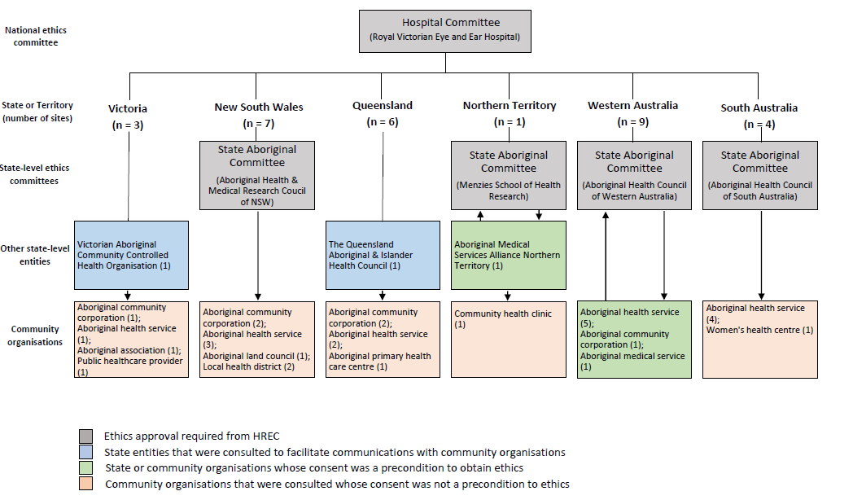
Figure 2. Indigenous ethics approvals and community consultations for the NEHS

The selection of testing sites for the NEHS

Overview
The NEHS aimed to recruit and examine a total of 4,400 participants. Selection of sites utilised Census 2011 data collected by the ABS. Using a multi-stage random-cluster sampling methodology, 30 randomly selected sites stratified by remoteness were selected (Figure 3).

Estimating the number of participants required in the NEHS
The sample size calculation for non-Indigenous participants was based on previous data regarding the prevalence of vision impairment from the Melbourne VIP of 5.15% (95% CI, 4.28-6.03%). The sample size was calculated as 1,552 with an upper limit of 1,799 based on a margin of error of 1.1%. Assuming a design effect of 1.5 that adjusts for the interclass correlations between participants within clusters, the required sample size was estimated at 2,328 (upper limit 2,798). After adjusting for an assumed 20% non-response rate, the required sample size became 2,794 (upper limit 3,238). Based on the sample size calculation of approximately 3,000 and the cluster size of 100, 30 recruitment sites were required.
The sample size calculation for the Indigenous sample was based on the results of the NIEHS, which reported a prevalence of 17.2% for VI. The required sample size was calculated to be 1,368 with a margin of error of 2%. The sample size was therefore taken to be approximately 1,400. As a result, the total target sample size for this study was 4,400.

Setting the geographical sampling unit for NEHS testing sites
Selection of sites utilised Census 2011 data collected by the ABS. For census data collection the ABS uses a geographical classification system, the Australian Statistical Geography Standard (ASGS) [15]. The ASGS divides Australia into discrete geographical structures across a number of dimensions, including remoteness, Indigenous Geographical Structures and Statistical Areas (SA). This study utilised the SA dimension to obtain targeted samples from 30 randomly-selected sites. The SA dimension is the main classification system used by the ABS and provides the most descriptive and reliable area-specific population data including remoteness, age, gender and Indigenous status. The ASGS categorises areas into SAs at different levels. Statistical Area Level 4 (SA4), the largest SA unit, is composed of multiple smaller SA3s, which in turn are composed of multiple smaller SA2s that are made up of multiple smaller SA1s. The initial geographic unit utilised in this study for site selection was the SA2.

Stratifying Australian Statistical Areas by remoteness
The ABS stratifies all SAs by remoteness within the framework of the Accessibility/Remoteness Index of Australia Plus (ARIA+) system. ARIA+ is a continuous varying index of remoteness and assigns a remoteness score between 0.00 and 15.00, corresponding to Highly Accessible, Accessible, Moderately Accessible, Remote and Very Remote. The NEHS utilised the ARIA+ system to stratify SA2 sites by remoteness. ARIA+ has replaced the Remoteness Areas (RA) classification system which used 5 tiers: Major City, Inner Regional, Outer Regional, Remote and Very Remote. The ABS provides a conversion table to allow new ARIA+ scores to be converted to their previous RA values for ease of interpretation. While the NEHS stratified sites by using ARIA+, the ARIA+ values of each site were then converted to their corresponding RA classifications (Table 1).
Table 1. Conversion of Accessibility/Remoteness Index of Australia Classifications to Remoteness Areas
¹Accessibility/Remoteness Index of Australia: The ABS endorsed remoteness classification system in the Australian 2011 Census.
²Remoteness Area: The remoteness classification derived from the Australian Standard Geography Classification (ASGC).
ARIA+¹ Category | ARIA+ Range | Corresponding Remoteness Area (RA)² | Corresponding RA Value
Highly Accessible | 0 – 0.2 | Major City | 1
Accessible | > 0.2 – 2.4 | Inner Regional | 2
Moderately Accessible | > 2.4 – 5.92 | Outer Regional | 3
Remote | > 5.92 - 10.53 | Remote | 4
Very Remote | > 10.53 – 15.00 | Very Remote | 5
Twelve Major City sites, six Inner Regional sites, six Outer Regional sites, four Remote sites and two Very Remote sites were randomly selected to correspond approximately to the population distributions within each of the RAs. Back-up sites were randomly selected for each RA, to be utilised in circumstances in which primary sites were unsuitable due to logistical or administrative reasons (Table 2). Back-up sites were used for recruitment in some circumstances.
Table 2. Distribution of SA2 geographical areas across Remoteness Areas
¹Remoteness Area: The remoteness classification derived from the Australian Standard Geography Classification (ASGC)
²Statistical Area – Level 2: The geographical unit of site pre-selection
³Target Indigenous population
⁴Target non-Indigenous population
⁵Total population
⁶Percentage of the total population within the total SA2 sampling pool distributed within each Remoteness Area classification
RA¹ | Description | SA2s² | Area | Tar IP³ | Tar NP⁴ | Tot P⁵ | Block Size | % Pop⁶
1 | Major City | 936 | 13,685,465,126 | 43,567 | 3,632,398 | 12,627,075 | 789,192.19 | 64.8%
2 | Inner Regional | 464 | 226,277,642,916 | 30,706 | 1,456,275 | 4,214,982 | 526,873 | 21.6%
3 | Outer Regional | 322 | 757,522,216,481 | 30,066 | 688,493 | 2,042,319 | 255,290 | 10.5%
4 | Remote | 61 | 823,823,296,747 | 11,383 | 108,372 | 395,061 | 49,383 | 2.0%
5 | Very Remote | 59 | 5,815,775,816,839 | 21,610 | 35,110 | 219,734 | 27,467 | 1.1%
 | Total | 1,842 |  |  |  | 19,499,171

Selecting the NEHS testing sites
A list of SA2 geographic areas was compiled for each RA, and SA2s within each RA were subdivided into discrete blocks based on the total size of the population in each RA and the required number of sites derived from each RA. The random number function in Microsoft Excel (32-bit Version 14.0.7.128.5000) was used to create a ‘seed value’ for each RA. Seed values were multiplied by the population block size in each RA to generate a selection value that was then used to select sites from within each block within each RA.

Secondary selection of targeted geographical areas for recruitment and testing
Following the initial site selection at the SA2 level, a refined area within each site containing 50 persons in the target Indigenous population and 100 persons in the target non-Indigenous population was selected to define the primary recruitment site (Table 3, Figure 4). As SA2s typically contain larger populations than the target sample, the smaller SA1 was used as the secondary geographic sampling unit. An SA1 was randomly selected from within each SA2 and designated as the targeted sample cluster for participant recruitment. If a randomly-selected SA1 did not contain a sufficient eligible population size, as reported by the Census data, the site was merged with a contiguous site, generating a larger cluster with approximately 100 eligible non-Indigenous residents. The geographical boundary of this site was then overlaid on a corresponding image from Google Maps to provide a street level map.
For Indigenous populations, or in instances where the target population within a given SA2 was too small, target populations in surrounding SA1 areas were added to the existing SA2 area until a population near to, but always greater than, the required sampling population was obtained. Where Indigenous populations were extremely small, surrounding SA2s or in a few cases, a neighbouring SA3 were used to obtain the required sampling population.

Sample Size Calculation
- n (non-Indigenous Sample) = 3000
- n (Indigenous Sample) = 1400
- Across 30 sites
Sample Size Calculation
Figure 3. Sampling methodology flowchart
Secondary
Site Selection
Stratifying Sites by Remoteness
Recruitment Site Pre-Selection
Secondary Selection
- SA Level 1 randomly selected from within each initial SA2
-Focused area for recruitment
Number of Sites for each RA selected
Stratifying SA2s by Remoteness
-ABS Accessibility/Remoteness Index of Australia (ARIA+)
-Correspond to Remoteness Areas (RA)
Australian Bureau of Statistics (ABS) Census 2011 Data
- Utilises Australian Statistical Geography Standard (ASGS) to categorise geographic regions

Statistical Areas (SA) Dimension
- Main Australian Statistical Geography Standard (ASGS) classification dimension
- Provides remoteness, age, gender & Indigenous data

Pre-selection at SA2 (Statistical Area Level 2) level
-Interactive community level
- 3000-25000 residents

Constraining SA2 selection pool
- Selectable SA2s must contain:
100 non-Indigenous residents aged 50 years and older
50 Indigenous residents aged 40 years and older

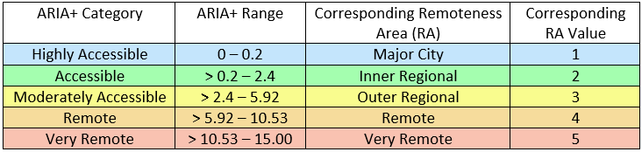

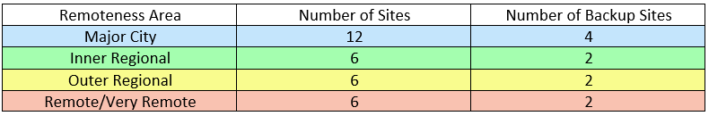

Selecting the Sites
-Random selection value assigned to each SA2
- SA2s for each remoteness classification randomly selected

Table 3. National Eye Health Survey selected sites
SA2 Area Details |  |  |  |  |  |  |  | SA1 Area Details
Site No | SA2 name | State | RA¹ | ARIA+² | Area (sqm) | Tar_IP³ | Tar_NP⁴ | SA1 | ARIA+ | Area (sqm) | Tar_IP | Tar_NP
 | Major Cities
1 | Brighton (Qld) | QLD | 1 | 0.00 | 6,482,055.16 | 64 | 2977 | 3104209 | 0.00 | 281,514.20 | 0 | 108
2 | Springfield⁵ | QLD | 1 | 0.00 | 6,673,459.51 | 32 | 874 | 3130301 | 0.00 | 590,391.40 | 0 | 74
 |  |  |  |  |  |  |  | 3130312 | 0.00 | 153,075.77 | 3 | 38
 |  |  |  |  |  |  |  | Total |  | 743,467.17 | 3 | 112
3 | Parklea - Kellyville Ridge | NSW | 1 | 0.00 | 9,877,842.94 | 36 | 3169 | 1131030 | 0.00 | 151,915.76 | 0 | 88
4 | Chipping Norton – Moorebank | NSW | 1 | 0.00 | 14,490,264.51 | 48 | 4851 | 1152323 | 0.00 | 105,418.34 | 0 | 121
5 | Concord - Mortlake – Cabarita | NSW | 1 | 0.00 | 6,325,574.85 | 24 | 6547 | 1138341 | 0.00 | 115,055.18 | 0 | 146
6 | Mornington | VIC | 1 | 0.00 | 21,089,872.96 | 32 | 8830 | 2138032 | 0.00 | 222,147.55 | 0 | 113
7 | Rowville - Central | VIC | 1 | 0.00 | 8,200,350.36 | 14 | 4290 | 2125620 | 0.00 | 142,965.52 | 0 | 124
8 | Craigie – Beldon | WA | 1 | 0.00 | 7,131,438.77 | 25 | 2561 | 5107009 | 0.00 | 175,983.96 | 0 | 85
 |  |  |  |  |  |  |  | 5107010 | 0.00 | 149,986.20 | 3 | 72
 |  |  |  |  |  |  |  | Total |  | 325,970.16 | 3 | 157
9 | Bassendean - Eden Hill – Ashfield | WA | 1 | 0.00 | 10,344,501.60 | 91 | 4514 | 5104429 | 0.00 | 458,631.67 | 0 | 209
10 | Kalamunda - Maida Vale - Gooseberry Hill | WA | 1 | 0.00 | 28,121,619.03 | 32 | 5807 | 5114002 | 0.00 | 280,332.42 | 0 | 133
11 | Elderslie - Harrington Park | NSW | 1 | 0.04 | 21,533,575.05 | 85 | 3772 | 1143410 | 0.00 | 289,357.00 | 3 | 91
12 | Warilla | NSW | 1 | 0.13 | 9,480,393.51 | 204 | 7266 | 1114313 | 0.13 | 111,417.98 | 3 | 169
 | Inner Regional
13 | Lesmurdie - Bickley – Carmel | WA | 2 | 0.37 | 219,991,095.83 | 21 | 3961 | 5114125 | 0.00 | 385,864.17 | 0 | 130
14 | Goulburn | NSW | 2 | 0.60 | 64,644,260.60 | 185 | 7411 | 1100125 | 0.60 | 9,219,031.38 | 0 | 161
15 | Wodonga | VIC | 2 | 0.89 | 278,809,991.40 | 92 | 6257 | 2107405 | 0.74 | 957,416.42 | 0 | 80
16 | Tomerong - Wandandian – Woollamia | NSW | 2 | 1.14 | 375,942,158.91 | 36 | 1319 | 1128110 | 0.94 | 16,049,084.33 | 3 | 162
17 | Ulladulla Region | NSW | 2 | 1.88 | 677,622,119.32 | 29 | 2338 | 1128313 | 1.51 | 56,185,123.80 | 0 | 117
18 | Rockhampton Region – East | QLD | 2 | 2.28 | 680,170,163.09 | 35 | 1094 | 3121802 | 2.44 | 352,559,355.71 | 6 | 74
 |  |  |  |  |  |  |  | 3121811 | 1.56 | 46,332,551.27 | 6 | 96
 |  |  |  |  |  |  |  | Total |  | 398,891,906.98 | 12 | 170
 | Outer Regional
19 | Whyalla | SA | 3 | 2.55 | 40,871,748.87 | 219 | 6648 | 4113660 | 2.54 | 340,824.86 | 6 | 148
20 | Geraldton | WA | 3 | 2.73 | 21,228,754.27 | 328 | 4161 | 5121007 | 2.73 | 780,992.96 | 3 | 168
21 | Wagaman | NT | 3 | 3.00 | 837,954.92 | 39 | 438 | 7102802 | 3.00 | 191,459.54 | 14 | 80
22 | Inverell | NSW | 3 | 3.35 | 207,668,432.14 | 203 | 4049 | 1119127 | 3.13 | 518,178.45 | 15 | 154
23 | Eden | NSW | 3 | 3.71 | 94,814,149.25 | 68 | 1389 | 1102303 | 3.73 | 3,240,030.21 | 3 | 98
 |  |  |  |  |  |  |  | 1102310 | 3.73 | 1,062,545.60 | 0 | 5
 |  |  |  |  |  |  |  | Total |  | 4,302,575.81 | 3 | 103
24 | Katanning | WA | 3 | 5.14 | 2,646,877,347.64 | 104 | 1343 | 5123013 | 4.67 | 558,965.56 | 10 | 113
 | Remote
25 | Mount Isa | QLD | 4 | 6.00 | 62,753,989.65 | 772 | 3229 | 3140541 | 6.00 | 182,476.25 | 6 | 81
 |  |  |  |  |  |  |  | 3140544 | 6.00 | 237,512.10 | 19 | 61
 |  |  |  |  |  |  |  | Total |  | 419,988.35 | 25 | 142
26 | Daintree | QLD | 4 | 6.27 | 2,230,932,070.87 | 244 | 1766 | 3116407 | 4.50 | 505,717.92 | 6 | 108
27 | Yorke Peninsula - South | SA | 4 | 8.04 | 2,273,732,701.26 | 13 | 2099 | 4112813 | 7.37 | 168,306,923.25 | 0 | 86
28 | South Hedland | WA | 4 | 9.00 | 22,287,425.89 | 500 | 956 | 5122419 | 9.00 | 177,083.43 | 22 | 27
 |  |  |  |  |  |  |  | 5122422 | 9.00 | 226,979.06 | 14 | 41
 |  |  |  |  |  |  |  | 5122424 | 9.00 | 121,649.26 | 12 | 39
 |  |  |  |  |  |  |  | Total |  | 525,711.75 | 48 | 107
 | Very Remote
29 | Exmouth | WA | 5 | 13.28 | 134,986,003,299.42 | 87 | 1172 | 5119705 | 11.99 | 610,061.74 | 4 | 133
30 | Derby - West Kimberley | WA | 5 | 14.33 | 110,883,574,518.85 | 1067 | 774 | 5120624 | 11.52 | 1,705,340.29 | 47 | 146
 | Back-up Sites⁶
Bck 1 | Willoughby-Castle Cove-Northbridge | NSW | 1 | 0.00 | 10,751,553 | 18 | 7803
Bck 2 | Seventeen Mile Rocks-Sinnamon Park | QLD | 1 | 0.00 | 5,389,722 | 21 | 2738
Bck 3 | Morphett Vale-East | SA | 1 | 0.00 | 7,684,247 | 61 | 4485
Bck 4 | Ashwood-Chadstone | VIC | 1 | 0.00 | 6,709,546 | 15 | 4618
Bck 5 | Nambour | QLD | 2 | 0.24 | 54,024,551 | 117 | 6113
Bck6 | Warrnambool-South | VIC | 2 | 1.56 | 120,194,041 | 34 | 4499
Bck7 | Rosebery-Bellamack | NT | 3 | 3.00 | 3,176,364 | 36 | 336
Bck8 | Dorrigo | NSW | 3 | 4.23 | 1,987,708,554 | 38 | 1410
Bck9 | Banana | QLD | 4 | 6.78 | 28,527,048,579 | 92 | 2668
Bck10 | Esperance Region | WA | 5 | 11.12 | 55,408,257,147 | 22 | 1147
¹RA is the Remoteness Area, the remoteness classification derived from the Australian Standard Geography Classification (ASGC).
²ARIA+ is the Accessibility/Remoteness Index of Australia, the ABS endorsed remoteness classification system in the Australian 2011 Census. Note that the ARIA+ score for the SA2 is the mean ARIA+ score of all constituent SA1s.
³Tar_IP is the target Indigenous Population, corresponding to the number of Indigenous Australians aged 40 years and older residing in the Statistical Area according to the Australian 2011 Census.
⁴Tar_NP is the target non-Indigenous Population, corresponding to the number of non-Indigenous Australians aged 50 years and older residing in the Statistical Area according to the Australian 2011 Census.
⁵All sites with 2 or more rows of SA1 data (Springfield, Craigie-Beldon, Rockhampton Region-East, Eden, Mount Isa and South Hedland) had 2 or more contiguous SA1s selected to provide a sufficient Tar_P population size.
⁶Back-up sites were sampled to provide alternative sites in cases where any of the 30 sites were unsuitable. Back-up sites used were Morphett Vale (SA) (replaced Indigenous testing in Concord-Mortlake-Cabarita), Banana (QLD) (replaced both Indigenous and non-Indigenous testing in Mount Isa), Seventeen Mile Rocks-Sinnamon Park (QLD) (replaced Warilla) and Esperance Region (WA) (replaced both Indigenous and non-Indigenous testing in Derby-West Kimberley). Recruitment of Indigenous Australians from the randomly-selected Major City site of Parklea-Kellyville Ridge was unachievable, and due to logistical concerns, the remaining available Major City backup sites could not be utilised. Ashwood-Chadstone (VIC) was identified as containing insufficient eligible Indigenous residents, and communications with local Indigenous organisations in Willoughby-Castle Cove-Northbridge proved difficult. Consequently, Indigenous organisations were consulted to identify an area with comparable sociodemographic characteristics to be used as a backup site. The suburb of Elizabeth Vale (SA) replaced Parklea
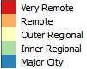
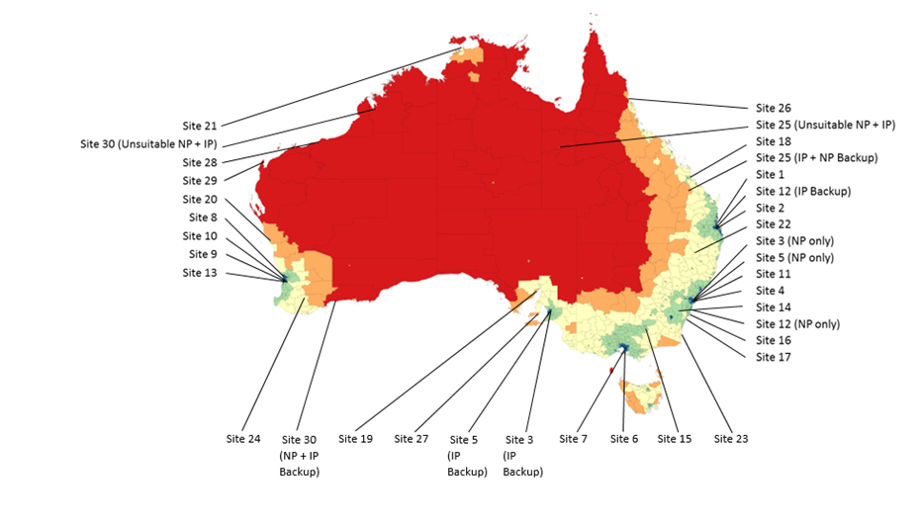
NP = Non-Indigenous Population
IP = Indigenous Population
Boundary lines represent Statistical Area – Level 2 boundaries
Figure 4. NEHS survey sites

Recruitment of participants in the NEHS

Overview
Recruiters arrived at each survey site 2-5 days prior to the commencement of testing and went door-to-door knocking at all accessible residences within the survey site (Figure 5). The recruiters used a standardised script (Appendix 12.4), to provide information about the survey.
Residents eligible to participate in the survey were non-Indigenous Australians aged 50 years and over, or Indigenous Australians aged 40 years and over, who were living at the residence at the time of recruitment. Eligible residents were invited to participate in the NEHS. Residents who agreed to participate and those who were unsure of whether they wanted to participate were provided with a NEHS recruitment pack (Appendix 12.5) containing an information booklet about the NEHS, participant instructions and an appointment card. Residents who agreed to participate were provided with a convenient appointment time.

Steps of the recruitment process
The recruitment team consisted of the recruitment coordinator and at least two trained recruiters. At each site recruiters were provided with sampling maps defining the recruitment boundaries for each area derived from the random stratified sampling process. Pamphlets outlining the nature of the study and a statement that recruiters would return to the residence within two days were left in the mailbox of each residence within the SA1. Recruiters subsequently went door-to-door knocking to recruit participants. If the primary SA1 was exhausted, recruiters went to the largest contiguous SA1, and if required, to progressively smaller adjacent SA1s to complete recruitment (Appendix 12.6). In cases where residents were absent at the first visit, recruiters returned to re-attempt contact. Residents who were not present following two attempts to contact were deemed non-contactable. If residents were present, recruiters engaged used a standardised script that outlined the significance, features and requirements of the survey. Residents who were present were then screened for eligibility and invited to participate.

Resident responses
Residents who agreed to participate in the NEHS were provided with an appointment card and a NEHS recruitment pack which consisted of an information booklet, testing protocol, and participant instructions. Sociodemographic information (postcode, age, gender and date of birth) and participant contact and appointment details were collected and recorded on a custom-built tablet-based database (Appendix 12.7).
Individuals who were undecided at the point of recruitment (‘Maybe’ response) were also provided with a NEHS recruitment pack and their sociodemographic details were recorded. Where possible, NEHS staff made a tentative appointment time and made a follow up phone call to determine the resident’s final response.
If a negative response was initially received, recruiters addressed the resident’s concerns and obtained reasons for refusals if objection handling was unsuccessful. Reasons for declining were recorded against a standardised list of refusals defined a priori: (1) Not interested, (2) No free time, (3) Previous bad research experience, (4) Recent eye test, (5) Transport concern, (6) Safety concern, (7) Refuse to answer, (8) Other.

Additional modes of recruitment
While the primary recruitment methodology involved a door-to-door knocking approach, alternative approaches were sometimes required for the recruitment of Indigenous Australians, as guided by local cultural norms. These methods included: telephone recruitment, word of mouth, media and public relations exercises and assistance from concurrent Aboriginal Health Service clinics.

Reminder calls and text messages
To ensure optimal clinical attendance, individuals were contacted via a text message or telephone call one day before their scheduled appointment to remind them of the time and location of their clinical examination. An online text message service, 5centsms.com.au, was used to send automated text message reminders to those who provided mobile telephone numbers.

Fail to Attend (FTA) and follow up
Individuals who failed to attend their scheduled appointment were followed up with phone calls and encouraged to reschedule at a new time. If the recruiter was unable to persuade the resident to reschedule, the reason for declining was recorded. Residents who did not answer phone calls after three separate attempts were visited at home by the recruitment coordinator who addressed their concerns and encouraged them to reschedule. If residents could not be contacted through this process, they were deemed to be non-contactable.

Confirm appointment verbally
Decline
Agree
Absent³
Present
Phone call to determine response
Reminder call day before appointment
Recruitment pack⁸
Recruitment pack⁸
Record reason⁶
Decline
Record demographics⁷
Record demographics⁷
Tentative appointment
Non-contactable
Present
Absent
Re-attempt⁵
Make appointment
Agree
Maybe
Ineligible
Eligible⁴
Mail Drop¹
Door-to-door knocking²

Figure 5. Flowchart illustrating the process of participant recruitment in the NEHS

¹Mail contains information about the NEHS and advises residents to expect contact from door-to-door recruiters within 1 day.
²Note: minor adjustments were made to Indigenous participant recruitment strategies. Modes of recruitment included:
Door-to-door knocking, word of mouth, telephone recruitment, media releases and public relations, and recruitment from concurrent Aboriginal Health Service clinics.
³Addresses with absent residents are recorded in the database and followed up within 24 hours.
⁴Inclusion criteria: Resident at time of recruitment and either Indigenous aged 40 years and older or non-Indigenous aged 50 years and older.
⁵Re-attempt at least 1 day later.
⁶Reasons for declining: Not interested, no free time, previous bad research experience, recent eye test, transport concern, safety concern, refuse to answer, other.
⁷Demographic details: Address, gender, age, date of birth.
⁸The recruitment pack contains an information booklet, participant instructions, an outline of the testing protocol and an appointment card.

Testing protocol of the NEHS

Overview
Individuals arriving at the testing centre were greeted by a member of the NEHS team and registered for the survey. Informed consent was obtained using a standardised consent form (provided verbally and in writing) as approved by the study ethics committees. An interviewer-administered general questionnaire recorded socio-demographic information, medical and past ocular history and current diabetes status. Participants then underwent a series of eye examinations, including: vision assessment, anterior segment examination, visual field examination, fundus photography and intraocular pressure (IOP) testing (Figure 6) using advanced eye testing equipment (Appendix 12.8). Participants were provided with verbal feedback about their test results throughout the course of the examination. When abnormalities were suspected, participants were provided with a referral letter to take to their local doctor or optometrist. If they did not have a local doctor or optometrist, they were advised to attend a local health service. All participant responses and clinical testing data were digitally recorded and stored in the secure, cloud-based NEHS database (Appendix 0). The average testing time for each participant was approximately 30 minutes.

Informed consent and registration
Written informed consent was obtained from each individual who participated in the NEHS. Individuals were provided with an information and consent form outlining the study background and significance, testing protocol and associated risks and conditions of participation (Appendix 0). Individuals were allowed sufficient time to review the consent form and examiners provided ample opportunity for questions. Persons who agreed to participate signed the consent form and the process was witnessed by two NEHS staff members. Following this, each participant was provided with a unique NEHS Participant Identification Number (PIN), beginning with the acronym NEHS and an adjacent number, such as NEHS0001, to ensure all participant data was de-identified.

Interviewer-administered general questionnaire
Each participant was required to undertake an interviewer-administered questionnaire. This questionnaire included seven items relating to sociodemographic status, general health and past ocular history (Appendix 12.11).

Vision assessment

Distance visual acuity assessment
Presenting unilateral distance visual acuity (VA) was assessed using a 3-meter logMAR chart (Brien Holden Vision Institute, Australia) in a well-lit room. Distance refractive correction was worn during VA testing in participants who presented with distance spectacles or contact lenses. Participants were instructed to read the letters on the smallest line they were able to discern. The smallest line recorded was the 6/6 line (0.00 logMAR).
VA was recorded as the level of the lowest line that the participant correctly identified ≥ 4 letters. VA was recorded as “part” (pt) when the participant correctly identified three of the six letters on a line. If the participant identified ≤ 2 letters, the line above was attempted until they correctly identified ≥ 3 letters on the lowest discernible line. If the participant did not successfully identify half of the letters on the 6/60 line, light perception was assessed using a pen torch. The VA testing protocol was performed for both eyes and the results were recorded. VI and blindness were defined as VA <6/12-6/60 and <6/60 in the better eye, respectively.

Pinhole visual acuity test
If presenting VA was <6/12-≥6/60 in one or both eyes, a multiple pinhole test was conducted to determine whether the likely cause of vision impairment was refractive in nature. VA was assessed and recorded using the same procedure as the presenting visual acuity testing. If VA improved with pinhole testing to ≥6/12 in either eye, auto-refraction was subsequently conducted.

Auto-refraction
In order to obtain an objective measurement of refractive error in participants whose VA improved to ≥6/12 on pinhole examination, an auto-refraction was performed using a Nidek ARK-30 Type-R Hand-held auto-refractor/keratometer (Nidek Co., LTD, Japan). Using the auto-refraction results, spherical and/or cylindrical lenses were placed in a trial frame, and the distance VA protocol was repeated to ascertain auto-refraction-corrected visual acuity.

Presenting near vision assessment
Binocular, presenting near vision was assessed in well-lit room conditions using a CERA Vision Test E Chart (Centre for Eye Research Australia, Australia). The E chart consists of three rows corresponding to N48, N20 and N8, each containing the letter ‘E’ facing in four directions – up, down, left or right. Refractive correction was worn during near VA testing by those participants who presented with reading spectacles. Participants were asked to hold the E chart at their preferred reading distance and state the directions in which the ‘E’s faced on each line. Presenting near vision was recorded as the lowest line that the participant could correctly identify at least three out of the four ‘E’s.

Anterior segment examination
The anterior segment of each eye was assessed with a Keeler PSL One hand-held slit lamp (Keeler Ophthalmic Instruments, UK). The presence of pterygium and lid abnormalities, including stye, chalazion, mechanical disorders and other eyelid lesions were noted. Participants who presented with a distance VA of <6/12 in one or both eyes had anterior segment photographs taken using a non-mydriatic Diabetic Retinopathy Screening (DRS) camera (CenterVue SpA, Italy). These photographs were utilised for the grading of cataract, trachoma and other anterior segment changes.

Visual field testing
The Frequency Doubling Technology (FDT) perimeter (Zeiss Humphrey Systems & Welch Allyn, USA) was used for the detection of peripheral visual field loss. The N-30-5 screening protocol was used because of its high sensitivity and specificity for detecting glaucomatous field loss and because of its short testing time (approximately one minute) (7). If applicable, participants wore their presenting distance refractive correction while performing the test. If sensitivity was reduced in any of the 19 field test locations for either eye, the test was repeated to determine the reproducibility of the defect and the best result was graded.

Fundus photography
Two 45° colour fundus photographs were taken using a DRS non-mydriatic fundus camera to detect retinal disease, glaucomatous optic disc changes and other pathology. Participants were seated in a darkened room to allow for physiological pupil dilation and the DRS was programmed to automatically take two photographs of each retina, the first centred on the optic disc and the second centred on the macula, respectively. Examiners ensured that the optic disc, macula and surrounding vessels were clearly apparent in photographs to enable reliable grading of pathology.
Retinal photographs of reduced quality were retaken without the use of dilating drops if the participant’s pupil size was deemed to be sufficiently large (≥3.0mm). If photographs were of reduced quality due to a small pupil size, pupil dilation was performed with tropicamide 0.5% (Mydriacyl) and photographs were retaken. Pupil dilation was performed for 663 participants (13.71%). In order to minimise the risk of inducing anterior chamber angle closure associated with the use of tropicamide, participants requiring dilation underwent Van Herick grading using the hand-held slit lamp to estimate their anterior chamber angle depth [16] (Appendix 12.12). Dilation was not performed in cases where the angle was graded as 1 or 2.
All fundus photographs were saved onto the DRS internal hard drive. Duplicate photographs were also saved onto an external hard drive for later analysis by the retinal image grading centre at CERA.

Intraocular pressure
Intraocular pressure (IOP) was measured in both eyes of all participants using the iCare rebound tonometer (iCare, Finland). The tonometer head was held at a distance of 4-8mm from the participant’s central cornea. Six consecutive readings were taken, and an average IOP was recorded.

Verbal feedback and recommendation for referral
At the completion of the examination, participants were provided with verbal feedback on the health of their eyes. In cases where abnormalities were suspected, participants were provided with a standard referral letter (Appendix 12.13) that outlined the nature of the abnormalities noted to be taken to a local doctor or an optometrist. A referral protocol was developed by the principal and co-investigators to assist with this process (Appendix Error! Reference source not found.). Of the total sample recruited and examined in the NEHS (n = 4836), 32.09% (994/3098) of non-Indigenous participants and 43.56% (757/1738) Indigenous participants were provided with a referral to seek follow-up eye assessment.

Certificate of participation and sunglasses
All participants were provided with a certificate of participation to signify their completion of the survey testing protocol (Appendix 12.15). In addition, participants were provided with a free pair of high-quality sunglasses donated by our industry partner, OPSM.

Participant evaluation forms
Participant evaluation forms were administered in the first 16 sites to ensure that participant satisfaction was high, after which forms were no longer required due to consistently high satisfaction in the 16 sites. In total, 1189 participants completed the evaluation questionnaire. The mean overall satisfaction rate was 97.64% across the five items, with results ranging from 90.27% to 99.30%. Overall, the highest rating item was interaction with research staff (mean = 98.44%), while waiting time/appointment duration (mean = 96.93%) rated lowest.

Registration and administration
Failed to Attend (FTA)
Clinical Attendance
Attended
Follow Up Phone Call or Visit
Informed consent
Figure 6. Clinical Examination Flowchart
Post
examination
Images Ungradable
Images Gradable
Clinical Eye Testing Protocol
Re-take Photographs
Recommendation for referral where required
Verbal Feedback + Certificate of Participation + Free OPSM Sponsored Sunglasses
Grade 1 or 2=No Dilation
Grade 3 or 4=Tropicamide Dilation
Anterior Segment Photographs if VA<6/12
- DRS camera
Fundus Photography
- Diabetic Retinopathy Screening (DRS) camera
- 2-field: Macula + Disc Centred
New Appointment
Cancelled/Non- Contactable (FTA)
Intraocular Pressure
- iCare Tonometer
Anterior Segment Assessment Using Handheld Slitlamp
- Lid Abnormalities + Pterygium
- Trachoma Grading in Indigenous only
Improvement
No Improvement
Autorefraction-Corrected Visual Acuity
Hand-held Autorefraction
Pinhole
≥6/12
<6/12
Unilateral Presenting Distance Visual Acuity
- logMAR Chart
General Questionnaire
Registration

Visual Field Testing Using Frequency Doubling Technology (FDT)
- N-30-5 screening test
Van Herick to assess
anterior chamber
angle using slit lamp
Presenting Near Visual Acuity
(Both eyes open)
- E Reading Chart

Data management and analysis

Online tablet-based database
All data collected during the recruitment and clinical examination processes were recorded, stored, backed-up, extracted, cleaned and analysed using a standardised data management protocol (Figure 7). All data were entered into a specialised online, cloud-based database using tablet computers (Samsung Galaxy Tab S 10.5, Samsung). An external software design company constructed the online database and assisted with technical troubleshooting. A password-protected website allowed only NEHS staff to access to the database. Due to the mobile nature of the survey, particularly during recruitment, staff frequently did not have access to Wi-Fi internet connectivity, and all tablet computers were consequently connected to a mobile data plan, allowing continual access to 3G or 4G mobile network coverage.
The database interface was composed of three main user interfaces:
- Recruitment interface
All data collected during participant recruitment were entered into the database through this interface (Appendix 12.7).
- Clinical examination interface
All data collected during clinical examinations were entered into the database through this interface (Appendix 12.8).
- Administration interface
All data modifications and data exports were conducted though this interface (Appendix 12.16).

Hardcopies
Due to the risks of data loss associated with disruption of mobile network connections, recruiters carried hardcopy recruitment forms to each recruitment site (Appendix 12.17). During times of loss of connectivity, all data pertaining to the recruitment process were recorded on hardcopies and entered into the database when a reliable network connection was re-established. Similarly, examiners carried hardcopy questionnaire and examination forms to every clinic (Appendix 12.11) for use during data network inaccessibility. Hardcopy data obtained from each participant including: consent forms, auto-refraction result printouts, FDT printouts, and questionnaire and examination hardcopies (where applicable) were securely stored in a locked filing cabinet at CERA that was only accessible to key study personnel.

Online database data backup and export
All data uploaded to the NEHS online cloud-based database were backed up every 24 hours onto a local server housed at CERA. Data were exported as a .SAV file (SPSS format) from the administration interface of the NEHS database weekly and checked by the senior biostatistician. Cleaned data were merged with an existing master dataset and stored on the Principal Investigator’s computer and an external hard drive.

Management of DRS camera photographs
A folder was created for each NEHS participant on the internal DRS hard drive, labelled with the participant ID code, date of birth and gender. All fundus and anterior segment photographs were automatically saved into each participant’s folder. In addition, all photographs were manually saved onto an external portable hard drive connected to the DRS. DRS photographs were then transferred to the retinal image grading centre at CERA for retinal grading. Grading data were then merged with the master dataset for analysis.

Figure 7. Data flow and management
Master dataset
management
Statistical analysis
Master data backed up on PI’s computer and external hard drive
Data
Management
Export
as .SAV
and Excel files
Data entry when connectivity available
Fundus photography management
Hardcopy data management
Tablet-based database entry
Filed in secure storage facility
Autorefractor measurement printout
Consent forms
Questionnaire & clinic hardcopy
(when no connectivity)
Merged with master data
External
hard drive
Images graded
Diabetic Retinopathy Screening fundus photography
Door-to-door recruitment information
Daily
backup on in-house server
Cloud-based server
Tablet
based database
Anterior segment assessment
Frequency Doubling Technology
printout
iCare tomometer reading
Auto-refractor measurement
Visual acuity (Distance and Near)
Questionnaire responses
Frequency Doubling Technology
printout

Protocols for determining causes of vision impairment and blindness

Refractive error
Vision impairment was attributed to refractive error when VA improved to ≥6/12 on pinhole testing or following refraction.

Cataract
Anterior segment images were taken in all participants with visual acuity of <6/12. In the absence of a standardised grading system to determine the presence or absence of vision threatening cataract using the clinical data at hand, a protocol was developed. Two experienced graders independently assessed digital anterior segment photographs +/- posterior segment photographs to categorise participants into one of three groups; no cataract, probable cataract or definite cataract. Both graders reported high levels of inter-grader reliability (85%) and intra-grader reliability (94% and 96%, respectively). When the grading differed, the photographs were adjudicated by an ophthalmologist. A high sensitivity and specificity of detecting visually significant cataract as a cause of vision impairment with a non-mydriatic fundus camera compared with dilated slit-lamp grading has been reported in the literature [17]. Where photographs were unavailable, a clinical grade was assigned based on anterior segment examination by a trained clinician using a hand-held slit lamp.

Trachoma
Trachoma grading was conducted for all Indigenous participants for Trachomatous Trichiasis (TT) and Corneal Opacity (CO), according to the WHO Trachoma Simplified Grading System[18]. A clinical grade was assigned based on anterior segment examination using the hand-held slit lamp. Trachoma was graded as TT if at least one eyelash was turned inward and rubbed against the cornea or there was evidence of recent removal of in-turned eyelashes. CO was assigned if the cornea was visibly opaque over the pupil.

Grading of retinal pathology
At the completion of clinical examinations in each site, de-identified images were transferred to the retinal image grading team at CERA. Images were 24-bit colour depth and displayed at a resolution of 5.04 megapixels. Images were converted to JPEG files of approximately 1.2 to 1.8 megabytes in size and stored on a password encrypted external hard drive. OpenClinica software (OpenClinica LLC and collaborators, Waltham, MA, USA) was used as a platform for all retinal grading. Retinal graders were masked to the identity and clinical characteristics of study participants.
Image quality for each eye was assessed by an independent grader as follows: (1) good quality: both macula-centred and optic disc-centred fields well positioned with good focus (blood vessels and small lesions such as retinal microaneurysms are clearly identifiable) and good illumination (no or minimal shadowing across the central part of the image); (2) moderate quality: both fields were present, however, clarity or illumination is decreased in one image (only); (3) poor quality: one field missing or both fields are difficult to grade with certainty; and (4) ungradable: the eye has obscuration of most, or all of the available fields. For an eye to be deemed fully gradable, both macula-centred and optic disc centred images were required to be of good quality. Eyes were deemed partially gradable when one or both fields were of moderate or poor quality.
Diabetic retinopathy, age related macular degeneration and glaucomatous optic disc changes were graded according to protocols that have been described below and in detail elsewhere [19-21]. An ophthalmologist provided weekly adjudication on cases flagged by retinal graders as requiring a confirmation of diagnosis.

Retinal image quality
Almost all participants had at least one gradable fundus image (97.02%). Both macula- and optic disc-centred images were fully gradable in both eyes for 33.33% of participants. Good quality, gradable macula- and optic disc-centred images of at least one eye were acquired for 59.28% of participants. Retinal images were partially gradable for both eyes in 34.22% of participants and only one eye in 3.51% of participants. Images were either ungradable or missing in 2.98% of cases (Table 4). Missing or ungradable images were mostly attributed to small pupil size (60.42%), and poor participant compliance or mobility (14.58%). Additional causes included poor fixation, corneal opacity and technical malfunction Table 5.
Table 4. Retinal image quality in the NEHS
Gradability of retinal images (n=4836) | n (%)
At least 1 gradable image | 4692 (97.02%)
Both fields gradable in both eyes | 1612 (33.33%)
Both fields gradable in 1 eye & partially/non-gradable in 1 eye | 1255 (25.95%)
Both fields gradable in at least 1 eye | 2867 (59.28%)
Partially gradable for both eyes | 1655 (34.22%)
Partially gradable for 1 eye | 170 (3.51%)
Ungradable in both eyes | 59 (1.22%)
No images for both eyes | 85 (1.94%)

Table 5. Reasons for ungradable or missing retinal images
Reason (n=144) | n (%)
Small pupil size | 87 (60.42%)
Poor compliance/mobility | 21 (14.58%)
Poor fixation due to pathology | 11 (7.63%)
Corneal/lenticular opacity | 9 (6.25%)
Technology malfunction | 6 (4.17%)
No reason attributed | 10 (6.94%)

Diabetic retinopathy (DR)
DR was graded in accordance with the modified Airlie House Classification system. Grading protocols have been described in detail elsewhere [22]. Briefly, two-field, 45-degree, non-stereoscopic retinal images were graded, masked to diabetes status, to establish the severity of DR lesions, such as: microaneurysms, hemorrhages, hard exudates, venous beading, intraretinal microvascular abnormalities, cotton-wool spots, neovascularisation, as well as preretinal or vitreous haemorrhage. Level 20 was defined as minimal retinopathy, and levels > 20 were defined as early to proliferative diabetic retinopathy. Macular oedema was graded separately. The criterion for the diagnosis of macular oedema was hard exudates within 500 microns of the centre of the macula.

Age related macular degeneration (AMD)
AMD was graded using macula-centred images according to the Beckman clinical classification system [23]. Lesions were assessed using a transparent overlay consisting of a macular grid of concentric circles of 1000, 3000, and 6000 microns diameter. Early AMD included drusen 63–125μm in diameter within 2 disc diameters (3000 microns) of the fovea in either eye. Intermediate AMD included drusen larger than 125 μm in diameter and/or any AMD pigmentary abnormalities. Pigmentary abnormalities are defined as any definite hyper- or hypo-pigmentary abnormalities associated with medium or large drusen but not associated with known disease entities. Late AMD included geographic atrophy or evidence of neovascular AMD.

Glaucoma
The optic disc-centred images were graded for: vertical cup to disc ratio (CDR), CDR asymmetry, disc haemorrhage, neuro-retinal rim thinning, cup notching and retinal nerve fibre layer defects. For the purpose of assigning a main cause of VI or blindness, case notes were generated for participants who had clinical or grading data that fell within one or more of the following categories; 1) IOP greater than 21 mm Hg and a possible glaucomatous visual field defect on FDT, 2) self-reported glaucoma, 3) CDR >0.6, 4) CDR asymmetry of >0.2, 5) disc haemorrhage, 6) disc rim thinning, 7) cup notching or 8) retinal nerve fibre layer defect. Two ophthalmologists with glaucoma sub-specialty training independently assessed optic disc images and then assessed the clinical and grading data.
Glaucoma was diagnosed on an ascending scale of 1) no glaucoma, 2) possible, 3) probable, 4) definite glaucoma, or 5) abnormal due to other causes, based on the clinical judgment of each of the ophthalmologists, and no fixed criteria was used. In all cases of disagreement between the classifications of the two graders, adjudication by a third glaucoma specialist masked to the prior grading results was conducted.

Assigning main cause of bilateral vision impairment or blindness
In cases in which VA improved with pinhole or auto-refraction to ≥6/12 in one or both eyes, refractive error was assigned as the major cause of vision impairment. For all other cases, the relevant case notes, visual field results and retinal and optic disc-centred images were reviewed independently by two ophthalmologists who attempted to identify the disorder causing the greatest limitation of vision. A third ophthalmologist adjudicated any cases of conflict. Similarly to previous population based research, when multiple disorders were present the disease with the most clinically significant and irreversible influence was chosen as the primary cause [24]. If a single primary cause couldn’t be identified, visual impairment or blindness was considered to be due to combined mechanisms.

Data analysis

General analysis
Normality of the variables was examined using boxplots, Kolmogorov-Smirnov and Shapiro-Wilks tests. Continuous variables are presented as median (interquartile range [IQR]) for skewed distribution and mean (standard deviation [SD]) for normal distribution. Categorical variables are presented as absolute (n) and relative frequencies (%) and 95% confidence intervals. Confidence intervals were calculated using the “ci” command in Stata 14. “ci” computes confidence intervals for population means, proportions, variances, and standard deviations. For multinomial categorical data, the “proportion” command in Stata with “citype(logit)” was used to calculate the proportions and related 95% CI. With rare events, such as blindness, the “ci” command with the “Poisson” option was used. Differences in continuous variables between the Indigenous and non-Indigenous populations were evaluated by the Mann-Whitney-Wilcoxon test for skewed distributed data, and the independent student t-test for normally distributed data. The proportions of categorical variables between the Indigenous and non-Indigenous populations were compared using Chi Square Pearson’s tests (Fisher exact method if the sample size is less than 40).

Positive response rates and examination rates
Differences in continuous variables between RAs and states were evaluated by the Kruscall-Wallis test for skewed distributed data and the One-way Analysis of Variance (ANOVA) test for normally distributed data. Spearman rank order correlation was used to investigate correlations between positive response and examination rates (continuous) and RAs (ordinal). A p value of less than 0.05 was considered significant.

Comparison by Remoteness Areas
The proportions of categorical variables among different RAs in Indigenous and non-Indigenous populations were compared using univariate logistic regression analysis. As study participants were stratified by 5 discrete RAs, analysis of the effect of remoteness on the prevalence of bilateral VI employed an Odds Ratio (OR) analysis to resolve which specific RAs, if any, were statistically significantly different from each other. As the Major City RA comprised the largest number of participants, the prevalence of VI in this stratum was the reference proportion against which all other RAs were tested for significant differences.
For rare events (blindness), we used Penalized Maximum Likelihood (PML) to estimate the adjusted prevalence (the Stata command “firthlogit”). Adjusted prevalence of vision impairment was estimated from Logistic regression model adjusting for age.
The demographic characteristics of the participants were expressed as either mean [standard deviation (SD)] or number and prevalence (95% CI), as appropriate, for all participants.

Comparison by state/territory
Differences between states/territory were evaluated using Logistic regression analysis. It should be noted that the NEHS sampling methodology stratified the sample by geographic remoteness, and not by state/territory. Consequently, the number of sites within each state/territory and hence the number of participants from each state/territory are not reflective of their true population distributions. Due to the disproportionate representation of populations within each state/territory, interpretation and extrapolation of the statistical comparisons between them should be made with caution.

Definitions of vision impairment and blindness
VI was defined as a presenting visual acuity of <6/12-6/60 in the better eye.
Blindness was defined as presenting visual acuity of <6/60 in the better eye.
The WHO sub-categorises VI into mild, moderate and severe VI. This classification system was beyond the scope of the NEHS, as previous Australian population-based surveys on VI and blindness did not use the WHO system. An important outcome of the NEHS was to compare the prevalence of VI and blindness with previous studies, thereby requiring similar measures, consequently limiting the comparability of results with WHO-established definitions. However, the results of the NEHS could be analysed in accordance with the WHO category of moderate VI (VA <6/18-6/60). Therefore, the prevalence of moderate VI in Indigenous and non-Indigenous were determined and statistically compared using Chi Square Pearson’s tests.
All statistical analyses were conducted using Stata version 14.1 (Stata Corp, College Station, TX) and SPSS version 23 (IBM Corporation, USA). A two-tailed p-value <0.05 was considered to be statistically significant.

Recruitment statistics and sample demographics

Recruitment statistics

Overall positive response rates and examination rates
Recruiters attempted to contact residents at 23,235 dwellings across the 30 NEHS sites, of which 11,883 (51.14%) had someone present at the time of recruitment. A total of 6,760 (56.89%) contactable residents were determined to be eligible to participate in the NEHS. Of these, 5,747 initially agreed to participate, 127 said ‘maybe’ and 886 declined to participate. Upon follow-up, 17 residents who provided a ‘maybe’ response, agreed to participate. Therefore, a total of 5,764 residents agreed to participate, resulting in an overall positive response rate of 85.27% (5,764/6,760). Of these, 4,836 residents attended NEHS testing venues and underwent examinations, resulting in an overall attendance rate of 83.90% (4836/5764) and an overall clinical examination rate of 71.54% (4,836/6,760) (Figure 8,
Table 6).

Positive response rates and examination rates of non-Indigenous and Indigenous populations
 | Indigenous | Non-Indigenous | Total
Present, n (% of attempts) | 2828 (77.91) | 9055 (46.19) | 11883 (51.14)
Eligible, n, (% of present) | 2240 (79.21) | 4520 (49.92) | 6760 (56.89)
Agreed to participate, n (% of eligible) | 2035 (90.85) | 3729 (82.50) | 5764 (85.27)
Examined, n (% of eligible) | 1738 (77.59) | 3098 (68.54) | 4836 (71.54)
Of the 4,520 non-Indigenous residents identified as eligible, 3,729 agreed to participate and 3098 attended and were examined, giving a positive response rate of 82.50% and an examination rate of 68.54% (Figure 9). A total of 2,240 Indigenous residents were identified as eligible, of whom 2,035 agreed to participate and 1738 attended and were examined, giving a positive response rate of 90.85% and an examination rate of 77.59% (Figure 10), both of which were significantly higher than the non-Indigenous population (p<0.0001).

Table 6. Recruitment statistics for the NEHS
Total doors knocked
n = 23235
Contactable
n = 11883
(51.14%)
FTA/Cancelled
n = 928
(16.1%)
Attended
n = 4836
(83.90%)
Reasons for declining:
Not interested, n = 260 (26.10%)
No free time, n = 164 (16.47%)
Previous bad research experience, n = 4 (0.40%)
Recent eye test, n = 167 (16.77%)
Transport concern, n = 19 (1.91%)
Safety concern, n = 3 (0.30%)
Refuse to answer, n = 5 (0.0%)
Other, n = 140 (14.06%)
Undetermined, n = 234 (23.49%)

Non-contactable
n = 11352
(48.86%)
Figure 8. Overall recruitment statistics for the NEHS
Decline
n = 996
(14.73%)
Agree
n = 5764
(85.27%)
Eligible
n = 6760
(56.89%)
Ineligible
n = 5123
(43.11%)
Total doors knocked
n = 19605

Reasons for declining:
Not interested, n = 226 (28.57%)
No free time, n = 148 (18.71%)
Previous bad research experience, n = 3 (0.38%)
Recent eye test, n = 139 (17.57%)
Transport concern, n = 19 (2.40%)
Safety concern, n = 3 (0.38%)
Refuse to answer, n = 2 (0.26%)
Other, n = 103 (13.02%)
Undetermined, n = 148 (18.71%)

Non-contactable
n = 10550
(53.81%)
Figure 9. Recruitment statistics of the target non-Indigenous population in the NEHS
Attended
n = 3098
(83.08%)
FTA/Cancelled
n = 631
(16.92%)
Agree
n = 3729
(82.50%)
Decline
n = 791
(17.50%)
Ineligible
n = 4535
(50.08%)
Eligible
n = 4520
(49.92%)
Contactable
n = 9055
(46.19%)
Total doors knocked
n = 3630

Reasons for declining:
Not interested, n = 34 (16.58%)
No free time, n = 16 (7.80%)
Previous bad research experience, n = 1 (0.49%)
Recent eye test, n = 28 (13.66%)
Refused to answer, n = 3 (1.46%)
Other, n = 37 (18.05%)
Undetermined, 86 (41.95%)

Decline
n = 205
(9.15%)
Non-contactable
n = 802
(22.09%)
Ineligible
n = 588
(20.79%)
Figure 10. Recruitment statistics of the target Indigenous population in the NEHS
Attended
n = 1738
(85.41%)
FTA/Cancelled
n = 297
(14.59%)
Agree
n = 2035
(90.85%)
Eligible
n = 2240
(79.21%)
Contactable
n = 2828
(77.91%)

Positive response rates and examination rates by Remoteness Area
Positive response rates in Indigenous communities did not vary significantly between RAs (Range = 89.12% – 93.75%, p = 0.47) (Table 7). While examination rates between RAs were quite variable for the Indigenous population, with the highest examination rate in Very Remote sites (85.71%) and the lowest in Major City sites (73.73%), these differences were not statistically significant (p=0.09). Correlational analysis revealed that both the positive response rate (p=0.60) and the examination rate (p=0.17) were not correlated with increasing remoteness of RAs.
Unlike the Indigenous population, positive response rates for non-Indigenous residents varied significantly between RAs, from 77.72% in Major City sites to 96.30% in Very Remote sites (p = 0.01). Similarly, significant differences in examination rates were found between RAs (p=0.004), with the lowest rate of 62.74% in Major Cities and the highest rate of 89.3% in Very Remote sites. Both positive response rates (r = 0.622, p<0.0001) and examination rates (r = 0.602, p<0.0001) were correlated with an increase in remoteness of sites, suggesting that non-Indigenous Australians living in increasingly remote geographic regions were progressively more likely to participate in the survey.

Positive response rates and examination rates by state/territory
Positive response rates for residents of Indigenous communities were consistently high across all states and the Northern Territory, ranging from 87.36% in Victoria to 92.94% in Western Australia (Table 8), whereas positive response rates for non-Indigenous residents were highly variable, (range: 59.97% in Victoria to 90.08% in Western Australia). A similar trend was observed for examination rates, with Indigenous residents displaying relatively stable rates across the states and the Northern Territory (range: 75.66% - 80.78%), while non-Indigenous examination rates varied notably between each of the states and the Northern Territory (range: 52.10 %– 77.96%).

Table 7. Positive response rates and examination rates for recruitment of Indigenous and non-Indigenous participants by Remoteness Area
 | Positive response rate (%)¹ |  |  |  | Examination rate (%)²
Remoteness Area | Indigenous | p* | Non-Indigenous | p | Indigenous | p | Non-Indigenous | p
Major City | 91.24 | 0.47 | 77.72 | 0.01 | 73.73 | 0.09 | 62.74 | 0.004
Inner regional | 89.12 |  | 83.28 |  | 83.55 |  | 68.17
Outer Regional | 89.60 |  | 85.02 |  | 76.56 |  | 72.59
Remote | 93.55 |  | 89.30 |  | 83.41 |  | 75.51
Very Remote | 93.75 |  | 96.30 |  | 85.71 |  | 89.30
¹The positive response rate is calculated as the proportion of eligible residents who agree to participate at the point of recruitment.
²The examination rate is calculated as the proportion of eligible residents, as determined at the time of recruitment, who undergo the general questionnaire and the eye examination.
*p values based on Kruskal Wallis test (not-normally distributed variables) or one-way ANOVA (normally distributed variables). Significance was defined as p<0.05. The NEHS sampling methodology did not stratify sites by state/territory, and the proportional representation of each state/territory did not reflect the true population distribution in the wider Australian population. The representation of each of the 5 RAs in each state/territory were also not equal, which may have influenced differences in positive response and examination rates between states. Consequently, the positive response and examination rates for states and the Northern Territory are displayed without statistical comparisons.

Table 8. Positive response rates and examination rates for recruitment of Indigenous and non-Indigenous participants by state/territory
 | Positive response rate (%)¹ |  | Examination rate (%)²
State/territory | Indigenous | Non-Indigenous | Indigenous | Non-Indigenous
VIC | 87.36 | 59.97 | 75.82 | 52.10
NSW | 89.84 | 83.47 | 78.32 | 65.65
QLD | 89.47 | 86.34 | 80.78 | 71.99
NT | 92.06 | 81.43 | 77.78 | 66.43
SA | 91.01 | 82.57 | 75.66 | 72.37
WA | 92.94 | 90.08 | 76.38 | 77.96
¹The positive response rate is calculated as the proportion of eligible residents who agree to participate at the point of recruitment.
²The examination rate is calculated as the proportion of eligible residents, as determined at the time of recruitment, who undergo the general questionnaire and the eye examination.

Key characteristics of participants in the NEHS
Of the total sample examined (n=4,836), 1,738 were Indigenous Australians (58.92% female vs 41.08% male; mean age [SD] = 55.0 [9.97] years, range: 40 – 92 years) and 3098 were non-Indigenous Australians (53.62% female vs 46.38% male; mean age [SD] = 66.57 [9.69] years, range = 50 – 98 years) (Table 9). The mean years of educational attainment were significantly higher in non-Indigenous participants (mean [SD] = 12.54 [3.73] years) compared to their Indigenous counterparts (mean [SD] = 10.98 [3.31] years, p<0.001). The prevalence of self-reported diabetes mellitus (DM) was almost 2.7 times higher in Indigenous participants when compared to non-Indigenous participants (crude rate=37.11% vs. 13.91%, p<0.001; age-adjusted rate= 43.77% vs. 11.49%, p<0.001). Similarly, self-reported stroke was significantly higher in Indigenous Australians compared to that in non-Indigenous Australians (Indigenous = 8.75% vs. non-Indigenous = 5.04%, p<0.001).
Table 9. Key characteristics of participants in the NEHS
Characteristics | Indigenous (n=1738) |  | non-Indigenous (n=3098) |  | p value*
 |  | 95% CI⁴ |  | 95% CI
Mean age (SD)¹ | 55.01 (9.97) | 54.55, 55.48 | 66.57 (9.69) | 66.23, 66.91 | NA³
Gender (n, % male) | 714 (41.08) | 38.75, 43.44 | 1437 (46.38) | 44.62, 48.16 | <0.001
Educational attainment (years, SD) | 10.98 (3.31) | 10.83, 11.14 | 12.54 (3.73) | 12.40, 12.67 | <0.001
English spoken at home (%) | 1671 (96.14%) | 95.12, 96.95 | 2923 (94.35%) | 93.47, 95.14 | 0.006
Self-reported diabetes (n, %) | 645 (37.11%) | 34.83, 39.43 | 431 (13.91%) | 12.71, 15.18 | <0.001
Self-reported stroke (n, %) ³ | 152 (8.75%) | 7.46, 10.17 | 156 (5.04%) | 4.29, 5.87 | <0.001
*p values are based on the chi-squared test for categorical variables or two independent samples t-test for continuous variables, comparing characteristics of non-Indigenous and Indigenous participants in the NEHS. Statistical significance was set as a p value of ≤0.05 (two tailed).
¹The minimum age inclusion criteria was 40 years for Indigenous participants and 50 years for non- Indigenous participants.
³NA: Not Applicable
⁴CI = Confidence Interval

Ethnicity of non-Indigenous participants in the NEHS
Of the 3098 participants who identified as non-Indigenous, 69.14% (n = 2142) were born in Australia, and 94.35% reported English as the main language spoken at home (n=2923). However, of those who were not born in Australia, more than 85% reported having lived in Australia for more than 20 years. Ethnicity was categorised according to the Australian Standard Classification of Cultural and Ethnic Groups (ASCCEG) 2011 for non-Indigenous participants [25] (Table 10). Nearly three quarters of non-Indigenous participants were of Oceanian ethnicity, including the 2142 born in Australia, an additional 55 participants born in New Zealand and 19 from other Oceanian countries. North-West European ethnicity made up the second highest representation in the non-Indigenous sample at 17.30%, followed by Southern & Eastern European (3.84%) and South East Asian (2.10%).
Table 10. Ethnicity of non-Indigenous participants in the NEHS
Domain | n | % (95% CI)¹¹
Country of birth (% Australia) | 2142 | 69.14 (67.49, 70.74)
English spoken at home | 2923 | 94.35 (93.48, 95.11)
Ethnicity¹
Oceanian² | 2216 | 71.53 (69.91, 73.09)
North-West European³ | 536 | 17.30 (16.01, 18.68)
Southern & Eastern European⁴ | 119 | 3.84 (3.22, 4.58)
South East Asian⁵ | 65 | 2.10 (1.65, 2.67)
Southern and Central Asian⁶ | 55 | 1.78 (1.37, 2.31)
Sub-Saharan African⁷ | 37 | 1.19 (0.87, 1.64)
People of Americas⁸ | 31 | 1.00 (0.70, 1.42)
North African & Middle Eastern⁹ | 22 | 0.71 (0.47, 1.08)
North East Asian¹⁰ | 17 | 0.55 (0.34, 0.88)
¹Ethnicity was categorised according to the Australian Standard Classification of Cultural and Ethnic Groups (ASCCEG) 2011 developed by the Australian Bureau of Statistics [25]. ²Oceanian = Australian peoples, New Zealand peoples, Melanesian and Papuan, Micronesian, Polynesian. ³North-West European = British, Irish, Western European, Northern European. ⁴Southern and Eastern European = Southern European, South Eastern European, Eastern European.
⁵South-East Asian = mainland South-East Asian, maritime South-East Asian, North-East Asian, Chinese Asian, other
⁶Southern and Central Asian = Southern Asian, Central Asian.
⁷Sub-Saharan African = Central and West African, Southern and East African.
⁸People of the Americas = North American, South American, Central American, Caribbean Islander ⁹North African and Middle Eastern = Arab, Jewish, peoples of the Sudan, other North African and Middle Eastern.
¹⁰North-East Asian = Chinese Asian and other North-East Asian
¹¹CI= Confidence Interval

Main findings

The prevalence and major causes of bilateral vision impairment and blindness

The prevalence of bilateral vision impairment
The crude prevalence of bilateral VI was 1.6 times higher in Indigenous Australians compared to that in non-Indigenous Australians (10.53% vs. 6.49%, p<0.001) (Table 11). After age-adjustment the prevalence of VI increased to 13.60% for Indigenous Australians and decreased to 4.57% for non-Indigenous Australians, resulting in a 3.0-fold higher adjusted prevalence in Indigenous Australians (p<0.001).
More than 453,000 Australians are living with vision impairment or blindness. This was calculated using the age adjusted prevalence of vision impairment or blindness multiplied by the target population, stratified by remoteness. Based on the NEHS and age adjusted population data, it is estimated that this includes up to 432,800 non-Indigenous Australians aged 50 years or older and up to 18,300 Indigenous Australians aged 40 years or older.
Using the WHO definition of moderate VI (VA <6/18-6/60), the crude prevalence of VI was 3.57% for Indigenous Australians and 1.55% for non-Indigenous Australians. The age-adjusted prevalence in Indigenous Australians of 4.60% was 4.5 times higher than in non-Indigenous Australians (1.02%, p<0.001).

The prevalence of bilateral blindness
The crude prevalence of bilateral blindness for Indigenous and non-Indigenous Australians was 0.29% and 0.23%, respectively (Table 11). However, after age-adjustment, the prevalence of blindness was three times higher in Indigenous Australians compared to non-Indigenous Australians (0.36% vs. 0.12%, p<0.001).

Table 11. Prevalence of bilateral presenting vision impairment and blindness in the NEHS
 | Indigenous (n=1738) |  | non-Indigenous (n=3098)
 | n | % (95% CI) | n | % (95% CI) | p*
Crude prevalence
Vision Impairment (<6/12 - 6/60) | 183 | 10.53 (9.13, 12.07) | 201 | 6.49 (5.65, 7.41) | <0.001
Blindness (<6/60) | 5 | 0.29 (0.09, 0.67) | 7 | 0.23 (0.09, 0.47) | 0.766
WHO VI definition (<6/18-6/60) | 62 | 3.57 (2.75, 4.55) | 48 | 1.55 (1.14, 2.05) | <0.001
Age-adjusted prevalence
Vision Impairment (<6/12 - 6/60) | 183 | 13.60 (11.84, 15.58) | 201 | 4.57 (3.88, 5.37) | <0.001
Blindness (<6/60) | 5 | 0.36 (0.14, 0.92) | 7 | 0.12 (0.06, 0.25) | <0.001
WHO VI definition (<6/18-6/60) | 62 | 4.60 (3.59, 5.87) | 48 | 1.02 (0.73, 1.42) | <0.001
*p values are based on the chi-squared test for categorical variables, comparing crude prevalence of vision impairment and blindness between non-Indigenous and Indigenous participants. P values for age-adjusted prevalence of vision impairment and blindness between non-Indigenous and Indigenous participants are based on Z test from the logistic regression model. Statistical significance was set as a p value of ≤0.05 (two tailed).
CI = Confidence Interval
Age-adjusted prevalence: the prevalence after performing age-adjustment -a statistical operation that allows populations with different age profiles to be compared

The main causes of bilateral vision impairment
The main cause of VI for both Indigenous and non-Indigenous Australians was uncorrected refractive error (63.39% and 61.69%, respectively). Cataract was the second leading cause of VI in both groups, with 20.22% of cases of VI in Indigenous Australians being attributed to cataracts and 13.93% of cases for non-Indigenous Australians. The proportion of VI explained by AMD was higher for non-Indigenous Australians compared to that in the Indigenous Australian group (8.96% vs. 1.09%). In contrast, diabetic retinopathy contributed to a higher proportion VI cases in Indigenous Australians with self-reported diabetes when compared to their non-Indigenous counterparts (5.46% vs. 1.49%) (Table 12 and Figure 11 and Figure 12).
Approximately 90% of vision impairment and blindness among both Indigenous and non-Indigenous Australians is preventable or treatable. This was calculated by combining the five major conditions responsible for the majority of vision impairment and blindness in Australia (age-related macular degeneration, cataract, diabetic retinopathy, glaucoma and uncorrected refractive error) as a percentage of all vision impairment and blindness.

The major causes of bilateral blindness
The primary cause of bilateral blindness in non-Indigenous participants was AMD (5/7, 71.42%), while the causes of blindness in Indigenous participants consisted of cataract (2/5, 40%), diabetic retinopathy (1/5, 20%), optic atrophy (1/5, 20%) and a combination of mechanisms (1/5, 20%) (Table 12 and Figure 11 and Figure 12).

Table 12. Main causes of bilateral presenting vision impairment and blindness in the NEHS
 | Indigenous |  | non-Indigenous
Main cause of vision impairment (<6/12-6/60) | n (%) | 95% CI (%) | n (%) | 95% CI (%)
Refractive error | 116 (63.39%) | 55.96, 70.37 | 124 (61.69%) | 54.59, 68.44
Cataract | 37 (20.22%) | 14.65, 26.77 | 28 (13.93%) | 9.46, 19.50
Age-related macular degeneration | 2 (1.09%) | 0.13, 3.89 | 18 (8.96%) | 5.39, 13.78
Diabetic retinopathy | 10 (5.46%) | 2.65, 9.82 | 3 (1.49%) | 0.31, 4.30
Glaucoma | 1 (0.55%) | 0.01, 3.01 | 3 (1.49%) | 0.31, 4.30
Combined mechanisms¹ | 3 (1.64%) | 3.39, 4.72 | 1 (0.50%) | 0.01, 27.40
Other² | 2 (1.09%) | 1.32, 3.89 | 8 (3.98%) | 1.73, 7.69
Not determinable³ | 12 (6.56%) | 3.43, 11.17 | 16 (7.96%) | 4.62, 12.61
Total n | 183 |  | 201
Main cause of blindness (<6/60)
Refractive error | 0 |  | 0
Cataract | 2 (40%) | 5.27, 85.34 | 0
Age-related macular degeneration | 0 |  | 5, 71.42% | 29.04, 96.33
Diabetic retinopathy | 1 (20%) | 0.51, 71.64 | 0
Glaucoma | 0 |  | 0
Combined mechanisms | 1 (20%) | 0.51, 71.64 | 0
Optic atrophy | 1 (20%) | 0.51, 71.64 | 1 (14.29%) | 0.36, 57.87
Not determinable³ | 0 |  | 1 (14.29 %) | 0.36, 57.87
Total n | 5 |  | 7
¹Combined Mechanisms = ophthalmologists assigned 2 or more causes of vision impairment or blindness
²Other = macular dystrophy, retinal dystrophy, optic atrophy, retinochoroidal scarring, retinitis pigmentosa, myopic retinochoroidal degeneration, keratoconus (only 2 cases)
No Indigenous participants with VI or blindness were found to have trachoma.
³Indeterminable = ophthalmologist could not ascribe a main cause of vision impairment or blindness
CI=Confidence Interval

Figure 11. The main causes of presenting bilateral vision impairment (VA<6/12-6/60) in non-Indigenous Australians
Figure 12. The main causes of presenting bilateral vision impairment (VA<6/12-6/60) in Indigenous Australians

The prevalence and major causes of bilateral vision impairment and blindness by gender, age and geographical area

Prevalence and causes by gender
Gender had no significant effect on the prevalence of blindness in Indigenous Australians, with a prevalence of 11.33% in females and 9.38% in males (p=0.194). There was also no effect of gender on the prevalence of VI in non-Indigenous Australians (5.96% in females vs 7.10% in males, p=0.20). Similarly, blindness did not differ significantly between males and females for both Indigenous (p=0.389) and non-Indigenous Australians (p=0.29) (Table 13).
For both females and males in Indigenous and non-Indigenous groups, the main causes of VI were uncorrected refractive error and cataract. Of those participants for whom uncorrected refractive error was the main cause of VI, 60.34% were female in the Indigenous sample, while exactly equal proportions (50%) were male and female in the non-Indigenous sample. For those with VI attributed to cataract, 75.68% were female in the Indigenous group, while 42.86% were female in the Indigenous group (Table 14).
Table 13. Prevalence of vision impairment and blindness by gender
 | Indigenous (n=1738) |  |  |  |  | non-Indigenous (n=3098)
 | Female |  | Male |  |  | Female |  | Male
 | n | % (95% CI) | n | % (95% CI) | p | n | % (95% CI) | n | % (95% CI) | p
Vision Impairment (<6/12 - 6/60) | 116 | 11.33 (9.45, 13.43) | 67 | 9.38 (7.35, 11.76) | 0.194 | 99 | 5.96 (4.87,7.21) | 102 | 7.10 (5.82,8.55) | 0.200
Blindness (<6/60) | 2 | 0.20 (0.02, 0.71) | 3 | 0.42 (0.09, 1.2) | 0.389 | 5 | 0.30 (0.10, 0.70) | 2 | 0.14 (0.02, 0.50) | 0.290
WHO VI definition (<6/18-6/60) | 38 | 3.71 (2.64, 5.06) | 24 | 3.36 (2.17, 4.96) | 0.699 | 20 | 1.20 (0.74, 1.85) | 28 | 1.95 (1.30, 2.80) | 0.094

CI = Confidence Interval

Table 14. Gender proportions for major causes of vision impairment in Indigenous and non-Indigenous Australians
 | Indigenous (n=1738) |  |  |  |  | non-Indigenous (n=3098)
 |  | Female |  | Male |  |  | Female |  | Male
 | N¹ | n | % | n | % | N | n | % | n | %
Refractive error | 116 | 70 | 60.34 | 46 | 39.66 | 124 | 62 | 50.00 | 62 | 50.00
Cataract | 37 | 28 | 75.68 | 9 | 24.32 | 28 | 12 | 42.86 | 16 | 57.14
Age-related macular degeneration | 2 | 1 | 50 | 1 | 50 | 18 | 8 | 44.44 | 10 | 55.56
Diabetic retinopathy | 10 | 5 | 50 | 5 | 50 | 3 | 2 | 66.67 | 1 | 33.33
Glaucoma | 1 | 1 | 100 | 0 | 0 | 3 | 1 | 33.33 | 2 | 66.67
¹Total number of participants with VI attributed to each main cause

Prevalence and causes by age
The prevalence of VI for both Indigenous and non-Indigenous Australians increased markedly with age (Figure 13, Table 15). Among Indigenous Australians aged 60-69 years, almost 17% were vision impaired, compared to 4.37% in their non-Indigenous counterparts. In those aged 80 years above, these figures increased to more than 45% for Indigenous Australians and 15.21% for non-Indigenous Australians, respectively. Table 16 provides the mean ages for participants with VI attributed to the five main causes.
Table 15. The prevalence of vision impairment in Indigenous and non-Indigenous Australians by age
 | Indigenous |  | Non-Indigenous
 | % | 95% CI | % | 95% CI
40-49 | 5.66 | 3.93, 7.86 | - | -
50-59 | 8.23 | 6.21, 10.65 | 4.42 | 3.11, 6.07
60-69 | 16.85 | 13.14, 21.11 | 4.37 | 3.27, 5.71
70-79 | 18.52 | 12.36, 26.11 | 7.87 | 6.06,10.02
80+ | 46.15 | 26.59, 66.62 | 15.21 | 11.64, 19.38

Figure 13. The prevalence of vision impairment in Indigenous and non-Indigenous Australians by age
Error bars are 95% confidence intervals

Table 16. The mean age of participants with the major causes of vision impairment
 | Indigenous (n=1738) |  | Non-Indigenous (n-3098)
 | n | Mean age [SD]¹ | n | Mean age [SD]
Refractive error | 116 | 58.50 [10.94] | 124 | 67.58 [10.50]
Cataract | 37 | 66.30 [10.27] | 28 | 75.79 [9.32]
Age-related macular degeneration | 2 | 83.50 [9.19] | 18 | 84.44 [5.55]
Diabetic retinopathy | 10 | 60.7 [5.81] | 3 | 76 [8.540
Glaucoma | 1 | 67 (NA) | 3 | 73.67 [0.57]
¹Standard deviation

Prevalence by geographical area

The prevalence of bilateral vision impairment by Remoteness Area

The crude and age-adjusted prevalence of bilateral VI in non-Indigenous Australians did not vary significantly between RAs (Table 17). In contrast, a significant difference in the prevalence of bilateral VI across RAs was observed in Indigenous Australians (p<0.0001), with a significantly higher crude prevalence in Outer Regional (16.54%, p<0.001) and Very Remote sites (14.58%, p = 0.041). After adjusting for age, the prevalence of VI remained significantly higher in Outer Regional sites (21.59%, p <0.001), however, a significant difference was no longer observed in Very Remote sites (p=0.08).

Table 17. Crude and age-adjusted prevalence of bilateral presenting vision impairment (VA<6/12-6/60) in non-Indigenous and Indigenous participants in the NEHS, by Remoteness Area
Crude | Indigenous (n=1738) |  |  |  |  |  | Non-Indigenous (n=3098)
Crude | N | n¹ | % (95% CI) | OR² (95% CI) | p* | χ² p value**  <0.0001 | N | n¹ | % (95% CI) | OR ² (95% CI) | p | χ² p value  0.313
Major City | 746 | 61 | 8.18 (6.31,10.38) | 1 (reference) |  |  | 1253 | 81 | 6.46 (5.17, 7.97) | 1 (reference)
Inner Regional | 310 | 26 | 8.39 (5.55, 12.05) | 1.03 (0.64, 1.66) | 0.910 |  | 636 | 33 | 5.19 (3.60, 7.21) | 0.79 (0.52, 1.20) | 0.272
Outer Regional | 405 | 67 | 16.54 (13.06, 20.53) | 2.23 (1.54, 3.22) | <0.001 |  | 625 | 50 | 8.00 (5.99, 10.41) | 1.26 (0.87, 1.81) | 0.219
Remote | 181 | 15 | 8.29 (4.71, 13.30) | 1.01 (0.56, 1.83) | 0.961 |  | 367 | 21 | 5.72 (3.58, 8.61) | 0.88 (0.54, 1.44) | 0.607
Very Remote | 96 | 14 | 14.58 (8.21, 23.26) | 1.92 (1.03, 3.58) | 0.041 |  | 217 | 16 | 7.37 (4.27, 11.70) | 1.15 (0.66, 2.01) | 0.619
Age-adjusted
 |  |  |  |  |  | <0.0001 |  |  |  |  |  | 0.289
Major City | 746 | 61 | 11.01 (8.63, 13.94) | 1 |  |  | 1253 | 81 | 4.91 (3.86, 6.23) | 1
Inner Regional | 310 | 26 | 10.20 (7.01, 14.62) | 0.92 (0.56, 1.50) | 0.735 |  | 636 | 33 | 3.48 (2.40, 5.03) | 0.70 (0.46, 1.07) | 0.097
Outer Regional | 405 | 67 | 21.59 (17.29, 26.62) | 2.23 (1.52, 3.25) | <0.001 |  | 625 | 50 | 5.54 (4.07, 7.50) | 1.14 (0.78, 1.65) | 0.499
Remote | 181 | 15 | 11.10 (6.78, 17.66) | 1.01 (0.55, 1.84) | 0.973 |  | 367 | 21 | 4.22 (2.71, 6.52) | 0.85 (0.52, 1.41) | 0.534
Very Remote | 96 | 14 | 17.96 (10.84, 28.28) | 1.77 (0.93, 3.37) | 0.083 |  | 217 | 16 | 5.31 (3.20, 8.69) | 1.09 (0.62, 1.91) | 0.772
¹Number of participants with bilateral presenting vision impairment (<6/12-6/60).
²OR =Odds Ratio. Univariate logistic regression model was used to determine the associations between remoteness and vision impairment.
*p values denote whether differences between Remoteness Areas were significantly different from the reference RA, Major City.
**𝟀² p value: chi-squared test for categorical variables, comparing the prevalence of vision impairment and blindness between non-Indigenous and Indigenous NEHS participants, by remoteness
Age-adjusted p-value: chi-squared test after logistic regression model.
Statistical significance was set as a p value of ≤0.05 (two tailed).
Age-adjusted prevalence: the prevalence after performing age-adjustment -a statistical operation that allows populations with different age profiles to be compared

The prevalence of bilateral blindness by Remoteness Area
Due to the small number of participants with bilateral blindness (n=12), reliable statistical comparisons between the prevalence of blindness in RAs could not be performed. Table 18 summarises the prevalence of bilateral blindness in Indigenous and non-Indigenous Australians within each RA.
Table 18. Prevalence of bilateral presenting blindness (VA<6/60) in non-Indigenous and Indigenous participants in the NEHS, by remoteness area
Crude prevalence | Indigenous (n=1738) |  |  | Non-Indigenous (n=3098)
Crude prevalence | N | n ¹ | % (95% CI) | N | n | % (95% CI)
Major City | 746 | 1 | 0.13 (0.003, 0.75) | 1246 | 4 | 0.32 (0.09, 0.82)
Inner Regional | 308 | 0 | **0.00 (0.00, 1.19) | 636 | 0 | **0 (0, 0.58)
Outer Regional | 404 | 1 | 0.25 (0.006, 1.38) | 624 | 1 | 0.16 (0.004, 0.89)
Remote | 181 | 2 | 1.10 (0.13, 3.99) | 367 | 1 | 0.27 (0.007, 1.52)
Very Remote | 96 | 1 | 1.04 (0.03, 5.80) | 217 | 1 | 0.46 (0.001, 2.57)
¹Number of participant with bilateral presenting blindness (<6/60).
**:one-sided, 97.5% confidence interval

The prevalence of bilateral vision impairment by state/territory

Differences in the prevalence of bilateral VI in non-Indigenous Australians between states were observed, however this did not reach statistical significance (p=0.07) (Table 19). Age-adjusted analysis did not reveal any significant differences in the prevalence of VI between states in non-Indigenous Australians (p=0.28).

In the Indigenous population, an overall significant difference in the prevalence of bilateral VI between states/territory was observed (p=0.008). However, logistic regression analysis revealed no significant differences between individual states. Similarly, the age-adjusted prevalence appeared to have an overall significant between states (p=0.01), however, no individual differences between states were revealed with logistic regression. Due to the disproportionate representation of populations within each state/territory, interpretation of the statistical comparisons should be treated with caution.
Crude | Indigenous (n= 1738) |  |  |  |  |  | Non-Indigenous (n=3098)
Crude | N | n¹ | % (95% CI) | OR² (95% CI) | p* | χ² p value**  0.008 | N | n¹ | % (95% CI) | OR² (95% CI) | p | χ² p value  0.073
NSW | 578 | 61 | 10.55 (8.17, 13.35) | 1 |  |  | 1072 | 66 | 6.16 (4.79, 7.77) | 1
NT | 49 | 9 | 18.37 (8.76, 32.02) | 1.91 (0.88, 4.12) | 0.101 |  | 93 | 4 | 4.30 (1.18, 10.65) | 0.69 (0.24, 1.92) | 0.473
QLD | 296 | 20 | 6.76 (4.18, 10.24) | 0.61 (0.36, 1.04) | 0.069 |  | 527 | 30 | 5.69 (3.87, 8.03) | 0.92 (0.59, 1.44) | 0.714
SA | 87 | 12 | 13.79 (7.34, 22.85) | 1.35 (0.70, 2.64) | 0.369 |  | 220 | 14 | 6.36 (3.52, 10.45) | 1.04 (0.57, 1.87) | 0.908
VIC | 138 | 7 | 5.07 (2.06, 10.17) | 0.45 (0.20, 1.01) | 0.054 |  | 298 | 12 | 4.03 (2.10, 6.93) | 0.64 (0.34, 1.20) | 0.164
WA | 590 | 74 | 12.54 (9.98, 15.49) | 1.22 (0.85, 1.74) | 0.289 |  | 888 | 75 | 8.45 (6.70, 10.47) | 1.41 (1.00, 1.98) | 0.052
Age-adjusted
 |  |  |  |  |  | 0.011 |  |  |  |  |  | 0.279
NSW | 578 | 61 | 13.20 (10.38, 16.65) | 1 |  |  | 1072 | 66 | 4.52 (3.45, 5.89) | 1
NT | 49 | 9 | 23.52 (12.80, 39.19) | 2.02 (0.92, 4.39) | 0.079 |  | 93 | 4 | 3.79 (1.42, 9.74) | 0.82 (0.29, 2.35) | 0.730
QLD | 296 | 20 | 9.30 (6.07, 14.07) | 0.67 (0.40, 1.15) | 0.148 |  | 527 | 30 | 4.31 (2.97, 6.22) | 0.95 (0.61, 1.49) | 0.828
SA | 87 | 12 | 21.36 (12.64, 33.77) | 1.79 (0.90, 3.53) | 0.096 |  | 220 | 14 | 4.78 (2.79, 8.07) | 1.06 (0.58, 1.94) | 0.846
VIC | 138 | 7 | 7.05 (3.39, 14.09) | 0.50 (0.22, 1.13) | 0.095 |  | 298 | 12 | 3.09 (1.73, 5.45) | 0.67 (0.36, 1.27) | 0.221
WA | 590 | 74 | 16.00 (12.88, 19.70) | 1.25 (0.87, 1.81) | 0.233 |  | 888 | 75 | 5.88 (4.52, 7.61) | 1.32 (0.93, 1.87) | 0.116
Table 19. Prevalence of bilateral presenting vision impairment (VA<6/12-6/60) in non-Indigenous and Indigenous participants in the NEHS, by state/territory
¹Number of participant with bilateral presenting vision impairment (<6/12-6/60).
²OR =Odds Ratio. Univariate logistic regression model was used to determine the associations between state/territory and vision impairment.
*p values denote whether differences between remoteness areas were significantly different from the reference state, NSW.
**𝟀² p value: chi-squared test for categorical variables, comparing vision impairment and blindness between non-Indigenous and Indigenous NEHS participants, by state
Age-adjusted p-value: chi-squared test after logistic regression model. Statistical significance was set as a p value of ≤0.05 (two tailed).
Age-adjusted prevalence: the prevalence after performing age-adjustment -a statistical operation that allows populations with different age profiles to be compared

The prevalence of bilateral blindness by state/territory
Due to the small number of participants with bilateral blindness (n=12), statistical comparisons of the prevalence of blindness between states/territory were not conducted. Table 20 provides a breakdown of the prevalence of bilateral blindness by state/territory and by Indigenous status.
Table 20. Prevalence of bilateral presenting blindness (VA<6/60) in non-Indigenous and Indigenous participants in the NEHS, by state/territory
Crude  prevalence | Indigenous (n=1738) |  |  | Non-Indigenous (n=3098)
Crude  prevalence | N | n¹ | % (95% CI) | N | n¹ | 95% CI (%)
NSW | 578 | 0 | **0.00 (0.00, 0.64) | 1072 | 0 | **0.00 (0.00, 0.34)
NT | 49 | 1 | 2.04 (0.05, 11.37) | 93 | 0 | **0.00 (0.00, 3.97)
QLD | 296 | 0 | **0.00 (0.00, 1.25) | 527 | 5 | 0.95 (0.31, 2.21)
SA | 87 | 0 | **0 (0.00, 4.24) | 220 | 1 | 0.45 (0.01, 2.53)
VIC | 138 | 0 | **0.00 (0.00, 2.67) | 298 | 0 | **0.00 (0.00, 1.24)
WA | 590 | 4 | 0.68 (0.18, 1.74) | 888 | 1 | 0.11 (0.002, 0.63)
¹Number of participant with bilateral blindness (<6/60).
**one-sided, 97.5% confidence interval.

Detection and treatment coverage rates of major eye diseases and conditions

Undiagnosed major eye diseases and uncorrected refractive error
For those with VI or blindness, the identified main causes were correlated with self-report, to obtain estimates of the proportion of undiagnosed major eye diseases (Table 21). Of those Indigenous Australians with VI or blindness attributed to one of the five main causes of vision loss, 57.40% had not previously had that condition diagnosed. This represents 5.58% of all Indigenous participants. In non-Indigenous participants for whom VI or blindness were attributed to one of the five main causes, 51.93% reported to have not had that condition previously diagnosed, corresponding to 3.03% of the total non-Indigenous sample.
Table 21. Undiagnosed major eye diseases and conditions in participants with vision impairment
 | Indigenous |  |  | Non-Indigenous
Major disease or condition¹ | N² | n³ | % | N | n | %
Refractive error⁴ | 116 | 64 | 55.17 | 124 | 79 | 63.71
Cataract | 39 | 27 | 69.23 | 28 | 10 | 35.71
Age-related macular degeneration | 2 | 1 | 50.00 | 23 | 4 | 17.39
Diabetic retinopathy | 11 | 4 | 36.36 | 3 | 1 | 33.33
Glaucoma | 1 | 1 | 100 | 3 | 0 | 0
Total | 169 | 97 | 57.40 | 181 | 94 | 51.93
¹Undiagnosed major eye disease or condition defined as main attributed cause of vision impairment in participants who self-reported ‘No’ or ‘Unsure’ to the question ‘have you ever been told by a doctor that you have the following condition?’ for that condition
²Number of participants with VI attributed to each main cause
³Number of participants with VI attributed to each main cause who self-reported ‘No’ or ‘Unsure’ to the question ‘have you ever been told by a doctor that you have the following condition?’ for that condition
⁴Proportion of participants with uncorrected refractive error as the main cause of vision impairment who self-reported that they did not wear distance correction

Adherence to National Health and Medical Research Council (NHMRC) diabetic eye examination guidelines
Just over half (52.87%) of all Indigenous participants with self-reported diabetes adhered to the NHMRC diabetic eye examination guidelines (within the past 12 months) (Table 22), while 22.95% reported that they had never had a diabetic eye examination (Table 23). Adherence rates differed by remoteness, with Indigenous participants in Very Remote sites having the lowest rate at 35.42% (p=0.013). Greater adherence to the NHMRC guidelines was observed in non-Indigenous Australians, with 77.72% of participants with self-reported diabetes undertaking a diabetic eye examination within the past 2 years. No significant differences were observed between RAs.

Table 22. Adherence rates to the National Health and Medical Research Council (NHMRC) diabetic eye examination guidelines
 | N¹ | n² | % (95% CI) | OR (95% CI) | p* | χ² p value**
Indigenous³ |  |  |  |  |  | 0.038
Major City | 268 | 148 | 55.22 (49.05, 61.27) | 1
Inner Regional | 97 | 60 | 61.89 (51.43, 71.53) | 1.31 (0.82, 2.12) | 0.259
Outer Regional | 169 | 84 | 49.70 (41.93, 57.48) | 0.80 (0.55, 1.18) | 0.261
Remote | 63 | 32 | 50.79 (37.89, 63.62) | 0.84 (0.48, 1.45) | 0.526
Very Remote | 48 | 17 | 35.42 (22.16, 50.54) | 0.44 (0.23, 0.84) | 0.013
Total | 645 | 341 | 52.87 (48.93, 56.78)
Non-Indigenous |  |  |  |  |  | 0.135
Major City | 178 | 133 | 74.72 (67.67, 80.92) | 1
Inner Regional | 93 | 77 | 82.79 (73.57, 89.83) | 1.63 (0.86, 3.08) | 0.133
Outer Regional | 93 | 73 | 78.49 (68.76, 86.34) | 1.23 (0.68, 2.25) | 0.490
Remote | 39 | 34 | 87.18 (72.57, 95.7) | 2.30 (0.85, 6.25) | 0.102
Very Remote | 28 | 18 | 64.29 (44.07, 81.36) | 0.61 (0.26, 1.42) | 0.250
Total | 431 | 335 | 77.72 (73.49, 81.57)
¹Number of participants with self-reported diabetes
²Number of participant who met NHMRC diabetes eye examination guidelines.
³Current NHMRC guidelines recommend a diabetic eye examination annually for Aboriginal or Torres Strait Islander persons
with diabetes and at least every 2 years for non-Indigenous Australians with diabetes [26]
*p values denote whether differences between remoteness areas were significantly different from the reference RA, Major City.
Statistical significance was set as a p value of ≤0.05 (two tailed).

Table 23. Diabetes eye examination rate in non-Indigenous and Indigenous participants in the NEHS, by Remoteness Area
 | 1 year |  | 1-2 years |  | >2 years |  | Never
Indigenous¹ | n (%)² | 95% CI (%) | n (%) | 95% CI (%) | n (%) | 95% CI (%) | n (%) | 95% CI (%)
Major City | 148 (55.22) | 49.20, 61.10 | 33 (12.31) | 8.87, 16.84 | 25 (9.33) | 6.37, 13.45 | 62 (23.13) | 18.45, 28.58
Inner Regional | 60 (61.86) | 51.77, 71.01 | 20 (20.62) | 13.66, 29.88 | 3 (3.09) | 0.99, 9.22 | 14 (14.43) | 8.71, 22.97
Outer Regional | 84 (49.70) | 42.19, 57.23 | 14 (8.28) | 4.95, 13.53 | 13 (7.69) | 4.51, 12.83 | 58 (34.32) | 27.52, 41.82
Remote | 32 (50.79) | 38.53, 62.96 | 9 (14.39) | 7.55, 25.36 | 7 (11.11) | 5.35, 21.65 | 15 (23.81) | 14.82, 35.94
Very Remote | 17 (35.42) | 23.15, 49.95 | 5 (10.42) | 4.35, 22.89 | 6 (12.50) | 5.67, 25.35 | 20 (41.67) | 28.54, 56.08
Total | 341 (52.87) | 49.00, 56.70 | 81 (12.56) | 10.21, 15.35 | 54 (8.37) | 6.46, 10.78 | 169 (26.20) | 22.95, 29.74
non-Indigenous
Major City | 112 (62.92) | 55.55, 69.73 | 21 (11.80) | 7.80, 17.45 | 11 (6.18) | 3.44, 10.85 | 34 (19.10) | 13.95, 25.58
Inner Regional | 67 (72.04) | 62.01, 80.26 | 10 (10.75) | 5.85, 18.93 | 6 (6.45) | 2.91, 13.70 | 10 (10.75) | 5.85, 18.93
Outer Regional | 58 (62.37) | 52.05, 71.66 | 15 (16.13) | 9.92, 25.13 | 8 (8.60) | 4.34, 16.35 | 12 (12.90) | 7.44, 21.45
Remote | 32 (82.05) | 66.57, 91.29 | 2 (5.13) | 1.25, 18.66 | 2 (5.13) | 1.25, 18.66 | 3 (7.69) | 2.45, 21.61
Very Remote | 13 (46.43) | 28.87, 64.92 | 5 (17.89) | 7.49, 36.86 | 3 (10.71) | 3.41, 28.96 | 7 (25.00) | 12.22, 44.39
Total | 282 (65.43) | 60.80, 69.78 | 53 (12.30) | 9.51, 15.75 | 30 (6.96) | 4.91, 9.78 | 66 (15.31) | 12.20, 19.04

¹Current NHMRC guidelines recommend a diabetic eye examination annually for Aboriginal or Torres Strait Islander persons with diabetes and at least every 2 years for non-Indigenous Australians with diabetes [26].
²The proportion of participants with diabetes mellitus who have had a diabetic eye examination within the specified time categories.

Cataract surgery coverage rate and treatment of refractive error

Cataract surgery coverage rates
The cataract surgery coverage rate was defined as: [all participants who had cataract surgery (self-reported) in at least one eye / all participants who had cataract surgery (self-reported) in at least one eye + participants who had VI or blindness with cataract in one or both eyes (graded as probable or definite by trained graders)] x 100 (Table 24) .
A total of 631 non-Indigenous participants reported to have cataract surgery (20.37%). An additional 113 had VI and cataract at the time of testing, but 24 of these did not have clinically significant cataract as their VA improved to ≥6/12 with pinhole or auto-refraction, and were removed from the denominator. Therefore, the cataract surgery coverage rate was 87.63% [631/(631 + 89) x 100]. This cataract surgery coverage rate was significantly higher compared to that in Indigenous Australians, where the rate was 61.47% (p<0.001). An additional 20 Indigenous participants had cataract and VI, but improved to ≥6/12 and were not included in the calculation. Cataract surgery coverage rates did not differ between RAs for both Indigenous (p=0.15) and non-Indigenous groups (p=0.59).

Treatment rate of refractive error
The treatment of refractive error was defined using the formula; all participants who reported to have distance spectacle or contact lens correction and had VA≥6/12 / all participants who reported to have distance spectacle or contact lens correction and had VA≥6/12 + participants who had refractive error as their main cause of VI or blindness x 100. Using this formula the treatment of refractive error was 93.65% (1830 / (1830+124) x 100) in non-Indigenous Australians and 83.28% (578 / (578+116) x 100) in Indigenous Australians. Please note that these proportions must be considered with caution as refractive error was not measured as part of the testing protocol in participants without VI or blindness.

Table 24. Rates of cataract surgery coverage in non-Indigenous and Indigenous participants in the NEHS
 | N¹ | n | Cataract Surgery Coverage² (%) ( 95% CI) | OR (95% CI) | p* | χ² p value**
Indigenous |  |  |  |  |  | 0.149
Major City | 78 | 49 | 62.82 (51.13, 73.50) | 1 (reference)
Inner Regional | 42 | 29 | 69.05 (52.91, 82.38) | 1.32 (0.59, 2.94) | 0.497
Outer Regional | 77 | 44 | 57.14 (45.35, 68.37) | 0.79 (0.41, 1.50) | 0.472
Remote | 24 | 17 | 70.83 (48.91, 87.38) | 1.44 (0.53, 3.89) | 0.475
Very Remote | 10 | 3 | 30.00 (6.67, 65.25) | 0.25 (0.06, 1.06) | 0.060
Total | 231 | 142 | 61.47 (54.86, 67.78)
Non-Indigenous |  |  |  |  |  | 0.590
Major City | 263 | 228 | 86.69 (81.98, 90.55) | 1 (reference)
Inner Regional | 154 | 141 | 91.56 (86.00, 95.43) | 1.66 (0.85, 3.26) | 0.136
Outer Regional | 171 | 148 | 86.55 (80.50, 91.28) | 0.99 (0.56, 1.74) | 0.966
Remote | 86 | 74 | 86.05 (76.89, 92.58) | 0.95 (0.47, 1.92) | 0.879
Very Remote | 46 | 40 | 86.96 (73.74, 95.06) | 1.02 (0.40, 2.59) | 0.961
Total | 720 | 631 | 87.63 (85.01, 89.95)
¹The number of participants who had cataracts and vision impairment or blindness + the number of participants who have
had cataract surgery
²$Cataract Surgery Coverage=\frac{number of participants who have had cataract surgery }{number of participants who have cataracts and vision impairment or blindness + the number of participants who have had cataract surgery}$ .
*p values denote whether differences between Remoteness Areas were significantly different from the reference RA, Major City
** 𝟀² p value: chi-squared test after logistic regression model. Statistical significance was set as a p value of ≤0.05 (two tailed).

References
1. Stevens, G.A., et al., Global prevalence of vision impairment and blindness: magnitude and temporal trends, 1990-2010. Ophthalmology, 2013. 120(12): p. 2377-84.
2. Pascolini, D. and S.P. Mariotti, Global estimates of visual impairment: 2010. Br J Ophthalmol, 2012. 96(5): p. 614-8.
3. Frick, K.D. and A. Foster, The magnitude and cost of global blindness: an increasing problem that can be alleviated. Am J Ophthalmol, 2003. 135(4): p. 471-6.
4. Armstrong, K.L., et al., The global cost of eliminating avoidable blindness. Indian J Ophthalmol, 2012. 60(5): p. 475-80.
5. Pizzarello, L., et al., VISION 2020: The Right to Sight: a global initiative to eliminate avoidable blindness. Arch Ophthalmol, 2004. 122(4): p. 615-20.
6. WHO, Universal eye health: a global action plan 2014-19. 2013.
7. Health, A.G.D.o., Implementation plan under the National Framework for Action to Promote Eye Health and Prevent Avoidable Blindness and Vision Loss, D.o. Health, Editor. 2014.
8. Taylor, H.R., et al., Visual impairment in Australia: distance visual acuity, near vision, and visual field findings of the Melbourne Visual Impairment Project. Am J Ophthalmol, 1997. 123(3): p. 328-37.
9. Wang, J.J., S. Foran, and P. Mitchell, Age-specific prevalence and causes of bilateral and unilateral visual impairment in older Australians: the Blue Mountains Eye Study. Clin Experiment Ophthalmol, 2000. 28(4): p. 268-73.
10. Taylor, H.R., et al., The prevalence and causes of vision loss in Indigenous Australians: the National Indigenous Eye Health Survey. Med J Aust, 2010. 192(6): p. 312-8.
11. ABS, Australian Health Survey: First results, 2011-2012. 2012, ABS: Canberra.
12. Magliano, D.J., et al., Projecting the burden of diabetes in Australia--what is the size of the matter? Aust N Z J Public Health, 2009. 33(6): p. 540-3.
13. Tanamas, S., et al., AusDiab 2012. The Australian Diabetes, Obesity and Lifestyle Study. 2012, Baker IDI Heart and Diabetes Insitute: Melbourne.
14. Economics, A., Clear focus: the economic impact of vision loss in Australia in 2009. 2010.
15. ABS. Australian Statistical Geography Standard (ASGS). 2014 2014; Available from: http://www.abs.gov.au/websitedbs/D3310114.nsf/home/Australian+Statistical+Geography+Standard+(ASGS).
16. Dabasia, P., D. Edger, and J. Lawrenson, Methods of measurement of the anterior chamber angle part 2: screening for angle closure glaucoma. Optometry in Practice, 2013. 14(4): p. 147-154.
17. Ferraro, J.G., et al., Detecting cataract causing visual impairment using a nonmydriatic fundus camera. Am J Ophthalmol, 2005. 139(4): p. 725-6.
18. Thylefors, B., et al., A simple system for the assessment of trachoma and its complications. Bull World Health Organ, 1987. 65(4): p. 477-483.
19. DRS, Design, methods, and baseline results: a modification of the Airlie House classification of diabetic retinopathy (DRS Report #7), in Investigative Ophthalmology & Visual Science. 1981, Diabetic Retinopathy Study Research Group. p. 1b–226b.
20. Ferris, F., et al., Clinical classification of age-related macular degeneration. Ophthalmol, 2013. 120: p. 844-851.
21. Mukesh, B., et al., Five-year incidence of open-angle glaucoma. Ophthalmol, 2002. 109: p. 1047-1051.
22. Diabetic retinopathy study. Report Number 6. Design, methods, and baseline results. Report Number 7. A modification of the Airlie House classification of diabetic retinopathy. Prepared by the Diabetic Retinopathy. Invest Ophthalmol Vis Sci, 1981. 21(1 Pt 2): p. 1-226.
23. Ferris, F.L., 3rd, et al., Clinical classification of age-related macular degeneration. Ophthalmology, 2013. 120(4): p. 844-51.
24. Dimitrov, P.N., et al., Five-year incidence of bilateral cause-specific visual impairment in the Melbourne Visual Impairment Project. Invest Ophthalmol Vis Sci, 2003. 44(12): p. 5075-81.
25. ABS, Australian Standard Classification of Cultural and Ethnic Groups 2011, Australian Bureau of Statistics: http://www.abs.gov.au/AUSSTATS.
26. NHMRC, Guidelines for the management of diabetic retinopathy N.H.a.M.R. Council, Editor. 2008: https://www.nhmrc.gov.au.

Appendices

Contributing individuals and organisations

NEHS Steering Committee
Executing Research Body
Dr Peter van Wijngaarden, Centre for Eye Research Australia
Prime Contract Holder and Project Executive Sponsor
Brandon Ah Tong, Director of Policy and Advocacy, Vision 2020 Australia
Jennifer Gersbeck, CEO, Vision 2020 Australia
Major contributing partners
OPSM – Robyn Weinberg, Peter Murphy
Novartis Pharmaceuticals – Christine Black, Peter Murphy
Optometry Australia – Genevieve Quilty
Australian Government representatives
Louis Young, Director, Primary and Mental Health Care Division, Department of Health
Sonia Cornelly, Director, Population Health & Sport Division
Rhonda Stilling, Director, Rural, Remote and Indigenous Access Branch, Department of Health
Sector representatives
Anna Morse, the Aboriginal and Torres Strait Islander Committee
Professor Hugh Taylor, the Prevention and Early Intervention Committee
Sharon Bentley, the Independence and Participation Committee
Dr Jason Agostino, National Aboriginal Community Controlled Health Organisation
Additional Technical Support
Ms Holly Jones, Assistant Director of Population Health Policy and Analysis, Department of Health
Ms Kimily Harrison, Senior Adviser of Health Systems Analysis, Department of Prime Minister and Cabinet
Secretariat
Sarah Davies, Policy and Advocacy Officer, Vision 2020 Australia

National Aboriginal Community Controlled Health Organisation
Lisa Briggs
Daniel Suggit
Jason Agostino

Organisations and individuals by state

Victoria
Ophthalmology consultants
Peter van Wijngaarden, CERA
Jennifer Fan Gaskin, Royal Victorian Eye and Ear Hospital (RVEEH)
Brian Ang, RVEEH
Jonathan Crowston, CERA; RVEEH
Sukhpal Singh Sandhu, CERA
State-level or community representatives
Susan Forrester, Victorian Aboriginal Community Controlled Health Organisation
Mitchell D Anjou, School of Population and Global Health, University of Melbourne
Michael Cutmore, Mungabareena Aboriginal Corporation
Andrew Gardiner, Dandenong & District Aborigines Co-operative
Karinda Ritchie, Dandenong & District Aborigines Co-operative
Kirsty Bell, Willum Warrain Aboriginal Association
Local Indigenous workers
Margaret Murray
Tarni Cooper
Sharon Kilpatrick
Trevor Mobourne
Kylie Armstrong
Belinda Armstrong
Volunteers
Eleni Gilden
Chloe Gilden
Ranelle Gilden
Nathan Gilden
Eamonn Fahy
Sobhee El Dirani

South Australia
State-level or community representatives
Dr Rosie King, Aboriginal Health Council of South Australia
Desley Culpin, Aboriginal Health Council of South Australia
Chris Rektsinis, Aboriginal Health Council of South Australia
Cindy Zbierski, Nunyara Aboriginal Health Service
Theresa Francis, Southern Adelaide Local Health Network
Tracie Turnbull, City of Onkaparinga
Christine Thyer, Watto Purrunna Aboriginal Health Services
Local Indigenous workers
Geraldine McNamara
Rebecca McNamara
Lekesha Keelan
Danny Sevallos

Volunteers
Jenny Slade
Annette Giaretto
Lisa Pigliafiori
Harley Dutschke
Candice Riccio

Northern Territory
State-level or community representatives
John Paterson, Aboriginal Medical Services Alliance Northern Territory
Liz Moore, Aboriginal Medical Services Alliance Northern Territory
Janelle Scholz, Bagot clinic
Local Indigenous worker
Nadia Clements
Volunteer
Shaun Tatipata

New South Wales
State-level or community representatives
Colina Waddell, Brien Holden Vision Institute
Wendy Hermeston, Aboriginal Health and Medical Research Council of New South Wales
Melinda Bell, Tharawal Aboriginal Corporation
Tallulah Lett, Tharawal Aboriginal Corporation
Nathan Jones, South Western Sydney Local Health District
Leslie Jenkins, Budyari Community Health Centre
Aaron Day, Goulburn Community Health Centre
Simon Sadler, Grand Pacific Health
Jade Hansen, Katungal Aboriginal Corporation Community & Medical Services
Donna Wade, Katungal Aboriginal Corporation Community & Medical Services
Sharleen Dodd, Armajun Aboriginal Health Service
Athol Lester, Aunty Jean's Aboriginal Chronic Care Program
Joseph Stewart, Eden Community Health Centre
Local Indigenous workers
Bruce Porter
Judith Munro
Vicki Devries
Teigan Aldridge
Latoya Thomas
Kelvin Brown
Brian Donnelly
Bridgett Jerard
Malcolm Timbery
Pat Seymore

Queensland
State-level or community representatives
Dr Julieanne Graham, Queensland Aboriginal and Islander Health Council
Mark Mitchell, Queensland Aboriginal and Islander Health Council
Dr Carmel Nelson, Institute for Urban Indigenous Health
Lisa Penrose, Institute for Urban Indigenous Health
Renee Blackman, Institute for Urban Indigenous Health
Colleen Voss, Institute for Urban Indigenous Health
Julie MacKenzie, Kambu Aboriginal and Torres Strait Islander Corporation
Scott Hayden, Kambu Aboriginal and Torres Strait Islander Corporation
Marissa Smith, Bidgerdii Health Service
Louise Martin, Bidgerdii Health Service
Dr Jacki Mein, Apunipima Cape York Health Council
Sharyll Ellington, Apunipima Cape York Health Council
Local Indigenous workers
Melissa Ryan
Volunteers
Stephanie Button
Ray Nagas
Larissa Chambers
Suzan Chapman
Bronwyn Brown
Sheridan Di Pietro
Yi Zhang

Western Australia
State-level or community representatives
Dr Angus Turner, Lions Eye Institute
Michael Bradley, Derbarl Yerrigan Health Service
Jane Jones, Derbarl Yerrigan Health Service
Cecilia Cox, Derbarl Yerrigan Health Service
Beth Waters, Bega Garnbirringu Health Service
Robert Bell, Bega Garnbirringu Health Service
Julie Coverley, Great Southern Aboriginal Health Service
Michele Holloway, Geraldton Regional Aboriginal Medical Service
Helen Edwards, Wirraka Maya Aboriginal Health Service
Dr Pauline Vunipola, Wirraka Maya Aboriginal Health Service
Roma Sharp, Buurabalayji Thalanyji Aboriginal Corporation
Marianne Wood, Aboriginal Health Council of Western Australia
Patrica Bushby, Aboriginal Health Council of Western Australia
Sharon Bushby, Aboriginal Health Council of Western Australia

Local Indigenous workers
Lisa Marie Collard
Arthur Ugle
Kayleen Pickett
Peggy Michael
Jeff Farmer
Kyanne Heyward
Colleen Frost
Roslyn Rivers
Eric Delgety
Trevor Farrell
Donna Wright
Trevor Beasley
Chloe Kleehammer
Karen Hayes
Anne Hayes
Shirley Hayes

Ethics approvals and endorsements obtained in the NEHS

Table 25. Ethics approvals and endorsements obtained in the NEHS
Ethics – All Sites
Organisation | Corresponding NEHS site/s | HREC Ref# | Submitted | Approved
Royal Victorian Eye an Ear Hospital (RVEEH) | All Australian non-Indigenous sites | 14/1199H | 27/08/14 | 27/11/14
Ethics - Indigenous
Organisation | Corresponding NEHS site/s | HREC Ref# | Submitted | Approved
Aboriginal Health Council of South Australia (AHCSA) | Whyalla, Yorke Peninsula-South, Morphett Vale and Elizabeth Vale | 04-15-604 | 13/02/15 | 22/04/15
Menzies School of Health Research | Wagaman | 2015-2360 | 13/03/15 | 18/05/15
Aboriginal Health & Medical Research Council (NSW) | Concord-Mortlake-Cabarita, Parklea-Kellyville Ridge, Chipping Norton-Moorebank, Elderslie-Harrington Park, Warilla, Goulburn, Tomerong-Wandandian-Woollamia, Ulladulla Region, Eden and Inverell | 1079/15 | 29/03/15 | 19/05/15
Aboriginal Health Council of Western Australia (AHCWA) | Craigie-Beldon, Bassendean-Eden Hill-Ashfield, Kalamunda-Maida Vale-Gooseberry Hill, Lesmurdie-Bickley-Carmel, Katanning, Esperance Region | 622 | 16/04/15 | 26/11/15
Endorsement letter - Indigenous
The National Aboriginal Community Controlled Health Organisation (NACCHO) | All Australian Indigenous sites | N/A |  | 26/03/15
Victorian Aboriginal Community Controlled Health Organisation (VACCHO) | Rowville-Central, Mornington and Wodonga | N/A | 28/01/15 | 04/06/15
The Aboriginal Medical Services Alliance of the Northern Territory (AMSANT) | Wagaman | N/A | 08/04/15 | 03/06/15
The Queensland Aboriginal and Islander Health Council (QAIHC) | Springfield, Brighton, Seventeen Mile Rocks-Sinnamon Park, Rockhampton Region East, Banana, Daintree | N/A |  | 18/08/15
The Western Australian Country Health Service | Katanning | N/A |  | 15/09/15
Geraldton Regional Aboriginal Medical Service (GRAMS) | Geraldton | N/A |  | 15/09/15
Wirraka Maya Health Service | South Hedland | N/A |  | 05/10/15
Buurabalayji Thalanyji Aboriginal Corporation | Onslow | N/A |  | 08/10/15
Derbarl Yerrigan Health Service (DYHS) | Craigie-Beldon, Bassendean-Eden Hill-Ashfield, Kalamunda-Maida Vale-Gooseberry Hill, Lesmurdie-Bickley-Carmel | N/A |  | 09/10/15
Bega Garnbirringu Health Service | Esperance Region | N/A |  | 26/10/15

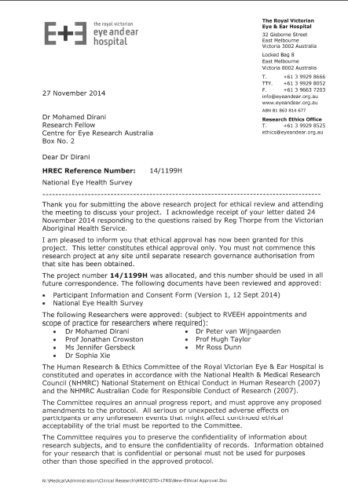

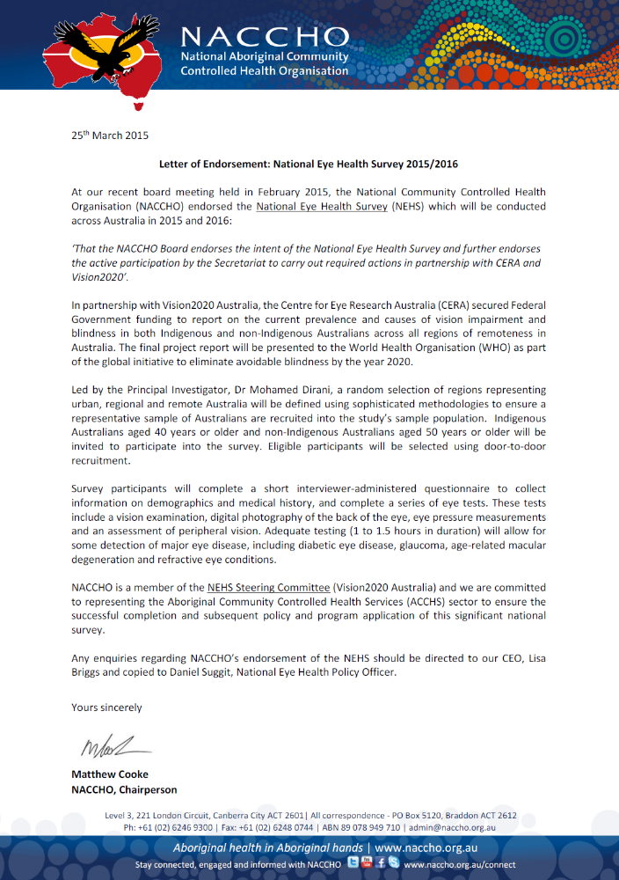
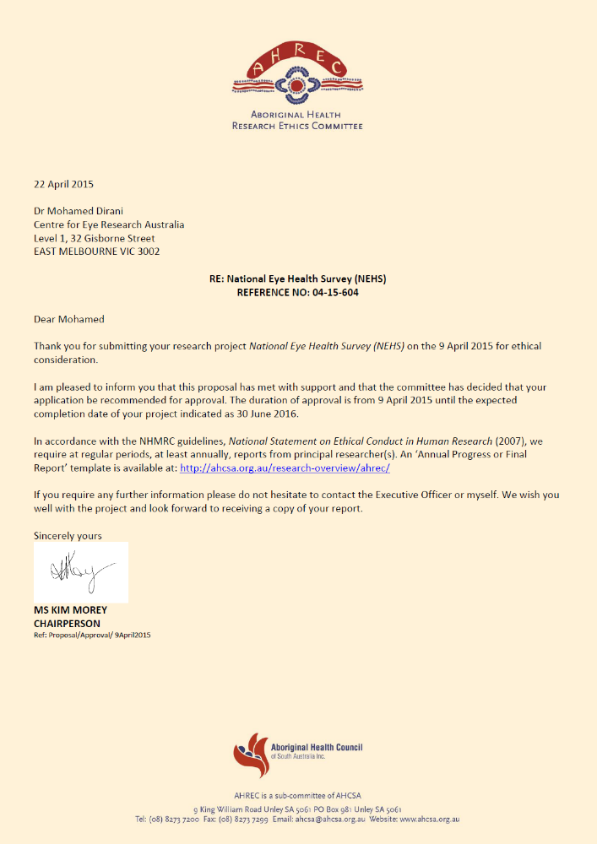
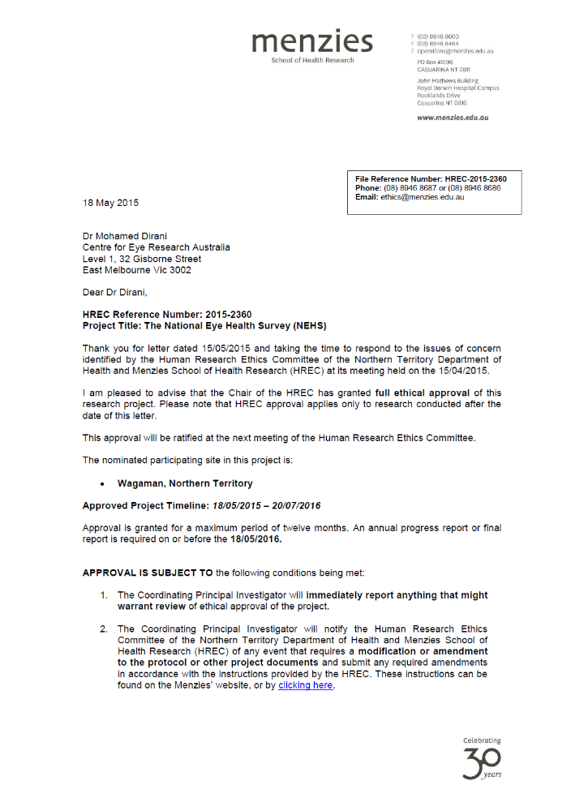
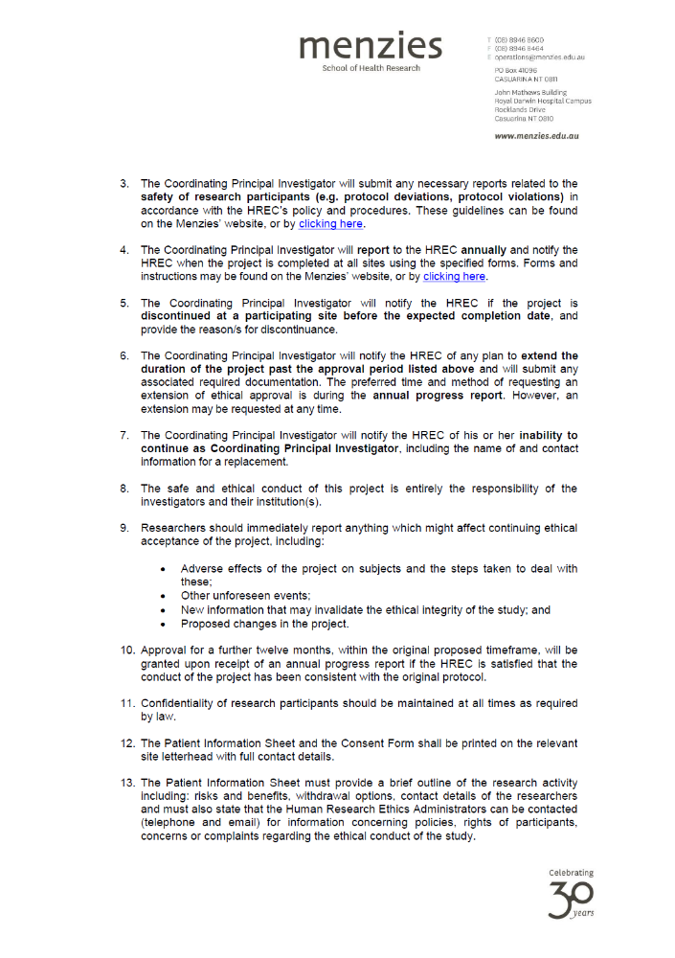
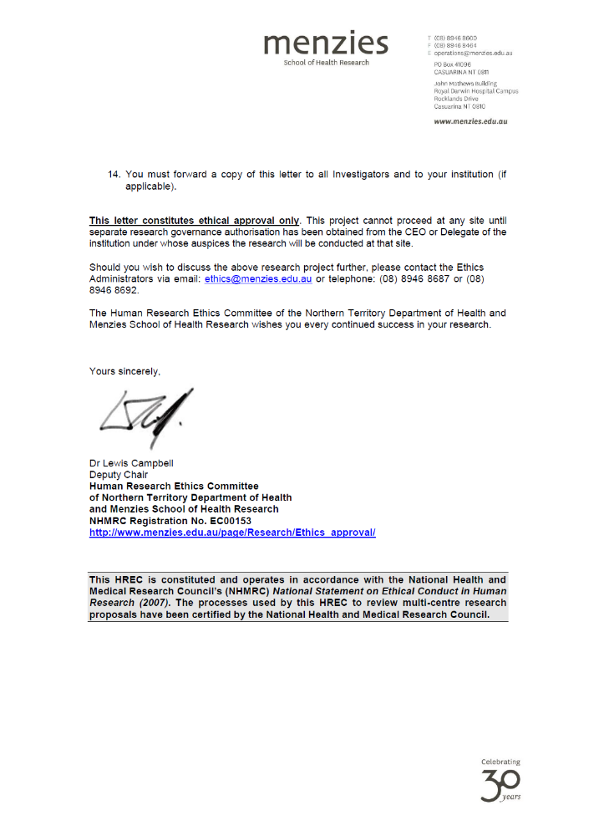
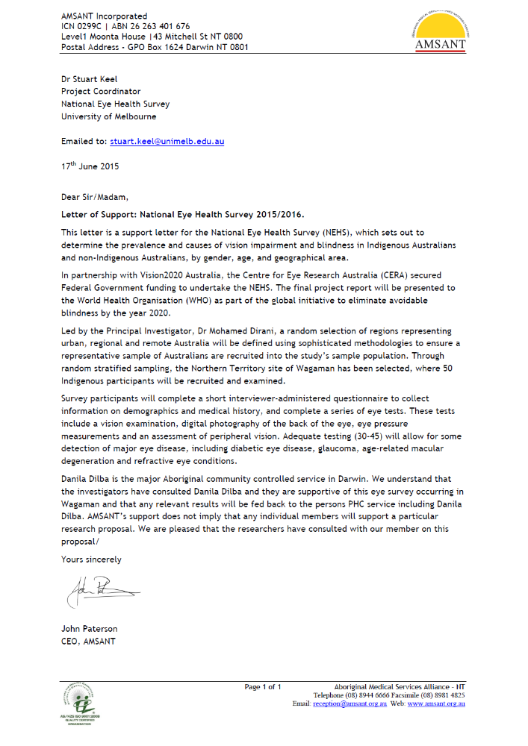
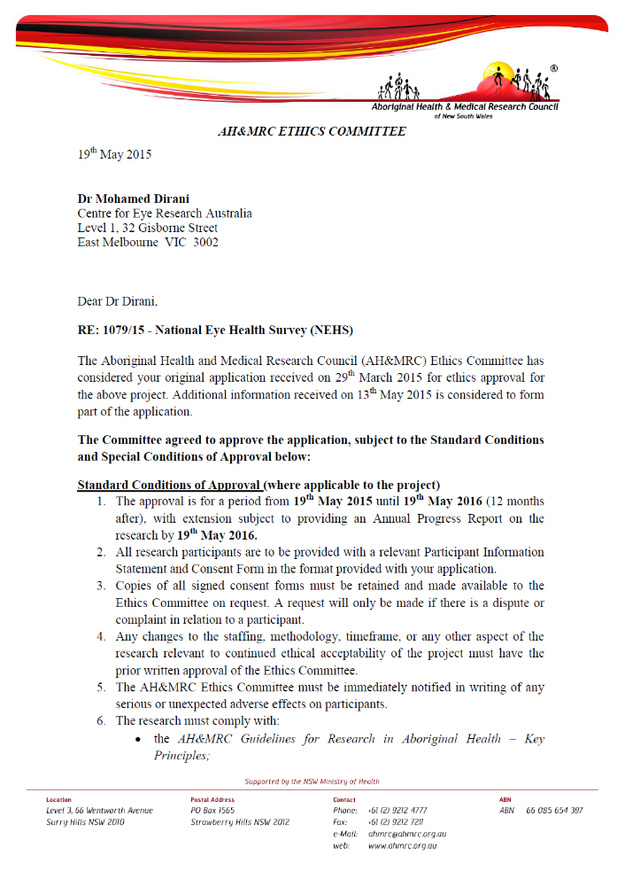
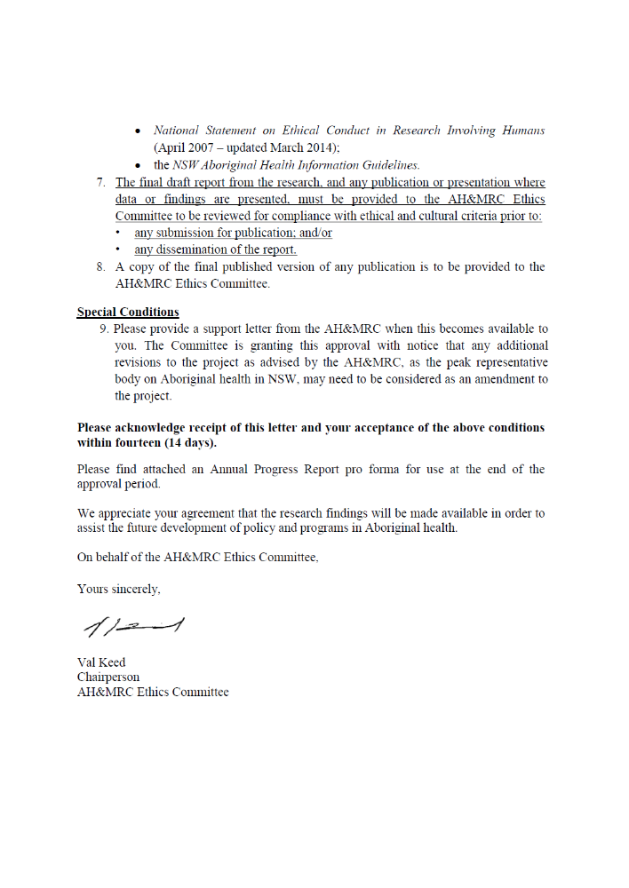
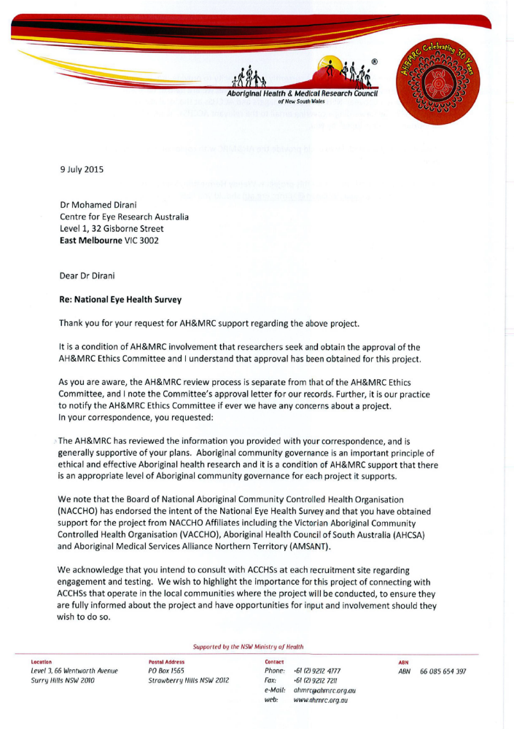
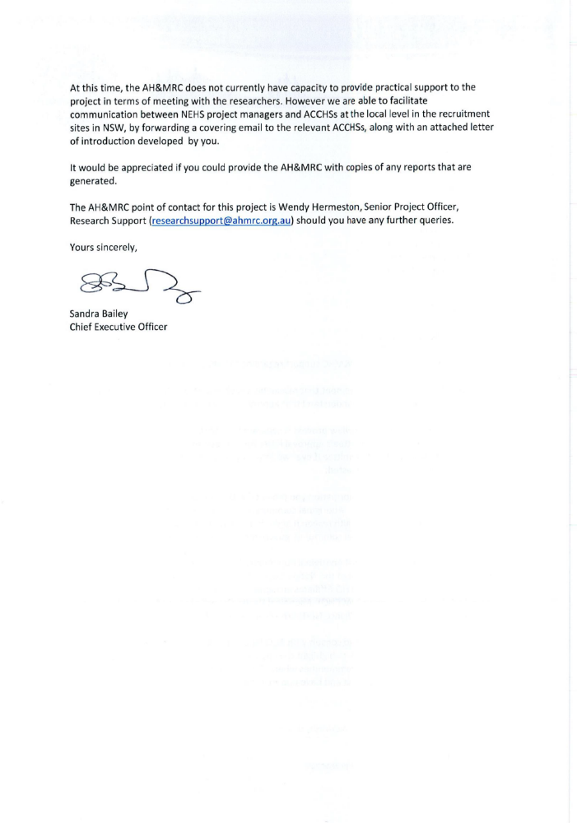
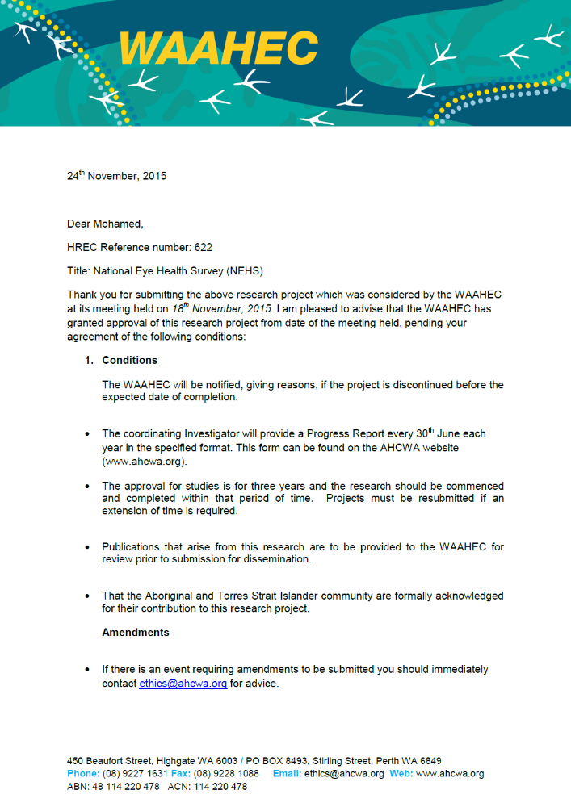
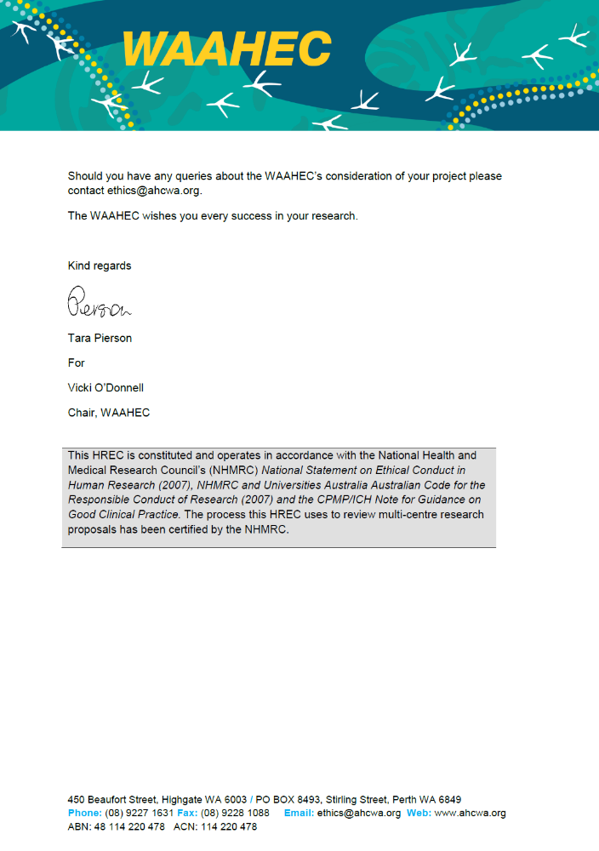
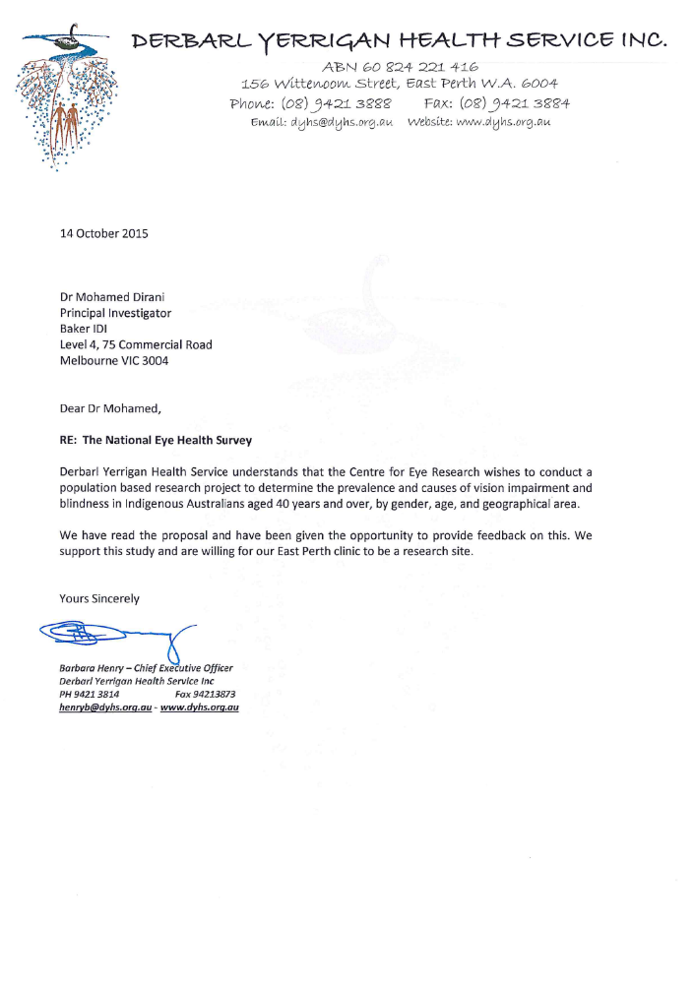
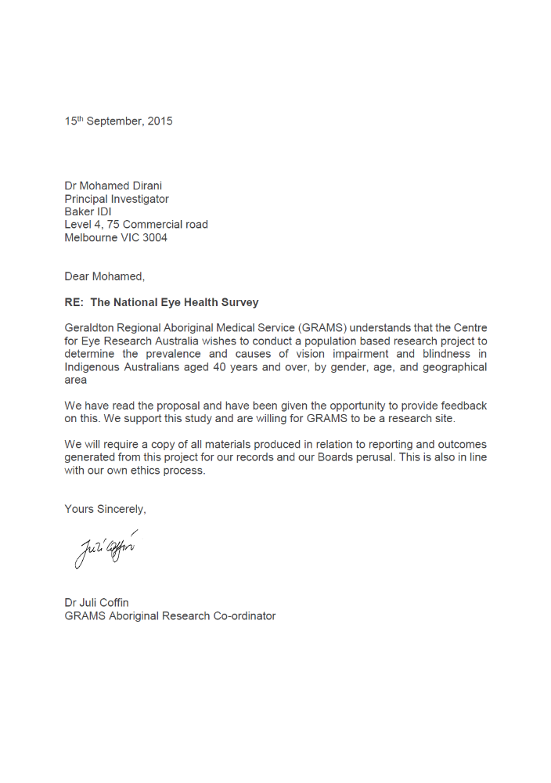
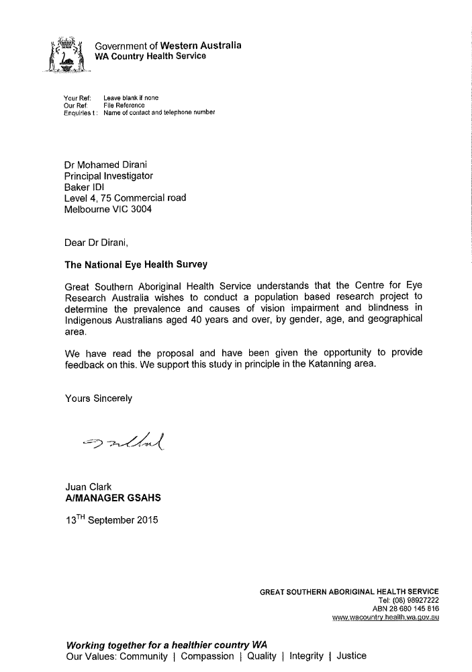

Primary Indigenous organisations consulted in each NEHS site

Table 26. Indigenous organisations consulted in each NEHS site, by remoteness
RA | Site | Indigenous Organisation
Major City | Brighton | Institute for Urban Indigenous Health, Deception Bay
 | Springfield | Kambu Aboriginal and Torres Strait Islander Corporation
 | Elizabeth Vale | Muna Paiendi Primary Health Care Services
 | Chipping Norton-Moorebank | South Western Sydney Local Health District
 | Morphett Vale | Southern Adelaide Local Health Network
 | Mornington | Willum Warrain Aboriginal Association
 | Rowville-Central | Bunurong Health Service
 | Craigie-Beldon | Derbarl Yerrigan Health Service, Mirabooka
 | Bassendean-Eden Hill-Ashfield | Derbarl Yerrigan Health Service, Midland
 | Kalamunda-Maida Vale-Gooseberry Hill | Derbarl Yerrigan Health Service, Midland
 | Elderslie-Harrington Park | Tharawal Aboriginal Corporation
 | Seventeen Mile Rocks-Sinnamon Park | Kambu Aboriginal and Torres Strait Islander Corporation
Inner | Lesmurdie-Bickley-Carmel | Derbarl Yerrigan Health Service, Midland
Regional | Goulburn | Goulburn Communtiy Health Centre
 | Wodonga | Mungabareena Aboriginal Corporation
 | Tomerong-Wandandian-Woollamia | Grand Pacific Health, Nowra
 | Ulladulla Region | Grand Pacific Health, Nowra
 | Rockhampton Region-East | Bidgerdii Health Service, Rockhampton
Outer | Whyalla | Nunyara Aboriginal Health Service
Regional | Geraldton | Geraldton Regional Aboriginal Medical Service
 | Wagaman | Bagot Community Health Clinic
 | Inverell | Armajun Aboriginal Health Service
 | Eden | Katungul Aboriginal Corporation, Bega
 | Katanning | The Western Australian Country Health Service, Albany
Remote | Banana | Bidgerdii Health Service, Mt Morgan
 | Daintree | Mossman Primary Health Care Centre
 | Yorke Peninsula-South | Yorke Peninsula Community Health Service
 | South Hedland | Wirraka Maya Health Service
Very Remote | Onslow | Buurabalayji Thalanyji Aboriginal Corporation
 | Esperance Region | Bega Garnbirringu Health Service

Standardised screening script
All recruiters followed a recruitment script to assist in relaying critical study information, increase the positive response rate and to ensure a consistent methodology of recruitment among recruiters. The script is presented below.
“Hi, I am Joshua from the Centre for Eye Research Australia, based in Melbourne. We are part of the new team that is collecting important vision and eye information as a part of the first ever national eye health survey that is endorsed by the Government. We want to understand how common vision impairment and blinding eye diseases are in our communities. Any person living here that is 50 years of age or older is invited to be part of this important project, where we will offer free eye tests and collect some simple information using a questionnaire. The testing will take approximately 30 minutes, and we will offer you some verbal feedback on your results on the day of the tests as well as a free pair of sunglasses valued at $130 from our industry partner OPSM. We will be conducting the tests at the [testing venue] over the next 5 days. We would love for you to be part of the Government funded national eye health survey. What day are you available?”

NEHS recruitment pack
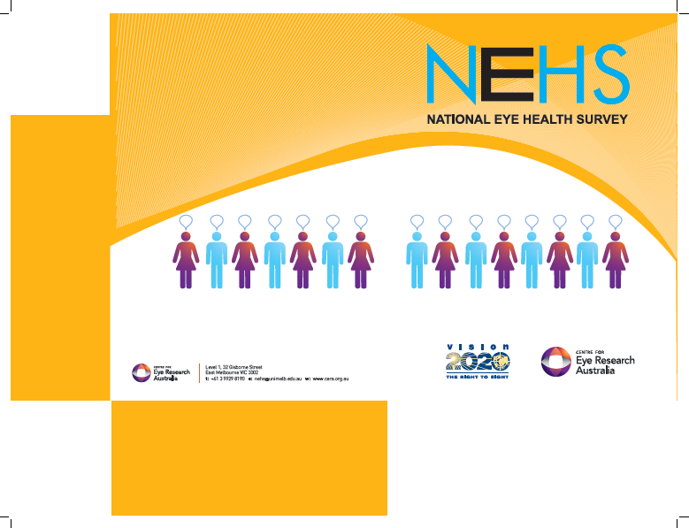
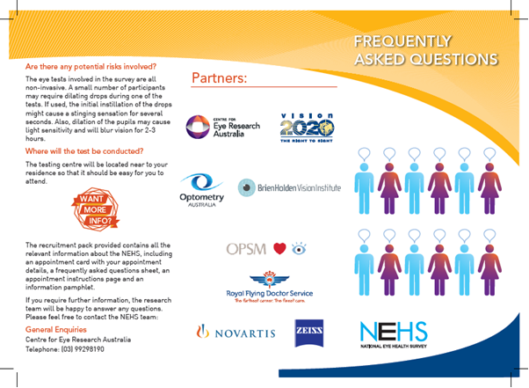
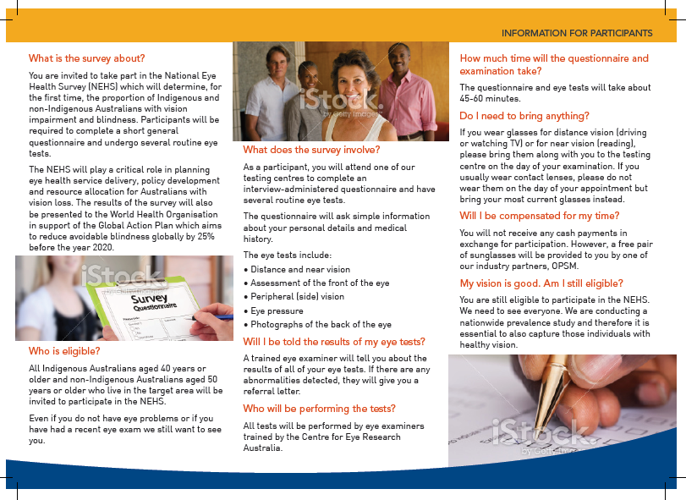

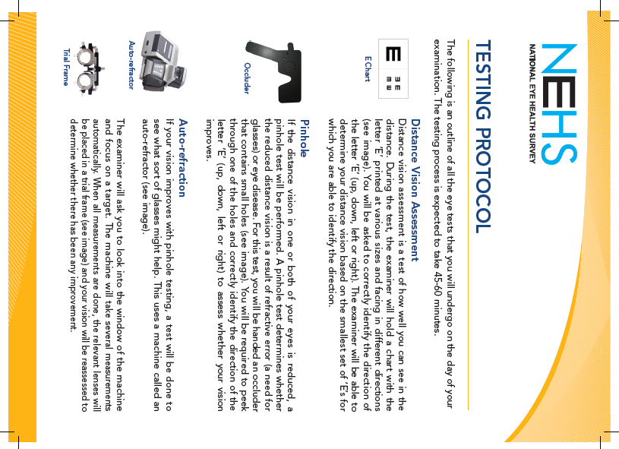

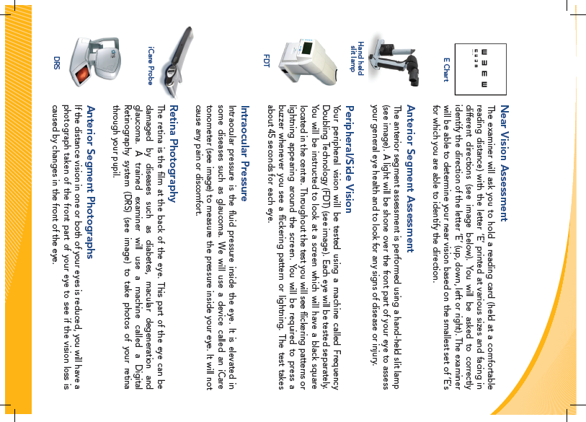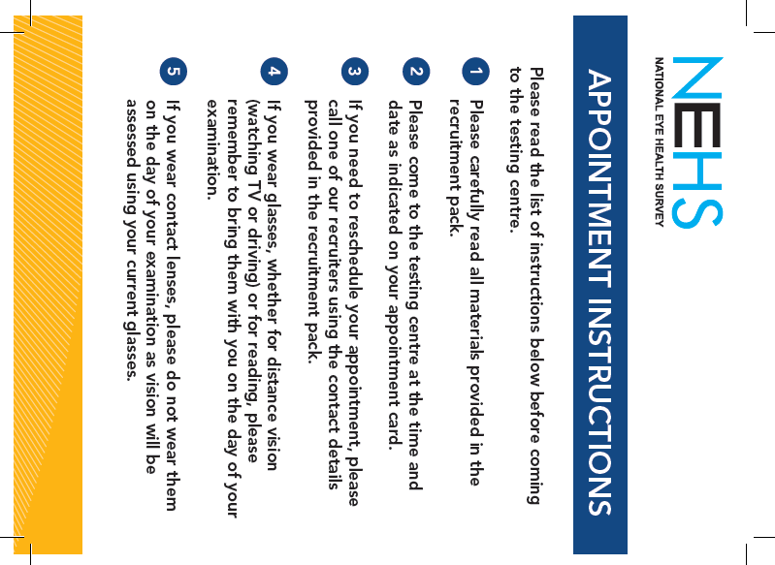
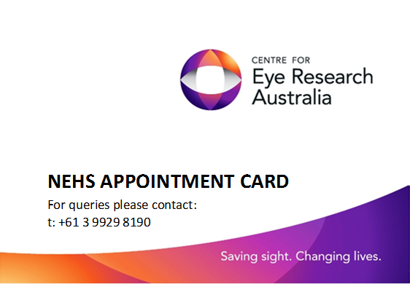


NEHS site summary data and descriptions

Remoteness Area: Major City

Site 1: Brighton (QLD)
The randomly-selected SA1 was located within the suburb of Brighton in the city of Brisbane QLD (Figure 14). Recruitment of the non-Indigenous sample was successful, with many residents fitting the eligibility criteria. However, due to a relatively high rate of absent residents within the SA1, recruiters were required to move onto the next contiguous SA1. Subsequently, recruitment from within approximately 5 additional SA1s was. All adjacent SA1s in which recruitment was conducted lie within the boundaries of the randomly-selected SA2. A total of 108 non-Indigenous participants were recruited and examined from October 10th to October 17th 2015. Examinations were conducted at the Sandgate Hall, Seymour St, Sandgate, QLD 4017. A total of 74 Indigenous participants were recruited and examined from October 4th to October 9th 2015. Examinations were conducted at the Moreton Aboriginal and Torres Strait Islander Community Health Service, 3/675 Deception Bay Road, Deception Bay, QLD 4508.
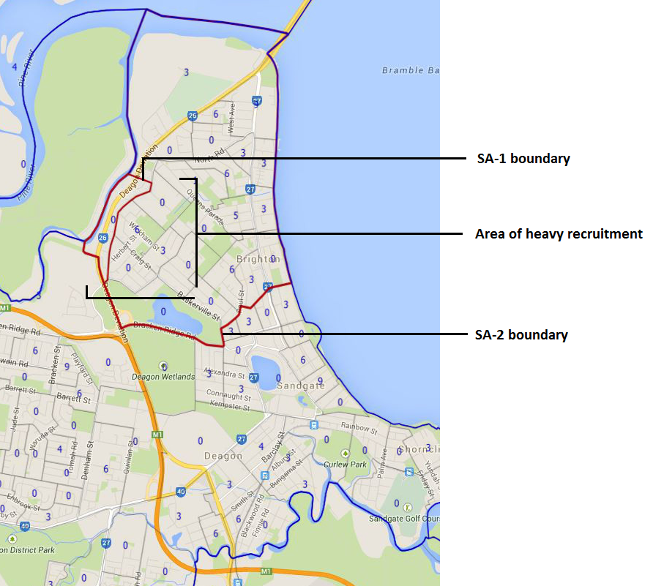
Figure 14. Brighton (QLD) survey site and surrounding areas targeted for recruitment

Site 2: Springfield (QLD)
The targeted recruitment area for this site comprised two adjacent SA-1s in an attempt to provide a sufficient population size for successful recruitment (Figure 15). The 2 SA1s were located within the southwestern suburb of Springfield in the city of Brisbane QLD. The suburb was comprised entirely of newly-constructed estates for young families, and had a very low eligibility rate. Discussions with local residents confirmed that successful recruitment was only possible if recruiters attempted the adjacent suburb, Camira, just north of the randomly-selected SA2 site. A total of 109 eligible non-Indigenous participants were recruited and examined from October 1st to October 9th 2015. Examinations were conducted at the Springfield Lakes YMCA, 63 Springfield Lakes Blvd, Springfield Lakes QLD 4300. A total of 59 Indigenous participants were recruited and examined from October 9th to October 14th 2015. Examinations were conducted at Kambu Aboriginal and Torres Strait Islander Corp, 13 Church St, Goodna QLD 4300.
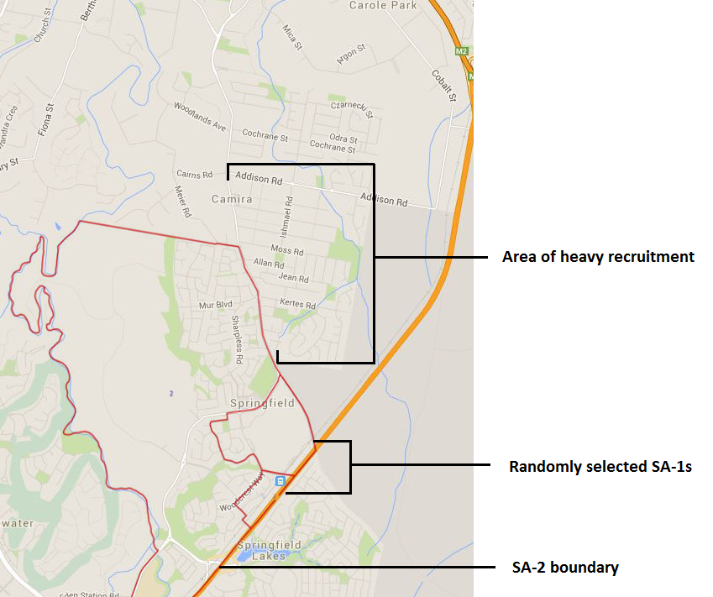
Figure 15. Springfield (QLD) survey site and surrounding areas targeted for recruitment

Site 3: Parklea-Kellyville Ridge (NSW)
The randomly-selected SA1 was located within the suburb of Kellyville Ridge in Sydney’s northwest (Figure 16). The SA1 and the surrounding SA2 in Kellyville Ridge consisted entirely of newly-constructed estates for young families, and the eligibility rate of the constituent population was therefore very low. Following attempts at recruitment in the adjacent suburbs of The Ponds and Stanhope Gardens, recruiters were required to relocate to Beaumont Hills. A total of 97 eligible non-Indigenous participants were recruited and examined from July 8th to 16th 2015. Examinations were conducted at Beaumont Hills Community Centre, 2-4 Arnold Janssen Dr, Beaumont Hills NSW 2155.
Attempts at establishing relationships with Indigenous organisations within the Parklea-Kellyville Ridge area were unsuccessful. As such, recruitment of Indigenous Australians within this area was not viable. The remaining randomly-sampled backup sites from the Major Cities RAs were also deemed to be inappropriate due to small Indigenous population sizes, and Indigenous consultants therefore suggested the suburb of Elizabeth Vale within the Elizabeth SA2 in South Australia. Consequently, Indigenous participants for this site were recruited from the Elizabeth Vale area (Figure 17). A total of 51 eligible Indigenous participants were recruited and examined from March 15th to March 18th 2016. Examinations were conducted at the Muna Paiendi Community Health Care Centre, Intersection of Mark Rd and Oldham Rd, Elizabeth Vale SA 5112.
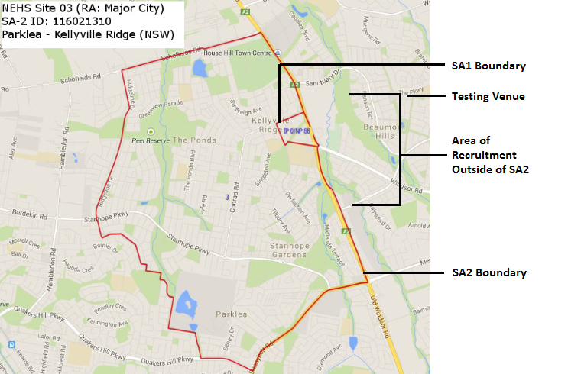
Figure 16. Parklea-Kellyville Ridge (NSW) survey site and surrounding areas targeted for recruitment of non-Indigenous participants

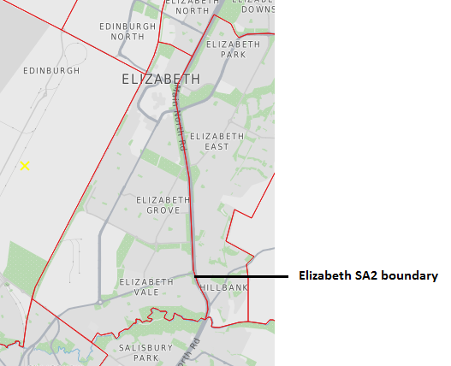
Figure 17. The specifically selected Major City backup site of Elizabeth Vale (SA) targeted for recruitment of Indigenous Australians

Site 4: Chipping Norton-Moorebank (NSW)
The randomly-selected SA1 for this site was located in the suburb of Chipping Norton in Sydney’s west (Figure 18). Recruitment in the SA1 was successful. A number of adjacent SA1s were visited to recruit the required sample. All participants were recruited from within the boundary of the randomly-selected SA2. A total of 108 eligible non-Indigenous participants were recruited and examined from July 23rd to August 3rd 2015. Examinations were conducted at the Chipping Norton Boatshed, Angle Park, Chipping Norton NSW 2170. A total of 57 eligible Indigenous participants were recruited and examined between two time periods – August 21st to August 26th 2015 and October 26th to October 30th 2015. Examinations were conducted at the Liverpool Community Centre, 148 Mill Rd, Liverpool and the Budyari Community Health Centre, 18 Woodward Cres, Miller NSW 2168.

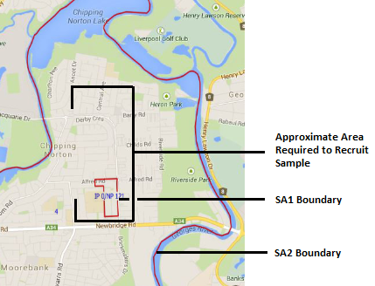
Figure 18. Chipping Norton-Moorebank (NSW) survey site and surrounding areas targeted for recruitment

Site 5: Concord-Mortlake-Cabarita (NSW)
The randomly-selected SA1 for this site was located within the suburb of Cabarita along the Parramatta River in Sydney NSW (Figure 19). While recruitment of eligible residents within the SA1 was successful, a significant portion were recruited from adjacent SA1 sites within the randomly-selected SA2 boundary. A total of 111 eligible non-Indigenous participants were recruited and examined from July 1st to July 9th 2015. Examinations were conducted at the Concord Bowling Club, Clermont Avenue, Concord NSW 2137. Consultation with Indigenous organisations revealed that recruitment of participants from within the Concord-Mortlake-Cabarita area would not be viable. Consequently, the Major Cities backup site of Morphett Vale (SA) was utilised for recruitment of Indigenous Australians (Figure 20). A total of 65 Indigenous participants were recruited and examined from December 4th to December 10th 2015. Examinations were conducted at Christie Downs Community House, Corner Flaxmill Road and Morton Road, Christie Downs SA 5164.

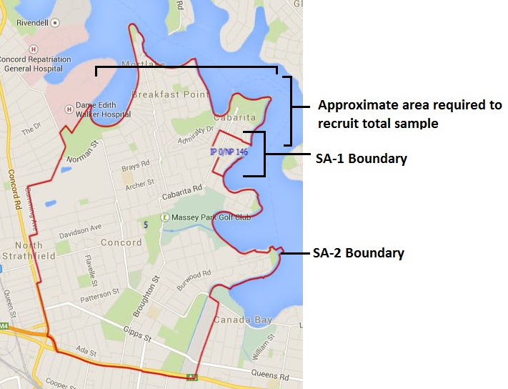
Figure 19. Concord-Mortlake-Cabarita (NSW) survey site and surrounding area targeted for recruitment

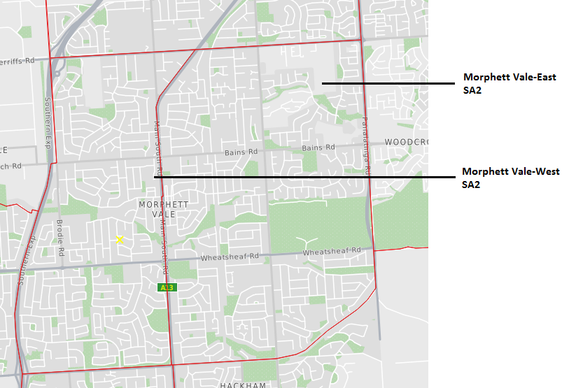
Figure 20. The backup site of Morphett Vale (SA) targeted for recruitment of Indigenous Australians

Site 6: Mornington (VIC)
The SA1 for this site was located on the southwestern corner of the suburb of Mornington, situated on the Mornington Peninsula, Victoria (Figure 21). While the eligibility rate was high, a number of contiguous SA1 areas were merged with the randomly-selected SA1 to ensure that sufficient participants were recruited during the allocated recruitment time. A total of 105 eligible non-Indigenous participants were recruited and examined from March 30th to April 10th 2015. Examinations were conducted at the Mornington Community Information and Support Centre, 320 main St, Mornington VIC 3931. A total of 38 Indigenous participants were recruited and examined from February 20th to February 26th 2016. Examinations were conducted at Willum Warrain Aboriginal Association, 10 Pound Rd, Hastings VIC 3915.
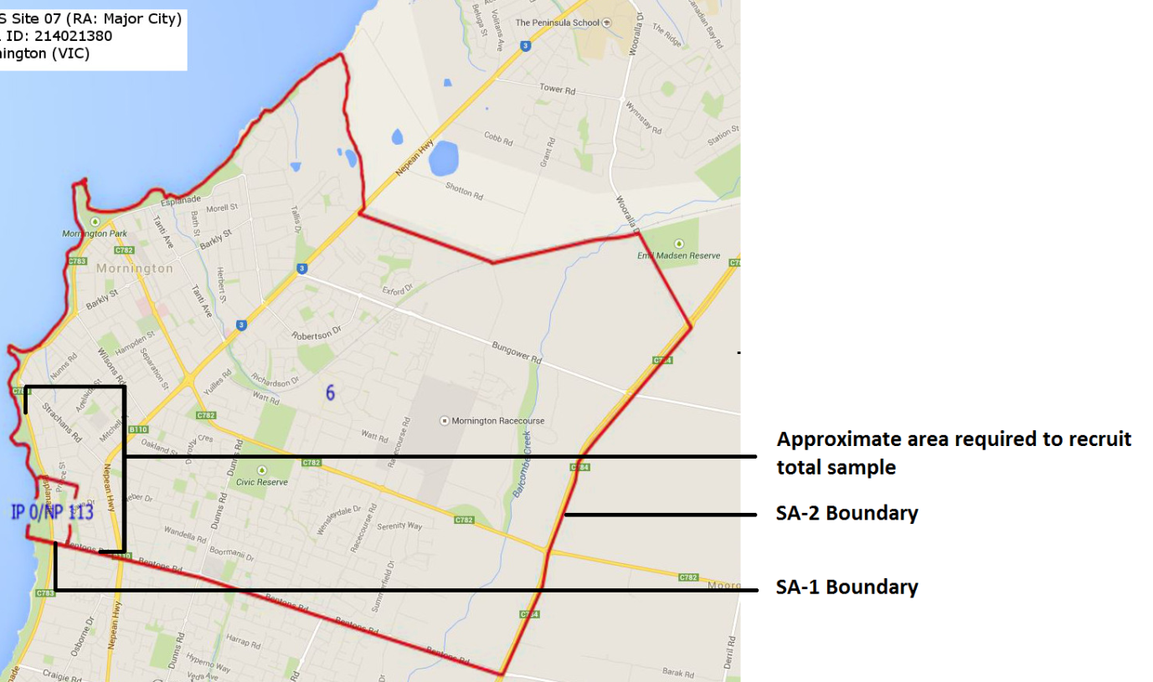
Figure 21.Mornington (VIC) survey site and surrounding area targeted for recruitment

Site 7: Rowville-Central (VIC)
The randomly-selected SA1 for this site was located within the central aspect of the eastern Melbourne suburb of Rowville (Figure 22). Due to a relatively high absent rate, a number of contiguous SA1s were merged with the selected SA1 to maximise recruitment during the allocated recruitment time. All SA1s were located within the randomly-selected SA2. A total of 100 eligible non-Indigenous participants were recruited and examined from March 11th to March 25th 2015. Examinations were conducted at Carrington Primary School, Laura Rd, Knoxfield VIC 3180. A total of 46 Indigenous participants were recruited and examined from February 17th to February 22nd 2016. Examinations were conducted at Vision Australia, 45 Princes Highway, Dandenong VIC 3175.
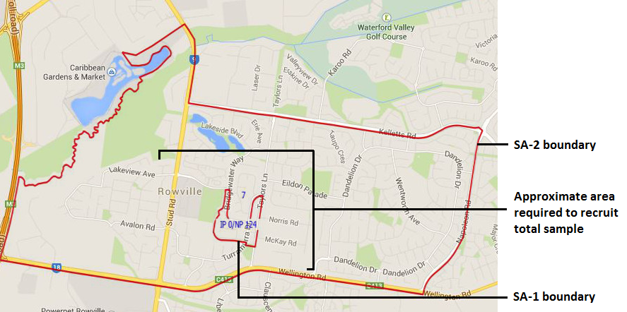
Figure 22. Rowville-Central (VIC) survey site and surrounding area targeted for recruitment

Site 8: Craigie-Beldon (WA)
The randomly-selected SA1 for this site was located within the suburb of Craigie in the northern suburbs of Perth (Figure 23). The selected SA1 was merged with surrounding SA1s to expand the recruitment zone to accommodate for a low eligibility rate. All participants were recruited from within the SA2 boundary. A total of 110 non-Indigenous participants were recruited and examined from January 19th to January 27th 2016. Examinations were conducted at the Craigie Leisure Centre, Whitfords Avenue, Craigie WA 6025. A total of 82 Indigenous participants were recruited and examined from January 22nd to January 29th 2016. Examinations were conducted at Derbarl Yerrigan Health Service, 22 Chesterfield Road, Mirrabooka WA 6061.
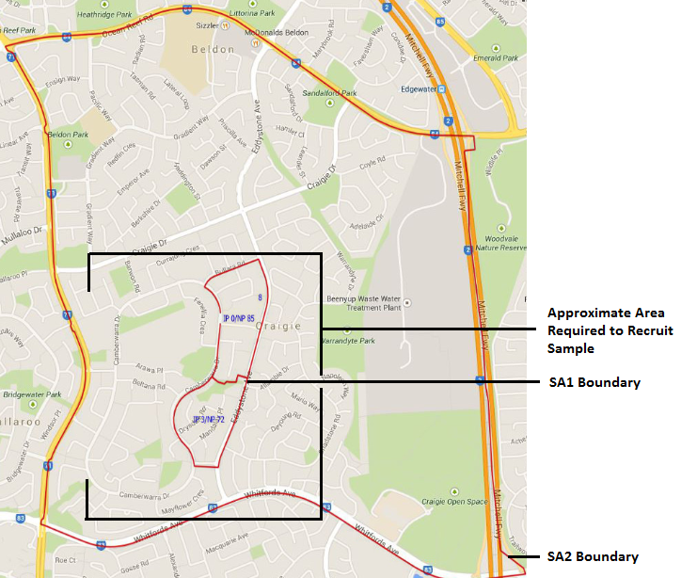
Figure 23. Craigie-Beldon (WA) survey site and surrounding area targeted for recruitment

Site 9: Bassendean-Eden Hill-Ashfield (WA)
The randomly-selected SA1 for this site was located in the suburb of Bassendean in Perth’s west (Figure 24). The SA1 was merged with a small number of contiguous SA1s to expand the recruitment zone. All contiguous SA1s were located within the randomly-selected SA2. A total of 106 non-Indigenous participants were recruited and examined from January 27th to February 4th 2016. Examinations were conducted at the Bassendean Senior and Community Centre, 50 Old Perth Road, Bassendean WA 6054. A total of 80 Indigenous participants were recruited and examined from January 29th to February 9th 2016. Examinations were conducted at Derbarl Yerrigan Health Service, 6 Centennial Place, Midland WA 6056.
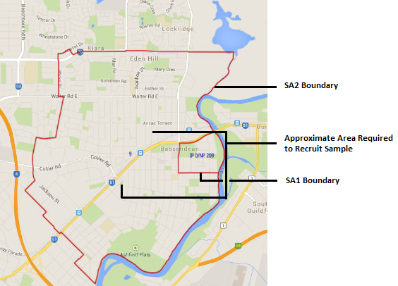
Figure 24. Bassendean-Eden Hill-Ashfield (WA) survey site and surrounding area targeted for recruitment

Site 10: Kalamunda-Maida Vale-Gooseberry Hill (WA)
The randomly-selected SA1 for this site was located in the suburb of Maida Vale in Perth’s east (Figure 25). Recruitment was successful in the SA1 due to the high eligibility rate. However, recruiters were required to approach a small number of contiguous SA1s as the primary recruitment site was exhausted relatively quickly. All participants were recruited from within the boundary of the randomly-selected SA2. A total of 102 eligible non-Indigenous participants were recruited and examined from February 1st to February 9th 2016. Examinations were conducted at the Jack Healey Centre, 5 Mead St, Kalamunda WA 6076. A total of 68 Indigenous participants were recruited and examined from January 29th to February 9th 2016. Examinations were conducted at Derbarl Yerrigan Health Service, 6 Centennial Place, Midland WA 6056.
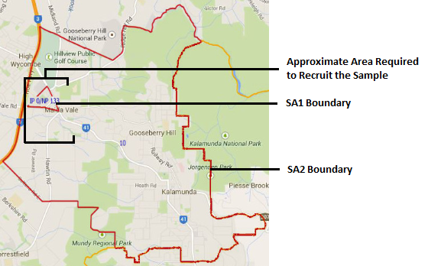
Figure 25. Kalamunda-Maida Vale-Gooseberry Hill (WA) survey site and surrounding area targeted for recruitment

Site 11: Elderslie-Harrington Park (NSW)
The randomly-selected SA1 for this site was located in the south-eastern Sydney suburb of Harrington Park (Figure 26). The SA1 was located on the north-eastern edge of the SA2. Due to the very low eligibility rate of the constituent population, recruiters consulted with local residents, who suggested attempting the suburb of Narellan, located within the randomly-selected SA2, south-west of the SA1. A total of 103 eligible non-Indigenous participants were recruited and examined from July 1st to July 11th 2015. Examinations were conducted at Fairfax Reserve, Sir Warwick Fairfax Drive, Harrington Park, NSW 2567. A total of 65 eligible Indigenous participants were recruited and examined from August 9th to August 14th 2015. Examinations were conducted at Tharawal Aboriginal Corporation, 187 Riverside Dr, Airds NSW 2567.
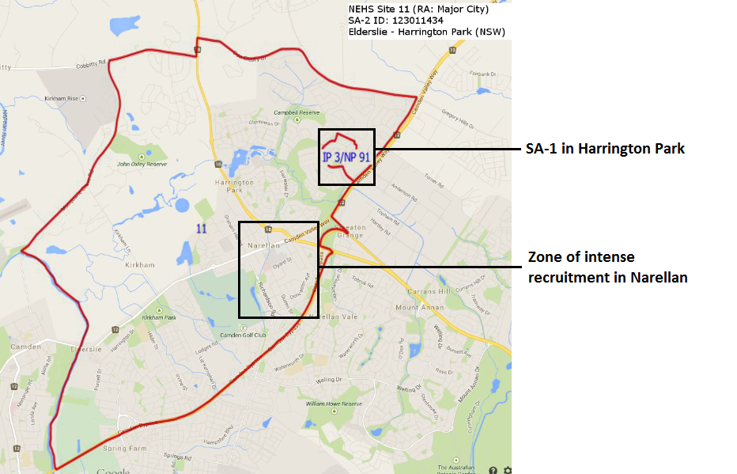
Figure 26. Elderslie-Harrington Park (NSW) survey site and surrounding area targeted for recruitment

Site 12: Warilla (NSW)
The randomly-selected SA1 for this site was located in the suburb of Barrack Heights, just south of the Suburb of Warilla near Lake Illawarra NSW (Figure 27). While recruitment in the primary SA1 was successful, a number of adjacent SA1 were approached to recruit the entire sample. All participants were recruited from within the boundary of the randomly-selected SA2. A total of 94 eligible non-Indigenous participants were recruited and examined from August 20th to August 27th 2015. Examinations were conducted at the Illawarra Institute of Technology, 10 College Avenue, Shellharbour Square, NSW 2529. The primary Indigenous organisation in Warilla declined to participate in the survey. Therefore, as a strong relationship had been established with Indigenous organisations in Queensland, it was decided that Indigenous participants for this Major City site would be recruited from the backup site of Seventeen Mile Rocks-Sinnamon Park (QLD). The nearest area with a significant Indigenous population corresponding to this site was the suburb of Ipswich in Brisbane’s southwest (Figure 28). A total of 61 eligible Indigenous participants were recruited and examined November 29th to December 4th 2015. Examinations were conducted at Kambu Aboriginal and Torres Strait Islander Corp, 27 Roderick Street, Ipswich QLD 4305.

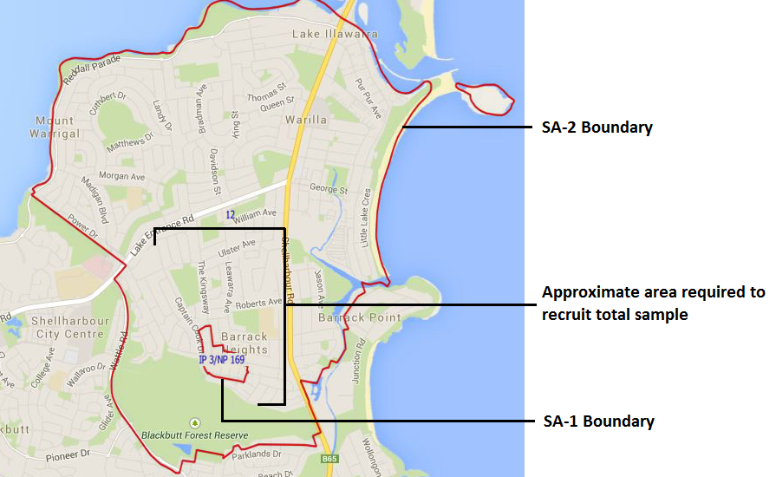
Figure 27 .Warilla (NSW) survey site and surrounding area targeted for recruitment

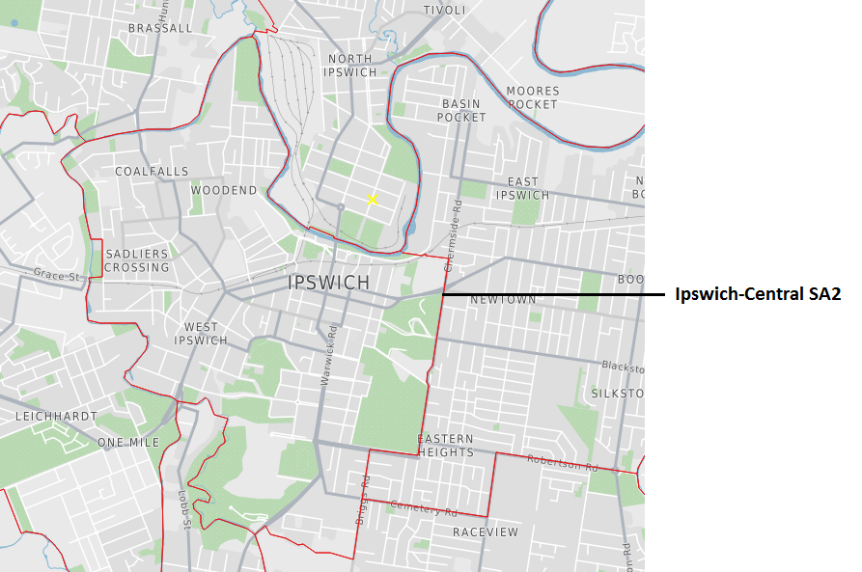
Figure 28.The Ipswich area, corresponding to the backup site, Seventeen Mile Rocks-Sinnamon Park (QLD), targeted for recruitment of Indigenous Australians

Remoteness Area: Inner Regional

Site 13: Lesmurdie-Bickley-Carmel (WA)
The randomly-selected SA1 for this site was located in the suburb of Lesmurdie near the southwest boundary of Perth (Figure 29). Despite lying directly adjacent to the Major City SA2 site for Kalamunda, the Lesmurdie area is characterised as Inner Regional according to the ARIA+ classification system. Recruitment was relatively successful in Lesmurdie due to the high eligibility rate. However, adjacent SA1 sites were merged with the selected SA1 to expand the recruitment site. All participants were recruited from within the boundary of the randomly-selected SA2. A total of 101 eligible non-Indigenous participants were recruited and examined from April 11th to April 18th 2016. Examinations were conducted at the Jack Healey Centre, 5 Mead St, Kalamunda WA 6076. Efforts to recruit eligible Indigenous residents from Lesmurdie were not successful due to low population numbers in the area. As a result, only 2 eligible Indigenous participants were recruited and examined from January 29th to February 9th 2016. Examinations were conducted at Derbarl Yerrigan Health Service, 6 Centennial Place, Midland WA 6056.

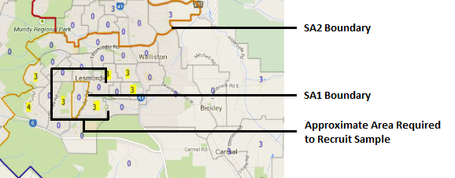
Figure 29. Lesmurdie-Bickley-Carmel (WA) survey site and surrounding area targeted for recruitment

Site 14: Goulburn (NSW)
The randomly-selected SA1 for this site was located in the area of Run-O-Waters just west of the town of Goulburn NSW (Figure 30). The area of Run-O-Waters is not located within a populated area, and visual inspection of the area revealed that door-to-door knocking would be unsuccessful due to the absence of accessible residences. Consequently, recruitment was conducted in a number of SA1s in the town of Goulburn proper due to its higher population density and accessible residences. All participants were recruited from within the boundary of the randomly-selected SA2. A total of 124 eligible non-Indigenous participants were recruited and examined from August 27th to September 9th 2015. Examinations were conducted at the Illawarra Institute of Technology, Verner St, Goulburn NSW 2580. A total of 37 eligible Indigenous participants were recruited and examined from August 26th to September 3rd 2015. Examinations were conducted at Goulburn Community Health Centre, Cnr Goldsmith and Faithful Streets, Goulburn NSW 2580 and the Goulburn Aboriginal Land Council, 80 Combermere St, Goulburn NSW 2580.

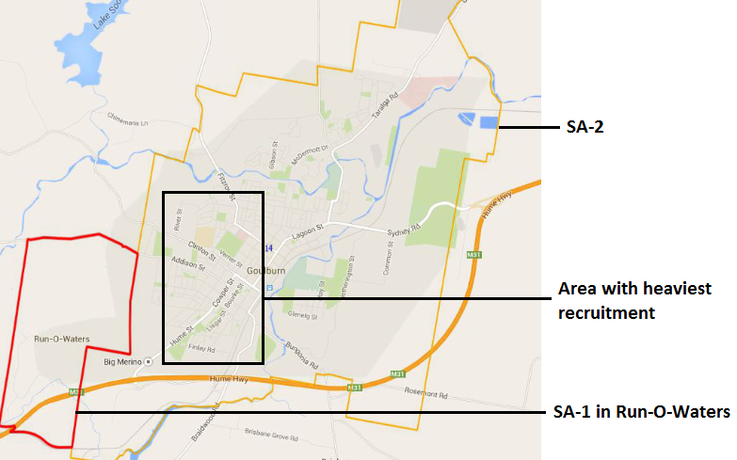
Figure 30. Goulburn (NSW) survey site and surrounding area targeted for recruitment

Site 15: Wodonga (VIC)
The randomly-selected SA1 for this site was located within the small estate community of Baranduda, approximately 11km southwest of the regional city of Wodonga (Figure 31). As Baranduda consists mostly of new estate homes for small families, the eligibility rate was low. Recruiters attempted to recruit participants from the surrounding parts of Baranduda not within the SA1 boundary. While the mean age of residents in the surrounding area appeared to increase, the population density decreased steeply and eventually tapered off to uninhabited farmland. The nearby community of Bandiana was attempted, but the demographic was similar to that of Baranduda. Residents revealed that all the estates in the region were inhabited by very young families due to the proximity of the army base. Exploration of the surrounding area revealed the Westmont community located 1.6km from the primary SA1. Recruiters then travelled to the most southern part of the city of Wodonga to recruit the remainder of the sample. A total of 93 eligible non-Indigenous participants were recruited and examined from April 21st to May 5th 2015. Examinations were conducted at the Baranduda Community Centre, 4 Sage Court, Baranduda VIC 3691. A total of 54 eligible Indigenous participants were recruited and examined from October 4th to October 9th 2015. Examinations were conducted at Mungabareena Aboriginal Corporation, 21 Hovell Street, Wodonga VIC 3690.

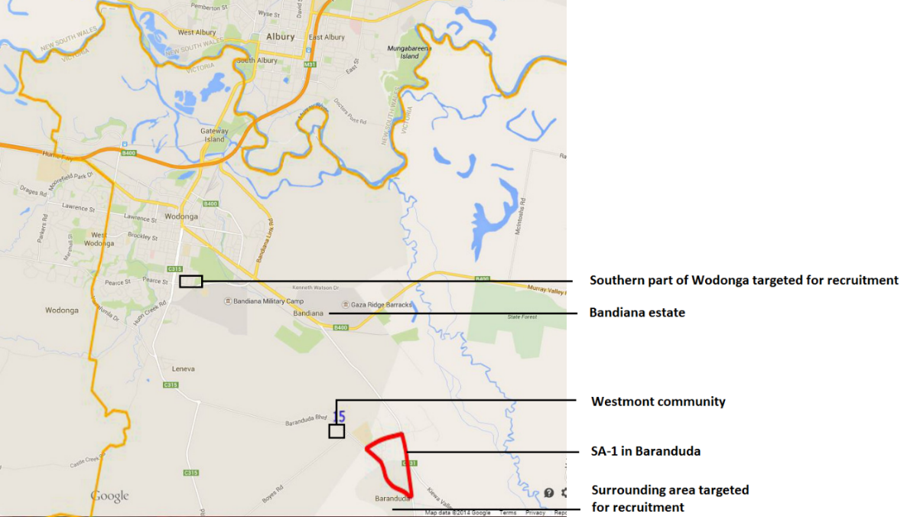
Figure 31. Wodonga (VIC) survey site and surrounding area targeted for recruitment

Site 16: Tomerong-Wandandian-Woollamia (NSW)
The randomly selected SA1 for this site encompasses Falls Creek and the surrounding countryside (Figure 32). The population within this SA1 is extremely sparsely dispersed. From the most northern to the most southern point, the SA1 spans over 7km. Areal satellite photography in Google Maps revealed that most of the SA1 is comprised of farmland. The SA2 in which the primary SA1 lies is similarly sparsely populated. The regions of Tomerong, Woollamia and Wandandian are almost entirely uninhabited, and due to logistical constraints, recruitment of participants in these areas was deemed unviable. Therefore, recruitment was not performed within the selected SA1. The small city of Nowra, located just northwest of the boundary was identified as an appropriate location for recruitment. Recruitment was conducted on the most westerly boundary of Nowra in an attempt to maintain close proximity to the primary site2. A total of 119 eligible non-Indigenous participants were recruited and examined from September 10th to September 16th 2015. Examinations were conducted at the Nowra School of Arts, Berry St, Nowra NSW 2541. A total of 103 eligible Indigenous participants were recruited and examined from September 11th to September 22nd 2015. Examinations were conducted at Grand Pacific Health, 107 Scenic Drive, Nowra NSW 2541.

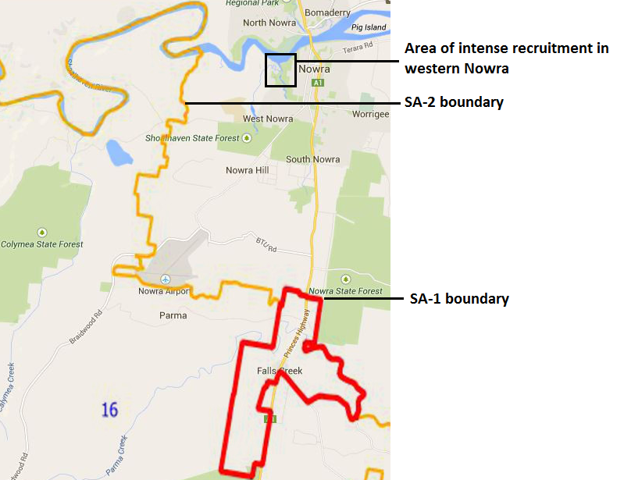
Figure 32. Tomerong-Wandandian-Woollamia (NSW) survey site and surrounding area targeted for recruitment

Site 17: Ulladulla Region (NSW)
The randomly selected SA1 for the Ulladulla site falls outside the central populated town of Ulladulla (Figure 33). This SA1 spanned several kilometres, consisting almost entirely of uninhabited land, with only a small number of residences, most of which are uncontactable due to locked fences. The nearest contiguous SA1 was selected as the primary recruitment site. This SA1 lies within the south-western aspect of Burrill Lake. After exhausting this SA1, recruiters then began to recruit participants from the next adjacent SA1 around Burril Lake, gradually moving northward toward the town centre of Ulladulla. Almost all participants were recruited within three adjoining SA1s. A total of 102 eligible non-Indigenous participants were recruited and examined from September 14th to September 23rd 2015. Examinations were conducted at Milton Ulladulla Ex Servos Club, 212-222 Princes Highway, Ulladulla NSW 2539. Only 10 eligible Indigenous participants were recruited and examined in the Ulladulla Region. However, due to the fact that this region is situated within the same SA3 as the Tomerong-Wandandian-Woollamia survey site with a similar ARIA+ score, the two sites were merged for Indigenous testing. Consequently, the total combined number of Indigenous participants for both sites was 113, exceeding the required sample. Participants were recruited and examined from September 11th to September 22nd 2015. Examinations were conducted at Grand Pacific Health, 107 Scenic Drive, Nowra NSW 2541.

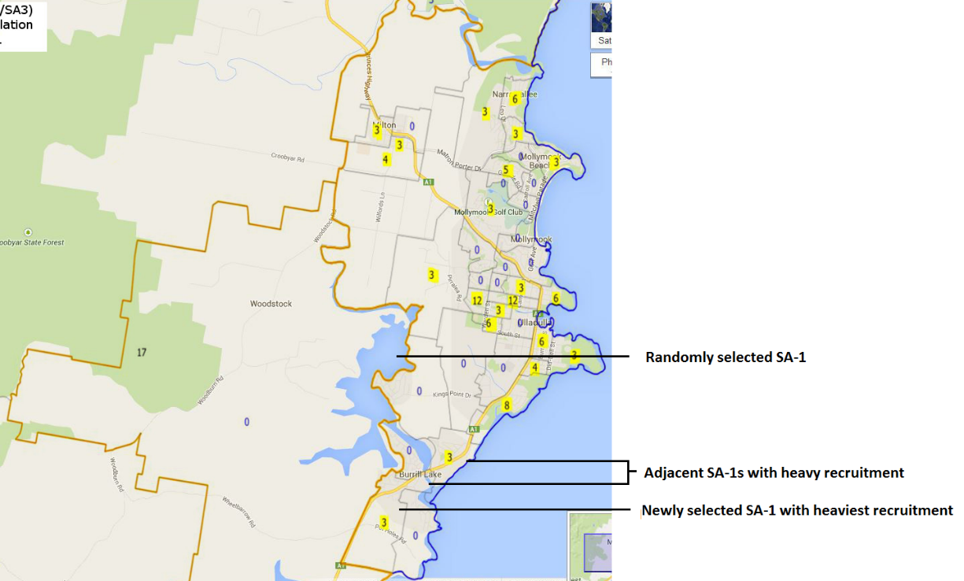
Figure 33. Ulladulla Region (NSW) survey site and surrounding area targeted for recruitment

Site 18: Rockhampton Region-East (QLD)
The randomly-selected SA1 for this site was a very large and sparsely-populated region consisting of a number of areas including Nankin, Keppel Sands, Joskeleigh and Thompson Point. This SA1 consisted of nature reserves and bushland with very few residences within its borders (Figure 34). Recruitment within the SA1 was determined to be unviable, and the next adjacent SA1 with an appreciable population density was selected as the primary recruitment site. This SA1 was located in the suburb of Koongal in the eastern part of the regional city of Rockhampton (Figure 35). A large proportion of residences either contained large dogs in their front yards, had locked gates surrounding their properties, or both. Consequently, these properties were deemed uncontactable, and only residences with open gates were approached. This process was performed systematically, with each contiguous SA1 being exhausted before moving onto the next. All participants were recruited from the areas surrounding the selected SA1. A total of 97 eligible non-Indigenous participants were recruited and examined from November 11th to November 19th 2015. Examinations were conducted at Lakes Creek State School, 445 Paterson St, Lakes Creek QLD 4701. A total of 71 Indigenous participants were recruited and examined from November 18th to November 20th 2015. Examinations were conducted at Bidgerdii Health Service, 162 Bolsover St, Rockhampton QLD 4700.

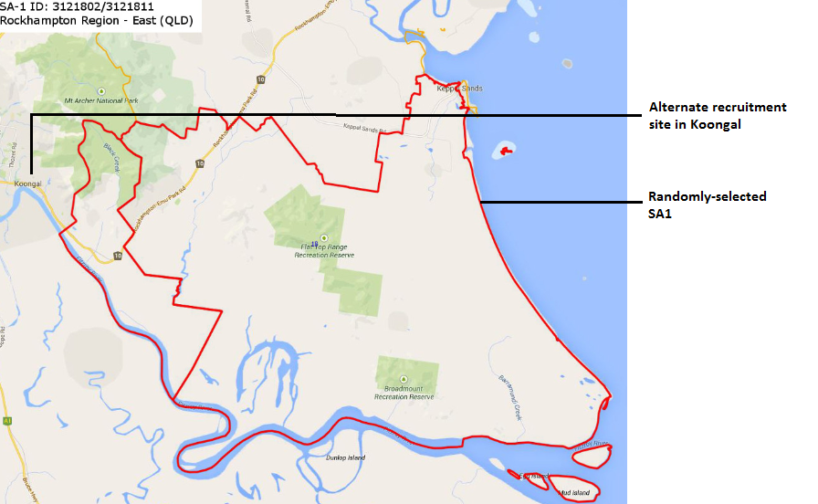
Figure 34. Rockhampton Region-East (QLD) survey site

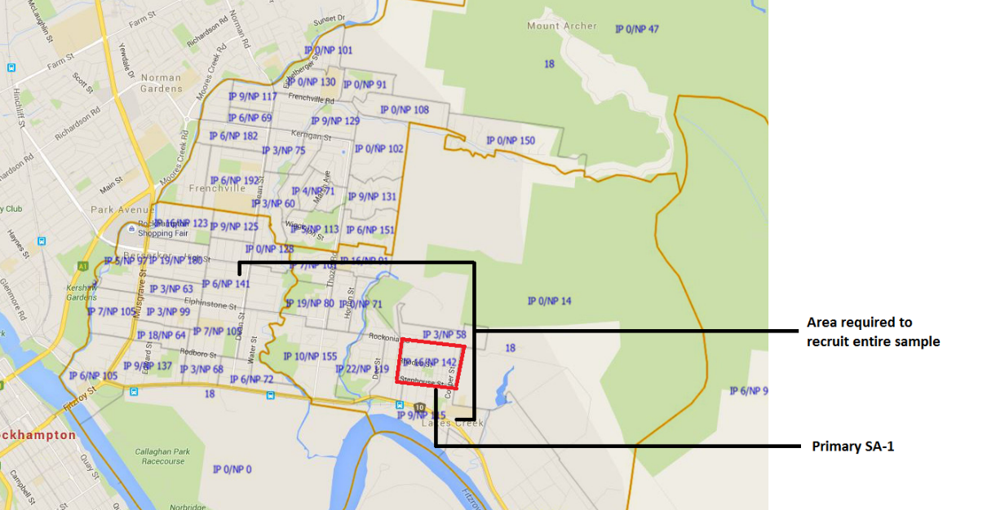
Figure 35. Suburb of Koongal in the Rockhampton Region-East (QLD) targeted for recruitment

Remoteness Area: Outer Regional

Site 19: Whyalla (SA)
The randomly-selected SA1 for this site was located in the town of Whyalla (Figure 36). Recruitment within the SA1 was successful. However, a number of adjacent SA1s were merged with the randomly-selected SA1 to expand the recruitment site. All participants were recruited from within the boundary of the randomly-selected SA2. A total of 108 eligible non-Indigenous participants were recruited and examined from May 13th to May 22nd 2015. Examinations were conducted at Memorial Oval Primary School, Bradford St, Whyalla SA 5600. A total of 63 eligible Indigenous participants were recruited and examined from May 17th to May 22nd 2015. Examinations were conducted at Westland Hotel, 100 McDouall Stuart Ave, Whyalla SA 5600.

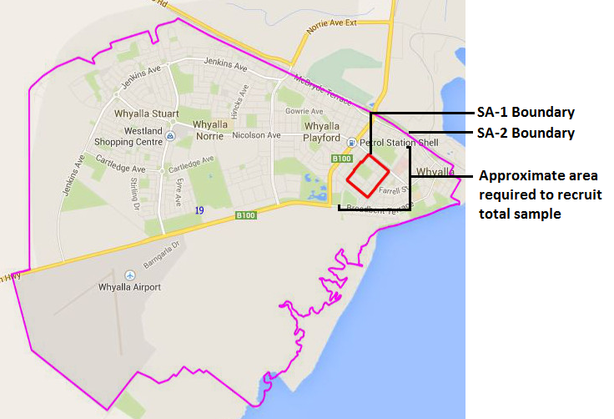
Figure 36. Whyalla (SA) survey site and surrounding area targeted for recruitment

Site 20: Geraldton (WA
The randomly-selected SA1 for this site was located in the western aspect of the regional city of Geraldton (Figure 37). A significant proportion of the SA1 area contained commercial properties rather than residential properties, and recruiters were required to approach a number of contiguous SA1s to compensate for the smaller than expected population size. All participants were recruited from within the boundary of the randomly-selected SA2. A total of 102 eligible non-Indigenous participants were recruited and examined from March 16th to March 23rd 2016. Examinations were conducted at City Health Clinic, 194 Durlacher St, Geraldton WA 6530. A total of 71 eligible Indigenous participants were recruited and examined from March 13th to March 18th 2016. Examinations were conducted at Geraldton Regional Aboriginal Medical Service, 60 Rifle Range Road, Rangeway WA 6530.

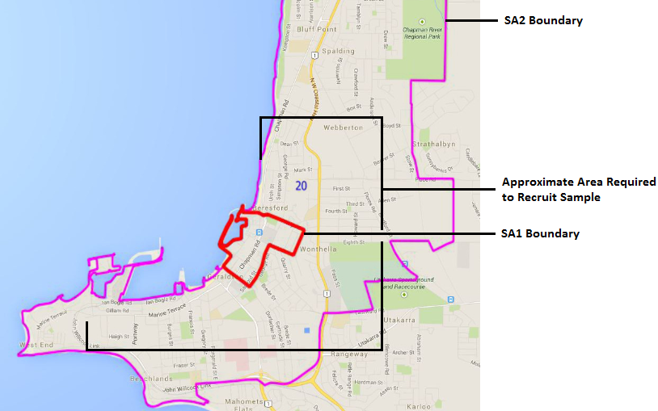
Figure 37. Geraldton (WA) survey site and surrounding area targeted for recruitment

Site 21: Wagaman (NT)
The randomly-selected SA1 for this site was located in the suburb of Wagaman in the north of Darwin (Figure 38). A large proportion of residences in the SA1 either contained large dogs in their front yards, had locked gates surrounding their properties, or both. All residents in these properties were therefore non-contactable. Consequently, only residences with open gates were approached. This process was performed systematically, with each contiguous SA1 being exhausted before moving onto the next. Due to the small size of the SA2 in which the primary SA1 was located, recruiters were required to approach sites outside of the Wagaman SA2, including the suburbs of Moil, Wulagi, Anula and Jingili to recruit the required sample. A total of 93 eligible non-Indigenous participants were recruited and examined from June 10th to June 18th 2015. Examinations were conducted at Salvation Army Darwin Corps & CSS, 3 Yanyula Drive, Anula NT 0812. A total of 49 eligible Indigenous participants were recruited and examined from June 7th to June 12th 2015. Examinations were conducted at Bagot Community Health Clinic, 107/109 Bagot Road, Ludmilla NT 0820.

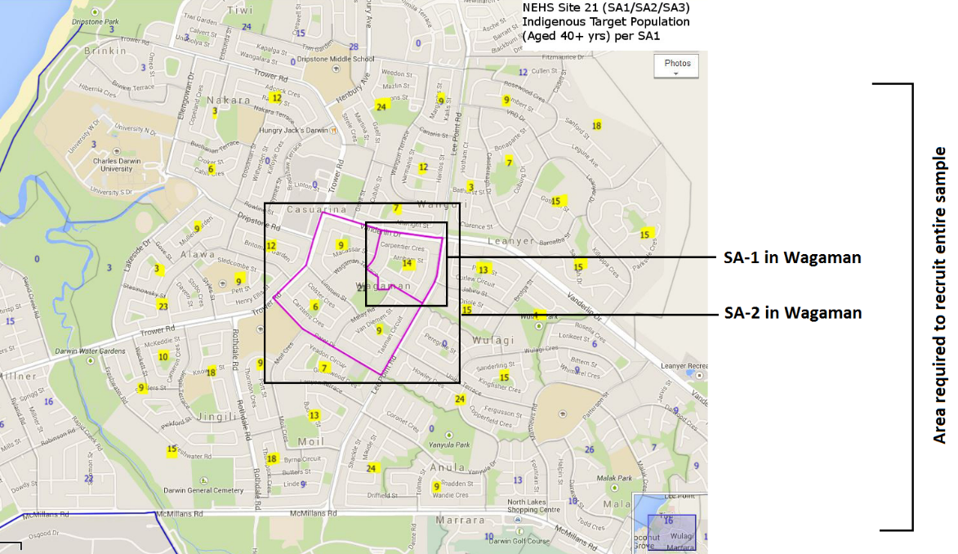
Figure 38. Wagaman (NT) survey site and surrounding area targeted for recruitment

Site 22: Inverell (NSW)
The randomly-selected SA1 for this site was located in the north-eastern area of the regional city of Inverell (Figure 39). All participants were recruited from approximately 5 SA1 sites within the SA2 boundary. A total of 99 eligible non-Indigenous participants were recruited and examined from October 23rd to October 29th 2015. Examinations were conducted at the Inverell Club, Corner Evans Street and Campbell St, Inverell NSW 2360. A total of 88 eligible Indigenous participants were recruited and examined from October 23rd to October 30th 2015. Examinations were conducted at Armajun Aboriginal Health Service, 1 Rivers St, Inverell NSW 2360.

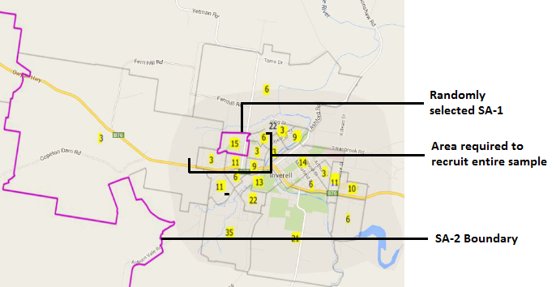
Figure 39. Inverell (NSW) survey site and surrounding area targeted for recruitment

Site 23: Eden (NSW)
The randomly-selected SA1 for this site included two combined adjacent SA1s in the town of Eden (Figure 40). The northern SA1 comprised mostly new estate with young families, and due to time constraints, recruitment would have been unsuccessful in this area. The southern SA1 contained almost no residences. The area consisted almost entirely of a body of water and a beach. Therefore, the next contiguous SA1 was selected for recruitment. This SA1 lies within the more central part of the town of Eden and recruitment in this area was therefore successful. A number of contiguous SA1s were merged with the chosen SA1 site to expand the recruitment site to ensure that optimal recruitment could be conducted. All participants were recruited from within the randomly-selected SA2. A total of 115 eligible non-Indigenous participants were recruited and examined from September 21st to September 26th 2015. Examinations were conducted at Eden RSL Hall, Corner Calle Calle Street and Bass St, Eden NSW 2551. A total of 41 eligible Indigenous participants were recruited and examined from September 21st to September 28th 2015. Examinations were conducted at Eden Fisherman’s Recreation Club, 217 Imlay St, Eden NSW 2551.

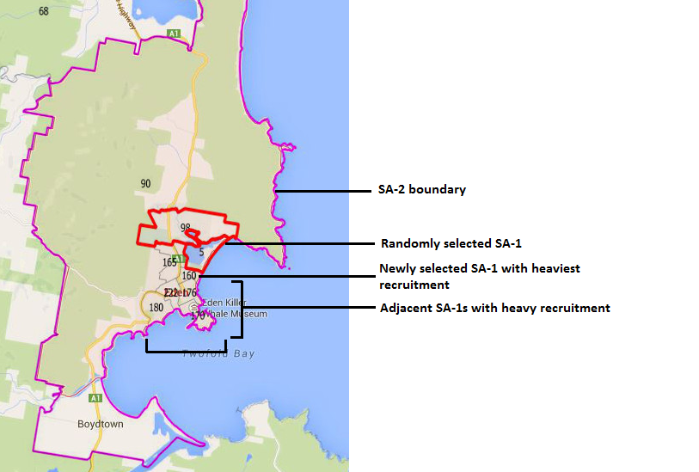
Figure 40.Eden (NSW) survey site and surrounding area targeted for recruitment

Site 24: Katanning (WA)
The randomly-selected SA1 for this site was located in the regional city of Katanning (Figure 41). Recruiters encountered a high proportion of vacant homes, and consequently merged the randomly-selected SA1 with adjacent SA1s to compensate for the lower than expected population size. Recruitment in this SA1 was successful, however, recruiters were required to approach a number of contiguous SA1 sites to recruit the required sample. All participants were recruited from within the boundary of the randomly-selected SA2. A total of 108 eligible non-Indigenous participants were recruited and examined from February 17th to February 24th 2016. Examinations were conducted at the Great Southern Institute of Technology, 9 Dore St, Katanning WA 6317. A total of 105 eligible Indigenous participants were recruited and examined from February 13th to February 19th 2016. Examinations of Indigenous participants were conducted at three locations; Noongar Community Centre in the town of Kojonup, the Noongar Community Centre in the town of Gnowangerup, and the Noongar Community Centre in Katanning. Note that Gnowangerup lies within a RA that is classified as Remote as opposed to Outer Regional, and the participants tested there were subsequently included in the Remote stratum for analysis.

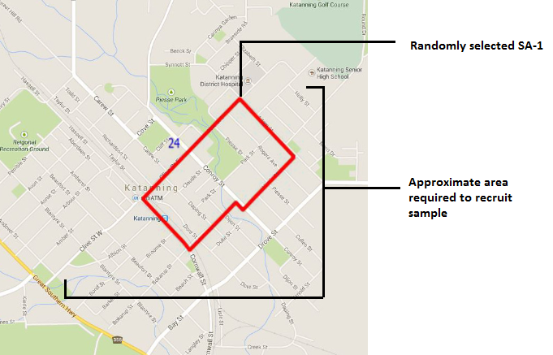
Figure 41. Katanning (WA) survey site and surrounding area targeted for recruitment

Remoteness Area: Remote

Site 25: Banana (QLD) (Back-up site)
The Banana region of Queensland is remote and very sparsely-populated (Figure 42). Therefore, the sampling manager of the survey was consulted to identify an appropriate SA1 to commence recruitment. The selected SA1 was located in the small town of Biloela. Initial efforts to recruit within the SA1 proved difficult due to a high absent rate and a low eligibility rate, and recruiters therefore strategically expanded the recruitment site to include other SA1 sites in Biloela. A total of 113 eligible non-Indigenous participants were recruited and examined from November 5th to November 12th 2015. Examinations were conducted at the Biloela Medical Centre, 38 Dawson Highway, Biloela QLD 4715. The Biloela area did not contain sufficient eligible Indigenous residents to conduct a survey. Consultation with Indigenous organisations revealed that the nearest Indigenous community resided in the region of Mount Morgan, approximately 105km from Biloela (Figure 43). A total of 35 eligible Indigenous participants were recruited and examined from November 13th to November 17th 2015. Examinations were conducted at Bidgerdii Community Health Service, 83 Morgan Street, Mount Morgan QLD 4714.

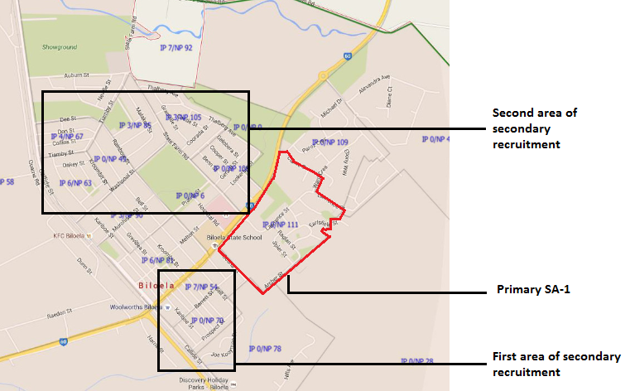
Figure 42. Banana (QLD) survey site and surrounding area targeted for recruitment of non-Indigenous participants

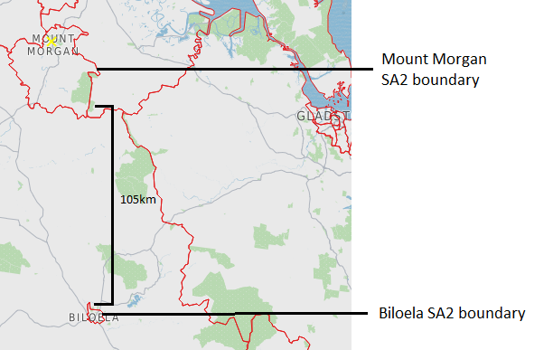
Figure 43.Relative positions of the Biloela back up site, targeted for recruitment of non-Indigenous participants and Mount Morgan, targeted for recruitment of Indigenous participants

Site 26: Daintree (QLD)
The randomly-selected SA1 for this site was located in the isolated coastal suburb of Newell Beach (Figure 44). Newell Beach consists of a high proportion of retired elderly Australians. Therefore, recruitment was highly productive and the majority of participants were recruited from the selected SA1. Due to the remoteness of the region, the next SA1 was located 4.5km from Newell Beach in North Mossman. Recruiters also approached the next coastal suburb of Cooya Beach and the most northerly aspect of the suburb of Mossman to recruit the required sample. A total of 100 eligible non-Indigenous participants were recruited and examined from November 27th to December 3rd 2015. Examinations were conducted at Mossman Boat and Fishing Club, Rankin Street, Newell Beach QLD 4873. A total of 57 eligible Indigenous participants were recruited and examined from November 22nd to November 27th 2015. Examinations were conducted at Mossman Gorge Primary Healthcare Centre, 4 Kankarr Street, Mossman Gorge QLD 4873.

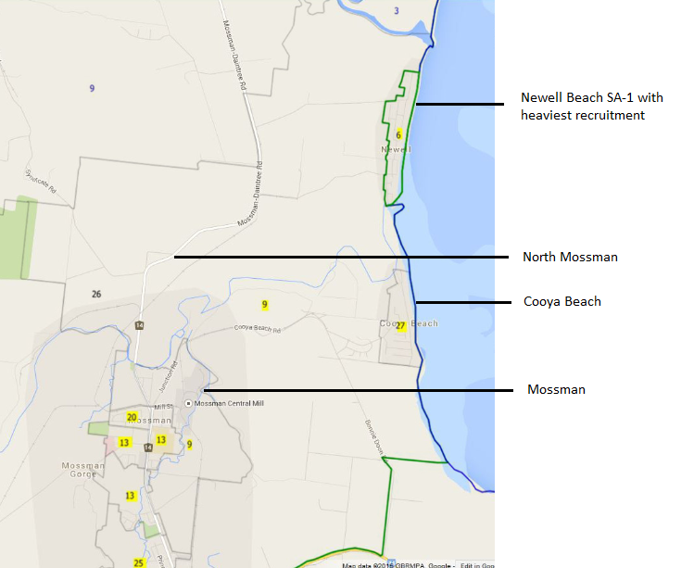
Figure 44.Daintree (QLD) survey site and surrounding area targeted for recruitment

Site 27: Yorke Peninsula-South (SA)
The randomly-selected SA1 for this site was located in a mostly uninhabited area in the southern aspect of the Yorke Peninsula, just west of the small town of Edithburgh and just south of the town of Yorketown (Figure 45). The SA1 spanned approximately 20km from west to east, and consisted mostly of bushland and lakes, rendering recruitment unviable. Therefore, recruiters designated the adjacent SA1s in the town of Yorketown to the north and the town of Edithburgh to the east as the primary areas of recruitment. Recruitment in these towns was successful. A total of 112 eligible non-Indigenous participants were recruited and examined from May 21st to May 29th 2015. Examinations were conducted at Yorke Peninsula Council Office, 15 Edithburgh Road, Yorketown SA 5576 and the Edithburgh Institute Hall, Blanche St, Edithburgh SA 5583.
The southern region of the Yorke Peninsula did not contain sufficient Indigenous population numbers to conduct a survey. Consultation with local Indigenous organisations revealed that the nearest region containing an Indigenous community was the town of Point Pearce, approximately 75km north of Yorketown (Figure 46). A total of 24 eligible Indigenous participants were recruited and examined from May 24th to May 28th 2015. Examinations were conducted at The Point Pearce Women’s Clinic.
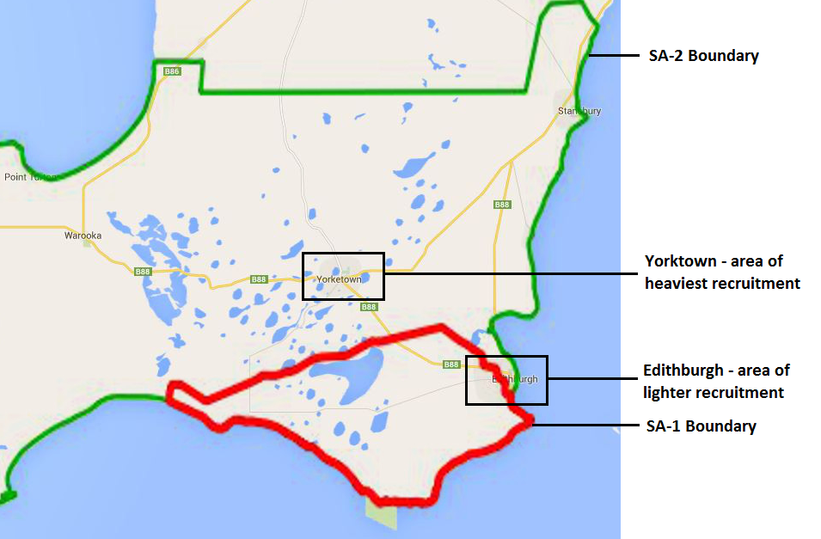
Figure 45.Yorke Peninsula-South (SA) survey site and surrounding area targeted for recruitment

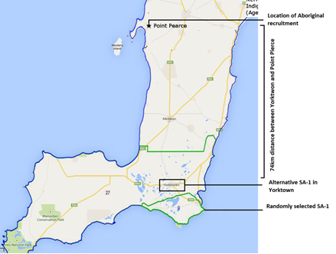

Figure 46. Yorke Peninsula (WA) map illustrating the relative positions of Indigenous and non-Indigenous recruitment sites

Site 28: South Hedland (WA)
The randomly-selected SA1 for this consisted of three contiguous SA1s in the remote town of South Hedland (Figure 47). Three SA1s were required to adjust for the very low eligibility rate within all of the SA1s in South Hedland. The low eligibility rate was reflected in the recruitment process, as all attempts to locate eligible non-Indigenous residents proved extremely challenging. The population of South Hedland consists predominantly of either Indigenous Australians or young non-Indigenous Australians who reside in the town to operate the mining industry. Therefore, very few eligible non-Indigenous residents were located. Multiple attempts were made in South Hedland itself and the nearby town of Port Hedland. However, only 42 eligible non-Indigenous participants were recruited and examined from March 30th to April 6th 2016. Examinations were conducted at South Hedland Lotteries House, 2 Leakes St, South Hedland WA 6722. A total of 86 eligible Indigenous participants were recruited and examined from March 27th to April 1st 2016. Examinations were conducted at Wirraka Maya Health Service Aboriginal Corporation, 17 Hamilton Road, South Hedland WA 6722.

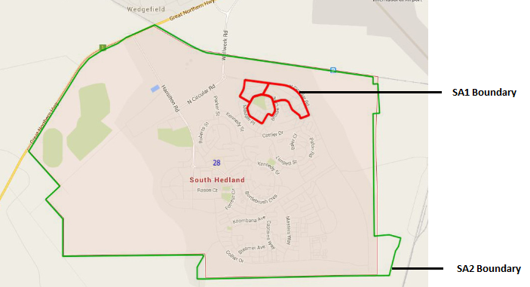
Figure 47. South Hedland (WA) survey site and surrounding area targeted for recruitment

Remoteness Area: Very Remote

Site 29: Exmouth (WA)
The randomly-selected SA1 for this site was located in the very remote town of Exmouth (Figure 48). A number of adjacent SA1s were merged with the selected SA1 to expand the recruitment site. All non-Indigenous participants were recruited from within the SA2 boundary. A total of 101 eligible non-Indigenous participants were recruited and examined from April 4th to April 13th 2016. Examinations were conducted at Exmouth recreation Centre, Murat Rd, Exmouth WA 6067. Recruitment of Indigenous participants was conducted in the very remote town of Onslow, as Exmouth did not contain sufficient Indigenous residents to conduct a survey (Figure 49). A total of 42 eligible Indigenous participants were recruited and examined from April 2nd to April 7th 2016. Examinations were conducted at Discovery Parks, 557 Beadon Creek Road, Onslow WA 6710, between

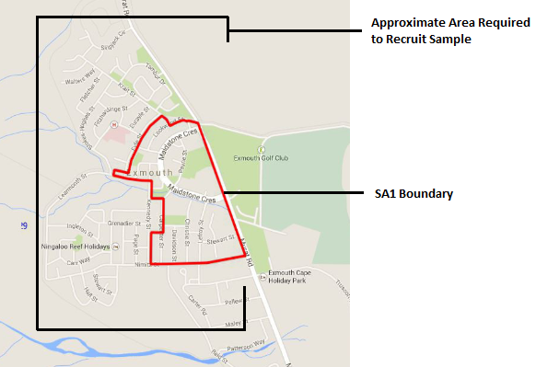
Figure 48. Exmouth (WA) survey site and surrounding area targeted for recruitment

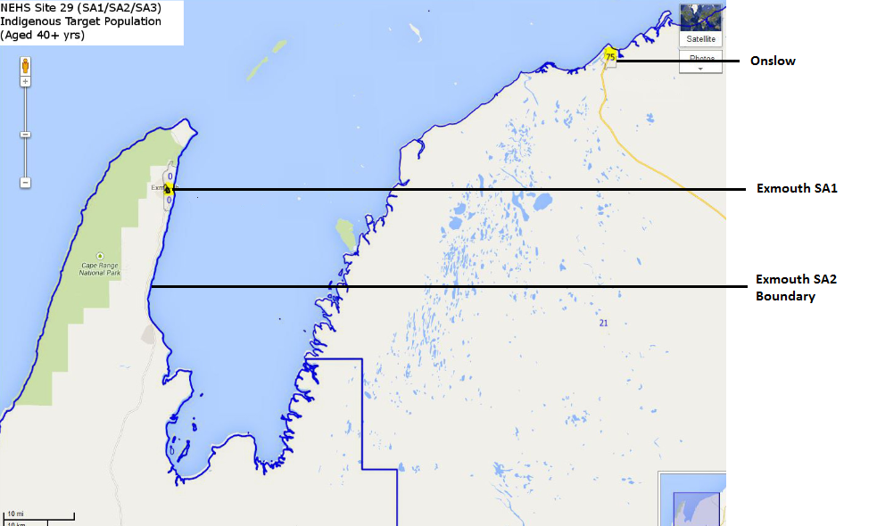
Figure 49. Exmouth (WA) survey site targeted for non-Indigenous recruitment and Onslow (WA) survey site targeted for Indigenous recruitment

Site 30: Esperance Region (WA) (Back-up site)
The vast majority of the Esperance Region SA2 is unpopulated. The town of Esperance itself has a well-settled population, but it constitutes its own discrete SA-2, separate from the Esperance Region SA2, and is characterised as Remote, rather than Very Remote. The selected SA1 was located in the town of Hopetoun, approximately 190km west of the town of Esperance (Figure 50). Recruitment in Hopetoun was successful, and almost all non-Indigenous participants were recruited from only two adjacent SA1s. A total of 116 eligible non-Indigenous participants were recruited and examined from February 26th to March 4th 2016. Examinations were conducted at Hopetoun Community Resource Centre, 2/46 Veal St, Hopetoun WA 6348. Hopetoun did not contain sufficient Indigenous residents to conduct a survey. Therefore, Indigenous participants were recruited from the region surrounding the town of Esperance (Figure 51) . A total of 54 eligible Indigenous participants were recruited and examined from February 20th to February 26th 2016. Examinations were conducted in a Bega Garnbirringu Mobile Clinic.

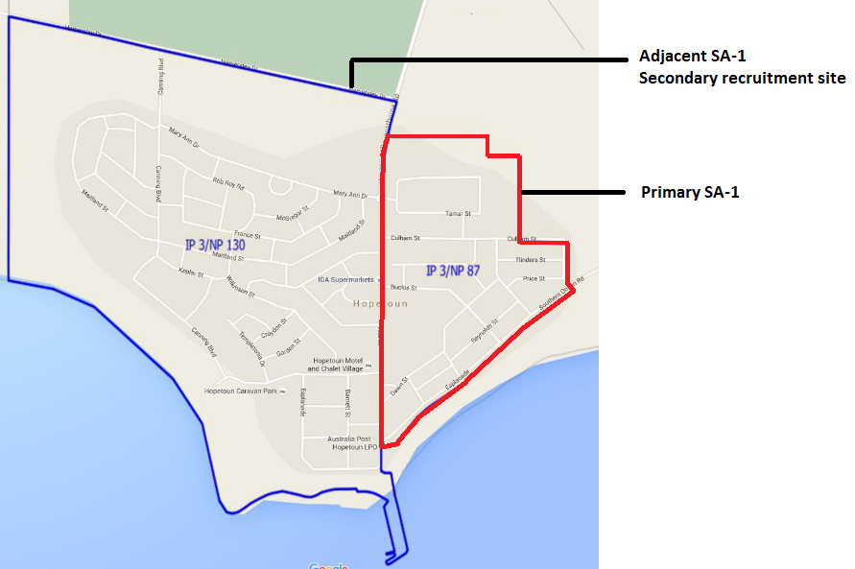
Figure 50. Esperance Region (WA) survey site located in Hopetoun targeted for recruitment

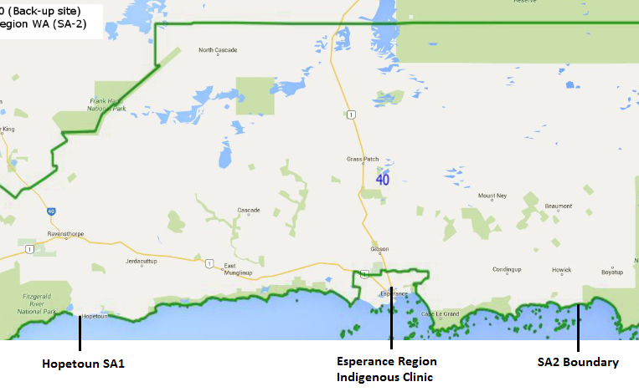
Figure 51. Esperance Region (WA) survey site in Hopetoun targeted for non-Indigenous recruitment and the eastern segment of the Esperance Region SA2 targeted for Indigenous recruitment

Tablet computer recruitment user interface for the NEHS online database
NEHS recruiters entered all information pertaining to the recruitment process into the recruitment interface during door-to-door recruitment using a touch-screen interface on Samsung Galaxy Tab S 10.5 tablet computers, including residential addresses, whether residents were present or absent, resident eligibility, resident responses, sociodemographic information, and appointment times. This information was automatically uploaded to the cloud-based database after which it was viewable and amendable by NEHS clinical staff.

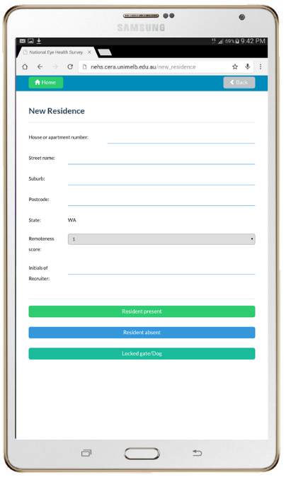
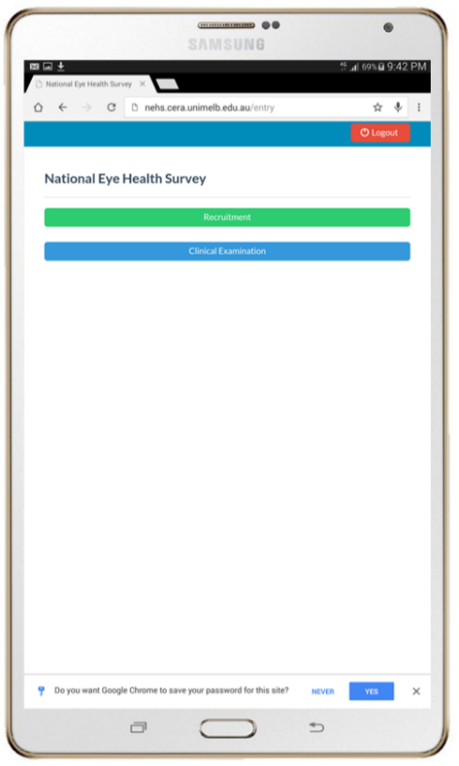
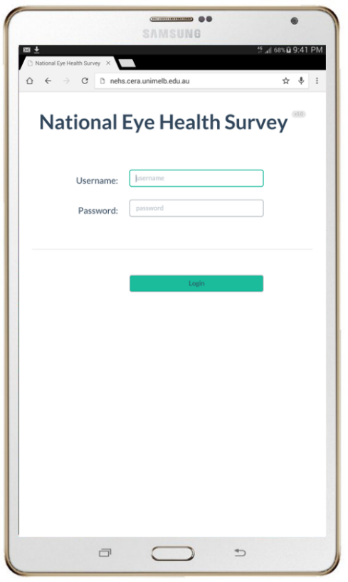
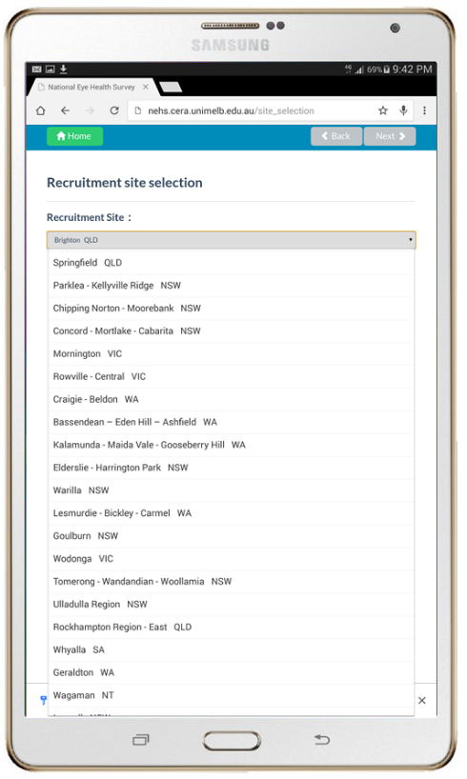
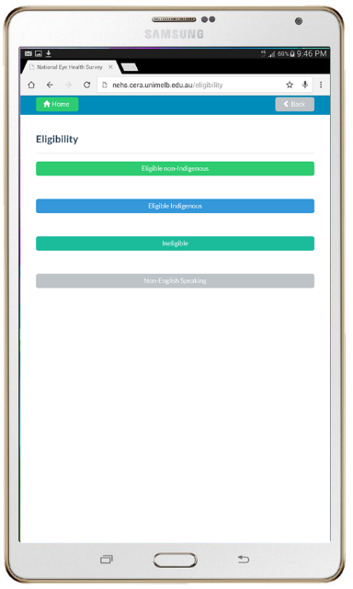
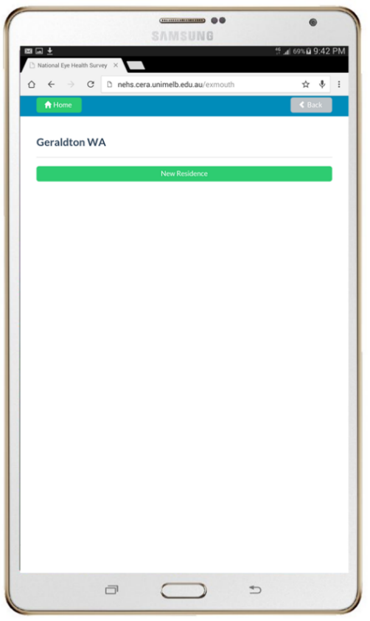
List of 30 sites appears
Select current site
All subsequent data stored in directory for this site
Selecting ‘Resident present’ prompts the ‘Eligibility’ screen.
Select ‘Eligible non-Indigenous’, ‘Eligible Indigenous’, Ineligible’ or ‘Non-English Speaking’.
Selecting ‘Ineligible’ or ‘Non-English Speaking returns to the ‘New Residence’ screen.
Use touchscreen keyboard to enter address, RA and recruiter initials.
Select ‘Resident absent’, ‘Resident present’ or ‘Locked gate/dog’.
Selecting ‘Resident absent’ or Locked gate/dog returns to the ‘New Residence’ screen
Select ‘New Residence’ tab to enter residence details.
Select ‘Recruitment’ tab
Log in to secure online database
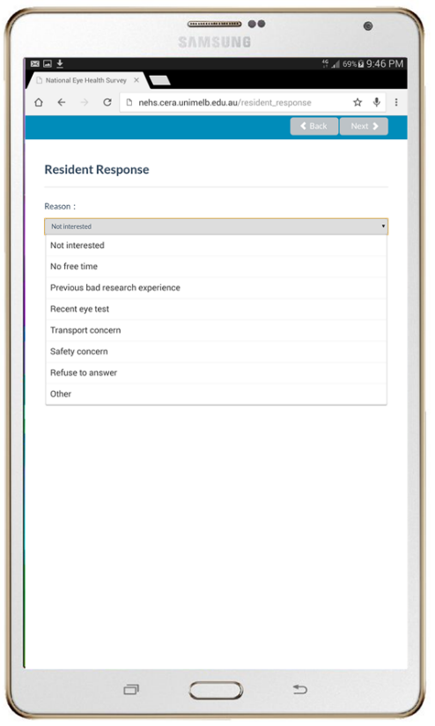
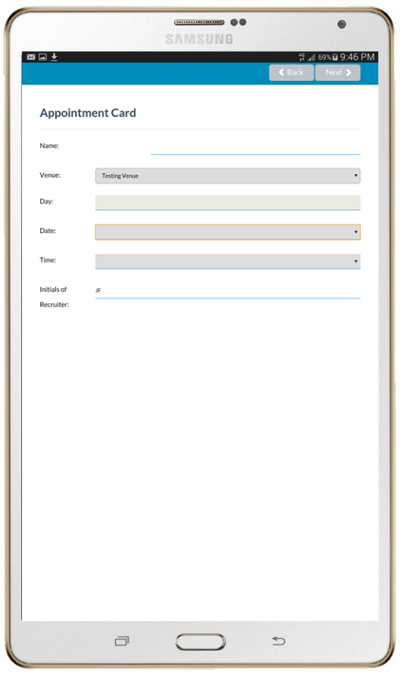
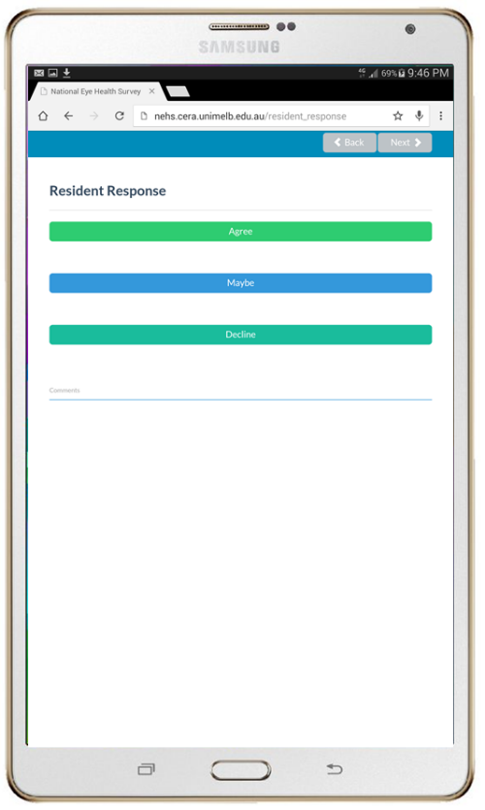
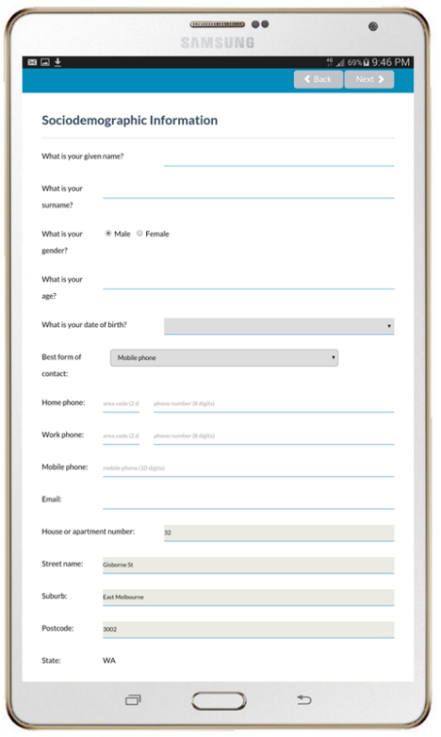
Figure 52. Recruitment user interface of the NEHS cloud-based database
Appointment date, day and time are recorded
If eligible resident provides an ‘Agree’ or ‘Maybe’ response, sociodemographic details are recorded
If eligible resident declines, select the reason for declining from dropdown list
Select ‘Agree’, ‘Maybe’ or ‘Decline’ depending on resident response

Examination equipment
Equipment | Manufacturer | Supplier | Model & Year | Function
LogMAR chart | Brien Holden Vision Institute | Brien Holden Vision Institute |  | Presenting Distance Visual Acuity
Pinhole Occluder |  |  |  | Pinhole Test for those with vision <6/12
Trial lens set | Weidir Impex | Designs for Vision | WD-260MF | Corrected Visual Acuity for those with vision < 6/12
Trial frame | Inami | Designs for Vision | K-0391 | Corrected Visual Acuity for those with vision < 6/12
CERA VISION TEST E chart | Centre for Eye Research Australia | Centre for Eye Research Australia |  | Presenting Near Visual Acuity
Trial frame | Inami | Designs for Vision | K-0391 | Corrected Visual Acuity for those with vision < 6/12
Nidek ARK hand-held auto-refractor | Nidek Co., LTD, Japan | Designs for Vision | ARK-30 Type R 2008 | Auto-refraction for those with vision equal to or worse than 6/12
Keeler PSL – portable slit lamp - (10x) magnification | Keeler Ophthalmic Instruments, UK | Designs for Vision | 3010-P-2001 | Anterior segment assessment & trachoma grading
Frequency Doubling Technology (FDT) | Zeiss Humphrey Systems & Welch Allyn, USA | Carl Zeiss Meditec | 00710-9,  2000 | Visual field Examination
Digital Retinopathy Screening (DRS) non-mydriatic fundus cameras | CenterVue SpA, Italy | Ellex | DRS, 2012 | Macular and optic disc photos
iCare tonometer | iCare, Finland | Designs for Vision | T | Intraocular pressure
Table 27. Major equipment items required for clinical examinations

Procedure | Item
Registration and  consent | Tablet computer
Registration and  consent | Appointment sheet
Registration and  consent | Stapler
Registration and  consent | Participant log
Registration and  consent | Folders
Registration and  consent | Information and consent form
General Questionnaire | Tablet computer
General Questionnaire | Pens
General Questionnaire | Questionnaire hardcopy
General Questionnaire | Folders
Presenting Distance Visual Acuity | logMAR vision chart
Presenting Distance Visual Acuity | Tablet computer
Presenting Distance Visual Acuity | Participant’s distance glasses
Presenting Distance Visual Acuity | Occluder
Presenting Distance Visual Acuity | Tape measure
Presenting Distance Visual Acuity | Examination hardcopy
Presenting Distance Visual Acuity | Alcohol swabs
Pinhole test | logMAR vision chart
Pinhole test | Tablet computer
Pinhole test | Participant’s distance glasses
Pinhole test | Alcohol swabs
Pinhole test | Tape measure
Pinhole test | Examination hardcopy
Pinhole test | Pinhole occluder
Auto-refraction | Nidek Hand-held auto-refractor
Auto-refraction | Extension cord
Auto-refraction | Trial lens set
Auto-refraction | logMAR chart
Auto-refraction | Tablet computer
Auto-refraction | Alcohol swabs
Auto-refraction | Auto-refractor print rolls
Auto-refraction | Trial frame
Auto-refraction | Tape measure
Auto-refraction | Examination hardcopy
Presenting Near Visual Acuity | CERA Low Vision E Chart
Presenting Near Visual Acuity | Alcohol swabs
Presenting Near Visual Acuity | Examination hardcopy
Presenting Near Visual Acuity | Participant’s reading glasses
Presenting Near Visual Acuity | Tablet computer
Anterior segment assessment | Keeler PSL One Hand-held Slit Lamp
Anterior segment assessment | Antiseptic handwash
Anterior segment assessment | WHO Simplified Trachoma Grading System
Anterior segment assessment | Examination hardcopy
Anterior segment assessment | Extension cord
Anterior segment assessment | Diabetic Retinopathy Screening (DRS)
Anterior segment assessment | Tablet computer
Visual Field Test | Zeiss Frequency Doubling Technology (FDT)
Visual Field Test | Alcohol swabs
Visual Field Test | Examination hardcopy
Visual Field Test | FDT printer rolls
Visual Field Test | Tablet computer
Visual Field Test | Extension cord
Fundus Photography | Diabetic Retinopathy Screening (DRS)
Fundus Photography | Extension cord
Fundus Photography | Keeler PSL One Hand-held Slit Lamp
Fundus Photography | Tropicamide 0.5% dilating drops
Fundus Photography | Tissues
Fundus Photography | Tablet computer
Fundus Photography | DRS adjustable platform
Fundus Photography | Alcohol swabs
Fundus Photography | Pen torch
Fundus Photography | Alcaine drops
Fundus Photography | External hard drive
Fundus Photography | Examination hardcopy
Intra-ocular Pressure | iCare Tonometer
Intra-ocular Pressure | Alcohol swabs
Intra-ocular Pressure | Examination hardcopy
Intra-ocular Pressure | iCare Tonometer probes
Intra-ocular Pressure | Tablet computer
Feedback | Tablet computer
Feedback | Referral letter
Feedback | Free OPSM sunglasses
Feedback | Examination hardcopy
Feedback | Certificate of participation

Tablet computer clinical examination user interface

Clinical staff entered all information pertaining to the clinical examination process into the clinical examination interface of the online database during participant examinations using a touch-screen interface on Samsung Galaxy Tab S 10.5 tablet computers, including Participant ID codes, interviewer-administered general questionnaire responses, vision screening results and referral information. The database user interface allowed easy input of examination results and minimised data entry errors by using a conditional logic branching function. These logic branches ensured that options to input results for particular tests, such as pinhole and auto-refraction, were provided only under the precondition that the examiner selected that VA was <6/12. Similarly, logic branching was utilised to ensure that subsets of questionnaire items were only available under preconditions that previous subsets were answered in a manner that required further questioning. The clinical examination interface included a function that allowed examiners to take photographs of FDT result printouts using the tablet computer camera. The photograph was uploaded to a web address, with each photograph possessing its own URL for later download. All information entered into the clinical examination interface was automatically uploaded to the cloud-based database after which it was viewable, amendable and exportable by NEHS staff.

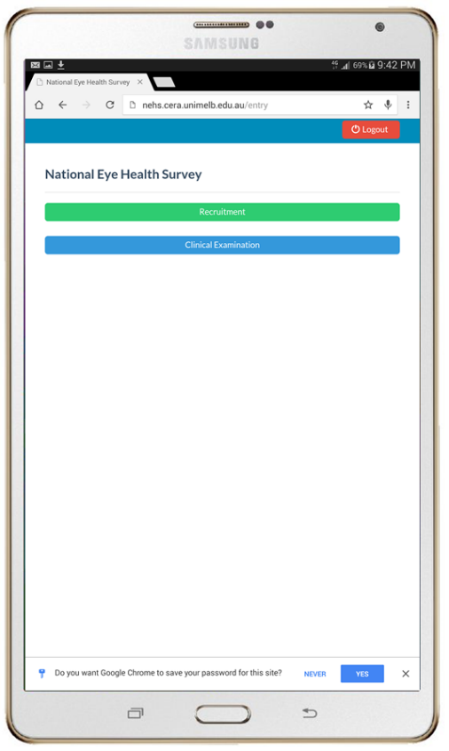
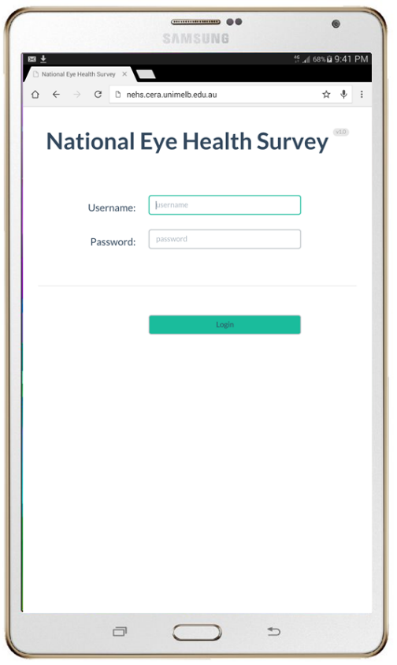
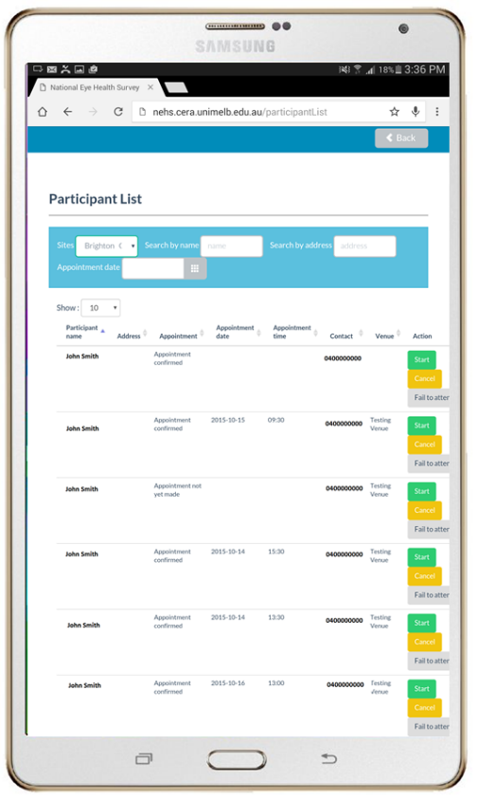
Filter participant list by date or search participant by name
Select ‘Start’ to begin
Log in to secure database.
Select ‘Clinical Examination’.
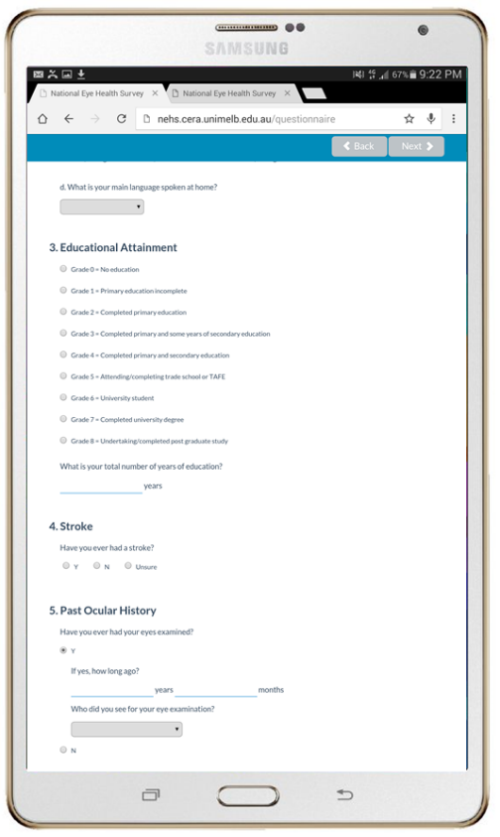
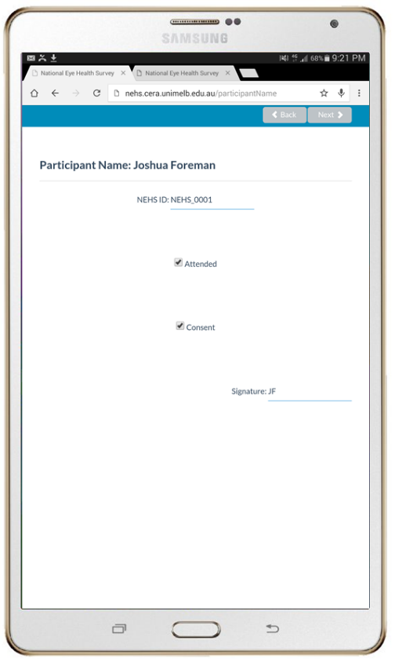
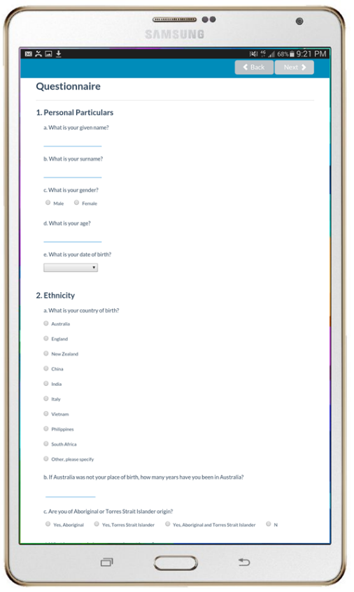
Enter Participant ID.
Select ‘Attended’ and ‘Consent’
Use touchscreen keyboard to enter examiner initials.
Select ‘Next’.
Select highest level of education
Enter number of years of education achieved
Select ‘yes’ or ‘no’ depending on history of stroke

Provide personal particulars:
Name, gender, age, DOB, country of birth, Indigenous status, and main language spoken at home

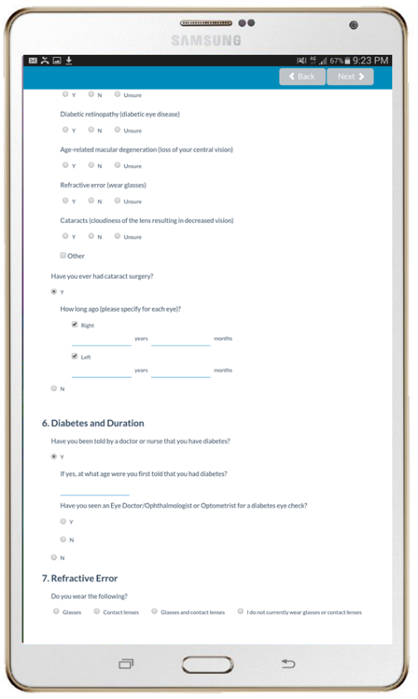
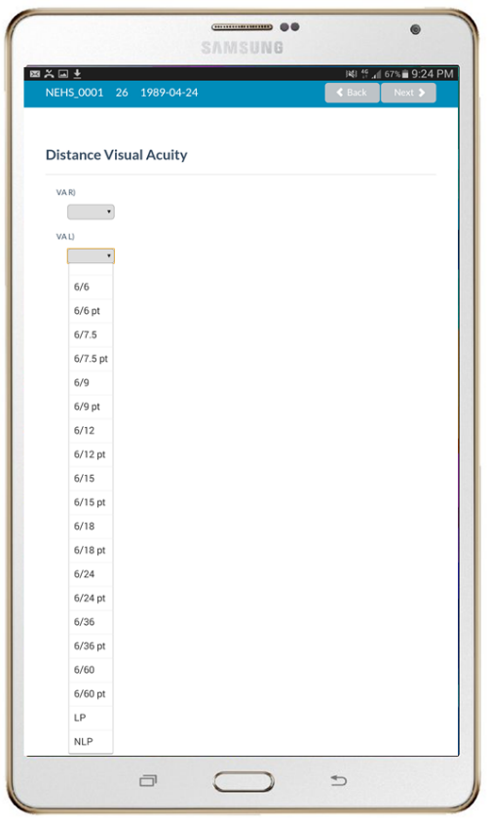
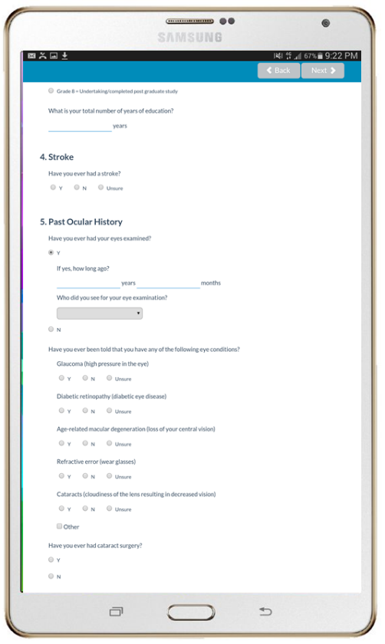
Select Y or N depending on if participant has had cataract surgery
Select ‘Right’ and/or ‘Left’ depending on which eye(s) underwent surgery
Enter years/months since surgery
Select Y or N depending on history of diabetes diagnosis
If Y selected, enter age at which diagnosis occurred
Select Y or N if participant received diabetes eye check – If Y selected, enter years since last check. If N, select reason from dropdown list.
Select ‘Next’.
Click the dropdown list to select the presenting distance visual acuity for each eye.
Select next.
Select ‘Yes’ or ‘No’ depending on whether participant’s eyes have been examined.
Enter number of years/months since examination
Select professional title of examiner from dropdown list
Select Y/N/Unsure for previous diagnosis of major eye conditions:
glaucoma, diabetic retinopathy, age-related macular degeneration, refractive error, cataract and Other

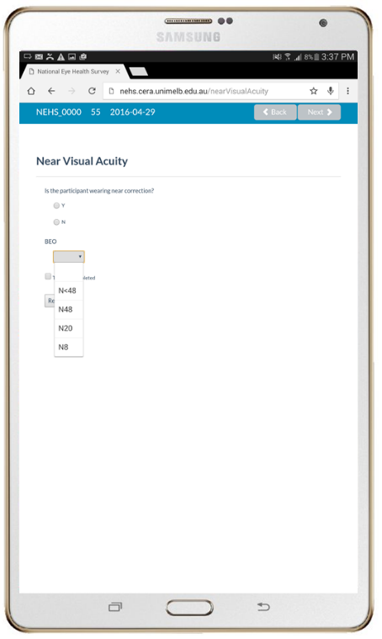
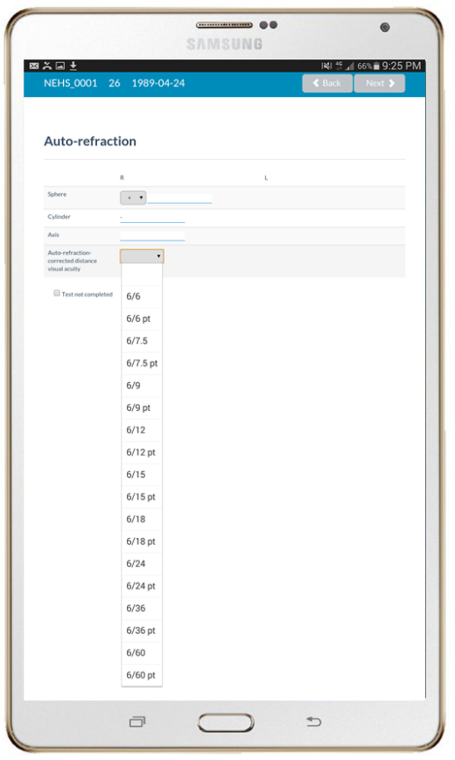
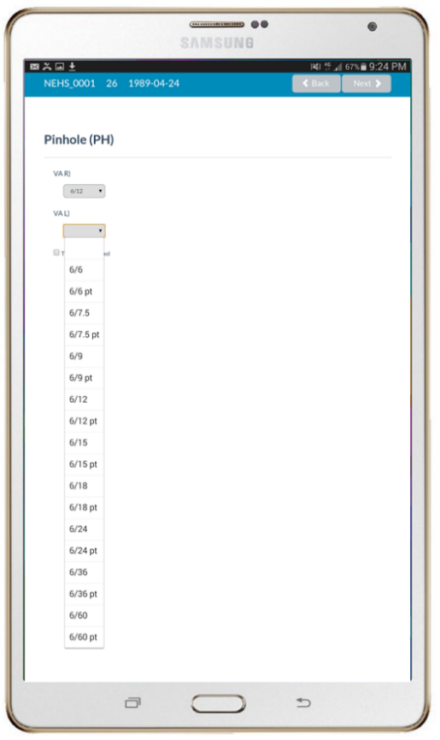
‘Near Visual Acuity’ page appears either after ‘Distance Visual Acuity’, ‘Pinhole’ or ‘Auto-refraction’ depending on conditional logic branching.
Select ‘Y’ or ‘N’ depending on if participant is wearing near correction
Click dropdown list and select option for participant’s near VA.
Select ‘Next’.
‘Auto-refraction’ page appears if visual acuity improved with pinhole testing on the ‘Pinhole’ page in either or both eyes.
Input the spherical, cylindrical and axis readings from the auto-refractor
Click dropdown box and select the visual acuity for either or both eyes corrected by auto-refraction.
Select ’Next’.
‘Pinhole’ page appears if visual acuity was less than 6/12 on the ‘Visual Acuity’ page in either or both eyes.
Dropdown boxes appear for any eye with VA <6/12
Click dropdown box and select pinhole visual acuity for either or both eyes.
Select ‘Next’.
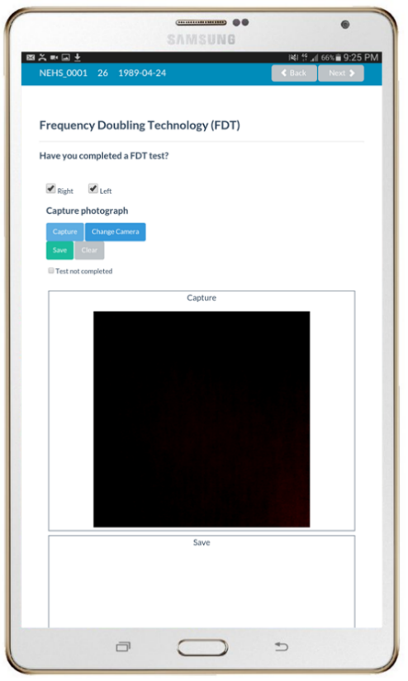
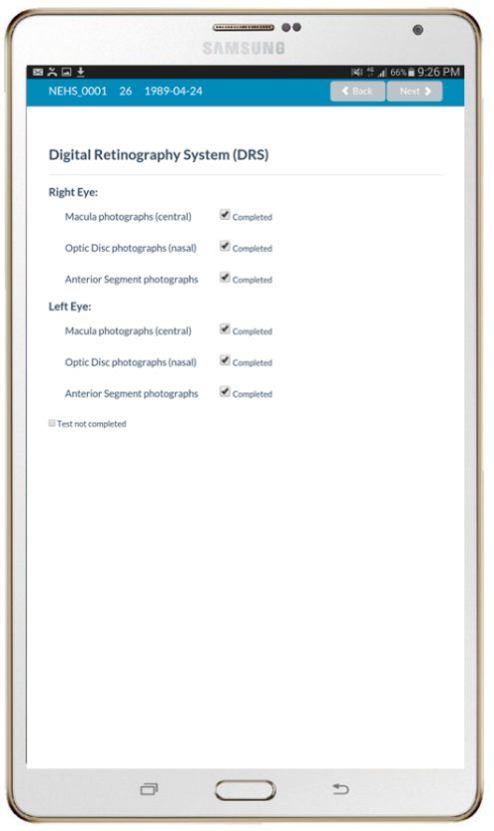
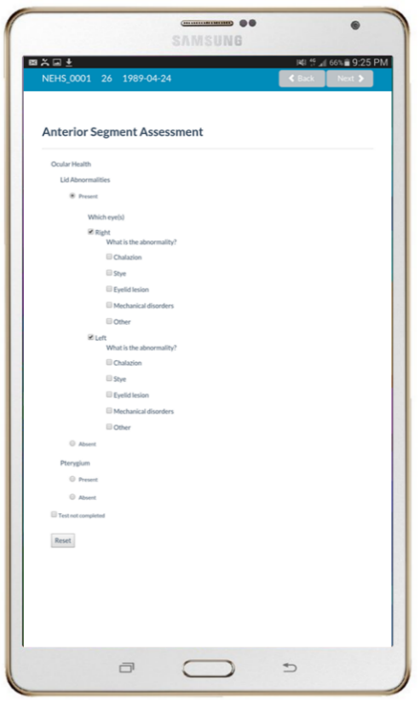
‘Diabetic Retinopathy Screening (DRS)’ page appears
Checkboxes appear for macula and disc fundus photographs for both eyes
Checkboxes appear for anterior segment photographs for either or both eyes for which VA was less than 6/12
Select checkboxes for photographs that have been taken.
Select ‘Next’.
‘Frequency Doubling Technology (FDT)’ page appears.
Select ‘Right’ and/or ‘Left’ for eyes tested.
Select ‘Capture’ to activate tablet camera.
Select ‘Save’ to capture image of FDT printout. (Select ‘Capture’ again if inadequate image quality.)
Select ‘Next’.
‘Anterior Segment Assessment’ page appears.
Trachoma grading appears for participants for whom ‘Y’ was selected in ‘Are you of Aboriginal or Torres Strait Islander origin?’ question.
Select ‘Absent’ or ‘Present’ depending on if trachoma is observed.
Select ‘CO’ or ‘TT’ for trachoma grade if ‘Present’ was selected.
For all participants, select “Absent’ or ‘Present’ depending on if lid abnormalities are observed.
If ‘Present’ was selected, select checkboxes for observed conditions. If other is selected, use keyboard to describe.
Select ‘Present’ or ‘Absent’ if pterygium is observed. If ‘Present’ is selected, select which eyes are affected.
Select ‘Next’.
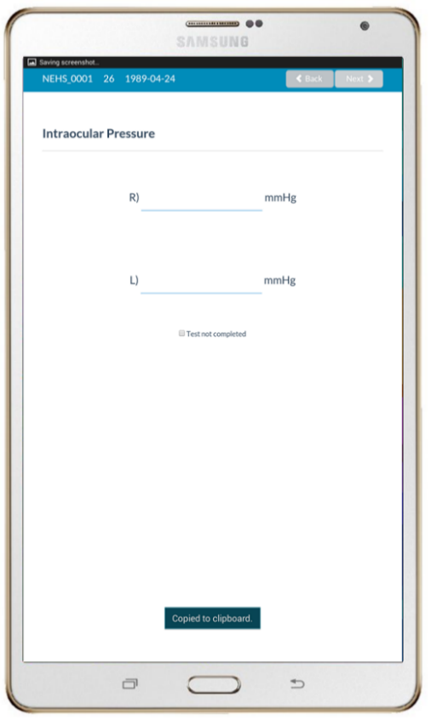
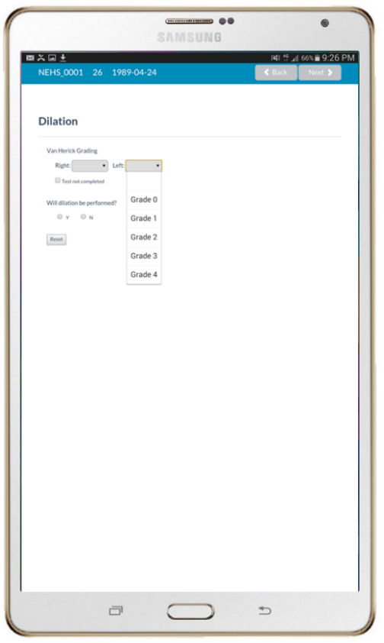
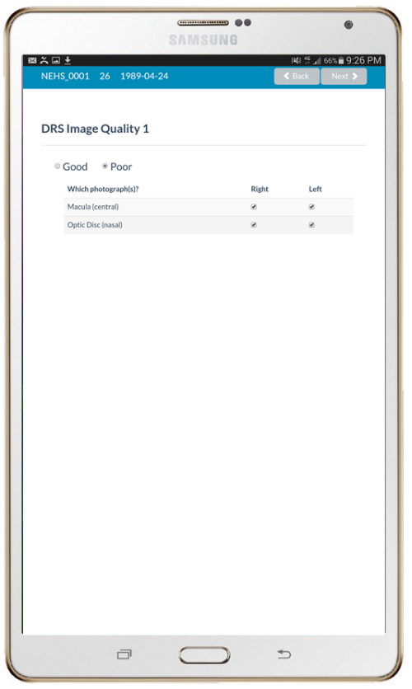
‘Intraocular Pressure’ page appears.
Use touch-screen keyboard to enter intraocular pressure readings.
Select ‘Next’.
‘Dilation’ page appears if ‘Poor’ was selected for DRS image quality.
Dropdown lists appear for Van Herick grades for either or both eyes if their selection boxes were ticked for poor image quality.
Select Van Herick grade
Select ‘Y’ for ‘Will dilation be performed?’ if ‘Grade 3’ or ‘Grade 4’ were selected.
Select ‘Next’.
‘DRS Image Quality’ page appears.
Select ‘Good’ if all fundus photographs are gradable.
Select ‘Poor’ if any fundus photographs are ungradable.
Select checkboxes of ungradable photographs.
Select ‘Next’.
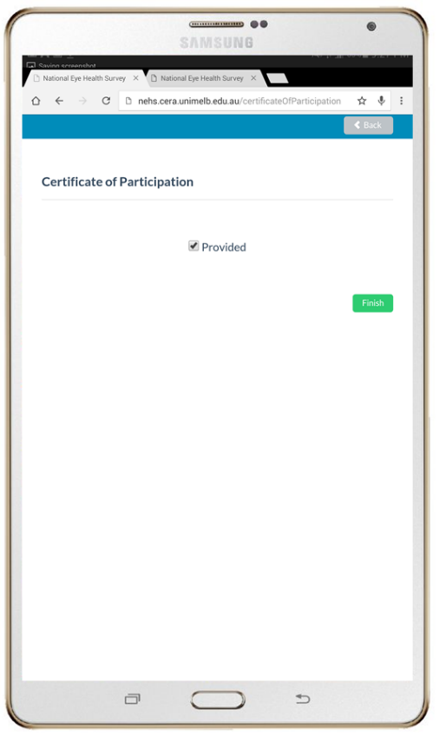
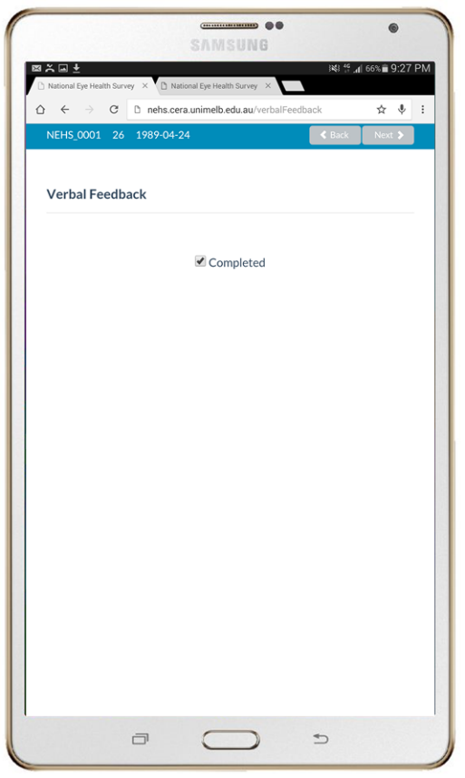
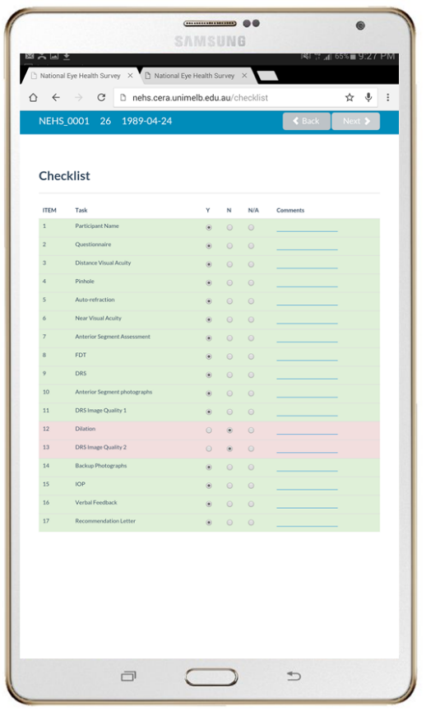
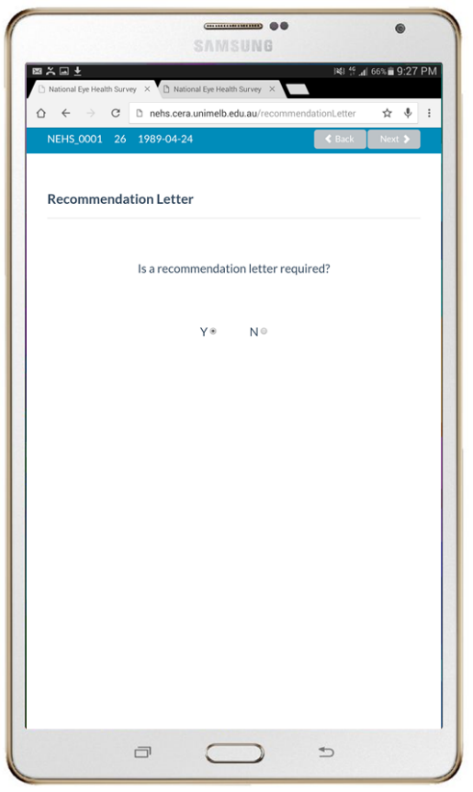
‘Certificate of Participation’ page appears.
Select ‘Provided’ if a certificate of participation was provided to the participant.
Select ‘Finish’
‘Recommendation Letter’ page appears.
Select ‘Y’ if a recommendation for referral is required.
Select ‘N’ if no recommendation for referral is required.
‘Checklist’ page appears.
Check that all relevant items have been completed.
Select ‘Next’.
‘Verbal Feedback’ page appears.
Select ‘Completed’ if feedback was provided.
Select ‘Next’.
Figure 53. Clinical examination user interface of the NEHS cloud-based database

NEHS participant information and consent form

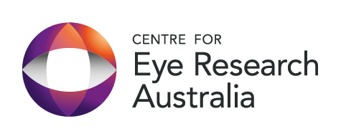
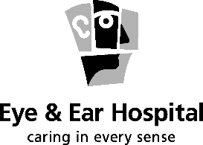
The Royal Victorian
Eye & Ear Hospital
32 Gisborne Street
East Melbourne
Victoria 3002 Australia
Locked Bag 8
East Melbourne
Victoria 8002 Australia
Telephone +61 3 9929 8666
TTY +61 3 9929 8052
Facsimile +61 3 9663 7203
Info@eyeandear.org.au
www.eyeandear.org.au

ABN 81 863 814 677

ROYAL VICTORIAN EYE & EAR HOSPITAL
PARTICIPANT INFORMATION and consent form (PICF)
Version: 1.0 – Dated 12th September 2014
Title | National Eye Health Survey
Short Title | Australian Eye Survey
Protocol Number
Project Sponsor | Vision2020 Australia
Principal Investigator | Dr Mohamed Dirani
Associate Investigator(s) | Professor Hugh Taylor, Professor Jonathan Crowston, Dr Peter van Wijngaarden, Dr Sophia Xie, Mr Ross Dunn, Ms Jennifer Gersbeck
Location | Royal Victorian Eye and Ear Hospital

This Participant Information and Consent Form is 11 pages long. Please make sure you have all the pages.

1. Introduction
You are invited to take part in this research project, National Eye Health Survey, as you have been identified as an eligible participant who meets the criteria for inclusion in this project. The research project is aiming to determine the prevalence of major eye disease in Australians living in urban, regional and rural areas.
This Participant Information and Consent Form tells you about the research project. It explains the tests and research involved. Knowing what is involved will help you decide if you want to take part in the research.
Please read this information carefully. Ask questions about anything that you don’t understand or want to know more about. Before deciding whether or not to take part, you might want to talk about it with a relative, friend or local doctor.
Participation in this research is voluntary. If you don’t wish to take part, you don’t have to. You will receive the best possible care whether you take part or not.
If you decide to take part in the research project, you will be asked to sign the consent section. By signing it, you are telling us that you:
- Understand what you have read;
- Consent to take part in the research project;
- Consent to the tests and research that are described;
- Consent to the use of your personal and health information as described.
You will be given a copy of this Participant Information and Consent Form to keep.
2. Purpose and Background
The purpose of this project is to provide national estimates of the causes and prevalence of the leading eye diseases and conditions in Australia. The following are the objectives and significance of the study:
Objectives
- To determine the prevalence and causes of vision impairment and blindness in Indigenous Australians aged 40 years and over, and non-Indigenous Australians aged 50 years and over, by gender, age, and geographical area.
- To measure the detection and treatment coverage rate of major eye diseases and conditions, including cataract, diabetic retinopathy, glaucoma, age-related macular degeneration and refractive error in both Indigenous and non-Indigenous Australian adults by:
- Determining the proportion of Australians with undiagnosed major eye diseases and uncorrected refractive error.
- Determining the proportion of Australians with known diabetes who adhere to the recommended retinal examination timeframes set by the National Health and Medical Research Council (NHMRC); once every two years for non-Indigenous Australians and once per year for Indigenous Australians.
- To determine an estimation on the rate of cataract surgery and the treatment of uncorrected refractive error in Australia.
Significance
Eye researchers, health professionals and policy makers still rely on prevalence data of blinding eye diseases from two landmark studies that date back to the early 1990s. Both studies, the Blue Mountains Eye Study (BMES) and the Melbourne Vision Impairment Project (VIP), were conducted between 1992-1994, where participants were recruited from selected regions within two Australian States (NSW and VIC), only included non-Indigenous Australians and did not include all levels of remoteness defined by the Australian Bureau of Statistic’s Accessibility/Remoteness Index of Australia (ARIA) regions. This is problematic as policy development, resource allocation and economic analysis of eye diseases and management still utilise these data that are over 20 years old and sub-national.
Our study findings will be presented to the World Health Organisation (WHO), alongside the data from our fellow countries who we actively work with to eliminate the burden of avoidable blindness worldwide. The current NEHS will define the principles and methods to assess the extent of eye disease, provide useful information for policy planning and better direct the allocation of funds.
The NEHS will assist in eye health care in multiple ways, including:
(1) being a core indicator in measuring the progress and impact of eye health care services in Australia;
(2) guiding the use of necessary resources in reducing the prevalence of avoidable vision impairment in Australia;
(3) assisting in developing effective, feasible and cost-effective eye health care services in Australia;
(4) aiding in developing education, awareness and screening programs in communities, including regional and remote areas for the prevention of eye disease.
The NEHS will contribute to achieving the global target of reducing the number of people with avoidable blindness and vision impairment by 25% by the year 2019.
A total of 4500 Australians will participate in this project.
Participant will be identified using sampling methods determined by the Accessibility and Remoteness Index of Australia to obtain a representative sample of Australians across urban, region and rural regions.
The National Eye Health Survey is the first nation-wide survey to determine the prevalence of major eye disease in Indigenous and non-Indigenous Australians. This survey will also provide follow up data for the National Indigenous Eye Health Survey (NIEHS) that was conducted in 2008.
You are invited to participate in this research project because you meet the criteria for inclusion of the survey.
This research is being led by Dr Mohamed Dirani from the Centre for Eye Research Australia, in association with Professor Hugh Taylor from the University of Melbourne, Professor Jonathan Crowston, Dr Peter van Wijngaarden, Mr Ross Dunn and Dr Sophia Xie from the Centre for Eye Research Australia, and with Jennifer Gersbeck, the CEO of Vision2020 Australia, who is the project sponsor.
This research has been funded by the Federal Government, with contributions from our major industry partners, including Novartis Pharmaceuticals, Luxottica (OneSight) and Optometry Australia.
Research coordinated outside the Centre for Eye Research Australia will be coordinated by the Lead Researcher Dr Mohamed Dirani, in collaboration with industry contributors, Luxottica and Optometry Australia.
- What is Involved?
If you agree to participate in this survey, and you meet the inclusion criteria of the survey determined by age and residence, you will be invited to attend one of the Survey testing sites to complete a short questionnaire and undergo a series of eye tests.
Testing will take approximately 30 to 45 minutes to complete.
General Questionnaire
The general questionnaire will obtain information on person particulars, including age, gender, ethnicity, and a thorough history on you general and eye health will be collected.
Eye Tests
There will be a number of eye tests that will be conducted, these include:
- Testing of your vision for both distance viewing and reading
- In those with reduced vision as determined by the protocol (less than 6/12 vision), a further test to determine the level of short-sightedness, long-sightedness or astigmatism using a non-invasive automated machine
- Digital photographs of the back of the eye will be taken using a special camera which is used in routine optometry and ophthalmological clinics
- To obtain measurements of your peripheral (side) vision, you will undergo a visual field test in each eye using Frequency Doubling Technology (FDT) Perimetry.
- An examination of the front part of your eye will be taken using a handheld slit lamp to obtain a general overview of the health of your eyes and eye lids.
All participants will be provided with verbal feedback on their eye test results at the completion of the clinical examination. Any participant with undiagnosed eye disease that can be detected through the survey’s testing protocol will receive a letter of recommendations for referral to an appropriate eye care professional.
Dilating Eye Drops
It is very important that we have a clear view through to the back of your eye to obtain high quality photographs. This is typically determined by the size of your pupil. At first instance, we will attempt to achieve the necessary pupil dilation by darkening the examination room, however if this is not achieved, standard dilating drops (Tropicamide) will be used to increase pupil size. These drops will be administered by trained staff 20 to 25 minutes before photographs are taken.
4. Possible Benefits
We cannot guarantee or promise that you will receive any benefits from this research, however if an eye condition is identified by the survey you will be provided with an appropriate referral recommendation to an eye care professional.
Possible benefits may include better guidance on eye care interventions for the broader community determined by this survey’s results. Also the Government will be better informed on the allocation of necessary eye services in Australia.
5. Possible Risks
While this research does not involve any interventional treatment, you may be receiving medical treatments that cause side effects. You may have none, some or all of the effects listed below, and they may be mild, moderate or severe. If you have any of these side effects, or are worried about them, talk with your study researcher. Your study researcher will also be looking out for side effects.
There may be side effects that the researchers do not expect or do not know about and that may be serious. Tell your study researcher immediately about any new or unusual symptoms that you get.
Many side effects go away shortly after treatment ends. However, sometimes side effects can be serious, long lasting or permanent. If a severe side effect or reaction occurs, your study researcher may need to stop your involvement with the study. Your study researcher will discuss the best way of managing any side effects with you and a doctor if necessary.
Possible risks, side effects and discomforts include:
With the initial instillation of the drops, you may experience a stinging sensation for several seconds. Also, dilation of the pupils may cause light sensitivity and will blur your vision for several hours. In rare situations (studies estimate it at 3 in 10000 people), the use of these drops can trigger a condition called angle closure glaucoma. If such an event occurs, eye care specialist services will be required immediately so that the condition can be treated. We do not advise you to drive after the use of these drops and other arrangements for transport should be put in place. We also advise you to bring sunglasses to the examination for comfort in daylight. Please note that these drops are only expected to be used in less than 20% of participants and you may decline administration of them.
To avoid any physical discomfort with seating positions during eye testing, examiners will ensure that you are comfortable at all times, however if you feel any discomfort at all during the testing please inform one of the examiners. Also, you will be offered frequent breaks to ensure optimal comfort during the entire course of the testing.
With some of the tests, particularly the camera used to take photos of the back of the eye, discomfort may be experienced with the flash used with the camera. This flash is the same as what you would experience using a regular camera. You will be given regular breaks to minimise any eye discomfort from these types of tests, but please do not hesitate to inform the examiner if longer breaks are required.
Participants can suspend or even end their participation at any time in the project if distress occurs.
There may be additional unforeseen or unknown risks that the researchers do not expect or do not know about. Tell a member of the research team immediately about any new or unusual symptoms that you get.
6. New Information Arising During the Project
Sometimes during the course of the research project, new information becomes available about the treatment that is being studied. If this happens, your study doctor will tell you about it and discuss with you whether you want to continue in the research project. If you decide to withdraw, your study doctor will make arrangements for your regular health care to continue. If you decide to continue in the research project you will be asked to sign an updated consent form.
Also, on receiving new information, your study doctor might consider it to be in your best interests to withdraw you from the research project. If this happens, he/she will explain the reasons and arrange for your regular health care to continue.
7. Other Treatments Whilst on Study
While you are participating in this research project, you may not be able to take some or all of the medications or treatments that you have been taking for your condition or for other reasons. It is important to tell your study doctor and the study staff about any treatments or medications you may be taking, including over-the-counter medications, vitamins or herbal remedies, acupuncture or other alternative treatments. You should also tell study staff about any changes to these during your participation in the research. Your study doctor should also explain to you which treatments or medications need to be stopped for the time you are involved in the research project.
It is not expected that you will need to stop any treatment whilst involved in this study.
8. Alternatives to Participation
There is no standard procedure or treatment that is being withheld as a result of your participation in this study. You do not have to take part in this research project to receive treatment at this hospital.
9. Participation is Voluntary
Participation in any research project is voluntary. If you do not wish to take part, you do not have to. If you decide to take part and later change your mind, you are free to withdraw from the project at any stage.
If you do decide to take part, you will be given this Participant Information and Consent Form to sign and you will be given a copy to keep.
Your decision whether to take part or not to take part, or to take part and then withdraw, will not affect your routine treatment, your relationship with those treating you or your relationship with the Royal Victorian Eye & Ear Hospital.
Before you make your decision, a member of the research team will be available so that you can ask any questions you have about the research project. You can ask for any information you want. Sign the Consent Form only after you have had a chance to ask your questions and have received satisfactory answers.
If you decide to withdraw from this project, please notify a member of the research team before you withdraw. This notice will allow that person or the research supervisor to discuss any health risks or special requirements linked to withdrawing.
If you do withdraw your consent during the research project, the study doctor and relevant study staff will not collect additional personal information from you, although personal information already collected will be retained to ensure that the results of the research project can be measured properly and to comply with law. You should be aware that data collected by the sponsor up to the time you withdraw will form part of the research project results. If you do not want them to do this, you must tell them before you join the research project.
10. Results of Project
Participants will be informed via their preferred from of contact of the results when the research project is complete and the data is published. Also, media release, progress reports and associated newsletters will be accessible to all participants online.
11. Privacy, Confidentiality and Disclosure of Information
By signing the consent form you consent to the study doctor and relevant research staff collecting and using personal information about you for the research project. Any information obtained in connection with this research project that can identify you will remain confidential. Your information will only be used for the purpose of this research project and it will only be disclosed with your permission, except as required by law.
It is anticipated that the results of this research project will be published and/or presented in a variety of forums. In any publication and/or presentation, information will be provided in such a way that you cannot be identified, except with your permission.
In accordance with relevant Australian and/or Victorian privacy and other relevant laws, you have the right to request access to your information collected and stored by the research team. You also have the right to request that any information with which you disagree be corrected. Please contact the study team member named at the end of this document if you would like to access your information.

Any information obtained for the purpose of this research project that can identify you will be treated as confidential and securely stored. It will be disclosed only with your permission, as or required by law.
13. Injury
If you suffer any injuries or complications as a result of this research project, you should contact the study team as soon as possible and you will be assisted with arranging appropriate medical treatment. If you are eligible for Medicare, you can receive any medical treatment required to treat the injury or complication, free of charge, as a public patient in any Australian public hospital.
14. Who is organising and funding the research?
This research project is being conducted by Dr Mohamed Dirani from the Centre for Eye Research Australia and Ms Jennifer Gersbeck from Vision2020 Australia. The Federal Government has funded the project with contributions from industry and not-for-profit partners.

There are no financial benefits that might arise from the conduct of the research. You will not benefit financially from your involvement in this research project even if, for example, your results (or knowledge acquired from analysis of your samples) prove to be of commercial value to the Centre for Eye Research Australia. In addition, if knowledge acquired through this research leads to discoveries that are of commercial value to the Centre for Eye Research Australia, the study doctors or their institutions, there will be no financial benefit to you or your family from these discoveries. The Centre for Eye Research Australia will receive a payment from Vision2020 Australia for undertaking this research project. No member of the research team will receive a personal financial benefit from your involvement in this research project (other than their ordinary wages).

15. Additional costs and reimbursement
There are no costs associated with participating in this research project, nor will you be paid.
16. Ethical Guidelines
All research in Australia involving humans is reviewed by an independent group of people called a Human Research Ethics Committee (HREC). The ethical aspects of this research project have been approved by the HREC of the Royal Victorian Eye & Ear Hospital.
This project will be carried out according to the National Statement on Ethical Conduct in Human Research (2007). This statement has been developed to protect the interests of people who agree to participate in human research studies.
17. Who can I Contact?
The person you may need to contact will depend on the nature of your query.
If you want any further information concerning this project or if you have any medical problems which may be related to your involvement in the project (for example, any side effects), you can contact the principal study doctor on 9929 8115 or any of the following people:
Study contact person
Name | Dr Mohamed Dirani
Position | Principal Investigator
Telephone | 03 9929 8190
Email | dirani@unimelb.edu.au

For complaints
If you have any complaints about any aspect of the project, the way it is being conducted or any questions about your rights as a research participant, then you may contact
Position: HREC Secretary
Telephone: (03) 9929 8525
You will need to tell the Secretary the name of one of the researchers listed above.
Reviewing HREC:
The reviewing HREC approving this research and contact details of the Executive Officer are:
Reviewing HREC name: Royal Victorian Eye & Ear Hospital
Position: HREC Secretary
Telephone: (03) 9929 8525

Email: ethics@eyeandear.org.au

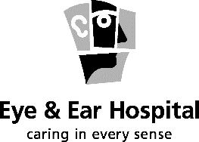
CONSENT FORM - Adult providing own consent
Version: 1.0 – Dated 12th September 2014

Title | National Eye Health Survey
Short Title | Australian Eye Survey
Project Sponsor | Vision2020 Australia
Principal Investigator | Dr Mohamed Dirani
Associate Investigator(s) | Professor Hugh Taylor, Professor Jonathan Crowston, Dr Peter van Wijngaarden, Dr Sophia  Xie, Mr Ross Dunn, Ms Jennifer Gersbeck
Location (where CPI/PI will recruit) | Royal Victorian Eye and Ear Hospital

Declaration by Participant
I have read the Participant Information Sheet, or someone has read it to me in a language that I understand.
I understand the purposes, procedures and risks of the research described in the project.
I have had an opportunity to ask questions and I am satisfied with the answers I have received.
I freely agree to participate in this research project as described and understand that I am free to withdraw at any time during the study without affecting my future health care.
I understand that I will be given a signed copy of this document to keep.
Participant’s Name (printed) ……………………………………………………
Signature Date

Witness (where required – see Note for Guidance on Good Clinical Practice CPMP/ICH/135/95 at 4.8.9)
Name of Witness* to Participant’s Signature (printed) ……………………………………………
Signature Date
* Witness is not to be the investigator, a member of the study team or their delegate. In the event that an interpreter is used, the interpreter may not act as a witness to the consent process. Witness must be 18 years or older.

Declaration by study doctor/senior researcher*: I have given a verbal explanation of the research project, its procedures and risks and I believe that the participant has understood that explanation.
Researcher’s Name (printed) ……………………………………………………
Signature Date
* A senior member of the research team must provide the explanation and provision of information concerning the research project.
Note: All parties signing the Consent Form must date their own signature.
CONSENT FORM - Person Responsible
Version: 1.0 – Dated 12th September 2014

Title | National Eye Health Survey
Short Title | Australian Eye Survey
Project Sponsor | Vision2020 Australia
Principal Investigator | Dr Mohamed Dirani
Associate Investigator(s) | Professor Hugh Taylor, Professor Jonathan Crowston, Dr Peter van Wijngaarden, Dr Sophia  Xie, Mr Ross Dunn, Ms Jennifer Gersbeck
Location (where CPI/PI will recruit) | Royal Victorian Eye and Ear Hospital

Declaration by Participant
I have read the Participant Information Sheet or someone has read it to me in a language that I understand.
I understand the purposes, procedures and risks of the research described in the project.
I have had an opportunity to ask questions and I am satisfied with the answers I have received.
I freely agree to the participant taking part in this research project as described and understand that I am free to withdraw them at any time during the project without affecting their future health care.
I understand that I will be given a signed copy of this document to keep.

Participant’s Name (printed) ……………………………………………………
Name of Person Responsible giving consent (printed) …………………………………….
Relationship of Person Responsible to participant: …………………………………………………….
(as defined by the Guardianship and Administration Act 1986)

Signature Date

Witness
Name of Witness to Person Responsible’s Signature (printed) ……………………………………………
Signature Date

Declaration by study doctor/senior researcher*: I have given a verbal explanation of the research project, its procedures and risks and I believe that the person responsible for the participant has understood that explanation.
Researcher’s Name (printed) ……………………………………………………
Signature Date
* A senior member of the research team must provide the explanation and provision of information concerning the research project.
Note: All parties signing the Consent Form must date their own signature.
form for withdrawal of participation
It is recommended that this form NOT be included as part of the PICF itself, but that it be developed at the same time and made available to researchers for later use, if necessary. Note that a participant’s decision to withdraw their separate consent to the use and storage of tissue will need to be documented separately and linked to the PICF used for that purpose.
On Institution’s Letterhead
Title | National Eye Health Survey
Short Title | Australian Eye Survey
Project Sponsor | Vision2020 Australia
Coordinating Principal Investigator/ Principal Investigator | Dr Mohamed Dirani
Associate Investigator(s) | Professor Hugh Taylor, Professor Jonathan Crowston, Dr Peter van Wijngaarden, Dr Sophia  Xie, Mr Ross Dunn, Ms Jennifer Gersbeck

Declaration by Participant
I wish to WITHDRAW from participation in the above research project and understand that such withdrawal WILL NOT affect my routine treatment, my relationship with those treating me or my relationship with the Royal Victorian Eye & Ear Hospital.

Participant’s Name (printed) …………………………………………………….

Signature Date

In the event that the participant’s decision to withdraw is communicated verbally, the Study Doctor/Senior Research will need to provide a description of the circumstances below.
Declaration by study doctor/senior researcher*: I have given a verbal explanation of the implications of withdrawal from the research project and I believe that the participant has understood that explanation.
Researcher’s Name (printed) ……………………………………………………
Signature Date
* A senior member of the research team must provide the explanation and provision of information concerning the research project.
Note: All parties signing the Consent Form must date their own signature.

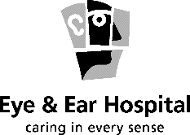
ROYAL VICTORIAN EYE & EAR HOSPITAL
EXPERIMENTAL PARTICIPANT’S STATEMENT OF RIGHTS

The Royal Victorian Eye and Ear Hospital considers it important that you know:

Any patient who is asked to participate in a research study involving medical experiment, or who is requested to consent on behalf of another, has the right to:
- Be informed of the nature and purpose of the experiment.
- Be given an explanation of the procedures to be followed and any drugs used in the medical experiment.
- Be given a description of discomforts and risks reasonably expected from the experiment, if applicable.
- Be given an explanation of any benefits to the participant reasonably to be expected from the experiment, if applicable.
- Be advised of appropriate, alternative procedures, drugs, or devices that might be advantageous to the participant, and their relative risks and benefits.
- Be informed of the avenue of medical treatment, if any, available to the participant after the experiment if complications should arise.
- Be given an opportunity to ask questions concerning the experiment or the procedures involved.
- Know that consent to participate in the medical experiment may be withdrawn at any time, and that the participant may discontinue participation in the medical experiment without prejudice.
- Be given a copy of the signed and dated written consent form when one is required.
- Be given the opportunity to decide to consent or not to consent to a medical experiment without the intervention of any element of force, fraud, deceit, duress, coercion or undue influence.

General questionnaire and examination hardcopy

National Eye Health Survey questionnaire (hard copy)
Interviewer Initials: _ _ _
Interviewer Code: NEHS _ _
Date of Examination: _ _ (dd) /_ _ (mm) /_ _ _ _ (yyyy)
Time of Examination: _____ am/pm
Participant Unique ID: NEHS _ _ _ _

- Personal Particulars:
  - What is your given name?__________________________________________
  - What is your surname?____________________________________________
  - What is your gender? Tick the correct option
Male
Female

d. What is your age? _______
e. What is your date of birth? _ _ (dd) /_ _ (mm) /_ _ _ _ (yyyy)
- Ethnicity:
  - What is your country of birth? Tick the correct option
Australia
England
New Zealand
China
India
Italy
Vietnam
Philippines
South Africa
Other, please specify___________________________________________

  - If Australia was not your place of birth, how many years have you been in Australia? Record as a whole number
__________________________________________________________

  - Are you of Aboriginal or Torres Strait Islander origin? Tick the correct option
Yes, Aboriginal
Yes, Torres Strait Islander
Yes, Aboriginal and Torres Strait Islander
No
  - What is the main language you speak at home? Tick the correct option
English
Italian
Greek
Cantonese
Arabic
Vietnamese
Indigenous language, please specify_______________________________
Other, please specify___________________________________________
- Educational Attainment:
- What is your highest level of education? Tick the correct option
Grade 0 = No education
Grade 1 = Primary education incomplete
Grade 2 = Completed primary education
Grade 3 = Completed primary and some years of secondary education
Grade 4 = Completed primary and secondary education
Grade 5 = Attending/completing trade school or TAFE
Grade 6 = University student
Grade 7 = Completed university degree
Grade 8 = Undertaking/completed post graduate study
- Total number of years of education _____ years Record in years
- Stroke:
  - Have you ever had a stroke? Tick the correct option
Yes
No
- Past Ocular History:
  - Have you ever had your eyes examined? Tick the correct option
Yes
No (Proceed to d)
  - If yes, how long ago? Record in years and months _____ years _____ months

  - Who did you see for your eye examination? Tick more than one
Optometrist
Eye Doctor/Ophthalmologist
GP/Local Doctor
Nurse
Health Worker
Ophthalmic Nurse/Technician
Other, please specify___________________________________________

  - Have you ever been told that you have any of the following eye conditions?
Tick the correct option for each eye condition.

Eye Condition | Yes | No | Unsure
Glaucoma (high pressure in the eye)
Diabetic Retinopathy (diabetic eye disease)
Age-related macular degeneration (loss of your central vision)
Refractive error (wear glasses)
Cataracts (cloudiness of the lens resulting in decreased vision)

Other, please specify: _______________________________________________________________

  - Have you ever had cataract surgery? Tick the correct option
Yes
No (Proceed to Question 6)

  - If yes, to which eye? Tick the correct option
Right
Left
Both eyes

  - If yes, how long ago (please specify for each eye)?Record in years and months

R) _____ years _____ months L) _____ years _____ months
- Diabetes and Duration:
  - Have you been told by a doctor or nurse that you have diabetes? Tick the correct option.
Yes
No (Proceed to Question 7)

  - If yes, at what age were you first told that you had diabetes? Record in years
_____ years old

  - Have you seen an Eye Doctor/Ophthalmologist or Optometrist for a diabetes eye check? Tick the correct option
Yes
No (Proceed to e)

  - If yes, how long ago? Record in years and months
_____ years _____ months

e. If no, why? Tick the correct option
I did not know
I was not told
I missed the appointment
I have no time
Other, please specify____________________________________________
- Refractive error:
  - Do you wear the following? Tick more than one
Glasses
Contact lenses
I currently do not wear glasses or contact lenses (Questionnaire complete)
  - If you do wear glasses or contact lenses, are they for: Tick the correct option
Distance (driving or watching TV)
Near (reading or computer work)
Both
c. At what age did you first wear glasses? Record in years
_____ years old

National Eye Health Survey Eye Examination (Hard Copy)

- Distance Visual Acuity Tick the correct option

- VA R) 6/6 pt L) 6/6 pt
6/7.5 6/7.5
6/9 6/9
6/12 6/12
6/15 6/15
6/18 6/18
6/24 6/24
6/36 6/36
6/60 6/60
LP LP
NLP NLP
Test not completed

- Pinhole (PH) Tick the correct option

- VA R) 6/6 pt L) 6/6 pt
6/7.5 6/7.5 6/9 6/9
6/12 6/12 6/15 6/15
6/18 6/18
6/24 6/24
6/36 6/36
6/60 6/60

Test not completed

- Auto-refraction

Sphere | Cylinder | Axis
 | - | °
Sphere | Cylinder | Axis
 | - | °
- R) L)

- Auto-refraction-corrected distance visual acuity Tick the correct option
VA R) 6/6 pt L) 6/6 pt
6/7.5 6/7.5 6/9 6/9
6/12 6/12 6/15 6/15
6/18 6/18
6/24 6/24
6/36 6/36
6/60 6/60

Test not completed

- Near Visual Acuity

- Is the participant wearing near correction? Tick the correct option
Yes No
- Both Eyes Open
N< 48 N48 N20 N8 Test not completed

- Trachoma grading (Indigenous only) Tick the correct option
a. R) Absent L) Absent
Present Present

- If present, what is the grade? Tick the correct option
R) Trachomatous Trichiasis (TT) L) Trachomatous Trichiasis (TT)
Corneal Opacity (CO) Corneal Opacity (CO)
Test not completed

- Ocular Health

- Are there any lid abnormalities? Tick the correct option
R) Absent L) Absent
Present Present
- If yes, what is the abnormality? Tick the correct option
R) Chalazion L) Chalazion Stye Stye Eyelid lesion Eyelid lesion Mechanical disorders Mechanical disorders Other _______________________ Other _______________________
- Is a pterygium/pterygia present? Tick the correct option|
R) Absent L) Absent
Present Present
Test not completed

- Frequency Doubling Technology (FDT) Tick the correct option

- Have you completed a FDT test?
Right
Left Test not completed
- Have you taken a photo of the FDT results?
Yes No

- Digital Retinography System (DRS)

- Have you captured images for the following? Tick the correct option

- Anterior segment (Perform only in participants with VA<6/12)

Right
Left Test not completed

- Nasal (Optic Disc)

Right
Left Test not completed

- Central (Macula)

Right
Left Test not completed

- Did you obtain good quality images for all photographs?

Yes (Proceed to h)
No

- If no, which photographs were of poor quality?

Right Nasal (Optic Disc)
Right Central (Macula)
Left Nasal (Optic Disc)
Left Central (Macula)

Note: If you have selected no, conduct a Van Herick Assessment.
- What is the Van Herick grade?

R) Grade 0 L) Grade 0
Grade 1 Grade 1
Grade 2 Grade 2
Grade 3 Grade 3
Grade 4 Grade 4

Test not completed

- Did you instil dilating drops?

Yes
No (proceed to h)

- In which eye(s) did you instil dilating drops?

Right
Left

- What time did you instil the drops?
_______________________________

- Did you obtain good quality images for all photographs?

Yes
No

- Have you backed up all photos?
Yes No

- Intraocular Pressure

- R) ______ mmHg L)______ mmHg
Test not completed

- Verbal Feedback

- Have you provided verbal feedback? Tick the correct option

Yes
No

- Recommendation Letter Tick the correct option

- Is a recommendation letter required?

Yes
No

- Checklist
Complete the following checklist:
ITEM | Task | Y | N | N/A | Comments
1 | Consent form signed
2 | Questionnaire completed
3 | Distance VA
4 | Pinhole  (Perform in participants with VA< 6/12)
5 | Auto-refraction (Conduct when VA in either one or both improves with PH)
6 | Near VA
7 | Trachoma Grading  (Indigenous only)
8 | Ocular Health
9 | RE FDT
10 | LE FDT
11 | RE Macular photo
12 | LE Macular photo
13 | RE Disc photo
14 | LE Disc photo
15 | RE Anterior segment photo  (Perform in participants with VA <6/12).
16 | LE Anterior segment photo  (Perform in participants with VA <6/12).
17 | Backup Photographs
18 | IOP obtained
19 | Verbal Feedback
20 | Recommendation Letter

Van Herick grading protocol
The Van Herick Method was used to estimate the anterior chamber angle width. This was important as some participants required pupil dilation to ensure adequate image quality was achieved when photos were taken with the DRS.
Van Herick grading was performed with the Keeler PSL One slit lamp. The examiner placed the illumination system at approximately 60º temporally to the observation system of the microscope. The slit width was adjusted to 0.15.The participant was instructed to look at the LED fixation light and the examiner positioned the slit beam at the temporal limbus. The examiner then approximated the thickness of the dark space between the back of the cornea and the temporal limbus (anterior chamber angle). A five point grading system was used to indicate the chamber angle.
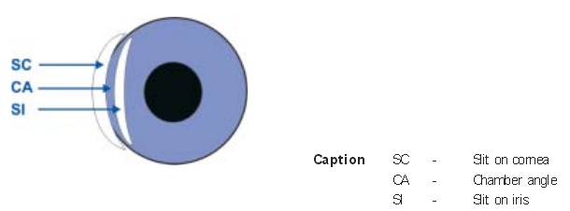
Figure 54.Illustration of the anterior chamber angle using the Van Herick method
Table 28. Van Herick grading system
Grade | Relation between corneal slit image SC & anterior chamber depth CA | Interpretation
4 | 1:1 or higher | Angle closure very unlikely; Chamber angle approximately 35° to 45°
3 | 1:1/2 | Angle closure unlikely; Chamber angle approximately 20° to 35°
2 | 1:1/4 | Angle closure possible; Chamber angle approximately 20°
1 | 1:<1/4 | Angle closure likely; Chamber angle approximately 10°
0 | closed | Angle closure; Chamber angle approximately 0°

Recommendation letter
Centre for Eye Research Australia – National Eye Health Survey Referral
Date:______________________
Dear____________________________,
As you may be aware, the Centre for Eye Research Australia (CERA) and Vision2020 Australia, in conjunction with participating state and national organisations, is conducting a National Eye Health Survey. The survey is designed to assess the prevalence and main causes of vision impairment and eye diseases, as well as barriers to health and the impact of vision impairment in Indigenous Australians over the age of 40 and non-Indigenous Australians over the age of 50.
___________________________________________ participated in the National Eye Health Survey today. During the eye examination, we detected a potential abnormality, and are therefore referring the participant to you for further assessment.
For this participant:
Centre for Eye Research Australia
ABN 72 076 481 984
32 Gisborne Street
East Melbourne, VIC 3002
Postal Address:
Locked Bag 8
East Melbourne
VIC 8002, Australia

www.cera.org.au
Presenting Visual Acuity
Right Eye: __________ | Left Eye: __________
Pinhole Visual Acuity
Right Eye: __________ | Left Eye: __________


Right eye | Left eye
An abnormality was detected on FDT (visual field instrument)
__________________________________________________________
__________________________________________________________
An abnormality was detected on Fundus Photography
__________________________________________________________
__________________________________________________________

There was evidence of pathology in the anterior segment __________________________________________________________
__________________________________________________________

There was evidence of trachoma
____________________________________________________________________________________________________________________

Other
____________________________________________________________________________________________________________________
If you have any queries or concerns, please do not hesitate to contact the study team on (03) 9929 8190 or email us at nehs@unimelb.edu.au
Thank you in anticipation of your cooperation.
Sincerely,
Dr Mohamed Dirani (Principal Investigator)

Referral guidelines

Table 29. Referral guidelines for the NEHS
Test | Findings | Timing of Referral
Visual acuity | Presenting BCVA <6/12 in either eye | 1-2/12 (unless longstanding and existing eye care)  Urgency dictated by onset and severity of vision loss  (Within 1/52 if VA <6/12 OU and participant is driving)
FDT | ≥2 points missed in either eye (for best result) | 1-2/12
Retinal photos | - DR | - Haemorrhages & exudates, refer in 1/12 if eye health care provider has not been seen in the last 3/12  - Central exudates & reduced vision (macular oedema) = 1/52  - Any proliferative retinopathy = 1/52  NB: At least yearly checks for all with DM (guidelines recommend review around 6/12)
Retinal photos | - AMD | - Large drusen, pigment change or atrophy = 1/12  - Any sub-retinal blood in macula = 1-2/7  - Any new symptoms (distortion, scotoma, vision loss) = 1-2/7
Retinal photos | - Glaucoma (≥0.4 C:D) | 1/12  (unless remains under care of eye health care provider in last 6/12 and has follow up planned)
Retinal photos | - Pigmented lesion (naevus or choroidal melanoma) | Naevus = 1/12  Melanoma = 1/52
Retinal photos | - Vitreous haemorrhage | Same day
Retinal photos | - Retinal vascular occlusion | Same day
Retinal photos | - Retinal tear or detachment | Same day
Trachoma grading | TT/CO | 1/12
Unilateral red eye | Especially if acute and painful; photophobic | Same day (exclude corneal opacity and AACG)
IOP | IOP>21mmHg (non-urgent) | 2/52 (sooner if advanced cupping >0.8)
IOP | IOP>30mmHg (urgent)# | Same day
Van Herrick | ≤Grade 2 in either eye | 1/12 (check for symptoms of iACG – urgent referral if so)
Other | Any other issue the examiner feels should be addressed by an eye care practitioner, e.g.:
Other | Symptoms:
Other | - Flashing lights (persistent , recent onset) | Same day
Other | - Transient visual obscuration (amaurosis)@ | Same day
Other | - Recent headaches (if severe; or temporal ache)@ | 1-2/7
Other | - Red colour desaturation | 1-2/7
Other | - Photophobia (marked light sensitivity) | 1-2/7
Other | - Recent history of significant eye trauma | 1-2/7
Other | Signs:
Other | - Reddening of the peri-ocular skin (cellulitis) | Same day
Other | **Urgent if double vision; reduced motility or proptosis**
Other | - Corneal ulcers or opacification; | Same day
Other | - Lid lesions | If raised, irregular lid margin & vascularised, 1/52  If longstanding, regular review at eye health care provider
Other | - Pterygium encroaching visual axis; | VA >6/12 = 1/12  VA <6/12 = 1/52  (if participant driving and VA <6/12 OU)
Other | - Significant cataract | 1/12
Other | - Conjunctival lesions; | If raised & vascularised, 1/52  If longstanding, regular review at eye health care provider
Other | Other issues on history:
Other | - Using unspecified eye drops/naturopathy eye drops etc; | 1/12
Other | - Strong family history of eye disease | 1/12

# Acute glaucoma: if marked elevation of IOP and other symptoms and signs of acute angle closure glaucoma the patient needs to be seen by an eye health professional immediately as any delay in treatment could result in permanent loss of vision. Symptoms may include: blurred vision; seeing “haloes around lights”; a dull ache around the eye/orbit or unilateral headache; nausea; vomiting. Signs include: a red eye (conjunctival injection); corneal oedema (glassy or cloudy appearance); pupil often mid-dilated and non-reactive to light; anterior chamber appears shallow (peripheral iris close to the endothelium). This warrants a phone call for referral.
@ Any history of transient visual disturbance (blacking or greying out of vision) in a person over the age of 50; particularly in the setting of ache on the side of the head, temples tender to touch or cramping in the jaw while chewing food should be regarded as an eye emergency – these are warning signs for temporal/giant cell arteritis. Often vision is reduced in one eye; acutely the optic disc may appear pale and swollen, however this does not need to be present to make a presumptive diagnosis of this condition. The patient needs urgent review (ie same day) by their local doctor or the local hospital for blood tests and anti-inflammatory steroid treatment. This condition is usually managed by ophthalmologists, so it may be advisable to call the local ophthalmologist. Missed giant cell arteritis can cause profound irreversible bilateral blindness. You need to make it clear in the referral that this diagnosis needs to be excluded. This warrants a phone call for referral.

NEHS certificate of participation
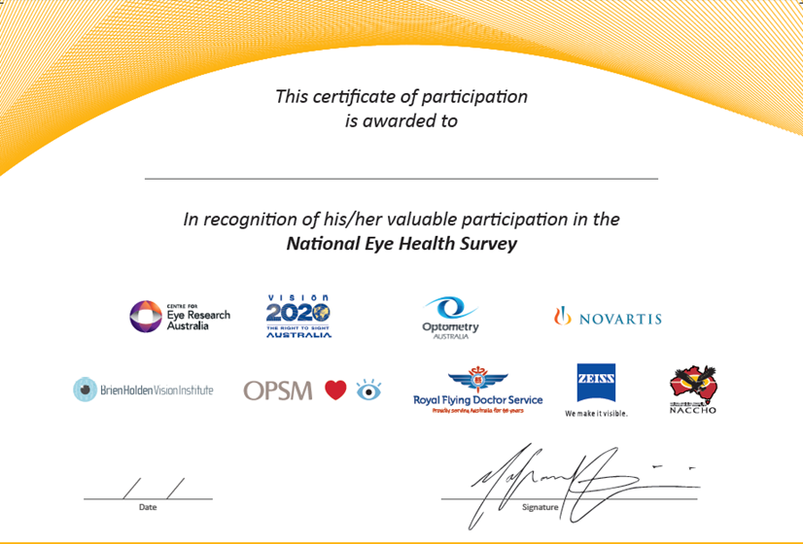

Tablet computer administration user interface

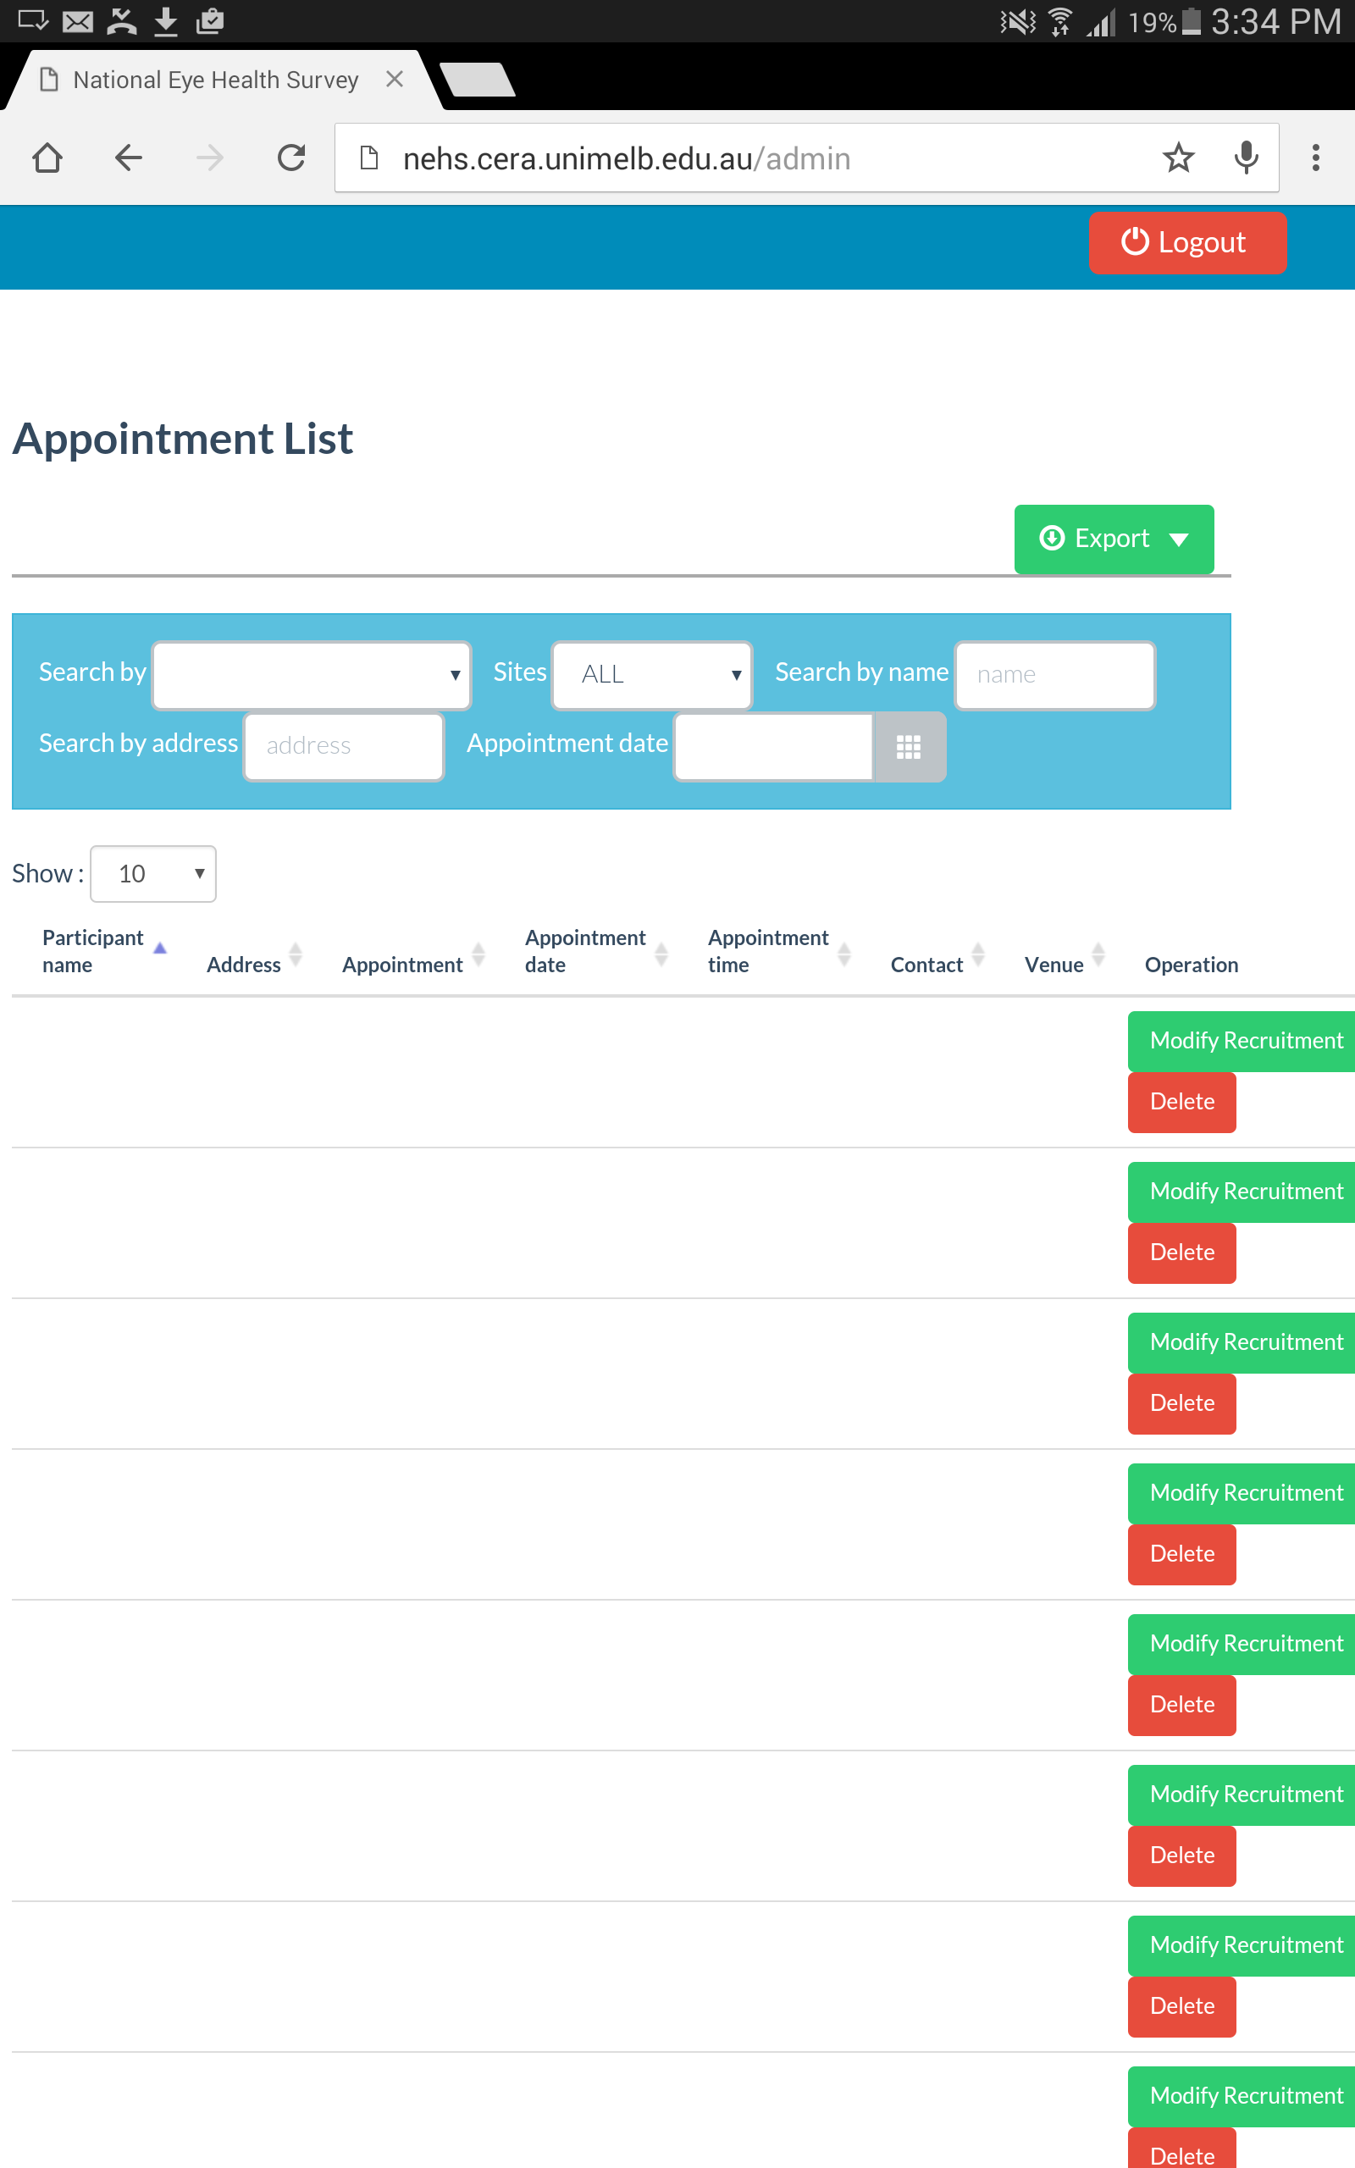
All data entered into the recruitment interface and the clinical examination interface could be viewed in and exported from the administration interface. The administration interface contained multiple search filters to allow NEHS staff to filter rows of data. Search filters allowed for data to be filtered by survey site, address, participant name as well as by characteristics recorded in the process of recruitment, such as those who were absent, ineligible, agreed or declined to participate. The administration interface also provided the option to modify existing data in case of errors in data entry or if participants wished to change their appointments.

Figure 55. Administration user interface of the NEHS cloud-based database

Recruitment hardcopy

Recruiter initials: _ _ _
Recruiter Code: NEHS _ _
Recruitment date: _ _ (dd) /_ _ (mm) /_ _ _ _ (yyyy)
- New Residence
Number: ______________ Street name: ________________________________________
Suburb: _____________________________________________ Postcode: ______________
State: (Tick the correct option)
NSW NT QLD SA VIC WA
Remoteness score: _____
Resident present Resident absent (Tick the correct option)
- Eligibility (Tick the correct option)
Eligible non-Indigenous Eligible Indigenous Ineligible
- Resident Response (Tick the correct option)

Agree Maybe Decline
a. If decline has been selected please specify:
Not interested No free time Recent eye test Previous bad research experience Safety concern Transport concern Refuse to answer Other (please specify) _______________________________________________________
- Sociodemographic Information
- What is your given name? ____________________________________________
- What is your surname? _______________________________________________
- What is your gender? (Tick the correct option)
Male Female
- What is your age? _____ years
- What is your date of birth? _ _ (dd) /_ _ (mm) /_ _ _ _ (yyyy)
- What is your best form of contact? (Tick the correct option and enter details)
Home phone: +61( ) ___________________________
Work phone: +61( ) ___________________________
Mobile phone: __________________________________
Email: ________________________________________

- Appointment Details
- Venue: ____________________________________
- Day: ______________________________________
- Date: ______________________________________
- Time: ______________________________________
- Has an appointment been made? (Tick the correct option)
Appointment confirmed Appointment tentative Appointment not yet made

