Rising Stars booklet

Welcome to Rising Stars in Eye Health and Vision Care

Introducing the Rising Stars of 2017
Australia is a world leader in eye health and vision care, and early-career professionals in this field are at the forefront of international efforts to eliminate avoidable blindness and ensure community participation for people who are blind or vision impaired.

Rising Stars in Eye Health and Vision Care will introduce some of these leading early-career professionals to the world of advocacy and give them a platform to share their vision for the future of the sector.

Rising Stars
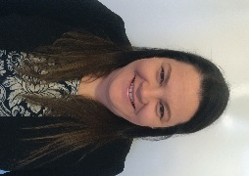

Laura Allison
Service Engagement Consultant, Vision Australia

What do you enjoy about your work?
‘I love seeing the moment of realisation for people that the goal they have created is possible and the determination that stems from that.’

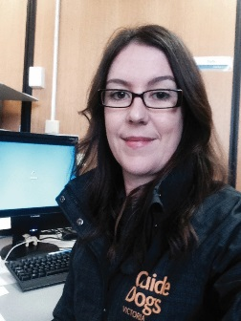

Sally Armstrong
Team Leader, Adult Mobility Services, Guide Dogs Victoria

What do you enjoy about your work?
‘I relish in the opportunity to support the work of six orientation and mobility specialists to ensure our service delivery is of high quality. I strive to be approachable and provide a supportive environment for the team.’
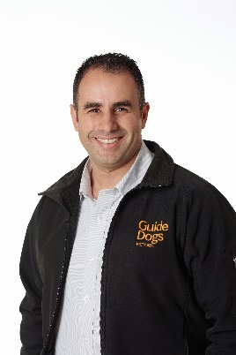

John-Ross Barresi
Innovation Coordinator, Guide Dogs Victoria

What are you currently working on?
‘Currently we’re working on two indoor navigation projects. The reason why we’re looking at this technology is we’ve found a lot of our clients use GPS as a wayfinding solution, and as soon as you travel inside GPS cuts and people are left in the dark.’
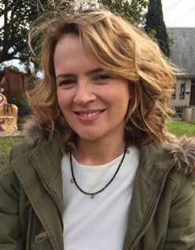

Kate Begly
Policy Advisor, Vision Australia

What are you currently working on?
‘The unemployment rate is more than ten times-higher among the blindness and low vision community than it is within the general population. The project I’m working on at the moment aims to open up public sector employment opportunities.’
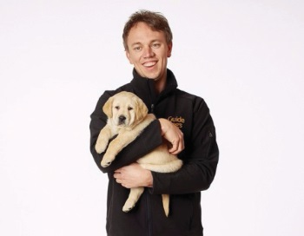

Tim Carter
Support Coordinator, Guide Dogs Victoria

What do you enjoy about your work?
‘The low-vision and blind community is as diverse as any that I’ve ever worked with. I enjoy the stories I hear and the journeys that people are on. I love helping them to overcome the barriers in their lives and watching them begin to do it all on their own.’
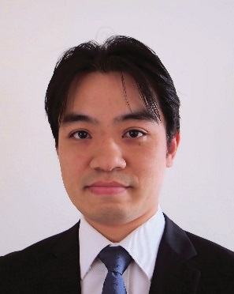

Dr Mark Chiang
Consultant Ophthalmologist, Lady Cilento Children’s Hospital, and Royal Brisbane and Women’s Hospital

What issues you are passionate about?
‘I am passionate in early diagnosis and treatment of preventable blindness, especially glaucoma. Therefore, I would like to see better cooperation between optometrists and ophthalmologists to eliminate preventable blindness.’
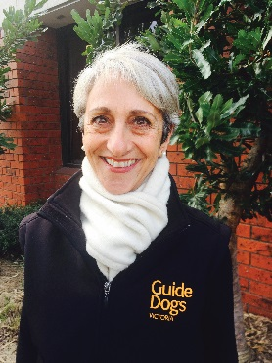

Vicki de Silvia
Orientation and Mobility Specialist, Guide Dogs Victoria

What do you enjoy about your work?
‘It is a great privilege to be invited into a client’s life at the very challenging time of vision loss. My work supports clients from the time they first receive their clinical diagnosis through to regaining their independence and mobility confidence in their everyday life.’
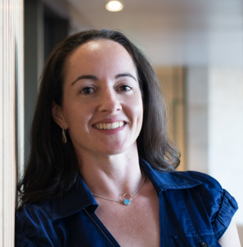

Associate Professor Clare Fraser
Associate Professor of Neuro-ophthalmology and Ophthalmic Education, University of Sydney, Neuro-ophthalmology Visiting Medical Officer and Consultant

What made you interested in your field?
Ophthalmology is an amazing mix of clinical work, surgery and research. I particularly became interested in neuro-ophthalmology after reading the work of Oliver Sacks, “the man who mistook his wife for a hat.”
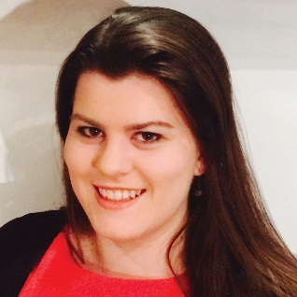

Cassandra Haines
Optometrist, Eyes & Vision Unley

What changes would you like to see in the sector?
‘Myopia, or medical short sightedness, is a growing concern among children both globally and in Australia. There needs to be a radical shift in public perception for eye testing as a vital health examination, with this information conveyed from birth and reinforced throughout life.’
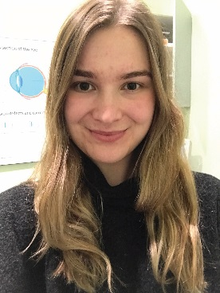

Tori Halsey
Optometrist, Specsavers Hobart

How do you engage with the sector outside of your work?
‘I’ve recently been elected to the Optometry Tasmania board. I try to encourage other recent graduates to see Tasmania as a state of opportunities for health professionals.’
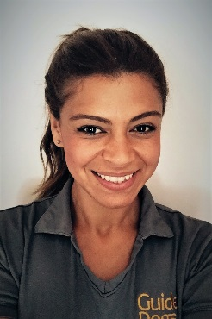

Rachel Henningham
Orientation and Mobility Specialist, Guide Dogs Victoria

How do you engage with the sector outside of your work?
‘A colleague and I facilitate our Young Adult Program, designed to capture those individuals that often fall away from services during the period of leaving school to entering the “world”.’
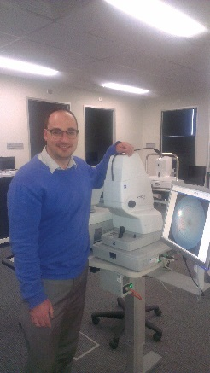

Luke Higgins
Associate Lecturer, Flinders University, Clinical Optometrist, Flinders Vision and Low Vision and Rehabilitation Optometrist, Royal Society for the Blind

What changes would you like to see in the sector?
‘I would like to see the model of low vision care in Australia to be better defined, efficient, and collaborative. I would like to see the scope of optometric practice to continue to expand.’
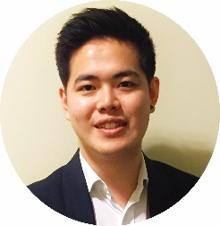

David Hsu
Optometrist, Specsavers Innaloo

What do you enjoy about your work?
‘I enjoy the social interactions I get to have with my patients. My work environment allows me to meet and affect the lives of different people of all walks of life.’
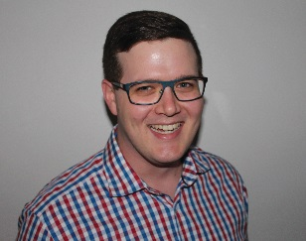

Rohan Hughes
Optometrist and PhD candidate, Queensland University of Technology

How do you engage with the sector outside of your work?
‘I joined the Optometry Queensland and Northern Territory Board mainly because I was motivated to contribute to ensuring that the optometry profession is enduring, and continues to develop and modernise.’
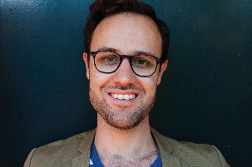

Scott Jacobs
NDIS Lead, Vision Australia

What do you enjoy about your work?
‘You are working directly for people and NDIS participants. You are trying to help the scheme live up to the promise that it gives to people who are blind or low vision.’
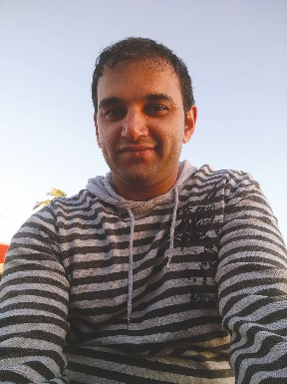

Shazaan Khambiye
Optometrist, OPSM Tasmania

What do you enjoy about your work?
‘Being on the frontline of patient diagnosis presents responsibilities of maintaining top-level practise. Patient interactions and conversations are the highlight of my day.’
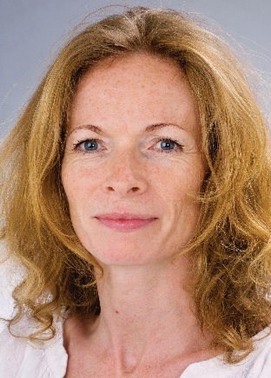

Dr Jane Khan
Consultant Ophthalmologist, Royal Perth Hospital

What are you currently working on?
‘My main aim at present is to tackle the efficient use of public sector resources to provide state-of-the-art eye care.’
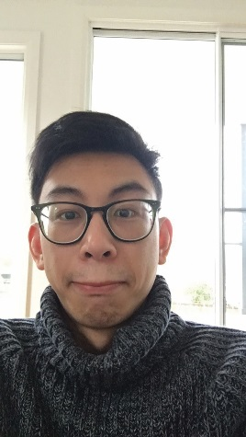

Wilson Luu
Optometrist, nib Eye Care Centre Rutherford

What changes would you like to see in the sector?
‘Stronger unity in the eye care profession, better collaborative care, and better awareness of what the profession can do, from a health professional and general public point of view.’
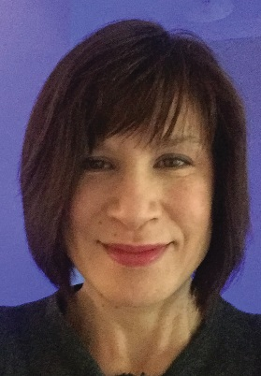

Darlene McIntosh
Orientation and Mobility Specialist, Guide Dogs Victoria

What are you currently working on?
‘I am beginning to branch out into access consulting, particularly in public transportation settings. I recently had the opportunity to respond to the new draft wayfinding standards.’
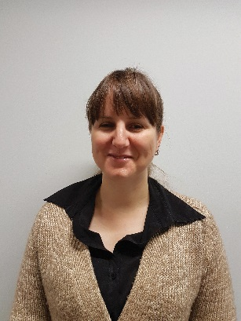

Courtney McKee
Client Insights and Engagement Consultant, Vision Australia

What issues you are passionate about?
‘I’m passionate about empowering consumers to be active informed participants, attain their personal goals, and contribute to society through work and activism across all fields.’
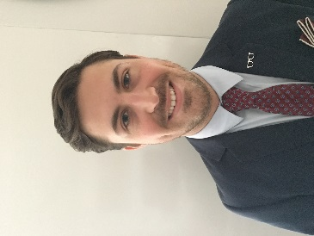

Drew Sherwin
Optometry Director, Specsavers Australia Fair

How do you engage with the sector outside of your work?
‘I am currently the primary mentor for a first year optometry graduate as well as a final year student within my practice. I also work within the Specsavers graduate program as a regional mentor for the current cohort of Queensland graduates.’
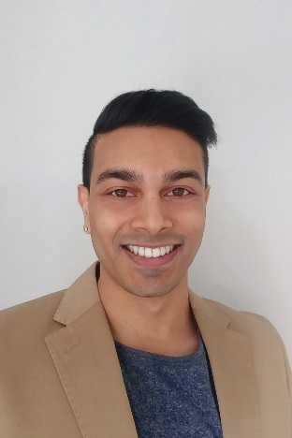

Kiran Sookroo
Optometrist, OPSM Rockingham

What issues you are passionate about?
‘Optometrists are the forefront at implementing treatment options to correct and control myopia, which has been described as an epidemic. It’s extremely satisfying to be able to present worried patients and their parents with options to slow down myopic progression.’
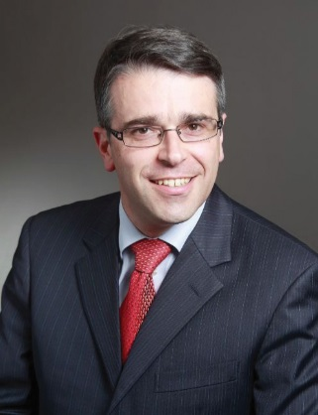

Associate Professor Andrew Symons
Head of Department of Ophthalmology, Royal Melbourne Hospital

What do you enjoy about your work?
‘This work is enormously rewarding. I am fascinated by the intellectual challenges in vision science and also in service provision.’
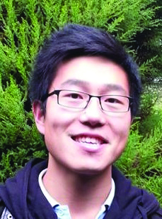

Jason Tan
Optometrist Partner, Specsavers Benalla

What do you enjoy about your work?
‘I find building rapport and communicating effectively with patients to be most rewarding, as well as the diversity in scope of practice.’
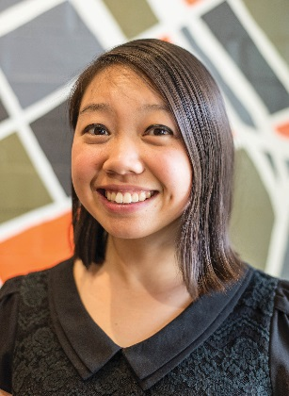

Carina Trinh
Optometrist, Dresden Optics

How do you engage with the sector outside of your work?
‘I’m part of Eyes4Everest, a charity organisation that delivers eye care to people of the Himalayas and Nepal. They don’t have the really basic things like a pair of glasses to help them see in class.’
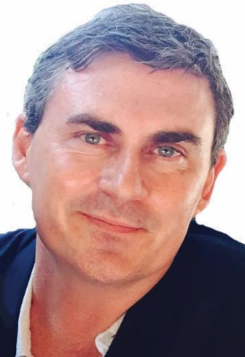

Associate Professor Andrew White
Head of Department of Ophthalmology, Westmead Hospital

What are you currently working on?
‘A project that I’ve developed over the last few years is making better use of the optometrists in Australia to do basic screening and assessment for glaucoma, such that ophthalmologists have more time and more room to see the people who need urgent help.’
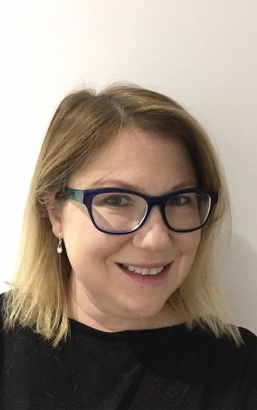

Belinda Wilson
Building Stronger Futures Program Lead, Vision Australia

What made you interested in your field?
‘For vision impaired or blind people, gaining employment is extremely important. It increases motivation, self-esteem, social interaction, skills development, in addition to the monetary rewards.’
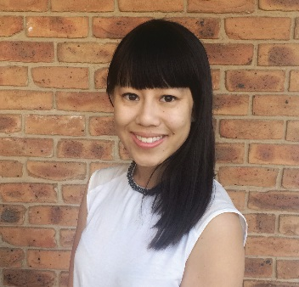

Katrina Yap
Optometrist and Melbourne University Clinical Teaching Instructor

What changes would you like to see in the sector?
‘I believe that we need to keep moving forward as a profession to continue to improve eye care accessibility for everyone in the community.’
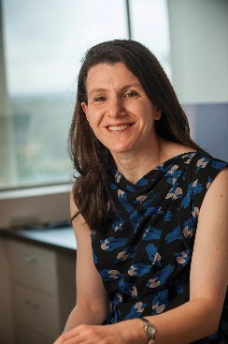

Dr Christine Younan
Ophthalmologist, Sydney Eye Hospital and Westmead Hospital

What issues you are passionate about?
‘When people develop bleeding at the back of the eye, wet macular degeneration, we know that the outcome for vision is quite poor without treatment. As eye doctors we need to do everything we can to ensure that our patients are able to access treatment in a timely manner.

Event partners
Guide Dogs Victoria, Optometry Australia, Royal Australian and New Zealand College of Ophthalmologists, Vision Australia

Event supporters
Bayer, Johnston & Johnston

