  - Streamlined consumer assessment for Aged Care
  - Eye Health and Vision Care Sector Submission to the
Department of Health Discussion Paper December 2018
  - February 2019

About Vision 2020 Australia
Vision 2020 Australia is the national peak body for the eye health and vision care sector.
Its role is to ensure that eye health and vision care remains high on the health, ageing, disability and international development agendas of Australian governments.
Vision 2020 Australia was established in October 2000. It is part of VISION 2020: The Right to Sight, a global initiative of the World Health Organization and the International Agency for the Prevention of Blindness.
The organisation represents almost 50 member organisations involved in local and global eye health and vision care, health promotion, low vision support, vision rehabilitation, eye research, professional assistance and community support.

Contents
About Vision 2020 Australia 2
Introduction and context 4
Vision loss in Australians aged 65 years and over 5
Proposed triage pathways 7
Primary presenting concern is vision loss 7
Co-morbidities and complex needs as well as vision loss 8
Figure 1: Proposed triage pathways flowchart 9

Introduction and context
Vision 2020 Australia welcomes the opportunity to respond to the Australian Department of Health Discussion Paper Streamlined Consumer Assessment for Aged Care released in December 2018.
The new streamlined assessment model is designed to respond to the current duplications and inefficiencies that exist in the Aged Care system. The new assessment model integrates the Regional Assessment Services and Aged Care Assessment Teams into one centralised workforce to conduct all Aged Care assessments.
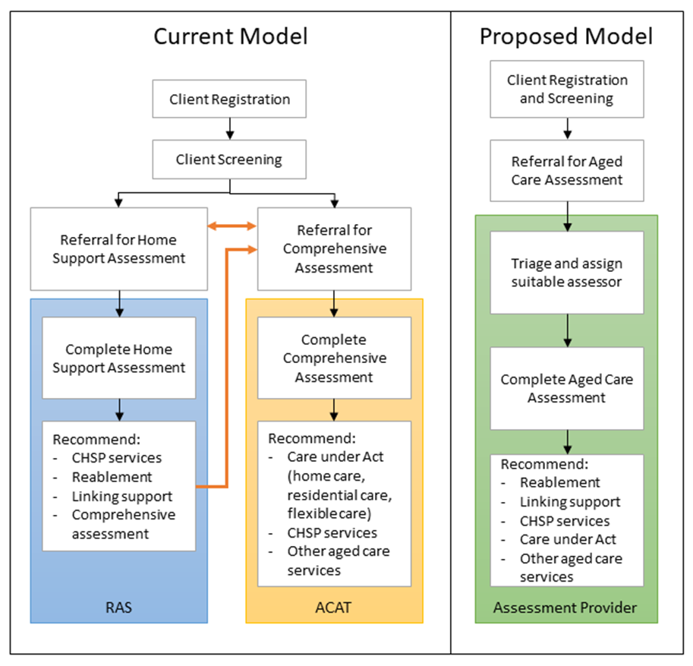
One of the challenges our members have identified is that the particular needs of people aged 65 years and older who are blind or have low vision are often poorly understood and/or not catered for through current assessment processes which seek to address the needs of the whole population.
This means that people who develop age related vision loss, or are transitioning into the aged care system as part of current reforms, may miss out on the practical tailored supports that could keep them independent, reduce the risk of falls and better equip them to complete activities of daily living with minimal/no assistance. This submission identifies a potential way forward to better address the needs of people who are blind or have vision impairment through adaptations to aged care assessment processes.
This submission has been shaped by the advice and expertise of Vision 2020 Australia members, in particular those from its Independence and Participation Policy Committee. The Committee’s response is focused on improving outcomes for older Australians who are blind or have low vision, through a new streamlined assessment model.

Vision loss in Australians aged 65 years and over
Ninety per cent of blindness and vision impairment can be attributed to five preventable conditions: age-related macular degeneration; cataract; diabetic retinopathy; glaucoma; and uncorrected refractive error. The risk of developing each of these conditions increases as a person ages.
Equally, the overall prevalence of vision impairment across the population increases markedly with age. For Indigenous Australians aged 60-69 years, almost 17% are vision impaired and up to 45% for Indigenous Australians aged over 80 years. Likewise in the non-Indigenous population, vision impairment affects nearly 5% of those aged 60-69 years and 15% of those aged over 80 years.
Unaddressed vision loss can substantially reduce quality of life by affecting physical, functional, emotional and social wellbeing. It is attributable to:
- double the rates of falls,
- increased risk of depression by three times,
- four times the risk of hip fractures, and
- admissions to nursing homes occur three year earlier.
By 2027, it is expected that there will be over 5 million Australians aged 65 and over and then increasing to roughly 6.5 million by 2037. As the population of older Australians continues to increase there will be a larger number of people requiring access to aged care services and an increasing cohort of Australians with blindness and vision loss.
It is important that older Australians are able to access the reablement supports and services they require, to minimise the occurrence of additional co-morbidities and to maximise quality of life. Adapting the way the aged care sector responds to vision impairment and increasing the ease of access to necessary support and equipment (including in some instances assistive technology) will improve the lives of people who are blind or have low vision aged 65 and older, supporting them to remain independent, reduce their risk of falls, and self-manage activities of daily living in their own homes.
The challenge with the current aged care system is that it is predicated on the concept that aged related disability is due to frailty: the assessment system and underpinning framework presumes that loss of physical capacity is the principle driver of seeking support through the aged care system.
However, a significant number of people aged over 65 will develop age related vision loss without physical frailty.
Providing better, timely access to appropriate supports and low vision aids and equipment for older Australians for this group can keep them healthy and safe in their own homes, allowing them to remain independent and reducing potential demand for more expensive models of care that can arise if these needs are not met.

Proposed triage pathways
Vision 2020 Australia is proposing two pathways for older Australians with vision impairment to improve access to the reablement supports and services they require. The first pathway focuses on people with a primary presenting concern of vision loss. The second pathway addresses the needs of people presenting with co-morbidities and complex needs and where vision loss is present, but not the primary presenting concern. Please see figure 1 for a flow chart representation.
The pathways are underpinned by a key design principle of flexibility, which allows older Australians with vision impairment to adapt and respond to their progressive levels of vision loss, with effective assistive technologies and reablement supports in a timely manner. Increasing access to assistive technology and reablement supports for older Australians with low vision and blindness is critical to ensuring that their needs are adequately supported, and they can be empowered to actively age within their homes and communities.

Primary presenting concern is vision loss
When a person presents for an aged care assessment and vision loss is assessed as the primary presenting concern (and with no other substantiative co-morbidities) it is recommended that the person be triaged to a separate assessment model, with a focus on procuring assistive technology and utilising timely reablement supports.
Older Australians presenting with a primary concern of vision loss will enter the assessment process through the normal means as designed in the proposed assessment model. After they have been triaged and no other co-morbidities identified, which require supports and/or services, they will undergo a low vision functional assessment by a suitably qualified assessor.
Once the low vision functional assessment has been completed, low vision and blindness service providers can be engaged to help develop a care plan for the client, aimed at addressing needs and achieving outcomes and goals.
Funding for supports and services will be delivered through the My Aged Care system. This could be through the procurement of some form of assistive technology and/or specific reablement services or training.
Finally, it is recommended that a six-month review be conducted by the original low vision assessor to ensure that the prescribed supports and services are meeting the client’s needs.
This separate assessment model will allow older Australians with vision impairment to access timely assistive technology and reablement supports, helping them to remain independent on lower levels of aged care funding. This model will have an added focus on flexibility that allows older Australians to respond to their progressive vision needs, and the ability to access a full assessment if other co-morbidities were to present.

Co-morbidities and complex needs as well as vision loss
When a person presents for an aged care assessment and is assessed as having co-morbidities and complex needs, of which vision impairment is one, it is recommended the person continue through the streamlined assessment model with the ability to be streamed out to have their low vision aids and equipment and reablement needs reviewed after their necessary supports have been implemented.
When other co-morbidities are present and broader supports and services are required, a complete assessment through the newly proposed assessment model is to be conducted first to respond to the person’s most immediate needs.
After this has been conducted, and if vision impairment is identified, the client will transition into the low vision and reablement section of the pathway. This will follow the same steps as outlined in the previous pathway, but will ensure that older Australians have timely access to appropriate assistive technology supports and reablement services after their holistic needs have been met.
Entering a separate assistive technology stream after other co-morbidities have been addressed through standard aged care assessment models, will provide older Australians the flexibility to adapt their low vision aid requirements as their needs progress, without requiring full reviews of their supports and services.

Figure 1: Proposed triage pathways flowchart
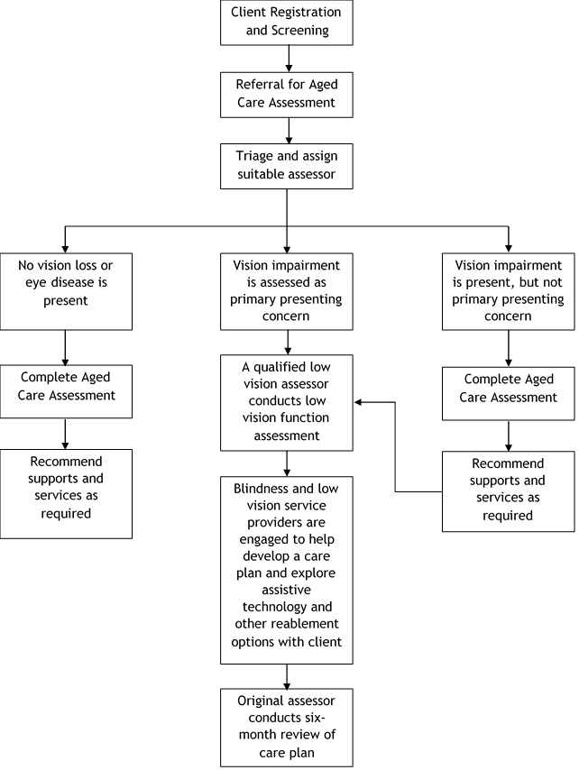

National Eye Health Survey Summary Report 2016.
Foreman J, Keel S, Xie J, and Wijngaarden P & et al. (2016) “National Eye Health Survey 2016”, Centre for Eye Research Australia, Royal Victorian Eye and Ear Hospital, Melbourne, Australia.
Access Economic Pty Ltd (2010), “Clear Focus: The Economic Impact of Vision Loss in Australia in 2009”, Vision 2020 Australia, Melbourne.
Australian Bureau of Statistics (2014), “Australian Historical Population Statistics”, ABS cat. no. 3105.0.65.001. Canberra: ABS.
A number of health professionals; occupational therapists, orientation and mobility specialists, orthoptists or low vision optometrists could conduct this assessment.

