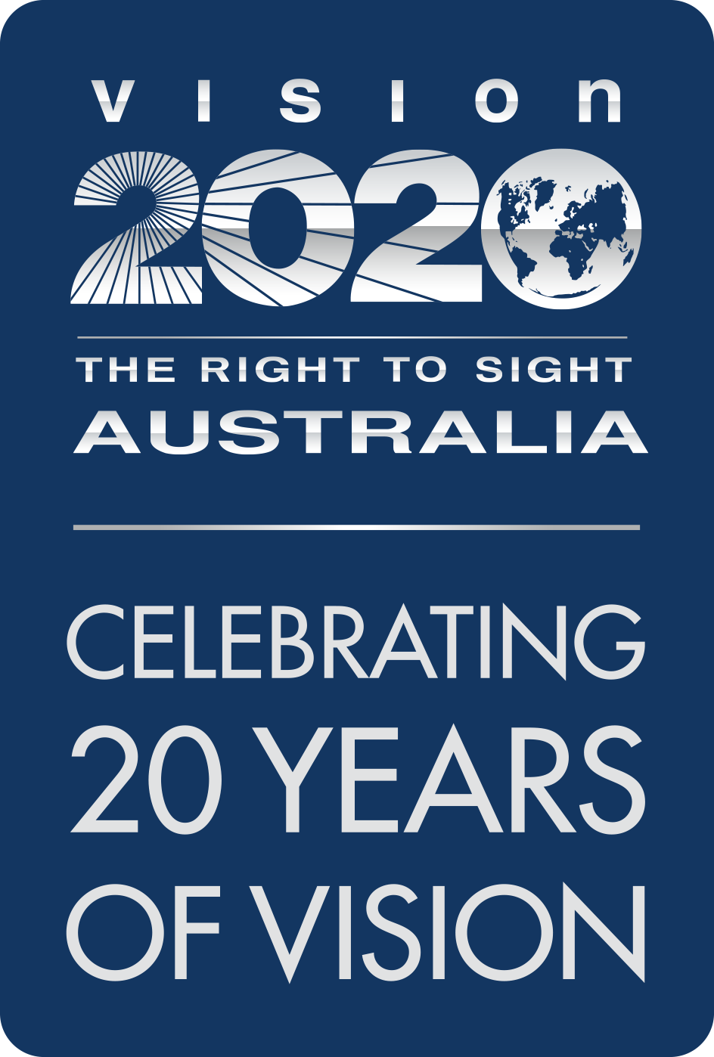

Response to Productivity Commission’s Draft Indigenous Evaluation Strategy
  - 3 August 2020

This submission has been developed by Vision 2020 Australia, with the input from members of its Aboriginal and Torres Strait Islander Policy Committee. For further information about Vision 2020 Australia and its membership, please go to www.vision2020australia.org.au
To discuss this submission or related matters, please contact Vision 2020 Australia’s Policy and Advocacy team on policy@vision2020australia.org.au or via phone, 03 9656 2020.

Introduction and context
Vision 2020 Australia is the national peak body for the eye health and vision care sector, representing nearly 50 member organisations involved in local and global eye health and vision care, health promotion, vision rehabilitation, eye research, assistance and community support.
A core Vision 2020 Australia priority is equitable access to quality eye health and vision care services for Aboriginal and Torres Strait Islander people, who are three times more likely to experience blindness than non-Indigenous Australians.
Vision 2020 Australia welcomes the development of the Productivity Commission’s Draft Indigenous Evaluation Strategy (the Draft Strategy).
Vision 2020 Australia’s membership collectively developed Strong Eyes, Strong Communities: a five year plan for Aboriginal and Torres Strait Islander Eye Health and Vision sets out a path to end avoidable blindness across Aboriginal and Torres Strait Islander communities and community ownership and empowerment is a fundamental principle underpinning this strategy.
Continued data collection and monitoring underpins that strategy, and in considering how progress against that strategy will be monitored, our member organisations have been exploring how best to engage community in both shaping the plans implementation and evaluation.
This means that in responding to the Draft Strategy, Vision 2020 Australia and its members bring the perspectives of organisations who:
- have been actively working through how best to engage communities in measurement and monitoring progress at a cross sector level
- have a strong understanding of existing evaluation frameworks and measurement that applies to Aboriginal and Torres Strait Islander eye health and vision related activities, and
- are separate to (but sometimes funded by) government.

Feedback on Draft Strategy
Vision 2020 Australia and its members welcome the intent of the Draft Strategy, and the way it has been structured to provide a clear framework for how that intent will be translated into meaningful action.
The guiding principles of useful, credible, ethical and transparent all reflect that important focus on meaningful action and the document in its current form provides the reader with a clear understanding of how this work could be sensibly implemented.
There are however some areas where the Draft Strategy could be enhanced, to strengthen its focus on the centrality of community and to capitalise on the opportunities this work presents to drive a more systemic, integrated approach and leverage the expertise, resources and interest of organisations beyond government. These areas are summarised below.

Embedding Self-determination and Indigenous Data Sovereignty
Vision 2020 Australia and its members support the broad intention of the Draft Strategy to enhance evaluation of funded Aboriginal and Torres Strait Islander programs.
While the challenges with existing evaluation efforts are by no means unique to those programs – inconsistency in the quality, scope and timeliness of evaluation efforts is a challenge across many government funded programs – the critical importance of improving outcomes for Aboriginal and Torres Strait Islander communities necessitates this kind of focus.
It is however essential that the approach adopted genuinely places Aboriginal and Torres Strait Islander communities and people its centre in true partnership, such that they can determine key elements of the evaluation process.
Vision 2020 Australia welcomes the Draft Strategy’s emphasis on ensuring that evaluation activity is shaped by “the perspectives, priorities and knowledges of Aboriginal and Torres Strait Islander peoples” (Draft Strategy, page 4) but notes it will need to be more than just input to a largely external process. Instead, Aboriginal and Torres Strait Islander people need to be at the heart of the process, shaping key aspects of evaluation design and delivery such as:
- how the process operates, and have the opportunity to freely consent to participation
- the measures that are most meaningful to them
- how these can most effectively be measured, and
- how the data collected is analysed, with the perspectives of community members actively shaping how issues and findings are weighted and prioritised
- how data sovereignty can be achieved, so that Aboriginal and Torres Strait Islander people maintain control over the data collected regarding their community and how this is used.
To achieve this, the Draft Strategy requires amendment to embed the language of self-determination, from its objective and principles section through to the way roles, responsibilities and actions are conceptualised and described.
This would also bring the Draft Strategy into direct alignment with the new National Agreement on Closing The Gap , signed by the Coalition of Aboriginal and Torres Strait Islander Peak Organisation and All Australian Governments in July 2020, which calls for support from government for Aboriginal and Torres Strait Islander communities and organisations to:
- participate as equal partners with government
- drive their own development on the design, implementation and evaluation of policies and programs
- build capability and expertise in collecting, using and interpreting data in a meaningful way .
In addition to referencing self-determination, Vision 2020 Australia recommends the Draft Strategy actively acknowledge and commit to Indigenous Data Sovereignty.
This would reinforce the right of Aboriginal and Torres Strait Islander people to exercise ownership and governance over Indigenous data through the creation, collection, access, analysis, interpretation, management, dissemination and reuse of that data to inform the design and implementation of locally determined solutions.
The work of the Maiam Nayri Wingara Indigenous Data Sovereignty Collective would be helpful in informing this aspect of the Draft Strategy.

Maximising the benefits of cross sector evaluation strategy and resources
While the Draft Strategy is primarily designed for government agencies, it is pleasing to see that the important role of many other organisations outside government in working with Aboriginal and Torres Strait Islander communities is acknowledged (Draft Strategy, Page 6) as it is through the collective efforts of all involved that we can achieve real and sustainable change.
Vision 2020 Australia encourages the Productivity Commission to consider how the final evaluation strategy and its supporting resources and materials can support consistency in evaluation approaches across all organisations, to increase the comparability of results and help drive the kind of integration that can benefit everyone and most importantly, communities themselves.
This will be challenging – while government agencies are large, comparatively well resourced and often have relatively sophisticated systems in place, other contributing organisations are much more diverse in their size, systems and resource base.
It would however be a way of maximising the utility and impact that this investment in enhancing evaluation efforts in this critically important area.

Seeking perspectives from ‘interfacing’ stakeholders
Vision 2020 Australia also requests that the Productivity Commission consider how proposed processes and structures in the final Evaluation Strategy might create an obligation for the evaluation process to have regard for the perspectives of others working with communities and/or interfacing with the programs under evaluation.
This would provide valuable insights into how programs fit into the broader system and contribute towards integration of effort.
Organisations such as the National Aboriginal Community Controlled Health Organisation, State and Territory member Affiliates and other Aboriginal and Torres Strait Islander Peaks and Leaders have provided our organisation and its members with valuable insights and advice to guide work in the eye health and vision sector, and would be critical contributors to future evaluation efforts.
Similarly, other member organisations of Vision 2020 Australia stand ready to contribute wherever they can to evaluation and other efforts that help achieve the commitment made in Australia’s Long-Term National Health Plan to end avoidable blindness in Aboriginal and Torres Strait Islander communities by 2025.
This would not need to be purely limited to eye and vision specific evaluations. Vision 2020 Australia encourages the Productivity Commission to include a requirement and acknowledgement in the final strategy that evaluation strategies must be flexible and adaptable to include multiple programs and/or policy areas, reflecting the holistic view of health held by Aboriginal and Torres Strait Islander communities, which encompasses mental, physical, cultural and spiritual health.
Examples in the eye care sector might include capturing collaboration indices for the activities of different eye health professionals working with communities and Aboriginal Community Controlled Health Organisations.
This could, for example, involve examining the work of optometry and ophthalmology in the work they do through outreach eyecare and other programs to measure and evaluate additive and complementary impacts and benefits that such programs provide to Aboriginal and Torres Strait Islander communities.

Preferencing Aboriginal and Torres Strait Islander expertise, building local capacity
Vision 2020 Australia and its members believe that the final strategy should prioritise local Aboriginal and Torres Strait Islander persons for delivery of key elements of the evaluation process (for example data collection and analysis) wherever possible.
This will directly benefit the conduct of the evaluation process itself, by increasing community involvement and drawing upon local knowledge and networks and enhancing cultural safety) as well as building local knowledge, skills and understanding of these processes.

Maximising the potential for a systems approach
Vision 2020 Australia and its members strongly support the proposed establishment of a clearing house to make evaluation reports readily available.
For Aboriginal and Torres Strait Islander communities, outcomes in areas like eye health and vision are often directly impacted by other areas such as housing and having the capacity to readily access evaluation reports related to all areas of activity will be another important element of supporting closer connections and integration.
In implementing the Final Indigenous Evaluation Strategy, it will also be important to explore how future evaluation efforts can complement and enhance other performance reporting and monitoring activities to provide a clearer picture of where progress is being made, and what is working.
In the Aboriginal and Torres Strait Islander eye health and vision field, for example, there are:
- A range of government funded organisations provide data to the Department of Health and other organisations as a condition of their funding. While some of this is captured in reports by the Australian Institute of Health and Welfare, other information is not released but would likely assist stakeholders in the design, targeting and delivery of services.
- The Indigenous Eye Health Unit at the University of Melbourne provides annual public updates on progress against the milestones identified in the Roadmap to Close the Gap for Vision .
- Program specific evaluations conducted by a range of organisations as part of quality assurance, program reporting and/or other requirements.

Conclusion
While it will take some time to establish the new arrangements for evaluation, Vision 2020 Australia and its members would encourage the Productivity Commission to further consider how the proposed investment in evaluation could also be designed or delivered in ways that support broader connections with other relevant data and reports.
Vision 2020 Australia thanks the Productivity Commission for the significant body of work that has already been done to enhance evaluation efforts across Aboriginal and Torres Strait Islander programs.
We look forward to working with the Commission, and eventually the Office of Indigenous Policy Evaluation (OIPE), as part of achieving our common goal of a future where all Aboriginal and Torres Strait Islander communities achieve their goals and aspirations.

Foreman, J., Keel, S., Xie, J., van Wijngaarden, P., Crowston, J., Taylor, H. and Dirani, M., The National Eye Health Survey 2016, Vision 2020 Australia, Melbourne, p. 12
https://www.closingthegap.gov.au/sites/default/files/files/national-agreement-ctg.pdf?q=0720
Ibid, page 13
Ibid, page 13
Ibid, page 14
https://www.maiamnayriwingara.org/
Which could, for example, include use for evaluation of programs and projects beyond those funded by government.
https://www.health.gov.au/resources/publications/australias-long-term-national-health-plan
Delivering primary eye care, refractive care, eye disease triage and secondary/tertiary/surgical care
https://www.vision2020australia.org.au/wp-content/uploads/2019/06/Roadmap-summary-upd-8BC18E-2-.pdf
https://mspgh.unimelb.edu.au/centres-institutes/centre-for-health-equity/research-group/ieh/roadmap/annual-update

