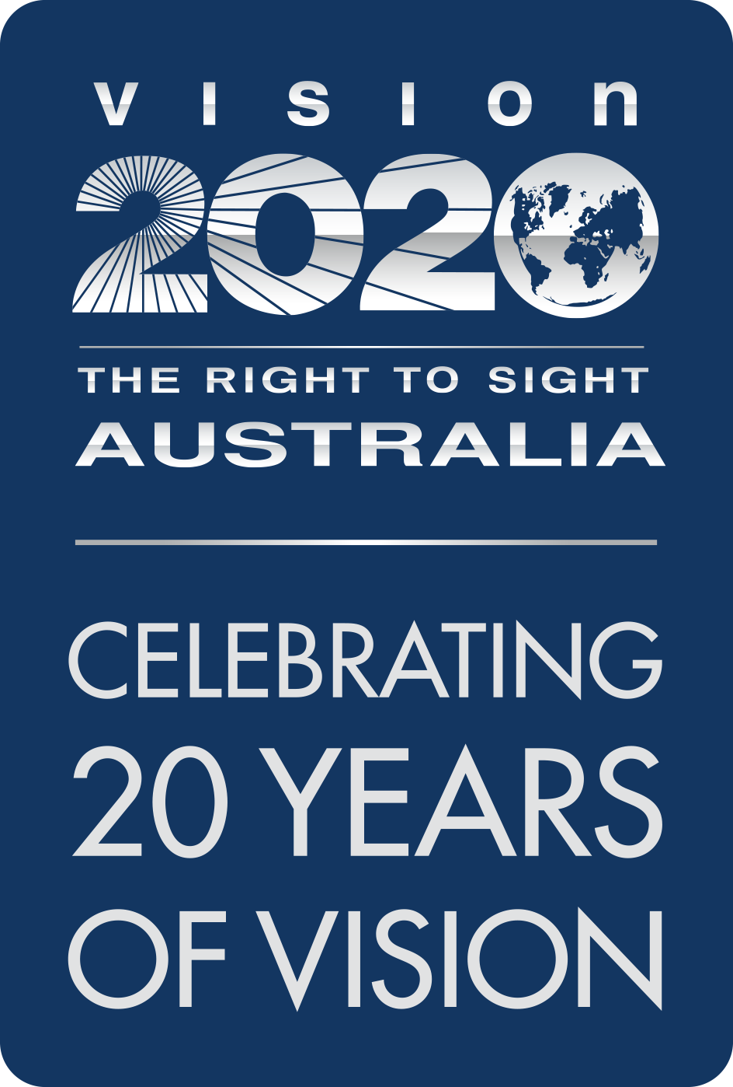

Submission to the Royal Commission into Violence, Abuse, Neglect and Exploitation of People with Disability
  - First Nations Peoples with disability – blindness and low vision perspectives

  - September 2020

About Vision 2020 Australia

Vision 2020 Australia is the national peak body for the eye health and vision care sector. Working with and representing almost 50 member organisations, we focus on supporting policy and funding changes to prevent avoidable blindness, enhance eye care delivery and better meet the needs of people who are blind or living with low vision.
Our members span a wide range of areas and are involved in local and global eye health and vision care, health promotion, low vision support, vision rehabilitation, eye research, professional assistance and community support. This means that the work we do in developing sector-supported policy and advice brings a diverse range of expertise and perspectives to bear, and that the perspectives and experiences of both service users and service providers are at the heart of our work.
Avoidable blindness and vision loss in Australia, and our region, can be prevented and treated by working in partnership across government, non-government, private and community sectors. People of all ages who are blind or vision impaired will benefit from these partnerships, with improved access to services that support their independence and community participation.
For further information about this submission, please contact Vision 2020 Australia on 03 9656 2020 or via email, policy@vision2020australia.org.au

Executive summary

First Nations peoples currently experience blindness and vision loss at three times the rates of other Australians.
First Nations people experience blindness and vision loss at three times the rates of other Australians….and people who are blind or have low vision are at higher risk of injury, depression and other issues
People who are blind or have low vision are at higher risk of a range of adverse social and health outcomes, including increased risk of injury and depression. And, as the Commission’s issues paper acknowledges, both First Nations peoples and people with disability are at greater risk of experiencing harm than the general population.
The Commission asked "how can current systems better prevent or respond to experiences of violence, abuse, neglect and exploitation of First Nations people with disability?”. Vision 2020 Australia and its members believe the first step toward protecting First Nations peoples who are blind or have low vision from these outcomes is facilitating their independence wherever possible.
Blindness or low vision can make everyday tasks such as driving, working, or caring for oneself or others difficult or impossible. This difficulty can have consequences for mental health, but it also increases the potential for dependency on others, which can be a vector for violence, abuse, neglect, or exploitation.
A first step toward protecting First Nations people who are blind or have low vision…is facilitating their independence
Adaptations and training can make all these tasks easier, but without appropriate assistive technology, this disability also creates difficulties accessing information. Therefore, First Nations peoples who are blind or have low vision can struggle to learn about what support is available. This struggle is compounded by an ongoing lack of culturally safe and appropriate services.
Vision 2020 Australia believes the NDIS has the potential to be a powerful mechanism for capacity-building for Australians living with blindness and low vision. However, current settings and arrangements mean that affected Australians are not always able to access the scheme as intended, or utilise their services to the fullest extent. This is especially true for First Nations peoples.
Adaptations, training and assistive technology is needed (but) First Nations people can struggle to learn about what support is available
In considering the issues raised by the Commission, members of Vision 2020 Australia have noted some specific challenges experienced by First Nations peoples:
- The NDIS is not compatible with the cultural norms of First Nations peoples, because it is founded on deficit-based assumptions. For example, there is no word in First Nations languages for disability, which historically has been viewed as a difference rather than absence of capacity. This means that First Nations peoples with disability may be less likely to proactively seek support, or identify with the language used by the NDIA.
- Support coordination is vital to ensuring that First Nations peoples with disability are able to both understand and navigate entry to the NDIS, and then be supported to access services once they have had NDIS plans developed.
It is essential that:
- Cultural norms are understood and reflected in the language used with First Nations people
-the role of family and community is recognised and included in planning
-There is effective support coordination available that is culturally safe and appropriate, with a role for ACCHOs
-There is a need to strength arrangements for First Nations children who are blind or have low vision
- Delivering these support coordination activities through Aboriginal Community Controlled Health Organisations (ACCHOs) would create a more culturally appropriate interface with the NDIS and help ensure that supports provided through the NDIS can be integrated with other aspects of the participant’s life and community participation.
- It is important that the NDIS recognises the role of family and community in planning for and responding to the needs of First Nations peoples living with disability. Especially in Aboriginal and Torres Strait Islander cultures, people rarely function only as individuals, instead forming part of strongly connected communities that support and share resources and care.
- There is continued evidence that First Nations children who are blind or have low vision struggle to access necessary services and resources. Increased understanding within the NDIA of First Nations culture and adaptations to the Early Childhood Early Intervention (ECEI) process is needed to address this and ensure that those children get timely access to the services they need.
Additionally, Vision 2020 Australia members have observed other problems with the interactions between the disability and health sectors in relation to First Nations peoples with disability. To address these:
- The social and emotional wellbeing aspects of vision loss for First Nations peoples must be recognised and addressed in planning for and supporting their needs. This should include systemic, preventative approaches to counteract the increased risk of violence, abuse, neglect, and exploitation for these people.
- ACCHOs should be funded to play a more significant role in the disability sector.
- Establishment of more culturally safe eye care pathways offers significant scope for preventing blindness or vision loss in First Nations peoples. Exploring opportunities to enhance connections between the NDIS and the health sector will be an important component of this, recognising the complementary roles that the health and disability sectors need to play.
Vision 2020 Australia and its members look forward to working with the Royal Commission, the government and Aboriginal and Torres Strait Islander communities and organisations to provide timely, effective access to culturally appropriate services and supports for First Nations peoples who are blind or have low vision.

Introduction and context

Across Australia, over 450,000 people are living with blindness and vision loss. A significant portion of that vision loss can be prevented or treated to slow its progression, if identified early. Improving access to, and the cultural safety of, eye care services is an important component of preventing vision loss.
For First Nations peoples this can be particularly challenging, as there is often a disparity in their level of service access when compared to that of other Australians. This means that they often wait significantly longer for care and experience higher levels of vision loss.
Strong Eyes, Strong Communities – a five year plan for improving Aboriginal and Torres Strait Islander eye health and vision describes the range of actions required to ensure all Aboriginal and Torres Strait Islander peoples can access eye care.
It also recognises that some First Nations peoples have permanent vision loss, and that improving access to specialist blindness and low vision services is essential to meet their needs (p22).
People living with vision loss are at higher risk of a range adverse health and social outcomes, including double the rates of falls, three times increased risk of depression, four times the risk of hip fractures, greater utilisation of health, aged care and social services, and earlier entry to residential aged care (Access Economics, 2010).
Blindness or low vision can make everyday tasks such as driving, working, or caring for oneself or others difficult or impossible. This difficulty can have consequences for mental health, but it also increases the potential for dependency on others, which can be a vector for violence, abuse, neglect, or exploitation.
Adaptations and training can make all these tasks easier, but without appropriate assistive technology, this disability also creates difficulties in accessing information. This compounds the situation, as it means people can struggle to learn about what support is available, how they can access it, and make choices which assert their independence.
The National Disability Insurance Scheme has a critical role to play in addressing these issues. Facilitating this access for First Nations peoples is particularly important, as Aboriginal and Torres Strait Islander people experience blindness and vision loss at three times the rate of other Australians (National Eye Health Survey, 2016).
Vision 2020 Australia members report a range of challenges with the current arrangements for disability support for Australians who are blind or have low vision. The challenges of particular relevance to First Nations peoples include:
- As blindness and low vision services are specialist services, and support a relatively small group of participants, there is a greater risk of thin markets or market failure. As a result, people living in more geographically remote areas can struggle to access what they need.
- Assessors and planners often have limited knowledge of blindness and low vision, what services, training and support is needed, or how and when participants can access these.
- Current limitations on funding for assistive technology can prevent people accessing the equipment that could keep them more independent, even though this may reduce their need for other services.
In addition, First Nations peoples experience significant cultural barriers to accessing services under the NDIS, because current services may not be culturally safe and operate within a system predicated on a ‘deficit’ model of disability. Where the role and relationships to family and community are not well understood, opportunities to align broader efforts to enhance the health, wellbeing and participation are not integrated and existing community-controlled health organisations are not leveraged, this is particularly problematic.
Vision 2020 Australia and its members believe the first step toward protecting First Nations peoples who are blind or have low vision from these outcomes is facilitating their independence wherever possible.
This submission to the Commission outlines several opportunities to enhance current arrangements so that First Nations peoples living with blindness or low vision can achieve that independence.

Disability and Culture for First Nations Peoples
Question 3 in the discussion paper asks how First Nations peoples think about, identify, and respond to disability in their communities.
Indigenous languages do not include words for disability in their vocabulary. The concept of community holds a special and significant place in Aboriginal and Torres Strait Islander culture - historically people with disability were included and supported by their community without prejudice.
Even though those cultural norms are no longer universal, one consequence of this is that asking for support is less habitual amongst First Nations peoples. The NDIS planning model relies on participants identifying the supports they need to maintain or improve their independence. Our members are concerned that as a result, First Nations peoples are not asking for, and therefore not receiving, the supports they need.
This problem is frequently compounded by the fact that the NDIA views disability as a deficit, whereas First Nations peoples have historically recognised disability as a difference and not a deficit. This is precisely the kind of systemic failure the Commission is seeking to address. We believe the solution must include provision of culturally appropriate services that recognise the need for a different approach.
The Aboriginal and Torres Strait Islander participants report released in June 2019 acknowledges that "Indigenous participants of all ages and their families and carers were less likely to perceive that the NDIS had helped them at their first plan review compared to non-Indigenous participants". This suggests that even in situations where First Nations peoples do have NDIS plans, those plans are not delivering the outcomes the participants hoped for.
Vision 2020 Australia encourages the Commission to ensure the conflicts between the NDIA’s approach and the cultural norms for First Nations peoples are addressed. This will not only result in improved access to the scheme, but also in better plan utilisation and satisfaction.
A more culturally informed NDIA will also be better equipped to prevent instances of violence, abuse, neglect, or exploitation for First Nations peoples who are blind or have low vision, by building their capacity and enabling their choice and control, as per the scheme’s intensions.

Encouraging Systems that Make Connections
The issues paper recognises that the challenges First Nations peoples with disability face may be compounded by their dual status. Vision 2020 Australia members agree that "double discrimination", based on race and disability, may create significant barriers to accessing services and systems. This can lead to First Nations peoples with disability being uniquely cut off from supports which they might otherwise access to avoid abuse, violence, neglect or exploitation.
Vision loss is often viewed as a medical or access problem, but it is important to acknowledge that it may also carry a social and emotional wellbeing component. Blindness or low vision can result in a series of adverse impacts on daily life, such as:
- Inability to drive
- Difficulty finding or keeping work
- Increased risk of accidents
- Social isolation.
Clearly, these factors impose strain on mental health, along with the already present complexities of living as a First Nations person. Services exist which are designed to address these problems, but First Nations peoples who are blind or have low vision are not always connected with these services, and when these services are not delivered in a culturally appropriate way, they can add to the hardship rather than resolving it.
Vision 2020 Australia believes that when working with First Nations peoples who are blind or have low vision, all parties must acknowledge and seek to address the social and emotional impacts of living with disability and multiple layers of discrimination. Approaches should include:
- Offering opportunities to connect with mental health supports where possible
- Ensuring that First Nations peoples who are blind or have low vision have been referred to expert and culturally appropriate service providers.
Vision 2020 Australia's members have noticed that health practitioners do not always refer patients with vision loss to service providers who can offer them the information and/or training they need to be independent. This is particularly problematic for First Nations peoples, who may already face other barriers to accessing these services.
In order to address this, Vision 2020 Australia members have created a Referral Pathway for Blindness and Low Vision Services which is soon to be released. This will support health practitioners to know how, when and where to refer people who require blindness and low vision services. Further work will progress to explore the unique challenges and factors relating to First Nations peoples with disability, to determine how the Pathway should be adapted.
Vision 2020 Australia is committed to this work as it strengthens connections between providers within the disability and health sectors, which will ultimately lead to better outcomes for First Nations peoples who are blind or have low vision.

NDIS Access for Children
Question 7 in the issues paper asks about the experiences of First Nations peoples with disability in childhood and early learning services.
Several Vision 2020 Australia members have raised concerns that First Nations children with vision loss are not being reached by current systems. In particular, there is growing evidence that the NDIS ECEI pathway is not working as effectively to capture First Nations children with vision loss. This is particularly the case in remote and regional areas and in First Nations communities.
This, like other problems identified by Vision 2020 Australia members, could be addressed in part by more culturally safe interactions between the disability sector and First Nations peoples.
Members have also noted that there is a high demand for, and a low supply of, culturally safe early learning institutions, particularly in metropolitan areas. It is possible these institutions would be more effective at encouraging families to seek help when they need it, and better positioned to find culturally informed sources of that help.

Building a First Nations Disability Sector
Question 10 in the issues paper asks how a national First Nations disability sector could be developed and sustained. Vision 2020 Australia and its members believe a key goal should be a more culturally appropriate interface between First Nations communities and the NDIS.
A system where community controlled entities (e.g. ACCHOs) took on support coordination roles would encourage better understanding and easier access to the NDIS for First Nations peoples with disability.
This would constitute a significant action toward Priority Reform 2 of the new National Agreement on Closing the Gap, “building the community controlled sector”. The agreement acknowledges that ACCHOs have potential to build capacity in First Nations peoples, and that they usually achieve better results than mainstream services.
Support coordination is a service which can help NDIS participants access the supports and services they need. Only 29 per cent of people who are blind or have low vision are currently provided support coordination as part of their NDIS plans.
Meanwhile, according to the most recent Aboriginal and Torres Strait Islander participants report, utilisation of NDIS plans for First Nations peoples with disability is 60 per cent, where utilisation for other Australian participants is 67 per cent.
Vision 2020 Australia members report that First Nations peoples with vision loss experience unique additional challenges in utilising plans, including:
- Thin markets, particularly in regional or remote areas
- Lack of culturally safe and informed services
- Lack of access to specialist equipment and training to enable community access.
Vision 2020 Australia recommends there be routine inclusion of support coordination in NDIS plans of First Nations people who are blind or have low vision. A range of Vision 2020 Australia members have noted that ACCHOs are best equipped to provide support coordination that is culturally safe and appropriate.
There is a real opportunity to enhance support coordination by utilising existing ACCHOs, which are well equipped to provide culturally safe and appropriate services and in doing so, can leverage their existing local knowledge and support better coordination of a participant’s needs.
For example, in Western Australia, ACCHOs are currently trialling “evidence, access and coordination” positions, which help First Nations peoples gather the evidence required for NDIS assessments and planning. This ensures that all medical evidence is captured from ACCHO systems and supports in place for participants to engage with the NDIA in establishing an NDIS plan. This model may prove the effectiveness of a more culturally safe and informed approach, and if successful, we hope it can be replicated nationwide.
The National Aboriginal Community Controlled Health Organisation (NACCHO) has received funding to help support Aboriginal and Torres Strait Islander communities with Community Connectors.
Community Connector positions are being established within ACCHOs to provide culturally appropriate advice and access to the NDIS. The National Community Connector Program will go some way to help First Nations people’s access and use NDIS services, however at this stage it is time limited 12-month funding, with no option of extension. More needs to be done to establish permanent supports for First Nations peoples to access and utilise NDIS services, including the appointment of culturally appropriate Local Area Coordinator providers (or allowing ACCHOs and/or affiliates to undertake those roles also).

Conclusion
Vision 2020 Australia believes there is significant scope for addressing some of the systemic problems that prevent First Nations peoples who are blind or have low vision from accessing the services that could help them either escape or avoid experiences of violence, abuse, neglect or exploitation.
Systems that effectively reach and support First Nations peoples who are blind or have low vision must be informed and able to make connections, both in respect to a person’s culture and to their disability.
Providing a central role for community-controlled organisations may prove the most effective method for creating those connections and supporting First Nations peoples to achieve their outcomes and goals.
Encouraging greater connections across health and disability services is also important as this will help ensure that all involved in working with First Nations peoples living with blindness and low vision have both a technical and cultural understanding of participants’ needs and preferences, as well as the local context within which these need to be safely provided.

Endnotes

Vision 2020 Australia (2019) Strong Eyes, Strong Communities – a five year plan for Aboriginal and Torres Strait Islander eye health and vision. Accessible at www.vision2020australia.org.au/resources
Access Economics (2010) “Clear Focus: The Economic Impact of Vision Loss in Australia in 2009”
Aboriginal and Torres Strait Islander Participants Report (NDIA, 2019)
National Agreement for Closing the Gap- Priority Reforms (2020)
Support Coordination Discussion Paper (NDIA, August 2020)
Aboriginal and Torres Strait Islander Participants Report (NDIA, 2019)

