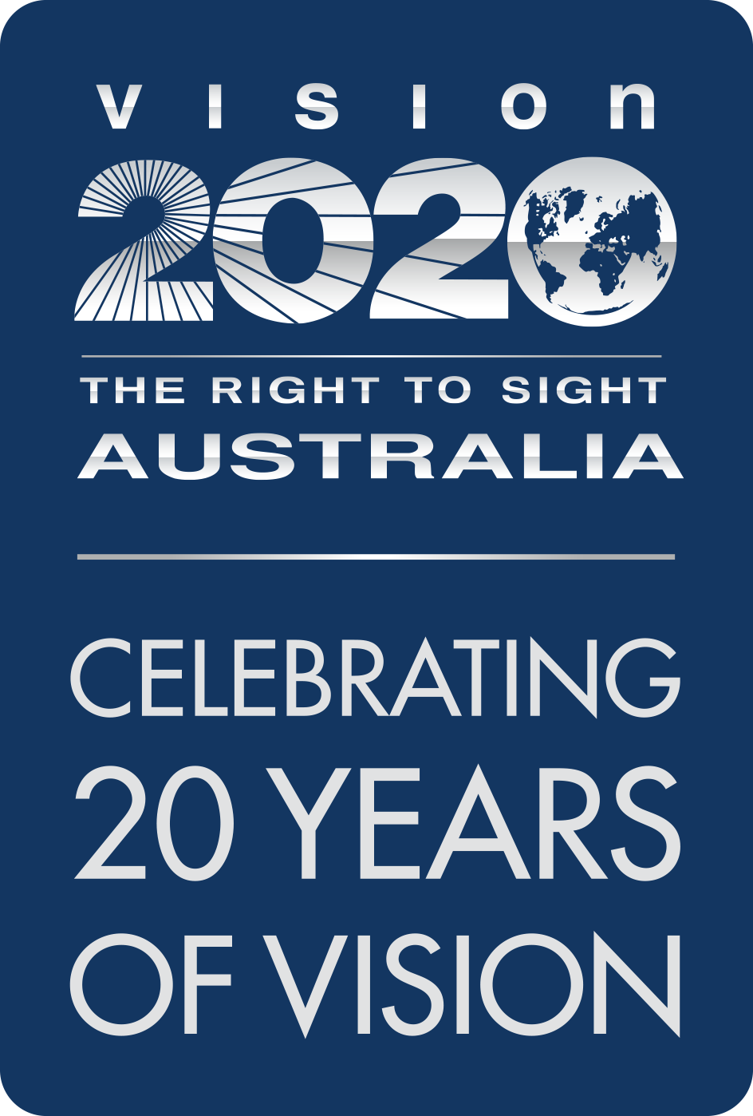

Submission to the Department of Social Services
  - A New National Disability Strategy

  - October 2020
  - [Subtitle]
  - [Date]

About Vision 2020 Australia

Vision 2020 Australia is the national peak body for the eye health and vision care sector. Working with and representing almost 50 member organisations, we focus on supporting policy and funding changes to prevent avoidable blindness, enhance eye care delivery and better meet the needs of people who are blind or living with low vision.
Our members span a wide range of areas and are involved in local and global eye health and vision care, health promotion, low vision support, vision rehabilitation, eye research, professional assistance and community support. This means that the work we do in developing sector-supported policy and advice brings a diverse range of expertise and perspectives to bear, and that the perspectives and experiences of both service users and service providers are at the heart of our work.
Avoidable blindness and vision loss in Australia, and our region, can be prevented and treated by working in partnership across government, non-government, private and community sectors. People of all ages who are blind or vision impaired will benefit from these partnerships, with improved access to services that support their independence and community participation.
For further information about this submission, please contact Vision 2020 Australia on 03 9656 2020 or via email, policy@vision2020australia.org.au

Responses to Guided Questionnaire

Question 1:
Do you have any comments on the vision and outcome areas being proposed for the new National Disability Strategy? – for example, is there advice on any specific issues within the outcome areas that you think need a particular focus in the strategy? (maximum 250 words)
The proposed vision and outcome areas are both broad and as such, supported in principle. While a number of outcome areas are presented as being of equal importance, Vision 2020 Australia’s members view economic security and health and wellbeing as critical outcome areas. Without sufficient economic means, or adequate health and wellbeing, people with disability will be unable to benefit from gains in the other outcome areas, let alone achieve the proposed vision.
People who are blind or have low vision are not “equal” or “included”, due to difficulty accessing vital information, equipment, and resources. These problems likely contribute to their lower employment rates and higher rates of psychological distress.
Achieving the strategy’s vision will require adjustments in relation to key enablers of participation, for example by addressing funding of essential aids and equipment. For blindness and low vision these can require significant up-front costs but enable individuals to live independently, travel and participate in the economy. Under current funding arrangements, Australians, particularly older Australians, are at risk of extreme economic hardship because they either need to meet significant costs themselves or bear the economic consequences of living without those supports.
Particularly for people who are blind or have low vision, acknowledging and addressing these two key areas will result in improvements in the other four. In a truly inclusive society, these people would have the same level of economic security and health and wellbeing as other Australians.

Question 2:
What do you think about the guiding principles proposed here? (are there any other principles that would help ensure policies and programs are right for people with disability, their family and carers? What information or guidance could help organisations to use and adhere to these principles? (maximum 250 words)
Vision 2020 Australia’s members view universal design as a key guiding principle, without which the strategy cannot be fully achieved. For people who are blind or have low vision, it can positively impact areas such as:
- Employment
- Safety in the community
- Information access.
Tactile surfaces, audio cues at traffic lights, spoken announcements on public transport, and high contrast colours are all practical examples of how universal design can enable people who are blind or have low vision to move safely through the physical environment. But they also demonstrate the need for constant review and consultation around design to reflect technological and other developments. For example, electric vehicles pose a safety challenge to people with limited sight, as they are often silent. Introduction of audio cues for these vehicles, following similar regulations in the US and EU, is essential.
Universal design saves costs in the longer term by minimising the need for retrofitting of systems and facilities, or the purchase of expensive specialist equipment. The NDS should aim to encourage adoption of universal design principles in all areas of society, including buildings, transport, technology, banking, wayfinding, voting and television services.
Vision 2020 Australia believes universal design principles should be normalised through leadership from all levels of government, via:
- Accessibility requirements in all government procurement processes, and
- A government-wide commitment to accessibility in all projects and information provision.
This is discussed further in our response to question 9.

Question 3:
What is your view on the proposal for the new Strategy to have a stronger emphasis on improving community attitudes across all outcome areas (maximum 250 words)
Vision 2020 Australia’s members have found that the attitude barrier remains the most significant obstacle to employment for people who are blind or have low vision, and improving employment rates is key to achieving the NDS vision and outcomes.
A 2018 survey carried out by the UK Royal National Institute for the Blind found that 50 %of people in the general public believed a person with vision loss “could not hold down a job”. The full-time employment rate for people with vision loss in Australia is around 24 %, less than half that of the general population, and the employment rate generally is around 50 per cent, compared to 80 per cent for the general population.
Attitude change can be led partly through relatively low-cost cultural change. The introduction of Audio Description on the ABC and SBS, for example, will result not just in greater inclusion, but also changes in perception, uniting people through the common ground of shared cultural touchstones. This is why it is essential that Audio Description on all television channels is permanently secured through legislation (e.g. amendment to the Broadcasting Services Act), as captions are for people with hearing loss.
Achieving this attitude change will require ongoing leadership, via government-wide commitments to universal design (see Question 9), preferencing and actively supporting the ongoing employment of people with disability, and ensuring that their voices, perspectives and experiences actively shape decisions that impact their lives and place within the community.

Question 4:
How do you think that clearly outlining what each government is responsible for could make it easier for people with disability to access the supports and services they need? (maximum 250 words)
Currently, one government department is responsible for disability issues in the community. This means there are few incentives for other parts of government to share responsibility for their experiences and outcomes, and during budget processes, they are in effect competitors for scant resources.
Ironically, the central tenets of current Australian disability policy - choice, control, maximising inclusion and opportunities - are not consistently reflected in the work of the broader public sector.
Shifting this would mean that people with disability do not get caught in the gaps between current programs and responsibilities, but rather experience a more integrated, pragmatic approach that recognises their preferences and finds practical ways to address challenges arising from current policy or funding barriers.
Embedding the concept of “accessibility to all” from the outset of planning for and design of government policies, programs and services would fundamentally shift the lived experience of people living with disabilities who need to engage with government services across many domains.
Vision 2020 Australia’s members have also noticed some specific service gaps for people who are blind or have low vision which may be addressed by clearer delegation of responsibilities:
- There is frequently confusion as to whether the NDIA or state education systems should be responsible for sourcing aids, equipment, and services for students.
- Older Australians with disability who were not eligible for NDIS at time of rollout are missing out on vital aids and equipment due to a failure by all levels of government to recognise their needs.

Question 5:
How do you think the Strategy should represent the role that the non-government sector plays in improving outcomes for people with disability? For example, you might like to suggest a way the strategy could better guide NGOs to improve inclusion and equity for people with disability. This could include their role in communities, the workplace or as part of delivering services. (maximum 250 words)
The business sector should be proactively encouraged to adopt and implement the new NDS, with all businesses encouraged and potentially incentivised to provide accessible goods and services to all Australians, including those with disability.
In particular, large industries such as the banking, telecommunications, retail, and technology sectors must ensure “accessibility for all” is paramount in their design and planning processes so that all Australians can access the essential services that they provide.
Peak bodies such as the Business Council of Australia could play a key role in highlighting the needs of people with disability in the operations of all businesses, and the accessibility of retail outlets in general.
The new NDS should encourage leadership across all sectors including NGOs in the disability sector, through the uptake of universal design principles, commitment to accessible provision of information, and employment of people with disabilities. This inclusivity must be modelled by all levels of government (see Question 9).
Specific actions towards these goals should include:
- Reforms to the Disability Discrimination Act, empowering the Australian Human Rights Commission to investigate discrimination against people with disability.
- Funding and support to enable small businesses to meet accessibility requirements
- The embedding of inclusion in the terms and conditions for all government contracts and procurement processes.

Question 6:
What kind of information on the Strategy’s progress should governments make available to the public and how often should this information be made available? In providing a response you might like to think about what type of reporting would help you know whether the lives of people with disability were improving? How often should reporting be done? (maximum 250 words)
Vision 2020 Australia’s members strongly support the idea of both an annual public statement from the Ministerial Council about policy commitments, and a report on measurable results against the outcome framework, although this preferably should be annual.
The National Disability Data Asset (NDDA) described in the Position Paper will likely also prove an important resource for identifying service gaps. For the blindness and low vision sector, it is important that regular data is gathered around:
    - Whether users of the NDIS are using the funding provided in their plans, and report satisfaction with outcomes
    - What services and supports are being used by older Australians who are blind or have low vision, and are not eligible for the NDIS
    - First Nations people who are blind or low vision, what services and supports they can access, and the quality of outcomes
    - Whether there is an increase in the adoption of universal design principles and accessibility of information within all levels of government, and organisations contracted by government.

Question 7:
What do you think of the proposal to have Target Action Plans that focus on making improvements in specific areas within a defined period of time? You might like to think about specific topics, areas or strategies you think TAPs should focus on (maximum 250 words)
Target Action Plans can play an important role in translating the aspirations of the NDS into measurable action and real change.
Based on the experiences of people who are blind or have low vision, Vision 2020 Australia’s members believe the following targets will produce genuine progress in all the strategy’s proposed outcome areas:
- A specific target for improving the employment rate for people with disabilities in Australia within a specific timeframe.
- A deadline by which time all levels of government should demonstrate consideration of consultative, universal design and accessible information provision in their procurement, funding and contracting decisions.
- A commitment to ensure that all people with disability in Australia have access to quality, stable internet connections (see Question 9 for rationale).
In accordance with Proposal 25 from the Australian Human Rights Commission in their 2019 Discussion Paper on human rights and technology, Vision 2020 Australia supports Recommendation 30 in the submission to the NDS by the Australian Communications Consumer Action Network, which suggests that “one of the first Targeted Action Plans must relate to the enabling role of digital communications technologies”. ACCAN’s submission provides more detail about the substance of such an action plan.

Question 8:
How could the proposed Engagement Plan ensure people with disability, and the disability community, are involved in delivering and monitoring the next Strategy? (maximum 250 words)
Vision 2020 Australia’s members believe the NDS should require the following targets for all projects which are part of its work:
- A concrete target of employment of people with disability throughout all government departments.
- Mandatory consultation of people with disabilities in any project involving the creation or alteration of:
- Physical environments (infrastructure, buildings, transport)
- Virtual environments (software, apps, information delivery systems).
- Improvement of accessibility practices within all government departments, so that people with disabilities are appropriately informed about new policies which may impact them.
- A focus on cultural safety in the engagement process, particularly for First Nations and culturally and linguistically diverse peoples.
The strategy should clearly define terms like “engagement” and “consultation”, and how these processes should work, in order to ensure they have a genuine influence on policy. Fundamentally, mechanisms that give people with disability a genuine say and ideally a decision making role are required, utilising approaches that make this participation simple and not onerous in terms of time or resource requirements.
Vision 2020 Australia’s members also recommend the establishment of a committee, made up of people with disabilities and their representatives, which could examine whether legislation, at all levels, is appropriately inclusive of people with disabilities.

Question 9:
Is there anything else you would like to share about the ideas and proposals in the position paper? (maximum 1000 words)

Article 9 of the United Nations Convention on the Rights of Persons with Disabilities, to which Australia is a signatory, requires, in part, that “States Parties shall take appropriate measures to ensure to persons with disabilities access, on an equal basis with others, to the physical environment, to transportation, to information and communications, including information and communications technologies and systems, and to other facilities and services open or provided to the public, both in urban and in rural areas”.
The new National Disability Strategy is a vital opportunity to further progress toward this goal. In order to ensure that people are not left behind, Vision 2020 Australia’s members offer the following three key recommendations:

Change Attitudes through Leadership
The Position Paper correctly identifies attitude change as an essential goal for the new NDS. As earlier noted, Vision 2020 Australia’s members believe universal design is a key principle which should inform the others, and without which progress cannot be achieved in the proposed outcome areas.
Vision 2020 Australia recommends a government-lead approach to attitude change around universal design and information accessibility. This will require:
- All levels of government to prioritise universal design as part of the procurement process when renting, leasing, or buying equipment, systems, or services.
- Any organisations funded by governments to be contractually required to deliver all information in accessible formats.
We believe these commitments would cause a “sea change”, resulting in the wide adoption of universal design in the community, a vital step toward genuine inclusion.

Consider the Internet Essential
The recent COVID-19 pandemic showed how necessary access to internet can become. The complexity of social distancing, and the higher prevalence of vision loss in older populations, who are also more at risk in case of infection, meant that during lockdown, many people who are blind or have low vision had to rely on the internet for a wide range of essential tasks, including:
    - Grocery shopping
    - Reading mail
    - Understanding how to follow restrictions
    - Attending medical appointments
    - Performing household tasks with visual guidance from online support workers.
The most significant difference in the lives of people with vision loss is the way they access information. In TV news stories for example, a lot of content is conveyed through infographics and captions. People who are blind cannot read printed newspapers, signs, or letters, and some of those with low vision do not use magnifiers for reading printed documents, instead using computer software which renders text in larger fonts.
Due to all these factors, people who are blind or have low vision, without appropriate access, can find themselves uniquely isolated and cut off from vital information. For some, communicating with friends and family, and discussing their unique problems with sympathetic allies in the blindness and low vision community has been vital for the maintenance of their mental health during lockdown.
Members have reported that the rapid rise of telehealth services has in fact had a positive impact for many people, especially those living in isolated locations. Vision 2020 Australia appreciates the way multiple sectors of government have acknowledged the value of maintaining some of the flexibility around telehealth introduced during the pandemic
It is well-documented that the cost of internet is prohibitively high, particularly for those who are unemployed. And in rural or remote communities especially, the quality of service is often inconsistent. 2020 has clearly shown how many Australians are only as equal and included, only as involved in their communities, only as capable of reaching their full potential, as their internet connections allow.
Vision 2020 Australia and its members contend that the new NDS must explicitly acknowledge the importance of internet access to all six outcome areas, and encourage policy approaches that ensure that people with disabilities have access to quality, consistent internet, regardless of their economic circumstance or location.
Approaches could include:
    - An affordable broadband concession for recipients of disability pensions
    - Funding of broadband through the NDIS in specific circumstances
    - Funding of broadband for older Australians who are not eligible for the NDIS
    - Ongoing collaboration between government training programs (e.g. Be Connected) and the blindness and low vision sector to provide training in digital technology to older Australians.

Better meet the needs of Older Australians
The prevalence of vision loss is highest in people over the age of 65, who are not eligible for the NDIS. If appropriate early intervention measures are not introduced, by 2027 it is estimated that 850 thousand older Australians will be blind or have low vision. The Aged Care system, in its current form, does not meet the needs of these people, because:
    - The assessment criteria for entry largely relate to frailty and problems with physical mobility, but people with vision loss are sometimes otherwise healthy.
    - Funding is generally insufficient, in both the CHSP and most Home Care packages, to provide these people with the aids and equipment they need.
    - Even with the recently announced new Home Care packages, lengthy waiting lists mean that opportunities for early intervention are missed.
    - Key staff across the system lack an understanding of issues relating to people who are blind or have low vision.
    - Information about the system and complaints processes is often provided in inaccessible formats.
As a result of all these factors, this population is at higher risk of falls, poor mental health outcomes, and early entry into the residential Aged Care system, all outcomes which would be significantly more costly than providing expert help and specialist equipment at point of need.
The NDS must acknowledge the value of preventing these outcomes, and should recognize older Australians with disabilities as one of its “priority populations”.
Vision 2020 Australia’s members further recommend that:
- The Aged Care act 2013 be amended to acknowledge older Australians with disability as a “special needs group”.
- The NDIS National Workforce plan should also acknowledge the need for expert and informed workers for older Australians with disability, and develop strategies via which this expertise can be ensured.

Question 11:
Do you agree to have your submission published on this website?
Yes.

