13 January 2021
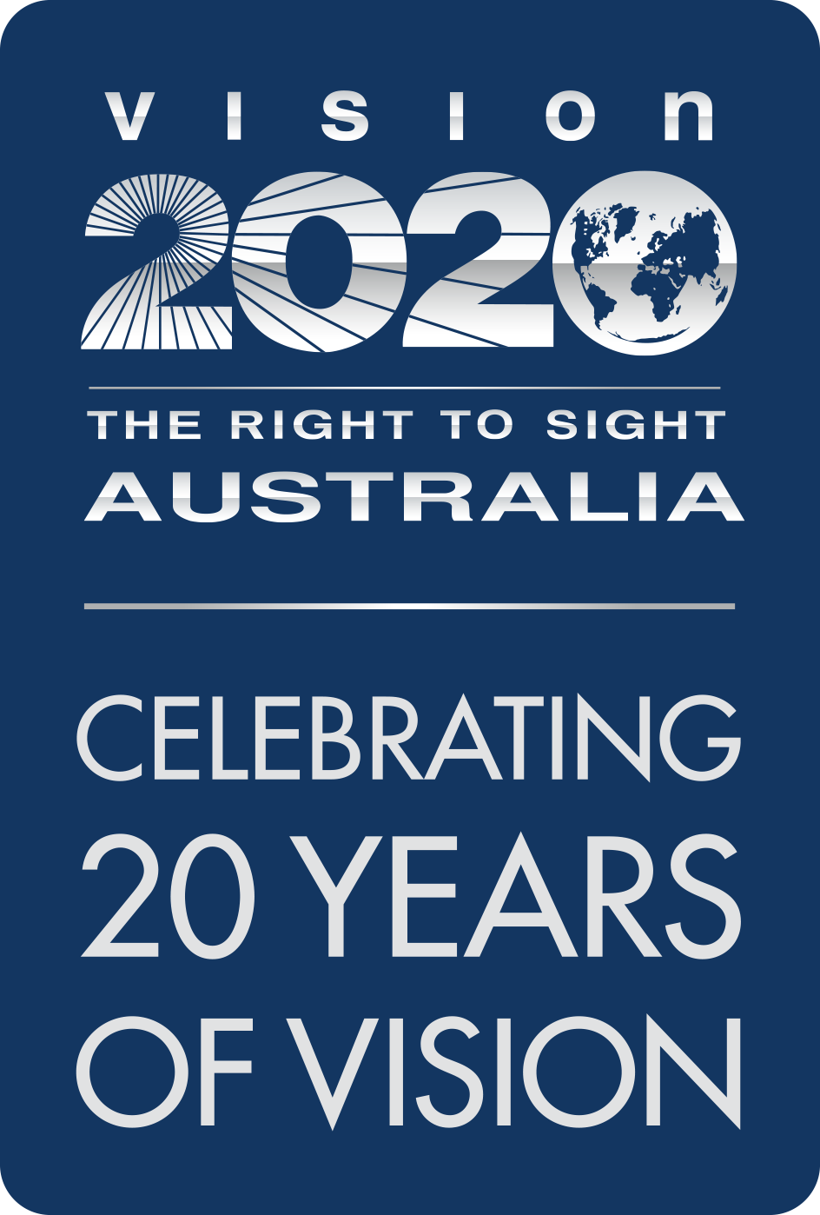
Vision 2020 Australia
ABN 34 094 070 014
Level 3
33 Lincoln Square South
Carlton Victoria 3053
Phone +61 3 9656 2020
Fax + 61 3 9656 2040
info@vision2020australia.org.au
www.vision2020australia.org.au
Lynelle Cogan
Project Officer, Government Relations Policy and Practice
The Royal Australian College of General Practitioners Ltd
100 Wellington Parade
East Melbourne VIC 3002

via email: qualitycare@racgp.org.au

Dear Ms Cogan
Vision 2020 Australia thanks you for the opportunity to make a submission to the review of the current version of the Guidelines for preventive activities in general practice, 9th Edition 2016 (the ‘Red Book’).
Our organisation works with many partners to prevent avoidable blindness, and we are keen to embed vision into chronic health checks, as we believe this would prevent more Australians unnecessarily losing their sight.
There are currently over 450,000 Australians living with blindness and low vision and on our estimates, this could almost double by 2030, so we are keen to progress this as one of a number of strategies to prevent that occurring. Fortunately, 90 per cent of vision loss can be prevented through early identification and treatment of the underlying condition, and ensuring at risk populations have regular eye tests is the key to prevention.
People aged over 40, people living with diabetes, people who smoke, people with a family history of eye disease and Aboriginal and Torres Strait Islander Peoples are at higher risk of vision loss. We are pleased that vision has been embedded in the NACCHO/RACGP National guide to a preventive health assessment for Aboriginal and Torres Strait Islander people, Third Edition 2018 and is an essential part of MBS item 715.
We are now seeking to extend those arrangements to other Australians to help reduce the prevalence of avoidable vision loss. To do this, Vision 2020 Australia requests that the RACGP expand the current content in the Red Book to include more comprehensive eye health and vision information, and encourage its members to make vision testing a mandatory component of all chronic health checks.
Vision 2020 Australia has worked with a range of its member organisations to develop the attached advice regarding recommended changes to the Red Book and the underpinning evidence base.

Amendments to current content
In inviting submissions to the review of the Red Book, the RACGP has requested advice regarding the changes requested to the current version of the Red Book. This currently includes content related to vision in the following chapters:
- Chapter 3 - Preventive activities in children and young people
- Chapter 5 - Vision and hearing impairment in older age
- Chapter 12 – Glaucoma.
We request that the current content in those chapters be expanded on, through a set of changes to content that are, where appropriate, consistent with similar content in the RACGP/NACCHO national guide.
As there are several options for how this could be achieved, we have developed three options for RACGP consideration which are summarised in Attachment 1: Content Relevant to Eye Health.
- Option A would involve reproducing the relevant eye content contained in the RACGP/NACCHO national guide in full
- Option B presents a pared back version of this which is tailored to the general population by removing trichiasis and trachoma as these are conditions primary seen in Aboriginal and Torres Strait Islander populations but does not contain any change to wording
- Option C presents a more tailored option, in which the content is tailored to the general population and a range of changes to the text are proposed to clarify and/or expand on existing text.
Ideally, we would prefer Option C to be incorporated into the Red Book but look forward to discussing the alternatives with you.

Evidence guide and establishment of dedicated chapter
In inviting submissions to the Red Book review, the College has also requested evidence to support the inclusion of proposed changes in the Red Book.
As much of the evidence to support the proposed changes is common to both Aboriginal and Torres Strait Islander Peoples and other Australians and we recognise the importance of consistency in approach, Vision 2020 Australia has adapted the evidentiary guide contained in the RACGP/NACCHO national guide for this purpose. This is provided at Attachment 2: Evidence Base.
At present, the Red Book does not have a designated chapter for “Eye Health” but rather addresses vision and eye health on pages 50 and 137. Vision 2020 Australia proposes that the next edition of the Red Book include a dedicated chapter on eye health and vision, which could be based on the content provided at Attachment 2. This would be a valuable complement to the changes proposed to testing protocols for patients of various ages.
Vision 2020 Australia recognises that general practitioners are extremely busy, and that there are likely many requests for them to expand existing testing protocols to incorporate additional activities. We consider an expanded focus on vision to be a change that could deliver a significant improvement in health and independence to many Australians into the future, but anticipate that the time required to incorporate this into those checks would be minimal (estimated time required would be 1-2 minutes).
In addition, our members have noted that general practitioners already have the necessary skills and training for the suggested changes, although free online training and resources are available should practitioners wish to refresh their knowledge and skills around eye health and vision.
This submission has been endorsed by the members of the Vision 2020 Australia Prevention and Early Intervention Committee, which includes representatives from the Royal Australian and New Zealand College of Ophthalmologists, Optometry Australia, the Indigenous Eye Health Unit, University of Melbourne amongst others. A list of all organisations represented on that Committee is at Attachment 3.
Vision 2020 Australia and its members would welcome the opportunity to meet with you to discuss how we can work together to prevent avoidable blindness, both by supporting the changes outlined in this submission and exploring what practical strategies might be helpful in supporting any change in GP practice in the future.
Yours sincerely
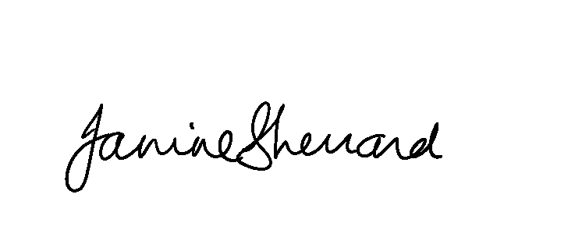
Janine Sherrard
General Manager Policy, Advocacy and Engagement

Attachment 1: Content Relevant to Eye Health

Option A: Reproduce in full relevant content from the RACGP/NACCHO national guide

(source: RACGP/NACCHO National guide to a preventive health assessment for Aboriginal and Torres Strait Islander people Chapter 6, pp 66 -67)
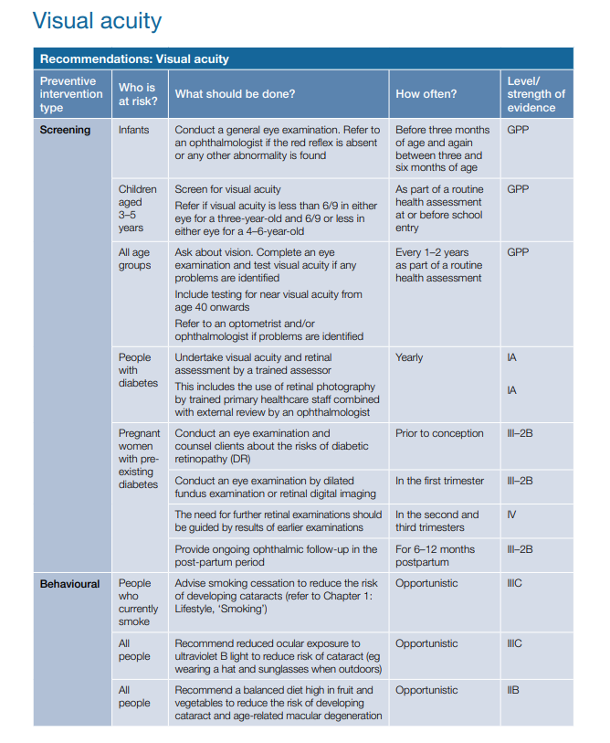
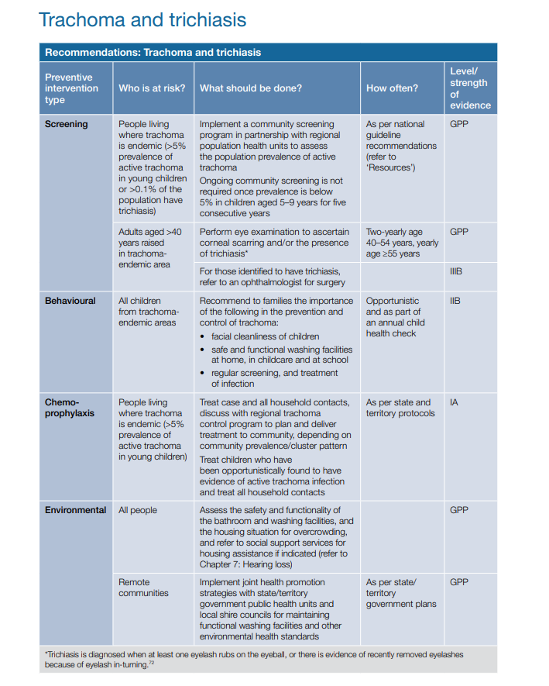

Option B: Reproduce part of the content from the RACGP/NACCHO national guide, removing references to trichiasis and trachoma)

(source: RACGP/NACCHO National guide to a preventive health assessment for Aboriginal and Torres Strait Islander people Chapter 6, p66)

Option C: Tailored changes to existing Red Book content

(based off current RACGP Red Book content, with suggested changes to content or wording is highlighted in yellow)
Red Book Chapter | Age | What should be done? | References (in Att 2)
Chapter 3: Preventive activities in children and young people (page 33).  Table 3.1. Age-related health checks in children and young people | 2, 4, 6, 12 and 18 months; and 3 years | Conduct a general eye examination. Refer to an ophthalmologist if the red reflex is absent or any other abnormality is found. Before three months of age and again between three and six months of age. | 15, 16, 17
 | 3.5-5 years | Check vision as part of a routine health assessment at or before school entry  Refer to optometrist and/or ophthalmologist if visual acuity is less than 6/9 in either eye | 15
 | 6-13 years | Check vision as part of a routine health assessment  Refer to optometrist and/or ophthalmologist if visual acuity is less than 6/9 in either eye
 | 14-19 years | Ask about vision. Complete an eye examination and test visual acuity if any problems are identified.  Refer to optometrist and/or ophthalmologist if problems reported or identified.
Chapter 4: Preventive activities in middle age (page 43) | 45-49 years | Ask about vision and family history of eye disease (age-related macular degeneration and glaucoma in first-degree relatives). Complete an eye examination and test visual acuity if any problems are identified.  Include testing for near visual acuity from age 40 onwards  Refer to optometrist and/or ophthalmologist if problems reported or identified. Consider referral to consumer organisations if family history of conditions such as glaucoma or retinal conditions.
 | 50-64 years | Ask about vision and family history of eye (age-related macular degeneration and glaucoma in first-degree relatives). Complete an eye examination and test visual acuity if any problems are identified.  Include testing for near visual acuity  Refer to optometrist and/or ophthalmologist if problems reported or identified.  Consider referral to consumer organisations if family history of conditions such as glaucoma or retinal conditions.
People with diabetes |  | Undertake visual acuity and retinal assessment by a trained assessor.  This includes the use of retinal photography by trained primary healthcare staff combined by with external review by an ophthalmologist or optometrist. Adherence to RANZCO patient screening and referral pathway guidelines for diabetic retinopathy is recommended.
Behavioural | All people | Recommend a balanced diet high in fruit and green leafy vegetables to reduce the risk of developing cataract and age-related macular degeneration. Adherence to RANZCO referral pathway on age-related macular degeneration management is recommended. | 37
Chapter 5: Preventive activities in older age (page 50)  5.4 Visual and hearing impairment |  | Visual acuity should be assessed from 65 years of age using the Snellen Chart (B) in those with symptoms or who request it.  Patients of all ages should be asked about vision and family history of age-related macular degeneration and glaucoma (first-degree relatives) as part of the health assessment, and should be referred to an optometrist or ophthalmologist for further assessment and management if problems are reported or identified.  Consider referral to consumer organisations if family history of conditions such as glaucoma or retinal conditions.  Adherence to RANZCO patient screening and referral pathway guidelines for diabetic retinopathy, age-related macular degeneration and glaucoma management is recommended. | 50, 51
Table 5.4.2 Visual and hearing impairment: Preventive interventions | Visual impairment: Case finding | Use a Snellen chart to screen for visual impairment in the elderly if requested, or indicated by symptoms or history.  Patients of all ages should be asked about vision and family history of age-related macular degeneration or glaucoma (first-degree relatives) as part of the health assessment, and should be referred to an optometrist or ophthalmologist for further assessment and management if problems are reported or identified. Referral is more urgent if family history is present.  Adherence to RANZCO patient screening and referral pathway guidelines for diabetic retinopathy, age-related macular degeneration and glaucoma management is recommended.  Also refer to Chapter 12: Glaucoma
Glaucoma  Chapter 12 (p137)  Table 12.1 | Increased risk: Family history of glaucoma (first-degree relatives)  Higher risk: Patients aged >50 years with:  - diabetes  - myopia  - long-term steroid use  - migraine and peripheral vasospasm  - abnormal blood pressure (BP)  - history of eye trauma  - diabetes | Refer for examination of the optic nerve head (ophthalmoscopy), measurement of intraocular pressure (tonometry),  assessment of visual fields (perimetry)* and diagnostic optic nerve and retinal nerve fibre layer imaging (e.g. optical coherence tomography).  Adherence to RANZCO referral pathway for glaucoma management is recommended.
Table 12.2 | Assessment of eye structure (ophthalmoscopy) | Indirect ophthalmoscopy performed with a slit lamp and diagnostic optic nerve and retinal nerve fiber layer imaging (e.g. optical coherence tomography) are the examinations of choice.  Adherence to RANZCO referral pathway for glaucoma management is recommended.

Attachment 2: Evidence Base
The adapted evidentiary guide contained in the RACGP/NACCHO National guide to a preventive health assessment for Aboriginal and Torres Strait Islander people, Third Edition 2018, with included modifications to reflect the evidence related to other Australians.

Visual acuity

Background
Eye health is critical to quality of life. In 2016, more than 453,000 Australians were living with vision impairment or blindness. Based on the 2016 National Eye Health Survey (NEHS) and age-adjusted population data, it is estimated up to 432,800 non-Indigenous Australians aged 50 years or older, and up to 18,300 Aboriginal and Torres Strait Islander people aged 40 years or older have visual impairment.¹ Approximately 90% of vision impairment and blindness among both Aboriginal and Torres Strait Islander people and non-Indigenous Australians is preventable or treatable.¹
In the 2016 NEHS, a person with vision impairment was defined as having visual acuity between <6/12 and 6/60 in the better eye and a person with blindness was defined as having visual acuity <6/60 in the better eye.¹
Impaired vision often goes unrecognised and contributes significantly to morbidity.² Eye and sight problems are a common self-reported long-term health condition.^{3,4}
In the elderly, visual impairment is a risk factor for falls, hip fractures, depression, social and functional decline and increased mortality.⁵⁻¹⁰
There is no significant difference in the prevalence of vision impairment between males and females, however, the prevalence of vision impairment increases markedly with age.¹
The age-adjusted prevalence of vision impairment in non-Indigenous Australians is 4.57%, with Aboriginal and Torres Strait Islander peoples exhibiting a rate three times higher (13.6%).¹ Similarly, the age-adjusted prevalence of blindness in Aboriginal and Torres Strait Islander peoples is three times higher compared to non-Indigenous Australians (0.36% versus 0.12%).¹
The main causes of vision impairment are: uncorrected refractive error (approximately 60% in both non-Indigenous Australians and Aboriginal and Torres Strait Islander peoples) and cataract (13.9% in non-Indigenous Australians and 20.2% in Aboriginal and Torres Strait Islander peoples). This highlights that approximately 80% of vision impairment is treatable with spectacle correction or cataract surgery.¹
Other notable causes of vision impairment were age-related macular degeneration in non-Indigenous Australians (8.96% compared with 1.09% in Aboriginal and Torres Strait Islander peoples), and diabetic retinopathy in Aboriginal and Torres Strait Islander peoples (5.46% compared with 1.49% in non-Indigenous Australians). Glaucoma accounts for 1.49% and 0.55% of vision impairment in non-Indigenous and Aboriginal and Torres Strait Islander Australians, respectively.¹
The primary cause of bilateral blindness in non-Indigenous Australians is age-related macular degeneration (71.4%).¹
Diabetic retinopathy (DR) is a significant cause of vision impairment, with prevalence of 1.5% in non-Indigenous Australians and 5.5% in Aboriginal and Torres Strait Islander individuals.¹
Cataract surgery occurs more often in non-Indigenous Australians than in Aboriginal and Torres Strait Islander people (87.6% versus 61.5%),^{1,14} and treatment coverage of refractive error in similarly higher for the non-Indigenous population (93.7% vs 83.3%).¹
Nearly 78% of non-Indigenous Australians with self-reported diabetes report having a diabetes eye examination within the last year, as recommended by National Health and Medical Research Council (NHMRC) guidelines, however, only around one half of Aboriginal and Torres Strait Islander people reported doing so. Very remote areas have significantly lower rates of eye examination.¹

Interventions

Evidence for the effectiveness of preventive interventions

Vision screening in children
Available literature and many professional guidelines generally recommend a check for congenital eye conditions within the first three months of life.15 The project advisory group from the National Children’s Vision Screening Project (NCVSP) in 2009 also recommended vision assessments for children between the ages of three and six months.16,17 For older children, the NCVSP, two recent Australian reviews and the US Preventive Services Task Force (USPSTF) recommend vision screening at least once between the ages of three and five years.15–17, 67
Screening should aim to detect diminished visual acuity, and follow-up screening and treatment should be available for those who require it. Referral criteria are dependent on the age of the child and include a visual acuity less than 6/9 in either eye for a three-year-old and 6/9 or less in either eye for a 4–6-year-old.15
Evaluation of the pupil red reflex with an ophthalmoscope should also be done wherever possible for all age groups (but especially in newborns, infants and young children), to screen for media opacities (e.g. cataract) and/or fundus abnormalities (e.g. retinal detachment). Abnormal colour (particularly white), or incomplete or asymmetrical colouring warrants an urgent referral to an optometrist or ophthalmologist for further assessment.
In Australia, the prevalence of amblyopia in children ranges from 1.4% to 3.6%, while strabismus ranges from 0.3% to 7.3% and refractive error ranges from 1% to 14.7%. Aboriginal and Torres Strait Islander children are five times less likely to have vision impairment than non-Indigenous children,16 with less refractive error and strabismus.
In addition to routine vision screening, Aboriginal and Torres Strait Islander children living in rural and remote areas should be screened for trachoma when there is increased risk.
Further, children with a history of prematurity, birth weight less than 1500 g, and developmental delay or disability, should have more comprehensive eye testing and follow-up as they are at increased risk of vision impairment.16 In Australia, each state and territory health department has separate guidelines for paediatric vision screening.17 These guidelines are all generally in keeping with the above evidence.7,17,19–22

Vision screening in adults
Vision screening for adults is beneficial, as many sight-threatening conditions increase in prevalence with advancing age and may be asymptomatic in the early stages and to promote eye care seeking behaviours. Early detection allows for earlier intervention, with the benefits of reductions in vision loss, maintenance of productivity, reduced risk of injury, falls and mobility and maintenance of quality of life. Further, early recognition of vision loss due to refractive error or cataract is correctable with spectacles, contact lenses and refractive surgery, where appropriate.^{23,24,}

Patients of all ages should be asked about vision and whether their ability to do what they want to do safely is affected by their vision, as part of the health assessment, and should be referred to an optometrist or ophthalmologist for further assessment and management if problems are reported or identified.
There is broad consensus in recommending an assessment of visual acuity in Australians from 65 years of age if requested or symptomatic.⁷ This is supported by the guidelines of RANZCO, American Optometric Association, and American Academy of Ophthalmology, which also recommends a dilation examination every 1 to 2 years for all adults 65 years or older who do not have risk factors or more frequently if risk factors are present.

Adults between 19 to 40 years of age are recommended to have an eye examination at least every two years, unless additional risk factors are present. ,
An Optometry MBS item 10910 is available to cover a comprehensive eye examination every 36 months, and Item 10911 for annual eye examinations in patients 65 years and older.

The substantially higher prevalence and under-diagnosis of vision impairment in Aboriginal and Torres Strait Islander peoples, along with poorer access to corrective services, warrants routine visual acuity screening in all age groups in this population.
An eye examination is a mandatory requirement for a ‘Medicare Health Assessment for Aboriginal and Torres Strait Islander Peoples Health Assessment’ (MBS item 715; refer to ‘Resources’),²⁵ and this is supported by recommendations in the CARPA standard treatment manual (7th ed) and the Queensland Chronic conditions manual.^{19,20}

Testing vision
The standard (Snellen) eye chart and tumbling E chart are the most suitable tools to assess visual acuity.²⁰
The CRANAplus Remote primary care manual also includes the option of using Lea charts.²⁶ Screening questions are not as accurate as visual acuity testing for identifying visual acuity impairment.^{27,28}
The E-test visual acuity charts for near and distance vision are useful for people who cannot read Roman letters²⁹ and were used routinely in the NIEHS.⁴ The need to test near or ‘reading’ vision, especially in those aged over 40 years, is of even greater importance. Near vision test cards or in fact any printed matter can be used to test near vision, and E-tests for near vision can also be used for the those who cannot read.²⁶

Vision testing resources and further training materials can be assessed online or from optometry or ophthalmology professional bodies.

Cataract
Cataract surgery has been shown to improve vision^{27,30} and quality of life,^{30, 35} and reduce the risk of car crash^{31,32} and the rates of falls in older people.^{33,34}
Risk factors for cataract include age,^{36–38} cumulative ocular exposure to ultraviolet light,^{36–40} diabetes and poor diabetic control,^{37,41} smoking,^{36–38,42} alcohol use,^{37,38} family history of cataract, ocular injury, use of corticosteroids and high myopia.³⁷ Although exposure to sunlight accounts for only 10% of cataracts in urban, non-tropical Australian settings,⁴⁰ this risk factor may be more important in northern Australian populations. A diet high in fruit and vegetable intake is associated with a lower risk of developing cataract,³⁷ and a recent meta-analysis indicated a clinically relevant reduction in cataract incidence associated with statin use.⁴⁴

Diabetic retinopathy
General practitioners are well placed to carry out screening for diabetic retinopathy based on the RANZCO referral pathway.
GPs play a significant role in regional and rural areas in screening for diabetic retinopathy (DR). There are Medicare item numbers for the use of nonmydriatic retinal cameras for screening (12325 or 12326). Examples of standard grading photographs are available and can be used as a reference.
General practitioners carrying out diabetic retinopathy screening may sometimes encounter a situation where the best corrected visual acuity (with spectacles or a pin hole, or both) is less than 6/12 and the fundus photograph is normal and no cause for this reduced acuity is obvious. If an ophthalmologist is not available to review the patient, it is recommended that the patient should first be referred to an optometrist (if possible) to rule out other causes of the reduced vision, before referring the patient to an ophthalmologist.
Adherence to RANZCO patient screening and referral pathway guidelines for diabetic retinopathy is recommended.
The overall prevalence of DR in those with known diabetes in Australia is around 25%.^{45–47}
Duration of diabetes is the strongest factor determining DR prevalence;^{38,49–51} however, early onset DR (within 10 years of onset of diabetes) is more common in Aboriginal and Torres Strait Islander peoples than in non-Indigenous people.³⁸ The most important systemic factors associated with increased risk of DR are poor glycaemic control,^{38,45,49,50,52} hypertension,^{38,50,52} dyslipidaemia ^{38,50,52} and renal impairment.^{50,52} There is a possible association with alcohol and the development of diabetic retinopathy.³⁷
Pregnancy is an independent risk factor for worsening of DR.^{38,50,53} Progression of retinopathy occurs at approximately double the rate in pregnant women compared with non-pregnant women and is a leading cause of blindness in women who have pre-existing diabetes during their childbearing years.⁵³
Current Australian recommendations are that all persons with diabetes should be screened and evaluated for retinopathy by an optometrist or ophthalmologist at the time of diagnosis, with recommended review interval for those with no or minimal retinopathy at 1 or 2 years).
Patients with higher risk (e.g. longer duration of diabetes; suboptimal glycaemic management, blood pressure or blood lipid control; people from a non-English-speaking background) should be reviewed at least annually.
Aboriginal and Torres Strait Islander people with diabetes should have visual acuity and retinal assessment (by dilated fundus examination or retinal photography) at the diagnosis of diabetes, and then yearly.^{47,48,50,54}
Establishing an effective referral process for those with retinopathy is important. People with diabetes may have refractive error and are at increased risk of developing cataract. Screening and referral pathways for these conditions are also important in providing appropriate eye care for those with diabetes.
Regular follow-up with early detection and timely treatment of vision-threatening retinopathy enables the prevention of up to 98% of visual loss.^{50–52,55} Those at high risk (poor glycaemic control, hypertension, dyslipidaemia and longer duration of diabetes), should be screened annually.^{47,50,54,56}
Screening for children with diabetes should begin at puberty unless clinical concerns become apparent before this.^{47,50,54}
Mydriatic or non-mydriatic retinal photography screening has been shown to be an effective alternative to dilated fundus examination ^{50,57–59} and is being used routinely in some isolated areas of Australia with support through telemedicine.⁵⁴
MBS item numbers for assessment of visual acuity and retinal photography with a non-mydriatic retinal camera for Aboriginal and Torres Strait Islander people with diabetes (MBS item 12325); and non-Indigenous people with diabetes (MBS Item 12326) for use in general practice became available in November 2016.^{25,54}
Good glycaemic,^{38,47,50,52,60–64} lipid ^{52,62,63} and blood pressure ^{38,47,50,52,61–63} control, together with regular eye examinations and early treatment of any diabetic retinopathy, remain the cornerstone of primary prevention and delay of progression of diabetic retinopathy.^{47,50,63,65}
These measures also increase the length of life, so do not reduce the lifetime risk of developing retinopathy. Once DR is detected, further examinations by an optometrist or ophthalmologist should be conducted annually or at three-monthly to 12-monthly intervals, depending on the level of DR.
Any new visual symptoms should prompt consideration of specialist referral.^{47,50}
Urgent ophthalmology referral (within four weeks) is recommended if any of the following are suspected: diabetic macular oedema (DME), proliferative diabetic retinopathy (PDR) or an unexplained fall in visual acuity.⁵⁰
For women with pre-existing diabetes who become pregnant, a first trimester eye examination, either by dilated fundus examination or retinal digital imaging, is recommended.^{50,52,53,66}
Many guidelines also recommend preconception counselling about the risks of DR and eye examination for women with pre-existing diabetes who are planning pregnancy.^{52,53,61,66}
Rapid optimisation of previously poor glycaemic control in pregnancy should be deferred until after retinal assessment for women with pre-existing diabetes.⁶¹ For pregnant women with pre-existing diabetes, retinal examinations in the second and third trimester are also recommended by most guidelines, depending on findings in earlier examinations.^{50,52,53,66} Evidence indicates a need for ophthalmic follow-up for 6–12 months postpartum for women who had diabetes prior to pregnancy.^{52,53,61} Women with gestational diabetes do not require screening because their risk of diabetic retinopathy does not increase during pregnancy.⁵²

Recommendations: Visual acuity
Preventive intervention type | Who is at risk? | What should be done? | How often? | Level/ strength of evidence | References
Screening | Infants and neonates | Conduct a general eye examination. Refer to an ophthalmologist if the red reflex is absent or any other abnormality is found  Screen for visual acuity  Refer to optometrist and/or ophthalmologist if visual acuity is less than 6/9 in either eye for a three-year-old and 6/9 or less in either eye for a 4–6-year-old | Before three months of age and again between three and six months of age  As part of a routine health assessment at or before school entry | GPP  GPP | 15–17  15–17, 67
Screening | Children aged 3–5 years
Screening | All age groups | Ask about vision and whether they are having difficulties doing any activities safely because of their vision. Complete an eye examination and test visual acuity if any problems are identified.  Include testing for near visual acuity from age 40 onwards.  Refer to an optometrist and/or ophthalmologist if problems are identified. Concerns about activities of daily living, or orientation and mobility may require further referral to low vision or patient and vision rehabilitation services | Every 1–2 years as  part of a routine health assessment | GPP | 7, 19, 20
Screening | People with diabetes | Undertake visual acuity and retinal assessment by a trained assessor  This includes the use of retinal photography by trained primary healthcare staff combined with external review by an optometrist or ophthalmologist.  Adherence to RANZCO patient screening and referral pathway guidelines for diabetic retinopathy is recommended. | Yearly | IA  IA | 50  57–59
Screening | Pregnant women with pre-existing diabetes | Conduct an eye examination and counsel clients about the risks of diabetic retinopathy (DR) | Prior to conception | III–2B | 52, 53, 61, 66
Screening | Pregnant women with pre-existing diabetes | Conduct an eye examination by dilated fundus examination or retinal digital imaging | In the first trimester | III–2B | 50, 52, 53, 66
Screening | Pregnant women with pre-existing diabetes | The need for further retinal  examinations should be guided by results of earlier examinations | In the second and third trimesters | IV | 50, 52, 53, 66
Screening | Pregnant women with pre-existing diabetes | Provide ongoing ophthalmic follow-up in the post-partum period | For 6–12 months postpartum  Opportunistic | III–2B  IIIC | 52, 53, 61  38
Behavioural | People who currently  smoke | Advise smoking cessation to reduce the risk of developing cataracts and age-related macular degeneration (refer to Chapter 1:  Lifestyle, ‘Smoking’) | For 6–12 months postpartum  Opportunistic | III–2B  IIIC | 52, 53, 61  38
Behavioural | All people | Recommend reduced ocular exposure to ultraviolet B light to reduce risk of cataract (e.g. wearing a hat and sunglasses when outdoors) | Opportunistic | IIIC | 38, 68, 69
Behavioural | All people | Recommend a balanced diet high in fruit and green leafy vegetables to reduce the risk of developing cataract and age-related macular degeneration | Opportunistic | IIB | 37

Resources
- Vision 2020 Australia. National Eye Health Survey, Full Report https://www.vision2020australia.org.au/resources/national-eye-health-survey-report/
- Centre for Eye Research Australia (CERA), Melbourne School of Population and Global Health, University of Melbourne, National Indigenous Eye Health Survey: Minum barreng (Tracking eyes) – Full report, http://mspgh.unimelb.edu.au/__data/assets/pdf_file/0004/1984144/niehs_full_report.pdf
- Lions Outback Vision, Diabetic retinopathy screening manual, www.outbackvision.com.au/wp-content/uploads/2017/03/161212-lov.man_.002-diabetic-retinopathy-screening-manual.pdf
- Royal Australian and New Zealand College of Ophthalmologists Referral Pathways Diabetic Retinopathy Management, AMD Management and Glaucoma Management https://ranzco.edu/home/policies-and-guidelines/referral-pathway/
- National Health and Medical Research Council (NHMRC), Guidelines for the management of diabetic retinopathy, www.nhmrc.gov.au/_files_nhmrc/file/publications/synopses/di15.pdf

References
1. Foreman J, Keel S, Xie J, van Wijngaarden P, et al. National Eye Health Survey. Vision 2020 Australia, 2016.
2. US Preventive Services Task Force. Guide to clinical preventive services. Report of the USPSTF. 2nd edn. Baltimore, MD: Williams and Wilkins, 1996.
3. Anjou MD, Boudville AI, Taylor HR. Correcting Indigenous Australians’ refractive error and presbyopia. Clin Exp Ophthalmol
2013;41(4):320–28.
4. National Indigenous Eye Health Survey Team. Minum Barreng (Tracking Eyes) Full Report: National Indigenous Eye Health Survey. Version 2, 2009. Available at www.iehu.unimelb.edu.au/publications/the_national_indigenous_eye_health_survey [Accessed 10 November 2017].
5. Japp D, Robson C, Colledge N. 13 strategies to improve visual assessment in patients attending a day hospital: A closed audit loop. Age Ageing 2014;43(Suppl 1):i3–i.
6. Green C, Goodfellow J, Kubie J. Eye care in the elderly. Aust Fam Physician 2014;43(7):447.
7. The Royal Australian College of General Practitioners. Guidelines for preventive activities in general practice. 9th edn. East Melbourne, Vic: RACGP, 2016.
8. Christ SL, Zheng DD, Swenor BK, et al. Longitudinal relationships among visual acuity, daily functional status, and mortality: The Salisbury Eye Evaluation Study. JAMA Ophthalmol 2014;132(12):1400–06.
9. Nevitt M, et al. Risk factors for injurious falls: A prospective study. J Gerontol 1991;46:164–70.
10. Taylor HR, et al. Updates in medicine: Ophthalmology. Med J Aust 2002;176(29).
11. Liu E, Ng SK, Kahawita S, et al. Ten year all‐cause mortality and its association with vision among indigenous Australians within central Australia: The central Australian ocular health study. Clin Exp Ophthalmol 2016.
12. Landers J, Henderson T, Craig J. The prevalence and causes of visual impairment in indigenous Australians within central Australia: The Central Australian Ocular Health Study. Br J Ophthalmol 2010;94(9):1140–44.
13. Arnold ALM, Goujon N, Busija L, et al. Near‐vision impairment and unresolved vision problems in Indigenous Australian adults. Clin Exp Ophthalmol 2013;41(3):223–30.
14. Randall DA, Reinten T, Maher L, et al. Disparities in cataract surgery between Aboriginal and non‐Aboriginal people in New South Wales, Australia. Clin Exp Ophthalmol 2014;42(7):629–36.
15. Mathers M, Keyes M, Wright M. A review of the evidence on the effectiveness of children’s vision screening. Child Care Health Dev 2010;36(6):756–80.
16. Centre for Community Child Health. National children’s vision screening project discussion paper. Melbourne: Centre for Community Child Health, 2008.
17. Hopkins S, Sampson GP, Hendicott P, Wood JM. Review of guidelines for children’s vision screenings. Clin Exp Optom 2013;96(5):443–49.
18. Hopkins S, Sampson GP, Hendicott PL, Wood JM. A visual profile of Queensland Indigenous children. Optom Vis Sci 2016;93(3):251–58.
19. Central Australian Rural Practitioners Association. CARPA standard treatment manual. 7th edn. Alice Springs: Centre for Remote Health, 2017. Available at www.remotephcmanuals.com.au/# [Accessed 6 November 2017].
20. Queensland Health, Royal Flying Doctor Service Australia (Queensland Section), Apunipima Cape York Health Council. Chronic conditions manual: Prevention and management of chronic conditions in Australia. Cairns: Rural and Remote Clinical Support Unit, Torres and Cape Hospital and Health Service, 2015. Available at https://publications.qld.gov.au/dataset/ef6d9f9e-e8aa-445e-a345-02a016e7251b/resource/ bbe5439c-be87-45b6-b704-3b557fbee1e0/download/chronicconditionsmanual1stedition.pdf [Accessed 10 October 2017].
21. Western Australia Department of Health. Community Health Manual. Guideline: Birth to school aged children. Government of Western Australia, 2007 (updated 2014). Available at www.pmh.health.wa.gov.au/general/CACH/docs/manual/4%20School%20Aged%20 Children/4.4/4.4.2/4.4.2.1.1_Vision_Developmental_Grid.pdf [Accessed 10 November 2017].
22. Central Australian Rural Practitioners Association, Central Australian Aboriginal Congress, CRANAplus, Centre for Remote Health. Minymaku Kutju Tjukurpa – Women’s business manual: Standard treatment manual for women’s business in remote and Indigenous health services in Central and Northern Australia. 6th edn. Alice Springs: Centre for Remote Health, 2017. Available at http:// remotephcmanuals.com.au/publication/wbm.html [Accessed 6 November 2017].
23. Murray A, Jones L, Milne A, et al. A systematic review of the safety and efficacy of elective photorefractive surgery for the correction of refractive error 2005. Available at www.nice.org.uk/nicemedia/pdf/ip/Finalreport%20010605.pdf
24. US Preventive Services Task Force. Screening for impaired visual acuity in older adults: Recommendation statement. Ann Intern Med 2009;151:37–43.
25. Department of Health. Medicare Benefits Schedule. Canberra: MBS Online, 2017. Available at www.mbsonline.gov.au/internet/mbsonline/publishing.nsf/Content/Home [Accessed 10 November].
26. CRANAplus, Central Australian Aboriginal Congress, Central Austalian Rural Practitioners Association Flinders University through the Center for Remote Health. Clinical procedures manual for remote and rural practice. 4rd edn. Alice Springs: Centre for Remote Health, 2017. Available at https://docs.remotephcmanuals.com.au/review/g/manuals2017-manuals/d/20362.html [Accessed 19 October 2017].
27. Chou R, Dana T, Bougatsos C. Screening for visual impairment in older adults: Systematic review to update the 1996 US Preventive Services Task Force recommendation. Rockville, MD: Agency for Healthcare Research and Quality, 2009.
28. Siu AL, Bibbins-Domingo K, Grossman DC, et al. Screening for impaired visual acuity in older adults: US Preventive Services Task Force recommendation statement. JAMA 2016;315(9):908–14.
29. International Council of Ophthalmology. Visual standards: Aspects and ranges of vision loss with emphasis on population surveys. Report prepared for the International Council of Ophthalmology at the 29th International Congress of Ophthalmology. Sydney, 2002.
30. Powe NR, Schein OD, Gieser Sc, et al. Synthesis of the literature on visual acuity and complications following cataract extraction with intraocular lens implantation. Cataract Patient Outcome Research Team. Arch Ophthalmol 1994;112:239–52.
31. Agramunt S, Meuleners LB, Fraser ML, Morlet N, Chow KC, Ng JQ. Bilateral cataract, crash risk, driving performance, and self-regulation practices among older drivers. J Cataract Refract Surg 2016;42(5):788–94.
32. Owsley C, McGwin G Jr, Sloane M, Wells J, Stalvey BT, Gauthreaux S. Impact of cataract surgery on motor vehicle crash involvement by older adults. JAMA 2002;288(7):841–49.
33. Gillespie LD, Robertson MC, Gillespie WJ, et al. Interventions for preventing falls in older people living in the community. Cochrane Database Syst Rev 2012;9(11).
34. Karlsson MK, Magnusson H, von Schewelov T, Rosengren B. Prevention of falls in the elderly—a review. Osteoporosis Int 2013;24(3):747–62.
35. Hewitt A, Verman N, Gruen R. Visual outcomes for remote Australian Aboriginal people after cataract surgery. Clin Exp Ophthalmol 2001;29(2):68–74.
36. Kang JH, Wu J, Cho E, et al. Contribution of the Nurses’ Health Study to the epidemiology of cataract, age-related macular degeneration, and glaucoma. Am J Public Health 2016;106(9):1684–89.
37. Prepared for the National Health and Medical Research Council by Biotext Pty Ltd. Risk factors for eye disease and injury. Literature review, 2008.. Available at www.health.gov.au/internet/publications/publishing.nsf/Content/ageing-eyehealth-risk-factors.htm [Accessed
10 November 2017].
38. Office for Aboriginal and Torres Strait Islander Health. Specialist eye health guidelines for use in Aboriginal and Torres Strait Islander populations. Cataract, diabetic retinopathy, trachoma. Canberra: Department of Health, 2001.
39. West S. Ocular ultraviolet B exposure and lens opacities: A review. J Epidemiol 1999;9(6 Suppl):S97–101.
40. McCarty CA, Taylor HR. A review of the epidemiologic evidence linking ultraviolet radiation and cataracts. Dev Ophthalmol 2002;35:21–31.
41. Robman L, Taylor H. External factors in the development of cataract. Eye 2005;19(10):1074–82.
42. Tan JS, Wang JJ, Younan C, Cumming RG, Rochtchina E, Mitchell P. Smoking and the long-term incidence of cataract: The Blue Mountains Eye Study. Ophthalmic Epidemiol 2008;15(3):155–61.
43. Goujon N, Brown CM, Xie J, et al. Self‐reported vision and health of indigenous Australians. Clin Exp Ophthalmol 2010;38(8):796–804.
44. Kostis JB, Dobrzynski JM. Prevention of cataracts by statins: A meta-analysis. J Cardiovasc Pharmacol Ther 2014;19(2):191–200.
45. Landers J, Henderson T, Abhary S, Craig J. Prevalence and associations of diabetic retinopathy in indigenous Australians within
central Australia: The Central Australian Ocular Health Study. Clin Exp Ophthalmol 2010;38(4):393–97.
46. Tapp RJ, Shaw JE, Harper CA, et al. The prevalence of and factors associated with diabetic retinopathy in the Australian population. Diabetes Care 2003;26(6):1731–37.
47. Central Australian Aboriginal Congress, Central Australian Rural Practitioners Association Inc, CRANAplus Inc, Flinders University through the Centre for Remote Health. Reference book for the remote primary health care manuals. Alice Springs: Centre for Remote Health, 2014. Available at www.remotephcmanuals.com.au/publication/ref.html [Accessed 10 November 2017].
48. Landers J, Henderson T, Abhary S, Craig J. Incidence of diabetic retinopathy in indigenous Australians within Central Australia: The Central Australian Ocular Health Study. Clin Exp Ophthalmol 2012;40(1):83–87.
49. McKay R, McCarty CA, Taylor HR. Diabetic retinopathy in Victoria, Australia: The visual impairment project. Br J Ophthalmol 2000;84(8):865–70.
50. National Health and Medical Research Council and Australian Diabetes Society. Guidelines for the management of diabetic retinopathy. Canberra: NHMRC, 2008.
51. Morris D. Prevention and treatment of diabetic retinopathy. Nurse Prescribing 2012;10(1):22–24.
52. Solomon SD, Chew E, Duh EJ, et al. Diabetic retinopathy: A position statement by the American Diabetes Association. Diabetes Care 2017;40(3):412–18.
53. Morrison JL, Hodgson LA, Lim LL, Al‐Qureshi S. Diabetic retinopathy in pregnancy: A review. J Clin Exp Ophthalmol 2016;44(4):321–34.
54. The Royal Australian College of General Practitioners. Management of type 2 diabetes: A handbook for general practice: 2016–18: East Melbourne, Vic: RACGP, 2016. Available at https://www.racgp.org.au/getattachment/41fee8dc-7f97-4f87-9d90-b7af337af778/Management-of-type-2-diabetes-A-handbook-for-general-practice.aspx [Accessed 19 October 2020].
55. Mohamed Q, Gillies MC,Wong TY. Management of diabetic retinopathy: A systematic review. JAMA 2007;298(8):902–16.
56. Centre for Eye Research Australia. Diabetic retinopathy: Fact sheet. East Melbourne, Vic: CERA, 2008. Available at www.cera.org.au/uploads/CERA_factsheet_DiabeticRetinopathy.pdf [Accessed 10 October 2011].
57. Ku J, Landers J, Henderson T, Craig JE. The reliability of single-field fundus photography in screening for diabetic retinopathy: The Central Australian Ocular Health Study. Med J Aust 2013;198(2):93–96.
58. Tapp RJ, Svoboda J, Fredericks B, Jackson AJ, Taylor HR. Retinal photography screening programs to prevent vision loss from diabetic retinopathy in rural and urban Australia: A review. Ophthalmic Epidemiol 2015;22(1):52–59.
59. Bragge P, Gruen RL, Chau M, Forbes A, Taylor HR. Screening for presence or absence of diabetic retinopathy: A meta-analysis. Arch Ophthalmol 2011;129(4):435–44.
60. Aiello LP, DCCT/EDIC research Group. Diabetic retinopathy and other ocular findings in the diabetes control and complications trial/epidemiology of diabetes interventions and complications study. Diabetes Care 2014;37(1):17–23.
61. The Royal College of Opthamologists. Diabetic retinopathy guidelines. London: RCOPHTH, 2012. Available at www.rcophth.ac.uk/wpcontent/uploads/2014/12/2013-SCI-301-FINAL-DR-GUIDELINES-DEC-2012-updated-July-2013.pdf [Accessed 15 November 2017].
62. Ting DS, Cheung GC, Wong TY. Diabetic retinopathy: Global prevalence, major risk factors, screening practices and public health challenges: A review. Clin Exp Ophthalmol 2016;44(4):260–77.
63. Marozas LM, Fort PE. Diabetic retinopathy – Update on prevention techniques, present therapies, and new leads. US Ophthalmic Rev 2014;7(1):54–58.
64. Chew EY, Davis MD, Danis RP, et al. The effects of medical management on the progression of diabetic retinopathy in persons with type 2 diabetes: The Action to Control Cardiovascular Risk in Diabetes (ACCORD) Eye Study. Ophthalmology 2014;121(12):2443–51.
65. Klein R, Klein BE, Moss SE, Davis MD, DeMets DL. Glycosylated hemoglobin predicts the incidence and progression of diabetic retinopathy. JAMA 1988;260:2864–71.
66. Pan American Association of Opthamology. Guidelines for diabetic eye care. International Council of Ophthalmology, 2016. Available at www.icoph.org/resources/364/ICO-PAAO-Guidelines-for-Diabetic-Eye-Care.html [Accessed 15 November 2017].
67. Force UPST. Vision screening for children 1 to 5 years of age: US Preventive Services Task Force Recommendation statement. Pediatrics 2011;127(2):340–46.
68. McCarty CA, Taylor HR. A review of the epidemiologic evidence linking ultraviolet radiation and cataracts. Dev Ophthalmol 2002;35:21–31.
69. West S. Ocular ultraviolet B exposure and lens opacities: A review. J Epidemiol 1999;9(6 Suppl):S97–101.

Attachment 3: Members of the Vision 2020 Australia Prevention and Early Intervention Committee

Member organisations on the Vision 2020 Australia Prevention and Early Intervention Committee, who endorse this submission:
- Australian College of Optometry
- Brien Holden Foundation
- Centre for Eye Research Australia
- Glaucoma Australia
- Guide Dogs NSW/ACT
- Indigenous Eye Health Unit – University of Melbourne
- Keratoconus Australia
- Macular Disease Foundation of Australia
- Novartis
- Optometry Australia
- Orthoptics Australia
- Retina Australia
- Royal Australian and New Zealand College of Ophthalmologists
- Royal Victorian Eye and Ear Hospital
- School of Optometry and Vision Science – University of NSW
- Sight For All
- The Fred Hollows Foundation
- Vision Australia

New footnote: Amblyopia and abnormal eye movements can manifest in the early years, and should be referred for follow up. Myopia (short sightedness) can also develop in childhood, typically from the age of 5 onwards.
https://ranzco.edu/wp-content/uploads/2020/08/Patient-Screening-and-Referral-Pathway-and-Clinical-Notes-for-Diabetic-Retinopathy-Management-in-Australia-2019.pdf
https://ranzco.edu/wp-content/uploads/2020/11/RANZCO-Referral-pathway-for-AMD-management.pdf
https://ranzco.edu/home/policies-and-guidelines/referral-pathway/
https://ranzco.edu/home/policies-and-guidelines/referral-pathway/
American Academy of Ophthalmology, Preferred Practice Pattern. Primary Open-Angle Glaucoma. 2015. Available at https://www.aao.org/preferred-practice-pattern/primary-open-angle-glaucoma-ppp-2015 (Accessed 19 October 2020)
https://ranzco.edu/wp-content/uploads/2019/06/RANZCO-Referral-Pathway-for-Glaucoma-Management.pdf
American Academy of Ophthalmology, Preferred Practice Pattern. Primary Open-Angle Glaucoma. 2015. Available at https://www.aao.org/preferred-practice-pattern/primary-open-angle-glaucoma-ppp-2015 (Accessed 19 October 2020)
https://ranzco.edu/wp-content/uploads/2019/06/RANZCO-Referral-Pathway-for-Glaucoma-Management.pdf
An Evidence-Based Guideline for the Frequency of Optometric Eye Examinations: https://pdfs.semanticscholar.org/7378/29031b22c94bb6baa62ac08a12d0913c3a30.pdf
Perceptions of Older People Regarding Their Vision and Incident Causation https://pubmed.ncbi.nlm.nih.gov/26367341/
Royal Australian and New Zealand College of Ophthalmologists. RANZCO Referral Pathway for AMD Management. Available at https://ranzco.edu/wp-content/uploads/2020/01/080120-RANZCO-Referral-pathway-for-AMD-management-revised.pdf (Assessed 19 October 2020)
American Optometric Association. Senior: Over 60 Years of Age. St. Louis, MO: American Optometric Association; 2014. Accessed https://www.aoa.org/healthy-eyes/eye-health-for-life/senior-vision?sso=y (Assessed 19 October 2020).
Feder RS, Olsen TW, Prum BE Jr, et al. Comprehensive Adult Medical Eye Evaluation Preferred Practice Pattern(®) Guidelines. Ophthalmology. 2016;123(1):P209-36.
American Optometric Association. Comprehensive Adult Eye and Vision Examination. Available at https://www.aoa.org/AOA/Documents/Practice%20Management/Clinical%20Guidelines/EBO%20Guidelines/Comprehensive%20Adult%20Eye%20and%20Vision%20Exam.pdf (Assessed 19 October 2020)
https://www.nhs.uk/common-health-questions/nhs-services-and-treatments/how-often-can-i-have-a-free-nhs-eye-test/
Department of Health. Medicare Benefits Schedule. Canberra: MBS Online, 2020. Available http://www9.health.gov.au/mbs/fullDisplay.cfm?type=item&q=10910 (Assessed 19 October 2020)
Indigenous Eye Health Unit, University of Melbourne. “Check Today, See Tomorrow” Resources. Available at https://mspgh.unimelb.edu.au/__data/assets/pdf_file/0005/2555600/A4-DR-Rdmap-resource-2017.10.05.pdf (Assessed 19 October 2020)
https://ranzco.edu/wp-content/uploads/2020/08/Patient-Screening-and-Referral-Pathway-and-Clinical-Notes-for-Diabetic-Retinopathy-Management-in-Australia-2019.pdf
Wilkinson CP, Ferris FL 3rd, Klein RE, Lee PP, Agardh CD, Davis M, Dills D, Kampik A, Pararajasegaram R, Verdaguer JT; Global Diabetic Retinopathy Project Group. Proposed international clinical diabetic retinopathy and diabetic macular edema disease severity scales. Ophthalmology. 2003 Sep;110(9):1677-82. doi: 10.1016/S0161-6420(03)00475-5. PMID: 13129861.
https://ranzco.edu/wp-content/uploads/2020/08/Patient-Screening-and-Referral-Pathway-and-Clinical-Notes-for-Diabetic-Retinopathy-Management-in-Australia-2019.pdf (p6).
https://ranzco.edu/wp-content/uploads/2020/08/Patient-Screening-and-Referral-Pathway-and-Clinical-Notes-for-Diabetic-Retinopathy-Management-in-Australia-2019.pdf
The Royal Australian College of General Practitioners. Management of type 2 diabetes: A handbook for general practice. East Melbourne, Vic: RACGP, 2020 (page 76).
https://pubmed.ncbi.nlm.nih.gov/26367341/
https://pubmed.ncbi.nlm.nih.gov/24400653/
https://ranzco.edu/home/policies-and-guidelines/referral-pathway/

