NCC Public Comment Draft
Response Sheet

This response sheet is to be used for submitting responses to the National Construction Code (NCC) 2022 Public Comment Draft.

How to use this response sheet
- Provide your details including name, organisation and contact details.
- Provide your response(s) to the Public Comment Draft. For each response you should include—
  - the relevant NCC volume(s) that your response relates to by clicking in the appropriate box(es);
  - the “Clause/Figure/Table” that you are responding to, e.g. J6D3(1)(a), Housing Provision Figure 7.2.3 or Table C2D2;
  - your “recommended change to draft”, e.g. it is recommended that the proposed drafting to J6D3(1)(a) be amended as follows…(see example);
If you are not recommending a change, insert “N/A” in this field;
  - your “comments/reasons for change”. This should include justification to support your recommended change, e.g. heaters that emit light do not need to be excluded because these heaters have already been exempted by J6D3(3)(d) (see example).
If you are including multiple “comments/reasons”, use dot points or a numbered list.
- Submit your response using the online response form on the ABCB website.
Notes:
Completing all relevant fields will help to describe what change in the Public Comment Draft you are commenting on, what your alternative change is and why it should be made.
This response form is to only be used for submitting responses to proposed NCC amendments contained within the NCC 2022 Public Comment Draft. If you wish to make comments or a submission on documents that have been released with the Public Comment Draft, please follow the instructions accompanying that document.

Response Sheet

Your details
Name: Jane Bryce
Organisation: Vision 2020 for the members of the Inclusion and Participation Committee including Australian College of Optometry, Beyond Blindness, Blind Citizens Australia, Brien Holden Foundation, The Centre for Eye Research Australia, Guide Dogs NSW/ACT, Guide Dogs Victoria, Macular Disease Foundation Australia, NACCHO, NextSense, Optometry Australia, Orthoptics Australia, RANZCO, Retina Australia, Royal Society for the Blind, UNSW School of Optometry and Vision Science, VisAbility/EverAbility and Vision Australia with technical assistance from Braille Tactile Signs Australia
Email or Phone No: jane.bryce@me.com

Response(s)
NCC Volume(s): ☒ One ☐ Two ☐ Three ☐ Housing Prov. ☐ Livable Housing
Clause/Figure/Table: D4D7 Signage
Recommended change to draft:
Separate the requirements for raised tactile and Braille and visual signs – Existing text in black and italicised blue; revised and/or relocated text in red; additional explanatory text in blue

(1) In a building required to be accessible—
(a) braille and tactile signage complying with Specification 15 must—
(i) incorporate the international symbol of access or deafness, as appropriate, in accordance with AS 1428.1 and identify each—
(A) sanitary facility, except a sanitary facility associated with a bedroom in a Class 1b building or a sole- occupancy unit in a Class 3 or Class 9c building; and
(B) space with a hearing augmentation system; and
(1) identify the type of hearing augmentation; and
(2) the area covered within the room; and
(3) if receivers are being used and where the receivers can be obtained

(ii) identify each door required by E4D5 to be provided with an exit sign and state—
(A) “Exit”; and
(B) “Level”; and
(C) the floor level number or floor level descriptor, or a combination of the two.
(iii) be provided at the entry of accessible unisex sanitary facilities to identify if the facility is suitable for left or right handed use
(iv) identify an ambulant accessible sanitary facility and must be
- located on the cubicle door, where the ambulant accessible sanitary facility is not a single user facility.
- Located in accordance with Specification 15 S15C2 (c) where the ambulant accessible sanitary facility is a single user facility and does not have a cubicle door

ADD Explanatory Information: Signs detailed in D4D7(1) and (3) are accessible signs. The content of the sign is to include raised tactile text and symbols as well as Braille.
(2) In a building required to be accessible - signage incorporating the international symbol of access or deafness, in accordance with AS 1428.1, must be provided -
(i) within a room containing a hearing augmentation system identifying—
(A) the type of hearing augmentation; and
(B) the area covered within the room; and
(C) if receivers are being used and where the receivers can be obtained; and

(ii) where a pedestrian entrance is not accessible to direct a person to the location of the nearest accessible pedestrian entrance; and
(iii) where a bank of sanitary facilities is not provided with an accessible unisex sanitary facility, directional signage must be placed at the location of the sanitary facilities that are not accessible, to direct a person to the location of the nearest accessible unisex sanitary facility.

ADD Explanatory Information: Signs detailed in D4D7(2) are visual signs. The symbols are to be in accordance with the requirements of AS1428.1 (2009)

(3) In a building that is subject TO F24D12 and is required to be accessible, directional signage complying with Specification 15 MUST direct a person to the location of the nearest accessible adult change facility within that building AND be provided at the location of each—
(a) bank of sanitary facilities; and
(b) accessible unisex sanitary facility, other than one that incorporates an accessible adult change facility.

Comment/reason for change:
There is inconsistent language used in this section when referencing AS1428.1. In some parts it is unclear if the reference is to the figures (International Symbol of Access or Deafness) or if it is referencing the complete signage requirements of AS1428.1 which in part are duplicates of Specification 15 (raised tactile and Braille signs)
D4D7(1)(a) requires that raised tactile and Braille signage is required to identify spaces with hearing augmentation. This is typically provided at the door into a room. It does not require that the type of system is identified. Provision of signs with raised tactile and Braille information at doors provides signs in a consistent and predictable location for people who are blind or have low vision.
D4D7(1)(b) states [in part] “signage including the international symbol for deafness in accordance with AS 1428.1 must be provided within a room containing a hearing augmentation system”. It is not clear if it is referencing only the symbol (AS1428.1 Clause 8.2 and associated figures) or the whole of the section about signage. The first option results in a visual only sign. The second option results in a raised tactile and Braille sign but there is no specific location required, which is difficult for people who are blind. (See figures below for illustration of this point)
Following on D4D7(1)(b) further states [in part] that the type of hearing augmentation system is to be identified. But is this information to be provided in raised tactile and Braille or is a visual only sign required? If it is provided within a room, how will a person who is blind locate the sign as a specific location is not detailed?
The above amendment proposed clarifies the types of signs by splitting them into two groups (1) signs with raised tactile and Braille content or (2) signs with the symbol as per AS1428.1 – typically visual only.
The requirements for signage for Accessible Adult Change facilities has always read poorly so changes highlighted in yellow and capitals (for easy location withing this document only) are also proposed.

The proposed amendment should not typically require signage beyond the scope of NCC2019 Amendment 1 but rather changes the location of some of the signs to provide greater consistency in the location of signage that is used by people who are blind or have low vision, particularly those who are deaf-blind or rely on the use of hearing augmentation systems. Consistent and specific locations of signage used by people who are blind or have low vision is critical.

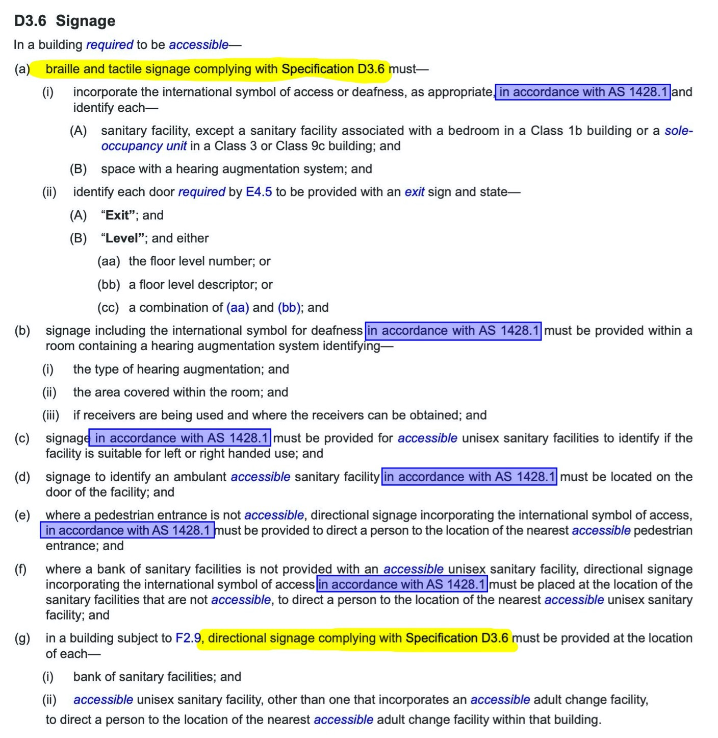
Figure above shows how it is possible to isolate the referencing of AS1428.1 resulting in an interpretation that all signs listed in this section of the NCC should include tactile text and braille content.
Figure below shows a different view of the content that means that in some clauses , the reference is to the symbol only.
Content of NCC2019 Amendment 1 is virtually identical to NCC2022 PCD
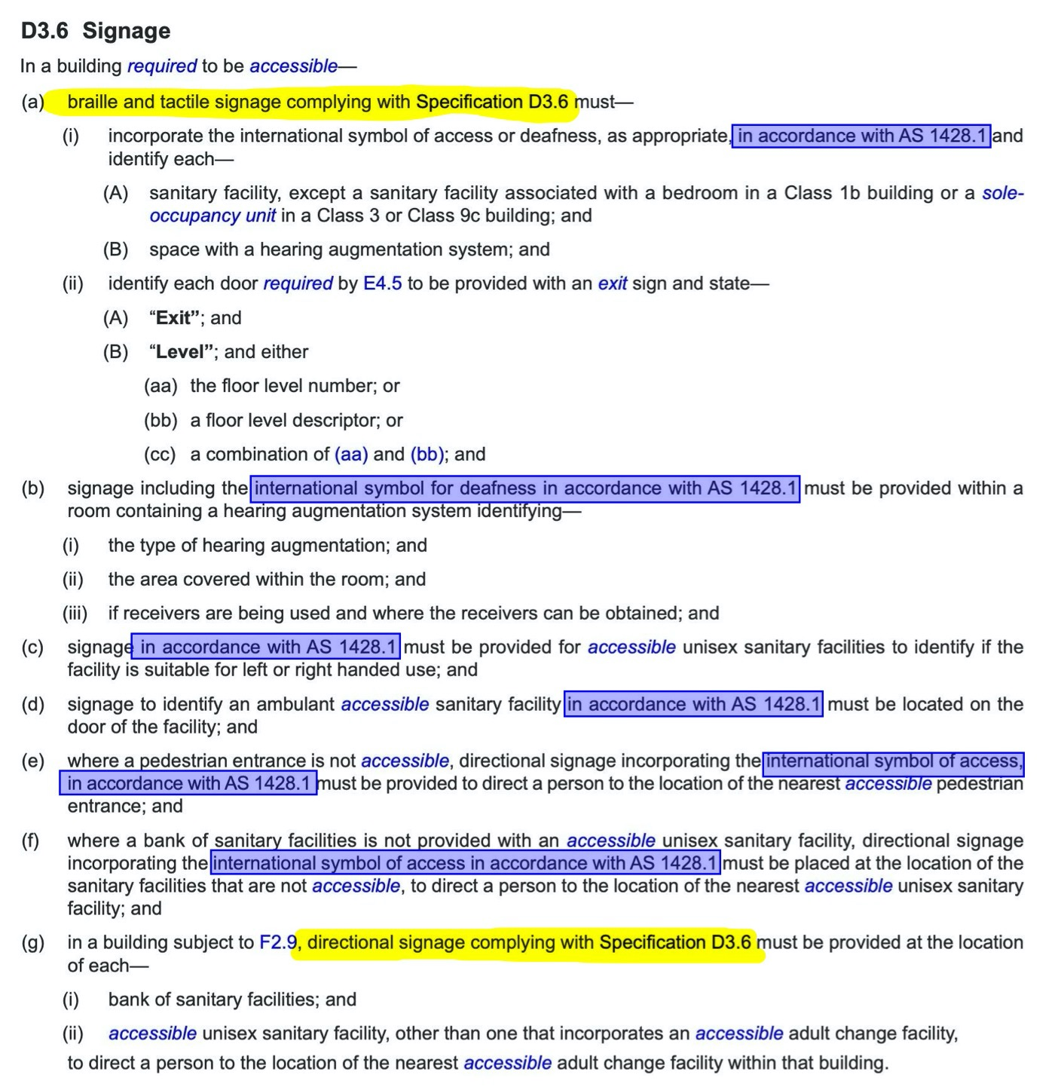

NCC Volume(s): ☒ One ☐ Two ☐ Three ☐ Housing Prov. ☐ Livable Housing
Clause/Figure/Table: D4D7
Recommended change to draft:
Simplification of the language used for Exit Level signs

(ii) identify each door required by E4D5 providing direct egress from a storey or doors on levels other than the discharge door level to be provided with an exit sign and state—
(A) “Exit”on line one; and
(B) “Level” on line two; and
(C) the floor level number or floor level descriptor, or a combination of the two on line two;or
(D) “Exit” separated by a dash; and (B) and (C) on the same line; and

(iii) identify each door required by E4D5 providing direct egress from the same storey as the discharge door to be provided with an exit sign and state—
(A) “Exit” on line one and “This Level” on line two; or
(B) “Exit” separated by a dash; and “This Level” on the same line; and

(iv) identify the door in an enclosed stairway, passageway or ramp at every level of discharge to a road or open space to be provided with an exit sign and state—
(A) “Exit”

Comment/reason for change:
The current terminology does not help people who are blind or have low vision to identify what is a path of travel to an egress point and what is the discharge door, or the door that is the last door on an egress path. In some cases an egress path commences well above gorund level; in other cases a person needs to go through a fire-isolated stairway but stay on the same level; in yet other cases the discharge door may not be on the ground level or there may be more than one street level, but which is deemed the ground level?
This amendment provides more accurate wayfinding descriptions for egress routes

NCC Volume(s): ☒ One ☐ Two ☐ Three ☐ Housing Prov. ☐ Livable Housing
Clause/Figure/Table: Specification 15
Recommended change to draft:
Consistent numbering format throughout the Specification
Comment/reason for change:
S15C2, S15C4 and S15C6 all have alpha identification of the subclauses (a), (b), (c) etc
S15C3 has a numeric identification of the subclauses (1), (2), (3) etc

NCC Volume(s): ☒ One ☐ Two ☐ Three ☐ Housing Prov. ☐ Livable Housing
Clause/Figure/Table: S15C3
Recommended change to draft:
Consistent use of terminology – deletion of text is via strikethrough; addition in red

Braille and tactile sign specification
- Tactile characters content including text, symbols, logos and features other than Braille must be raised or embossed to a height of not less than 1 mm and not more than 1.5 mm.
- Title case must be used for all tactile characters text, and—
  - upper case tactile characters text must have a height of not less than 15 mm and not more than 55 mm, except that the upper case tactile characters on a sign identifying a door required by E4.5 to be provided with an exit sign must have a height of not less than 20 mm and not more than 55 mm; and
  - lower case tactile characters text must have a minimum height of 50% of the related upper case characters.
- Tactile characters text, symbols, and the like, must have rounded edges.
- The entire sign, including any frame, must have all edges rounded.
- The background, negative space or fill of signs must be of matt or low sheen finish.
- The characters text, symbols, logos and other features on signs must be matt or low sheen finish.
- The minimum letter spacing of tactile characters on signs must be 2 mm.
- The minimum word spacing of tactile characters on signs must be 10 mm.
- The thickness of letter strokes of tactile text and symbols must be not less than 2 mm and not more than 7 mm.
- Tactile text must be left justified, except that single words may be centre justified.
- Tactile text must be Arial typeface.

Comment/reason for change:
There is inconsistent use of wording within the Clause. Use of the term characters in some cases refers to text, in other cases it refers to all raised tactile content
Items (1) to (8) uses tactile characters
Items (10) and (11) refers to tactile text

NCC Volume(s): ☒ One ☐ Two ☐ Three ☐ Housing Prov. ☐ Livable Housing
Clause/Figure/Table: S15C3(8)
Recommended change to draft:
Accommodate psacing needs between variable fonts sizes and apply also to non-text elements of tactile signs
The minimum letter spacing of between tactile characters elements on signs must be not less than
(a) 2mm between tactile text
(b) 1.5mm between elements of tactile symbols or the like

Comment/reason for change:
Set distances for spacing between letters is problematic for variable font sizes (minimum letter height 15mm to maximum letter height of 55mm)
Spacing between lines within symbols is not specified. Where lines of letters, symbols or the like are close together it is difficult for a person who is reading the information by touch to feel the gaps, making it hard to understand the tactile information.

NCC Volume(s): ☒ One ☐ Two ☐ Three ☐ Housing Prov. ☐ Livable Clause/Figure/Table: S15C3 (9)
Recommended change to draft:
deleted text is strikethrough; addition in red
Provide a range of spacing due to variable font sizing;
Expand context to include symbols and other tactile content

The thickness of tactile text letter strokes and lines of tactile symbols or the like must be not less than 1.5mm 2 mm and not more than 7mm
Comment/reason for change:
Set distances for letter stroke sizes is problematic for variable font sizes (minimum letter height 15mm to maximum letter height of 55mm)
When working with 20mm H text, this is suitable, however for 15mm text the letter stoke must be manually adjusted to reach the 2mm letter stoke

NCC Volume(s): ☒ One ☐ Two ☐ Three ☐ Housing Prov. ☐ Livable Housing
Clause/Figure/Table: S15C3 (11)
Recommended change to draft:

Tactile text must be Arial typeface sans serif font which does not have a looptail lower case g
Comment/reason for change:
Arial is a proprietary branded font. There are numerous other sans serif fonts.

Looptail lower case g is a letter shape that is similar to the shape of the number 8 or an ampersand ‘&’. An open tail g is easier to recognise especially for people who are blind who are reading the raised text elements of signs.
People who are blind can be divided roughly into two groups – Braille and non-Braille readers. Profficient Braille readers are typically those who have developed their vision loss early in life so have been educated using Braille. They maybe less familiar with text letter shapes.
People who lose their sight later in life may chose to not learn Braille or struggle to learn. Frequently they will have learnt to read using standard or visual text so they may be more comfortable with raised text than Braille on a sign.
Providing the simplest clearest letter shapes is important for all users, whether they are reading it visually or tactually.

NCC Volume(s): ☒ One ☐ Two ☐ Three ☐ Housing Prov. ☐ Livable Housing
Clause/Figure/Table: S15C4 (a) Luminance Contrast
Recommended change to draft:
deletion of text is via strikethrough; addition in red

(a) The background, negative space, fill of a sign or border with a minimum width of 5 mm must have a luminance contrast with the surface on which it is mounted of not less than 30%.
(a) To provide sufficient luminance contrast of the sign to the background or mounting surface:
(i)Where the wall surface colour is constant, the sign shall provide a 30 % luminance contrast to the wall.
(ii) Where the wall surface is not consistent in colour or is patterned, a border around the sign a minimum of 10 mm in width shall be provided to achieve a 30 % luminance contrast with the sign background.
(iii) Where the sign is mounted on a transparent surface then the sign shall provide a 10 mm border which shall provide a 60 % luminance contrast to the sign background.
Comment/reason for change:
Greater alignment with requirements of Australian Standard AS1428.4.2, which is based on more recent research into luminance contrast needs of people who have low vision
The content also addresses the provision of signage on glazed panels and doors.

NCC Volume(s): ☒ One ☐ Two ☐ Three ☐ Housing Prov. ☐ Livable Housing
Clause/Figure/Table: S15C6 (c)
Recommended change to draft:
Remove confusion by deleting “not including descenders” and replacing with words in red

Braille must be located
- 8 mm below the bottom line of text (not including descenders) where the bottom line of text does not include descenders.
- 4mm below the bottom line of text measured between the lowest part of text and the uppermost point of Braille content where there are descenders
Comment/reason for change:
Variable font sizes plus a set location of Braille beneath text is problematic as the font size varies but the Braille location remains fixed.
The term “not including descenders” is unclear. Does this mean that the tail of a lower case letter, the letter g for example, on a 50mm letter is permitted to “intrude” into the location of the Braille? Note this is not an issue when the raised text size is 15mm to 20mm.
The length of a descender of a 50mm letter intrudes into the location of the Braille information when the Braille must to be located 8mm below the bottom line of the text.
The 4mm gap is consistent with letter spacing and Braille spacing.

NCC Volume(s): ☒ One ☐ Two ☐ Three ☐ Housing Prov. ☐ Livable Housing
Clause/Figure/Table: S15C6(f)
Recommended change to draft:
On signs with multiple lines of text and characters braille-
- a semicircular braille locator at the left margin must be horizontally aligned with the first line of braille text-
  - At the left margin of the sign where the sign has no border; or
  - Is aligned with the left edge of the tactile text or tactile symbol or the like where there is no tactile text
- A space the equivalent of one braille word space (8.5 mm) must be provided between the right side of the braille locator and the left edge of the first braille cell
Comment/reason for change:
Click here to enter text.

NCC Volume(s): ☒ One ☐ Two ☐ Three ☐ Housing Prov. ☐ Livable Housing
Clause/Figure/Table: D4D9 Tactile indicators
Recommended change to draft:
(1) For a building required to be accessible, tactile ground surface indicators must be provided to warn people who are blind or have a low vision impairment that they are approaching—
Comment/reason for change:
Change of language describing particular functional groups of people with disabilities

